Bilingual Education and Mathematics in Early Years and Inclusion
Athena Dermentzi, Greece

Athena is an English Teacher serving the Bilingual Education (Greek-English) and holds an MA in Special Educational Needs. She has attended many conferences as a speaker and writes articles in Greek and English Magazines and websites. She is an advocate of experiential and holistic learning, and her intention is always to motivate and engage her students. Email: athina.derme@gmail.com
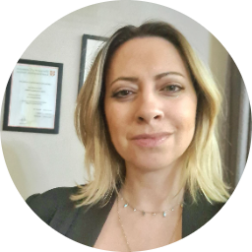

Bilingual syllabus

It is widely known that competition among the Bilingual Private Schools has created a very demanding syllabus for the Early Years students. A stimulating programme including math, science, STEM, languages, phonics, physical education, and sports along with music and dancing competitions, celebrations, and festivals, embrace the students’ skills in order to enhance and flourish them and make them competent in later years. But how inclusive can all these programmes be and are we sure that the students, especially the ones with ADHD are not going to get bored, tired, or distractive?

Teaching mathematics - revision
The Early Years students always have fun revising, counting, and showing fingers, but what about when they play bowling inside or outside the classroom as a part of the mathematics lesson in the bilingual classroom? It is easy to come up with ideas if you really want to include everyone in the learning procedure. The only prerequisite is that they need to have been taught the numbers 1-5.

How to create a stimulating environment

Creating a stimulating environment can be both challenging and demanding. The students who learn English as a Second Language and struggle because of their difficulties and the lack of concetration, are usually found hiding behind other classmates, staying silent or becoming hyperactive to avoid participation however, the following steps are structured to aid, no matter how difficult the situations are.
STEP 1: Create workstations (and/ or separate the students into 2 groups)
The first is bowling pins.
The second is a gymnastics ribbon or a long rope.
The third is a flour tray.
The fourth is a whiteboard.

STEP 2: Explain the rules in each workplace divide the students into 2 groups or 3 groups depending on the materials you have.
At the first workstation, the children throw the ball against the bowling pins and they count how many are down.
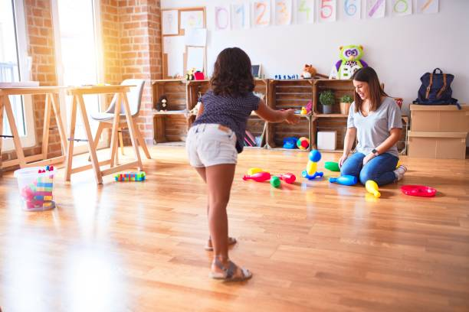

Then, they run to the 2nd workstation where they must form the number of the dropped bowling pins with the gymnastics ribbon or a long rope.
At the 3rd workstation, they must write the same number with their finger in the flour.
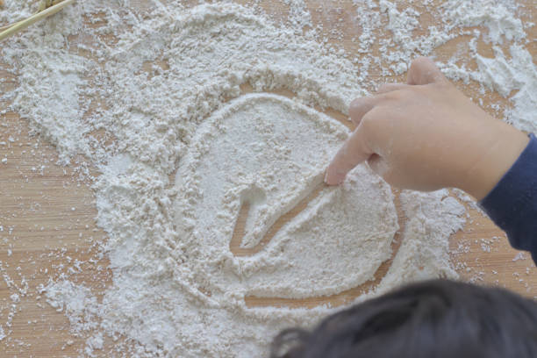

At the 4th workstation, they must write the same number on the board.
When they will have finished with everything, they ring a bell, or the teacher might decide to give points.
In that way, they will have practiced multiple times, they will have also stayed engaged and motivated and on top of everything, they will have fun.
STEP 3: Have them sit in a circle and sing a song including the numbers from 1 to 5 and let the students delve into learning.

The science behind the workstations

Bowling is a great technique to engage the students, involve and engage all learning styles (VAK) because they walk, they count out loud and they interact, minimizing their anxiety in a great way. The extra advantage that students have in this case, is the positive change that they demonstrate towards the lesson and the teacher, which as studies have indicated, it changes and eases the bad behaviour (Zaim, 2023). Also, games in an educational environment can create a bond among the classmates and lead to better social skills and the children with low competences seem to flourish (Vogt et al, 2018).
Getting to form the number with a ribbon or a rope it shows the student the way how to write it later in the flour, on the whiteboard and last on the paper. The intimacy with the number formed with a rope, can be more experiential for the student by assisting his whole body (holistic approach) to process the number.
Writing in the flour is part of multisensory approach where the student can relate the number formation to the texture of the flour and in this case, it stimulates the brain area called cortex which ‘’facilitates the establishment and retrieval of memory” (Neumann et al, 2012).
The last workstation, writing the number with the board marker, is the thought to get the students write the numbers preparing them for higher academic competency and skills (Katz, 2010).


Bibliography
Zaim, Ö. (2023). Multi-factorial effects of play interventions on pre-school or school aged children who have ADHD or ADHD symptoms.: A Scoping Review.
Franziska Vogt, Bernhard Hauser, Rita Stebler, Karin Rechsteiner & Christa Urech (2018). Learning through play – pedagogy and learning outcomes in early childhood mathematics, European Early Childhood Education Research Journal, 26:4, 589-603, DOI: 10.1080/1350293X.2018.1487160
Neumann, M., Hyde, M., Neumann, D., Hood, M., & Ford, R. (2012). Multisensory methods for early literacy learning. Beyond the lab: Applications of cognitive research in memory and learning, 197-216.
Katz, L. G. (2010). STEM in the early years. Early childhood research and practice, 12(2), 11-19.

Please check the Pilgrims f2f courses at Pilgrims website.

Please check the Pilgrims online courses at Pilgrims website.

