33rd IATEFL POLAND International Conference Gdańsk, 20th – 22nd September 2024, Poland
attended by Hania (Hanna) Kryszewska, Pilgrims trainer and HLT Editor

The venue
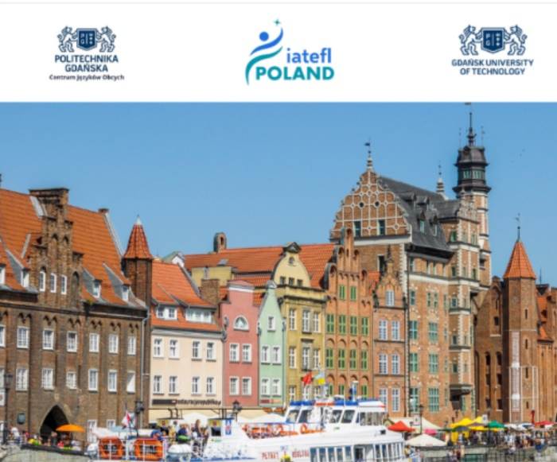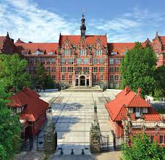
The conference was held in the historic city of Gdańsk, at the renown University of Technology founded in 1904. We could enjoy the beautiful old architecture during the delicious and atmospheric gala dinner
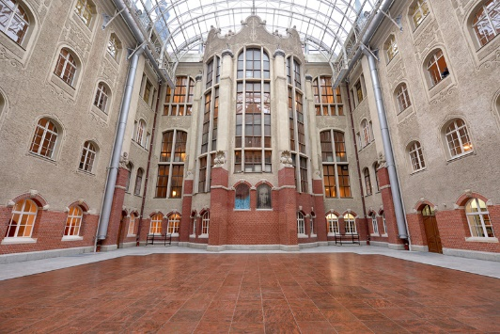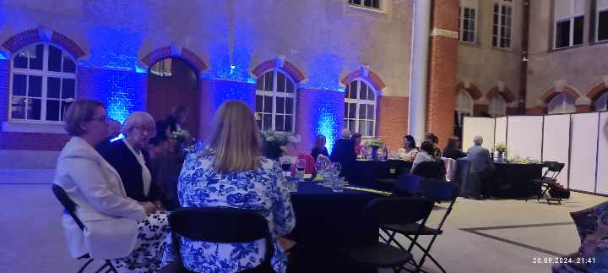
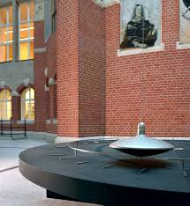
but the actual venue was the top-notch Faculty of Electronics, Telecommunications and Informatics. Rob (Howard, President of IATEFL Poland) you have chosen the venue really well.

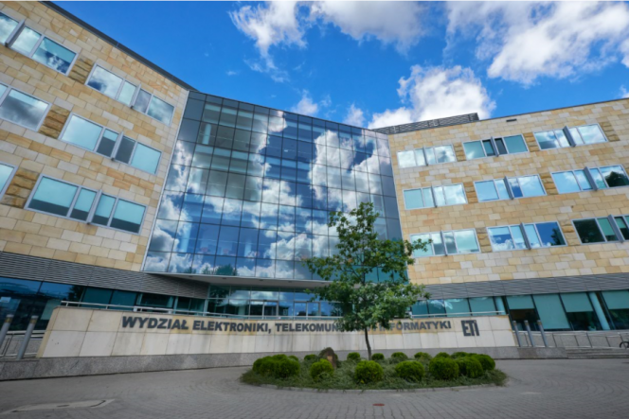
Get the feel
And this is how the conference was advertised. Rob I adore your sense of humour… and IT editing skills
https://www.youtube.com/watch?v=0Zeonl-4yic
Pilgrims at IATEFL Poland 
Pilgrims was represented by Alan Maley, Hania Kryszewska and Marta Bujakowska. Sadly, Magda Zamorska could not join us due to last minute personal developments. Alan Maley acted as Pilgrims Ambassador to the conference.
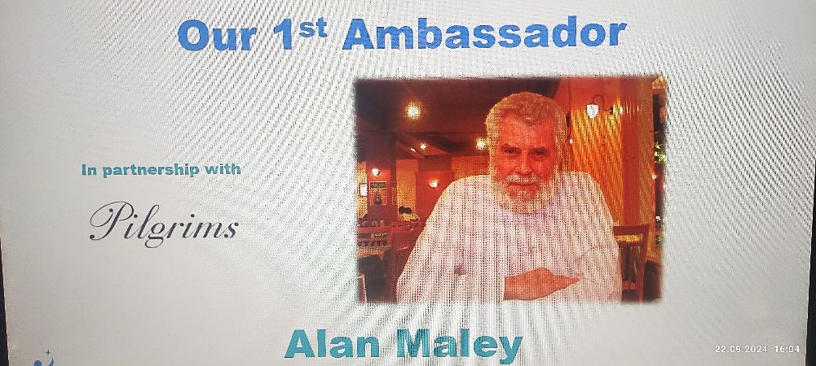

The speakers
The collection of speakers was impressive, among them some past IATEFL UK Presidents: Alan Maley, Marjorie Rosenberg and Aleksandra Popovski.
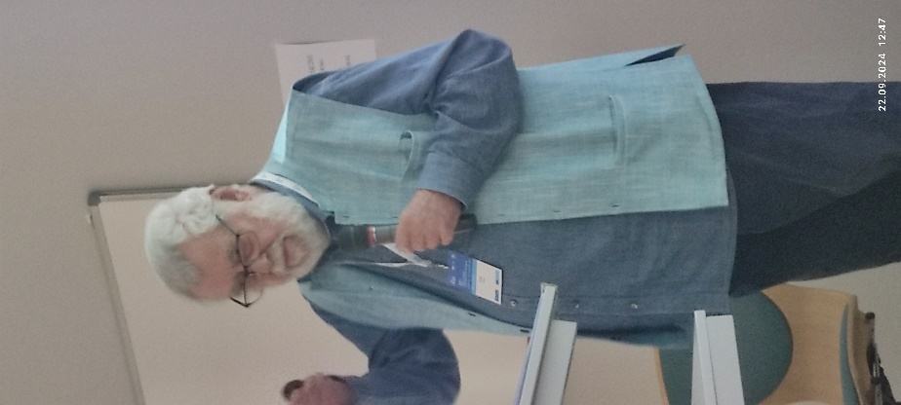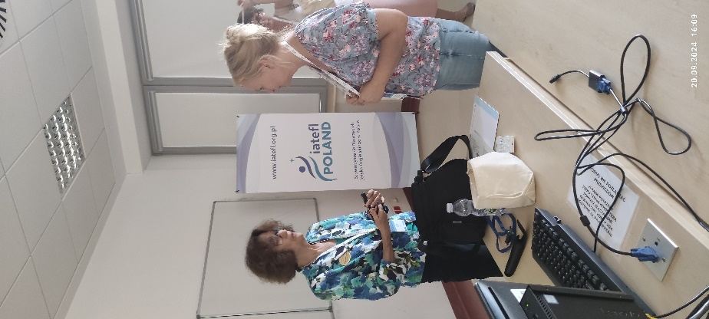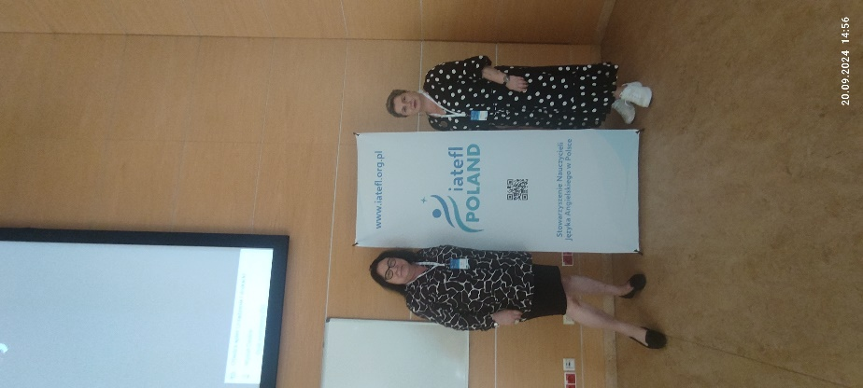
It was great to attend talks by old friends, colleagues and HLT contributors like Penny Ur, Hugh Deller, Piotr Steinbrich, Grzegorz Śpiewak, Jon Hird, Bruno Leys, Russel Stannard just to name a few.
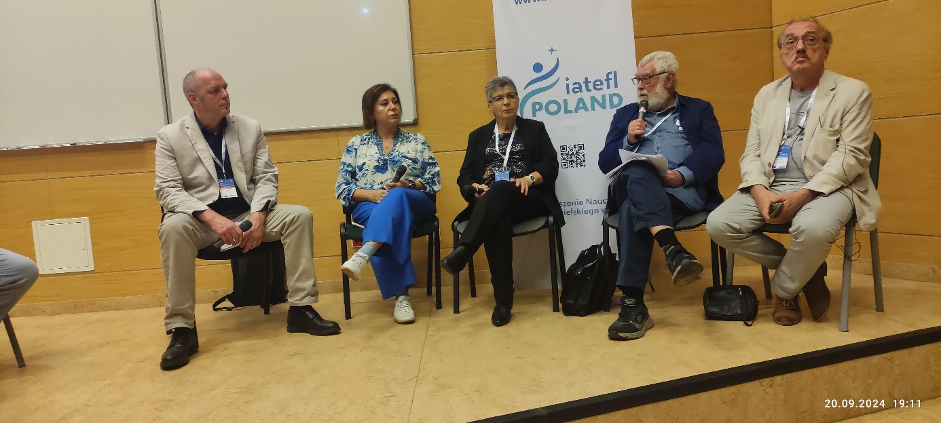
And we made new friends…among others with Claudia Molnar, Judy Boyle and Julia Aliverti, and Rachel Paling who will soon be contributing to HLT. Claudia is an expert on ADHD, Rachel on coaching, and Judy and Julia on social issues and modern slavery. Check out this website https://www.thenoproject.org/
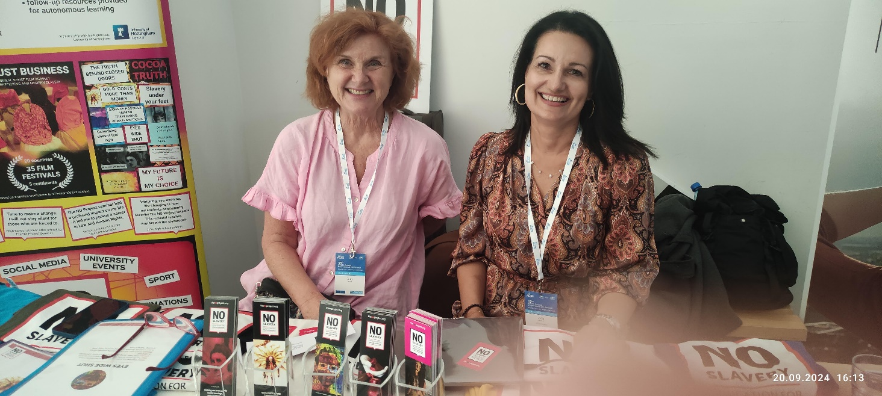

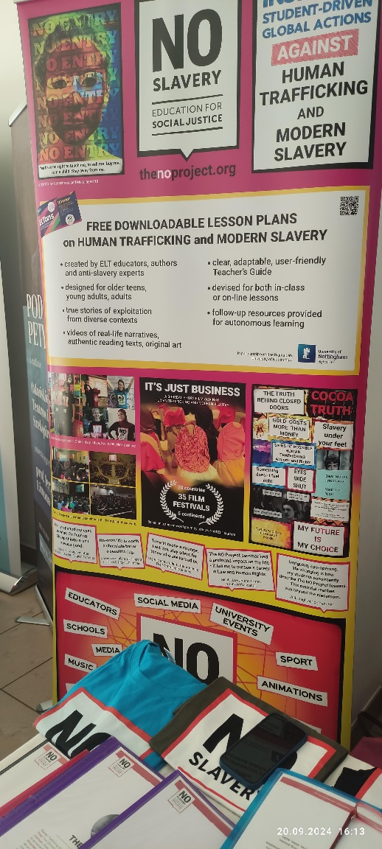
Another precious contact and plan come here… We want to cooperate with the Theatrum Gedanense Foundation who promote drama, Shakespeare through various programmes, events, projects and lesson ideas for language learners. There will be more coming from Justyna Limon and Magdalena Zawadzka.
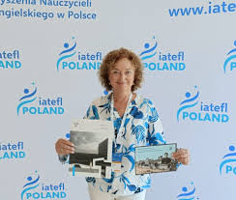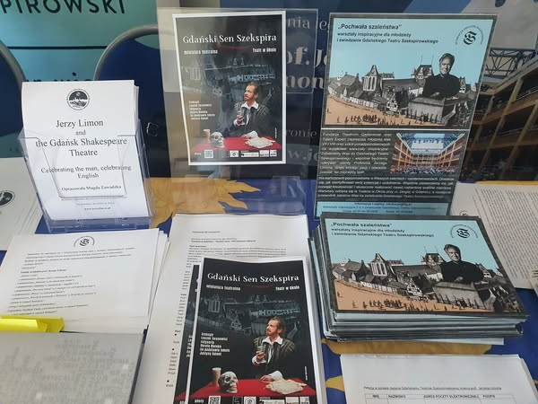

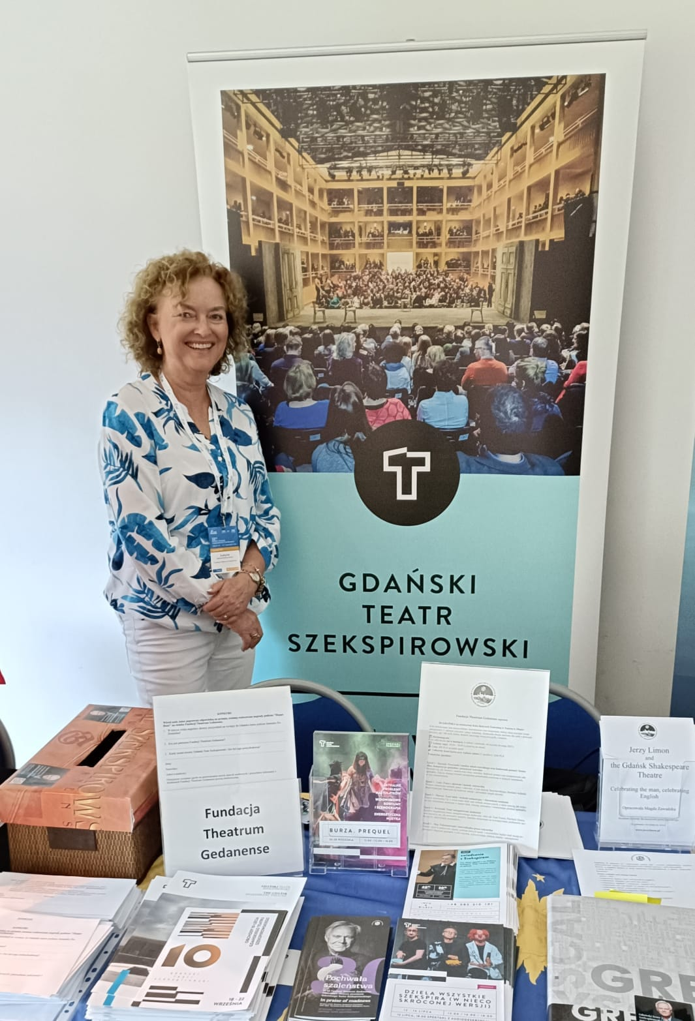

I feel really sorry for all the teachers, especially the local English teachers, who missed the Conference.
Such a great event on their doorstep!
Too precious to be missed!

Follow ups
The IATEFL Conference was attended by representatives of befriended teachers’ associations – TESOL France: Dianne Chen, Yvonne Chappell and Debra West, and HUPE Croatia: Sanja Paić, and TESOL Greece: Stamatis Papandreu. In fact, Hania Kryszewska and Marta Bujakowska have already attended the first two listed.
We are making plans for the future which seem to be linked to one of the final slides at IATEFL Poland. We are networking and cooperating and ticking conference events off the list like TESOL Spain, TWSOL Greece and many more.
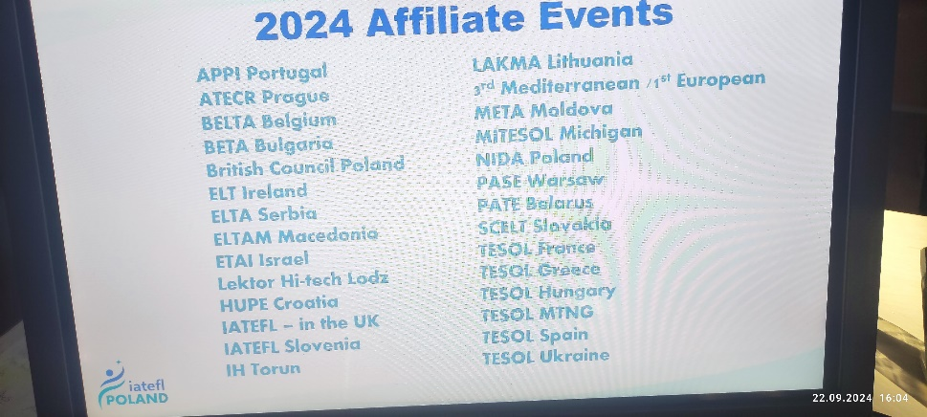

Also in December Hania Kryszewska
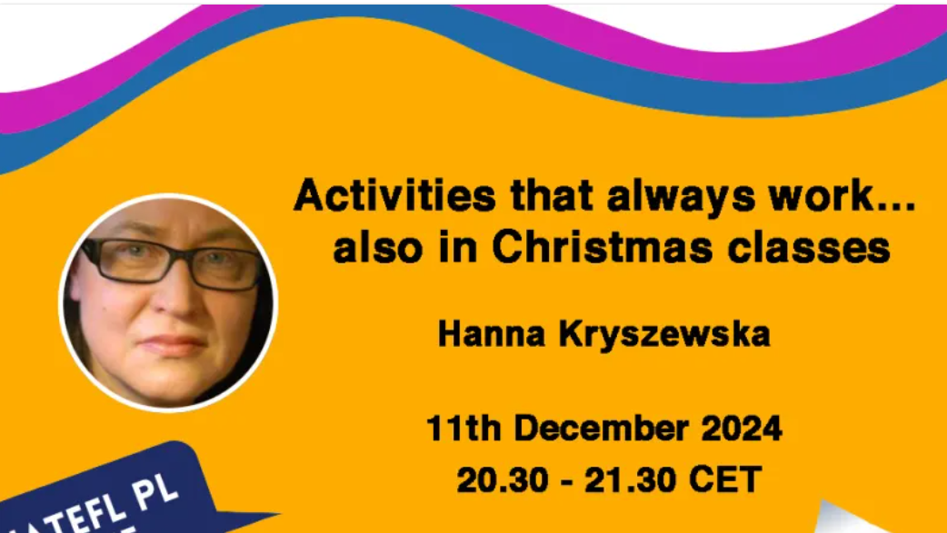
and Marta Bujakowska

will give one of the regular weekly webinars to IATEFL Pl members.

More news and updates to come…

