

Insights Index Newsletter: Artificial Intelligence

from Macmillan

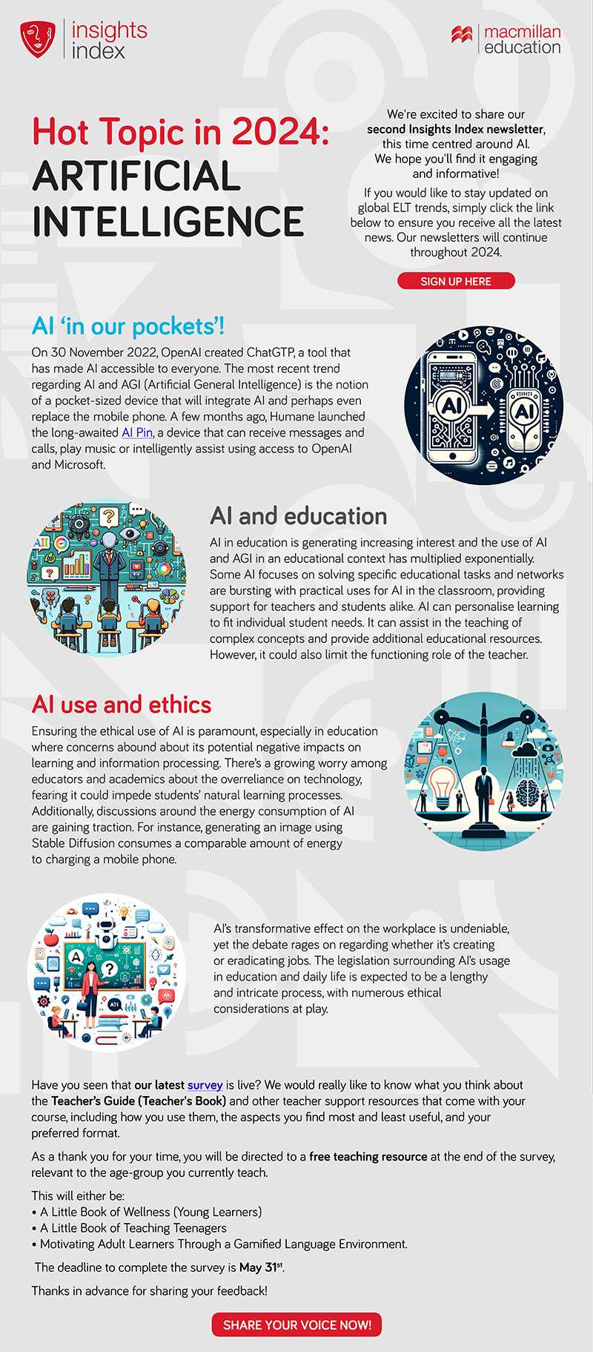

For more information or to sign up go here

