Learn & Lead Innovation Business Conference, Trnava, Slovakia October 10-12th 2024
attended by Phil Dexter, Director Pilgrims Segovia Teacher Training

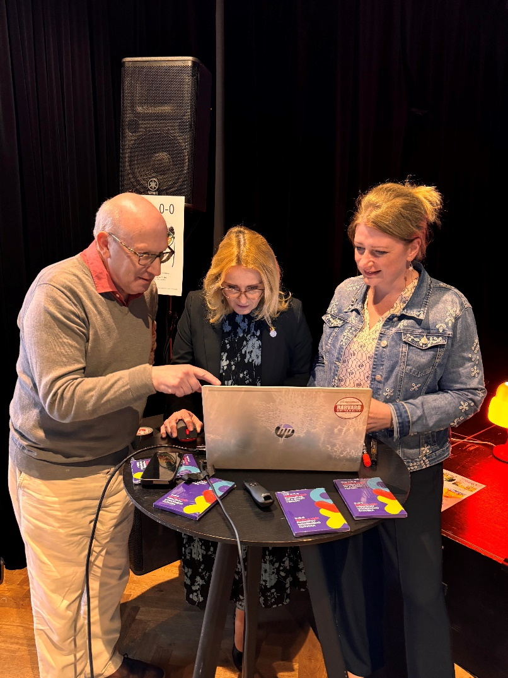

It was my pleasure to represent Pilgrims Teacher Training at the Learn & Lead Innovation business conference and support the beginning the process of Pilgrims Teacher Training becoming a partner in this wonderful Erasmus +multi-country trans-European activity. At Pilgrims teacher training we are aware there are so many different realities in the world of ELT post pandemic and, rather sadly, post BREXIT. Cooperating and partnering with Learn & Lead Innovation is an excellent example in how we can combine and collaborate on shared common beliefs on humanistic approaches to teaching and learning. All the participating language schools have their own programmes though working together means we can all learn from each other and have a significantly increased reach. I call it 1+1 = 3!!
The principles and ethos of Learn & Lead Innovation and the community that is represented is like a family and it was wonderful in the way I was welcome into the business conference as the latest family member.

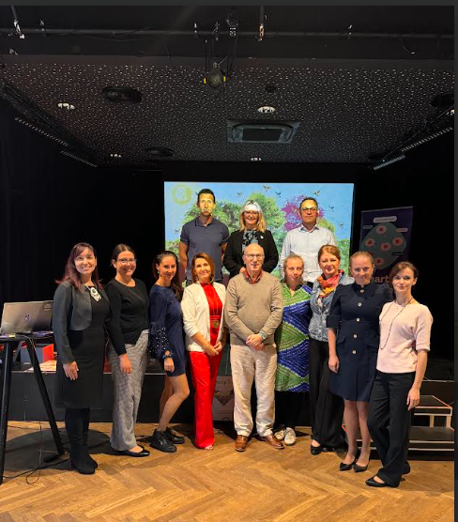
A look at some of the principles of Learn & Lead Innovation can speak for itself:
“Smart schools need smart-minded people in all positions. They create learning teams that communicate well together, collaborate, and continuously evolve to meet the dynamically changing needs of today’s world.”
“We create inclusive and inspiring learning environments where people love learning. Our programs improve workplace relationships, increase the motivation of teachers and school managers, build high-quality teams of professionals, and introduce a system of lifelong learning across the entire school, contributing to the transformation of traditional schools into smart learning organizations”
Learn and Lead Innovation is based on:
The Person-Centred Approach
“The fundamental basis of smart education and management is the person-centred approach. This applies at the classroom, team, and organizational level, resulting in exceptional outcomes and continuous growth. The approach emphasizes individualization, ensuring rapid and effective progress. Specially trained tutors help remove fear of speaking, build self-confidence, and develop key professional competencies of the Learner-Centred Approach.
Learn & Lead Innovation is based on 9 +1 principles
BE COURAGEOUS, BE PROACTIVE, BE A TEAM PLAYER, BE INTUITIVE, BE OPEN MINDED, BE PERSISTENT, BE PATIENT, BE THANKFUL, It’s YOUR LIFE. BELIEVE IN YOURSELF.

THE 10th Principle – which is so important - is called the O-O. The meaning of this is, “Your view of the world is a reflection of your perceptions. Be kind to yourself and be willing to help discover the beauty of life.”

A major element of our cooperation is in the CPD programme that Learn & Lead Innovation is planning across Europe in 2025 and this includes courses at the Pilgrims Teacher Training Centre in Segovia, Spain. Another exciting element of the cooperation is that Pilgrims trainers will be participating in an induction course facilitated by Learn & Lead Innovation accrediting our trainers as Learn and Lead Trainers. This for us is another important aspect of our collaboration and sharing.

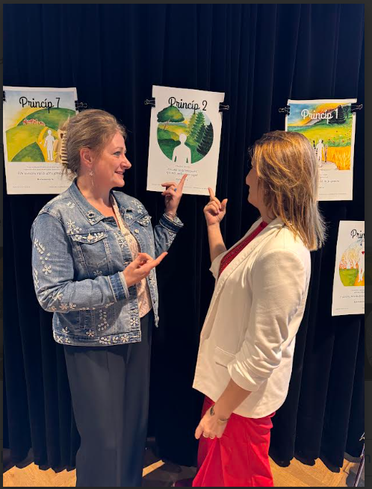

More information on Learn & Lead Innovation can found in the current issue of HLT with the conversation between Jana Chynoradská and Phil Dexter. Or if you’d like to watch the video of the conversation in the Pilgrims Teacher Trainer Journal in the interview with Jana Chynoradská

Please check the Pilgrims f2f courses at Pilgrims website.

