Short Book Reviews
Hanna Kryszewska, Poland
Hanna Kryszewska is a teacher, teacher trainer, trainer of trainers. She was a senior lecturer at the University of Gdańsk, Poland. She is co-author of resource books: Learner Based Teaching, OUP, Towards Teaching, Heinemann, The Standby Book, CUP, Language Activities for Teenagers, CUP, The Company Words Keep, DELTA Publishing, and a course book series for secondary schools: ForMat, Macmillan. She is also co-author of a video-based teacher training course: Observing English Lessons, and online course for Orient Black Swan on 21st Century Skills and Teaching the whole person: Humanising language teaching. Hania is a Pilgrims trainer, OTA trainer and editor of HLT Magazine.
Email: hania.kryszewska@pilgrimsteachertrainig.eu

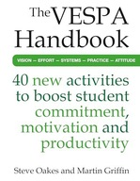

The VESPA Handbook. 40 Activities to boost student commitment, motivation and productivity. S. Oakes and M. Griffin. Crown House Publishing Limited (2024). ISBN 9781785837104, pp.212. To start with let me explain VESPA. It stands for Vision Effort Systems Practice and Attitude, and the book has been designed do address what the authors call the ‘new normal’ in the classroom. The idea is to give the students tools and the teachers ideas which will give the students ways to control and guide their own learning, to create good learning habits in the classroom and outside, to organise their resources and notes, to revise more effectively, and finally, to solve problems. The introduction is short and informative outlining the approach. You can read it here. Then come the chapters in the book which fall into the 5 VESPA sections. Each of the sections contains a kind of motto, a characteristic of the approach for the given area, and then follow 8 activities. The mottos can be as follows: Vision – If you have high control over the outcome, there’s no need to have general goal – you can afford to get specific. But if you have low control over the outcome, general might be better. The introductions to the chapters often have a list of 20, e.g. a list of 20 High-Vision Behaviours, or 20 High-Effort Behaviours. The activities are straightforward, with simple procedure descriptions which are easy to follow. Sometimes the titles are self-explanatory, but sometimes a bit enigmatic – like Outcome Control vs. Ikigal. I believe it is a way to whet the treader’s appetite. The book is very valuable for teachers who teach native speaker of English or learners whose English is a second language. EFL teachers would have to find a way to grade down the language and find the time to run the activities in or outside the class, but no doubt once they take place they will be very beneficial for the learners.

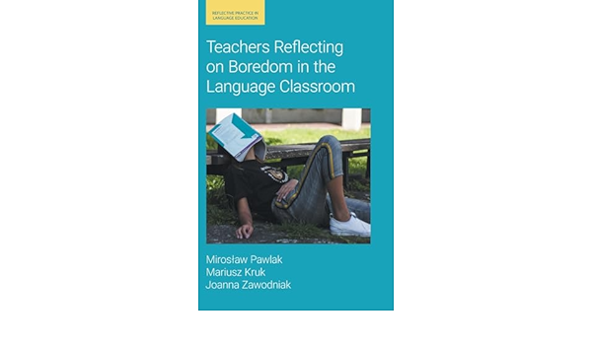Teachers Reflecting on Boredom in the Language Classroom. M. Pawlak, M. Kruk and J. Zawodniak. (2024) Equinox. ISBN-9781800504226, pp. 209. I have always been interested in boredom and I have always believed that it is very important for everyone’s brain. Of course, it does not exclude children. Statements that I have come across made me cheer and reinforced my beliefs, like these three voices for example:
- Boredom has many positive aspects: helps build personality and a sense of agency by spending time the way we want, gives the opportunity to take a break from excess stimuli and time to relax, develops imagination and creative thinking, teaches perceptiveness and planning.
- Boredom also helps children develop planning strategies, problem-solving skills, flexibility and organizational skills - key skills that may be lacking in children whose lives are typically highly organized.
- Your brain needs rest for the same reasons, even when you're awake. While sleep is extremely important in boosting brain power, doses of boredom are also important for brain health. This may seem like a waste of time, but it plays a big role in self-reflection, memory, and creativity.
However, I was not convinced when the authors say in the first sentence of the blurb: This book investigates teacher and student boredom from the perspective of the teacher and illustrates how thinking about different aspects of this negative emotion might enhance reflective practices. It consists of seven chapters. They call it a negative emotion which I would not necessarily agree with. I believe it is a phenomenon teachers and parents need to address, and the learners need to recognise and find tools to decide when boredom is wasteful and when it is constructive. However, I find it interesting that the authors look at both, teacher and learner boredom.
The book contains review of theories referring to boredom, then an empirical section - a collection of research results, and finally it proposes a reflective model to address the issue of boredom in the classroom…. But only to minimize teacher boredom. What about the learner? I suppose a language teacher on an advanced in-service TT course would benefit from the book, but I believe it needs to be read very carefully and needs thorough reflection.
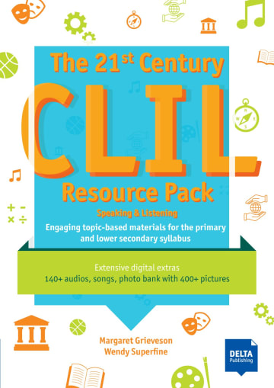

The 21st Century CLIL Resource Pack. Speaking and Listening. Engaging topic-based CLIL materials for the primary and lower secondary syllabus. M. Grieveson and W. Superfine. (202) DELTA Publishing. ISBN 9783125015074, pp. 151. The book aims to introduce engaging topic-based CLIL materials to the primary and lower secondary syllabus. The materials consist of photocopiable worksheets, use language suitable for the learners’ age and level, and are supported by an extensive bank of 100+ audios and many songs, a photo bank with 400+ pictures, activity sheets for every lesson, songs, chants, raps, poems, dialogues and news articles, and many more. The resources are divided into 10 Units: Geography, History, Science, Mathematics, Literature, Music, Art, Drama, Citizenship and PE. Each unit contains 6 activities, but all the content is presented in two ways – in a Table of Contents, and a much more detailed Contents Map with specifies aims and cross-curricular links. The focus of the book is speaking and listening as the main focus of the book, and I cannot find information if there is a Reading and Writing book to complement this publication, or perhaps Listening and Speaking is a better option this age and level than Reading and Writing. The activities are varied and engaging. On the website www.deltapublishing.co.uk (you need to register but it is free) you will find much more than in the book – for example for unit Our Classroom you have 6 pictures of classrooms, a situation map, the audio that goes with ethe task, its and transcript, and some fun facts. The paper book is actually a collection of detailed teacher’s notes and the accompanying photocopiable sheets. A really great resource for the primary class. You can study some sample pages here.

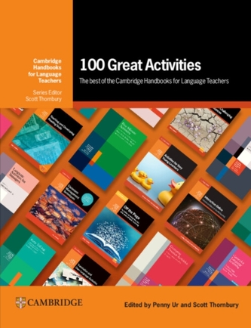

100 Great Activities: The Best of the Cambridge Handbooks for Language Teachers. Eds. P. Ur and S. Thornbury. (2024). Cambridge, pp.169. The series Cambridge Handbooks for Language Teachers was launched in 1979, so we are talking about many years of EFL and many years of quality in EFL. (You can read about its history in an interview with Penny Ur and interview with Scott Thornbury.) Historically, the editors have been Michael Swan, Roger Bowers, Penny Ur and Scott Thornbury. So, it seems very appropriate that the foreword comes from Michael Swan. However, it you expect words of academia you will be surprised. Michel strikes an anecdotal tone and paints a personal picture of the place, weather, food and people when the idea if the series was conceived. The first title was Games for Language Learning by Andrew Wright, David Betteridge and Michael Buckby. Altogether there were 55 titles, and you can see the covers here. I can imagine what a hard task it was to choose the 100 great activities, because every teacher who used these resource books has their favourites. The chapters fall into predictable categories like Speaking, Listening, Reading, Writing, Vocabulary and Grammar. But it comes as a surprise is that the chapters do not contain the same number of activities – Speaking has the most, Reading the fewest. This is a sign that the editors really cherry picked and did not try to mee the quota for each chapter or section. The authors used the following criteria:
- Plausibility/ face validity
- Likely learning value
- Interest
- Versatility/ adaptability
- Simplicity
- Spin-off
- Validation
I think the book is a good selection and the activities are 100 great activities; not it does not say ‘best’, so there could be another selection of 100 great activities, equally valid.
Looking through the book makes me feel very nostalgic, as it spans my professional career, and the list of names is like a roll call of friends and colleagues.
The book was launched at IATEFL Brighton, and it was a great event where we all rejoiced and enjoyed the magnificent views from i360.


Please check the Pilgrims f2f courses at Pilgrims website.

