

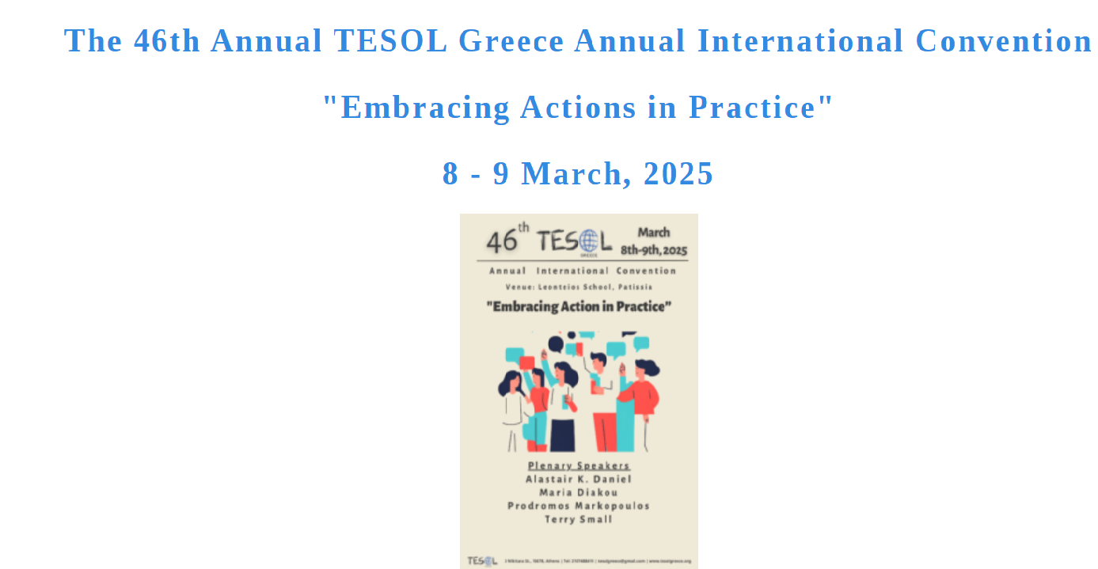



https://tesolgreece.org/event/46th-tesol-greece-annual-international-convention/

