Letter 1
Hania
If you have the time and are interested, could you please share these links with your followers.

If you would like to help me in my mission to help all children prepare for the real world of AI they must try to survive in.

Intelligence: The Great Lie Book Trailer
youtu.be

The Real Dangers of AI. One minute Book Trailer We should all be aware of
youtu.be

Whisperings of Betrayal One Minute Book Trailer
youtu.be

Thank you Hania.
God Bless you

Thanking you

Roy Anderson

Letter 2



Hania,
this short video below provides an overview of the free, award-winning lesson plans devised specifically by The NO Project - and it might help us guide the article for HLT.

https://www.youtube.com/watch?v=oCIoxxmZfaE

I look forward to hearing from you.
All the best,
Judy

Judy Boyle Ed.M., Harvard University

Founder & CEO
The NO Project
www.thenoproject.org

Director l Producer
www.itsjustbusiness-shortfilm.com

Letter 3
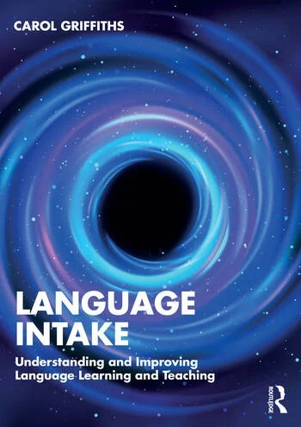

Dear Hania

Routledge have just notified me that my book on Language Intake is about to "hit the shelves", and they have asked me to "spread the word".

The book is about what I call "The Intake Hypothesis", which, in brief, contends that, rather than being about single factors or a small group of factors, language intake is the result of a complex and dynamic interaction of a vast number of factors, including input, interaction, identity and investment, each of which, in turn, includes a vast number of complex and dynamic interacting variables.

The book includes insights from a number of very successful learners, some of whom you may know!

If you are interested in it, it is available on Amazon or from the publisher: www.routledge.com/9781032799896

If you do not want to purchase it, you might care to order it from your library.

Best wishes,
Carol
______________________
(Prof. Dr) Carol Griffiths

PhD, MA(Applied Linguistics), DipELT,
DipTchg, BA(English/French)

Letter 4


Oxford Reading Club is about more than just reading

Oxford Reading Club, our digital library of graded readers for all ages and reading levels, includes interactive features and activities, such as games, word cards, audio with adjustable speed, and voice recording. We made sure your students won't get bored.

Access to over 700 titles can be purchased for anything between 1 and 12 months, with the price of monthly subscription costing less than a cup of coffee. The app can be downloaded onto a tablet or phone, so that your students can read at wherever location summer might take them.

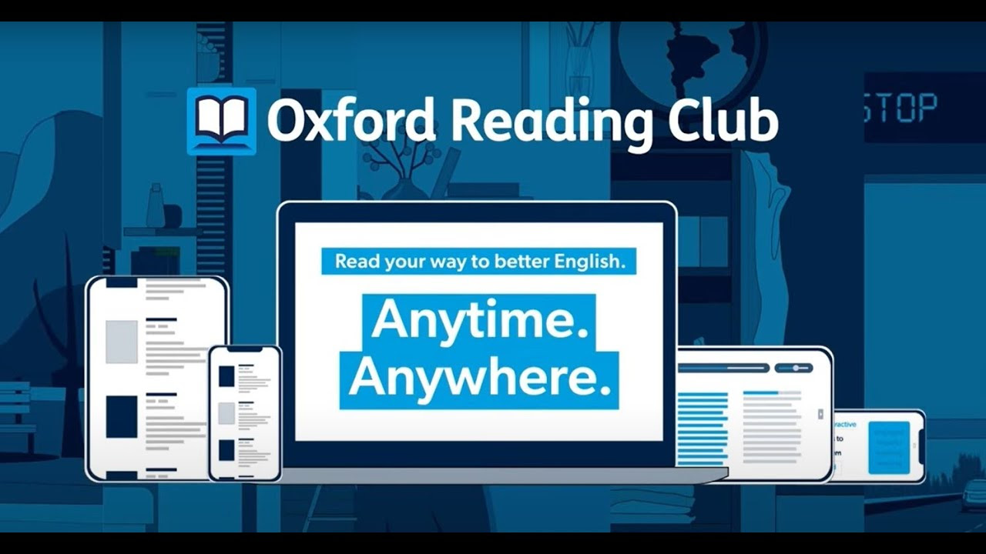

Find out more

Buy access

Letter 5


Welcome to your Pavilion ELT newsletter

In this edition, Anna Hasper explains why she writes end of year reflections and reminds us to be kind to ourselves, and Gerhard Erasmus reflects on a powerful story and draws out some useful lessons for teachers.



New from Modern English Teacher

Blog – Writing end of year reflections- be kind to yourself!

For many of us another school year has just come to an end or is ending soon. One habit Anna Hasper has developed over the years is planning in some time, at the start of summer, to write down her end-of-year reflections. Here, she explains how she takes time to think back and self-reflect, but also why it is important to be kind to yourself.

Read now

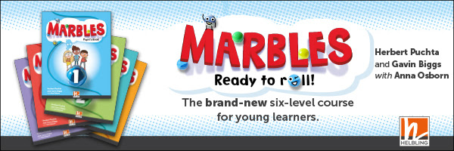



New from Modern English Teacher

Blog – The man who planted trees

We often wonder if what we do has any effect. Sometimes we get positive feedback, but often we don’t. In this blog, Gerhard Erasmus looks at the story ‘The man who planted trees’ and draws out some useful lessons for teachers.

Read now

Letter 6

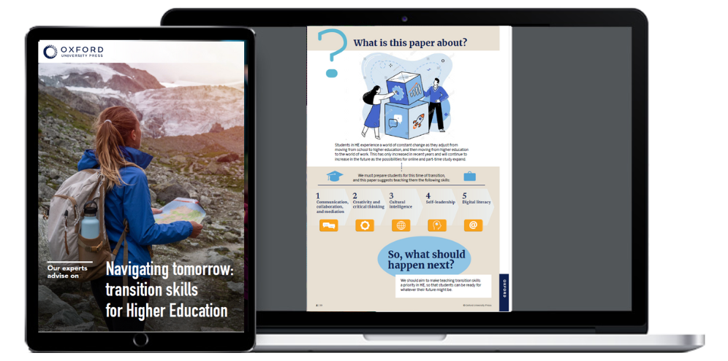

Hi Hanna

Prepare students for the world of work!

If we want learners to succeed at university and beyond, they need to develop skills like self-leadership, critical thinking, and cultural intelligence.

Whether you want to prepare students for higher education or run a successful university program, get the information you need with our latest position paper!

Download Now!

With best wishes,
Oxford University Press

Letter 7
FYI

Hania
FYI and…
Share with other people
Alan Maley

Protecting biodiversity: rejecting carbon offsetting

Biodiversity is the foundation of life – providing the food we eat, the air we breathe, the medicines that heal us and the ecosystems that sustain us. Yet, our natural world is in crisis, and our ecosystems are collapsing around us as the climate crisis intensifies. Corporations are pushing 'solutions' to the climate crisis such as carbon offsetting – in reality a licence to carry on polluting, profiting, and destroying our planet's biodiversity. Instead, we need real solutions that keep carbon in the ground, conserve nature and repair our ecosystems.



