TikTok Style Video Reaches ELT

Ben Goldstein, UK and Spain
Ben Goldstein is an English language teacher, teacher trainer and ELT materials writer. He is published by Cambridge University Press, Richmond and others. He taught for many years on the online MATESOL programme of the New School in New York. Ben was born in London but now lives in Barcelona, Spain. Ben Goldstein’s 30 Ideas for Inclusion was published by Cambridge University Press in August 2025. Email: ben@bengoldstein.es
Background

When I first started teaching, (nearly three decades ago now) ELT video was conceived of in a very different way, and its role entirely alien to what is on offer today. Of course, that’s something that won’t surprise most of you, but the extent to which ELT video has changed was brought home to me recently when I checked out the latest clips from DLA’s new TikTok Video Catalogue.

Back in the day, video was regarded as something separate and not integrated into other classroom tasks. When video arrived, I recall doing long “video lessons” on Friday afternoons as light relief after a hard week of grammar and vocabulary. Depending on the level, these could have been scenes from David Attenborough nature documentaries or dramatizations of Jane Austen novels.

Since then, of course we have seen videos become gradually more integrated into ELT materials but the concept of the self-contained “video lesson” has not really gone away. Besides, the focus has remained very much on listening comprehension – treating the video as if it were merely audio. Moreover, the length of the clips (though considerably shorter than three decades ago) has remained fairly consistent in recent years, hovering around the YouTube standard of 3 to 4 minutes. There has been more experimentation with the genre, but mini-documentaries, news items, sitcoms / humorous series and animations still predominate in the field.

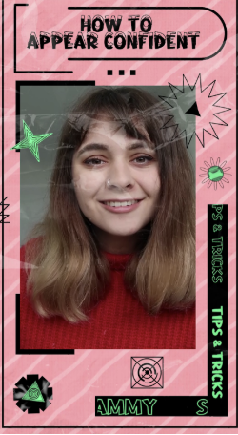

A break with tradition

That’s why these TikTok style clips come as a breath of fresh air. For one, because they reflect so clearly the kinds of videos so many of us take in on a daily basis nowadays. Like Instagram reels, clips like these now form part of our lives, especially for those of us who turn to them whenever we need distraction. For that reason, I think the highly dynamic nature of these clips would appeal to a broad age range, from young learners right up to mature adults.

DLA’s selection does really embrace this TikTok style, and the videos are seriously micro, some as short as 40 seconds and none longer than 90. They also vary enormously both in topic and genre. Naturally, because of their length they could be used at many different moments in class, not just Friday afternoons! Indeed, the clips are accompanied by useful teachers’ notes which suggest that they could be exploited either at the start of class (as a lively warmer) or to wrap up a topic. Indeed, to my mind, they could be used practically at any time to arouse interest whenever you feel students might be losing focus.

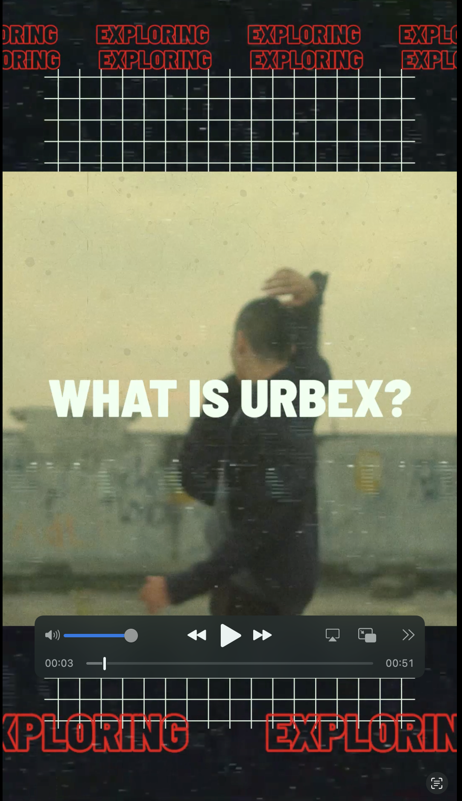

A new format

So far, I’ve taken for granted your prior knowledge of TikTok style clips. But, for those of you who may not be that familiar with them, the most striking element is their format. Designed to be viewed on mobile phones, their verticality and fast-moving action or delivery is quite striking. So much is packed into so little time, but this actually means that they can be viewed on multiple occasions as on each viewing you and your students will notice something different.

One of their most distinguishing features are the super-imposed elements: filters, double screen, emojis, stickers, GIFs, captions, fragments of popular songs, all combining to create - at times - a frenetic visual experience powered by choppy editing and camerawork. In fact, these technical or multimodal aspects could be highlighted by the teacher as some students may well be experts in incorporating such elements into their own videos.



Making the familiar unfamiliar

Although the format may be new, some of the genres may be quite familiar to you. Indeed, you’ll find ones eternally popular with students, particularly teens. For example, the How To, Vlog, Day in the Life and Guided Tour are all genres which work well because they can be so easily personalized and localized by students. The only difference here, of course, is that they are so much more condensed and snappier – blink and it’s all over!

Let’s look at some of clips now in more detail. We’ll see how many subvert familiar genres to make them unfamiliar.

An interesting example is Jack Reynolds’ 54 second Dublin Guide which focuses on three key places which Jack takes us to, giving a vision of his particular Dublin. I can see this working really well as a way to stimulate students to go out and make their own mini-guides of their hometown – the criteria being that they can only choose three places and only have approximately 20 seconds to explain why they like each. This obliges them to really think about what they value as important and wish to share with others.

Some of you may point out that this highly compressed format means that there is less scope for language learning, but I don’t think this has to be the case. Apart from making their own video responses, students can do all kinds of tasks with the Dublin Guide some of which won’t depend on listening comprehension at all. For example, they can do a quick visual memory test, place images in order of appearance or match the places with their characteristics (again based on visual stimuli). And, although, the video clip itself doesn’t include much language, that doesn’t mean it can’t generate language in class. Students can discuss which of the places they would go if they ever visited Dublin. They could even research into any one of the places described (or choose their own ones) as a mini-project, find out more about them and come to class the next day with their findings.

Although some genres will be familiar others are far more daring both in terms of genre and topic. A good example is the surprising Urbex (short for Urban Explorers) which shows an influencer called K describing the rules to follow if you want to explore abandoned buildings in a city. Though I have to say this description does not really capture the experimental nature of this original clip. Indeed, the soundtrack, fast-moving handheld camera and the overall atmosphere make it feel edgy and almost dangerous and these are not words I have often used to describe ELT clips-- you’ll just have to watch it for yourself!

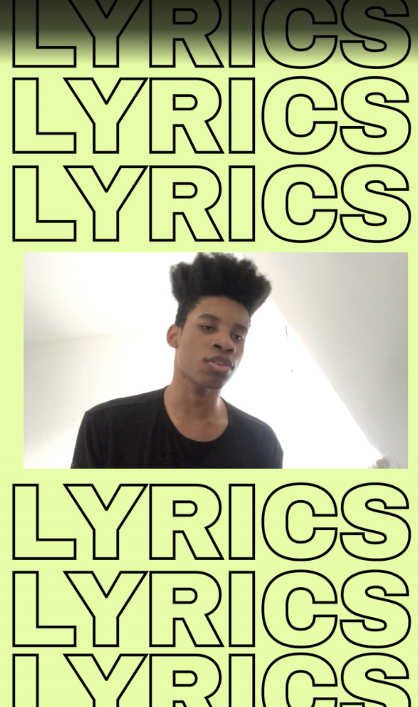

Another original clip, very good at making the familiar unfamiliar, is How To Write Songs with Regal. Non- musical people (like myself) will be reassured by the first step - “If you don’t play an instrument, I’d suggest finding a beat on YouTube that you can sing along to”. The advice carries on in this entertaining vein as Regal outlines his four-step approach to songwriting - all in an appealing and very natural presentation style. Regal clearly exploits the How-To genre but the topic and format is so different to typical How-To videos that you have the feeling that you are watching something totally different. This is in part due to his great charisma and the catchy way that he can create a song in no time. All in all, it makes for a fun, surprising viewing experience. Indeed, the capacity to surprise is one of the characteristics of this catalogue.



Animal Magic
For younger students, there are also a number of entertaining clips featuring animals. These range from guessing the facial expressions of monkeys, to discovering a day in the life of Theo the Smallest of Zebras and the Vumbi the Teenage Rhino. We also meet people’s pets such as Sansa the dog and find out what he has been trained to do. As a dog owner, I found this clip particularly appealing as we see how much his owner Saurabh values Sansa and how proud he is of him. Again, the fun and fast-moving nature of these videos will not just engage learners but could also act as models to prompt students to make their own clips of their pet or favourite animal.

Final thoughts

As you probably have guessed, some of these TikTok style clips are so short that students may not get exposed to that much language and this is a criticism that could be levelled at the videos in general. However, I feel that we shouldn’t really judge these clips in the same way as we evaluate longer videos, similar to the ones I used three decades ago!

To my mind, these videos are fulfilling an entirely different role. We have something here far more versatile and dynamic. Indeed, it’s not really about the language contained in the videos so much as what the students can say about them.

I have no doubt that these short energetic bursts of video will generate a lot of language in class, providing for students an important bridge between the classroom and the outside world. While, for teachers, they introduce authentic and relevant content in a genuinely entertaining and surprising way.

Please check the Pilgrims in Segovia Teacher Training courses 2026 at Pilgrims website.

