A New Cross Curricular Event Coming Up! News from APPI

APPI’s activity is focused on improving English language teaching in Portugal. To this effect APPI has been providing their members with a number of opportunities for building their own professional development. APPI’s mission is achieved through consistently appealing to members and teachers of English at large for a lifelong professional updating to be made possible both by APPI’s human and material resources.
You can find out more about APPI here.

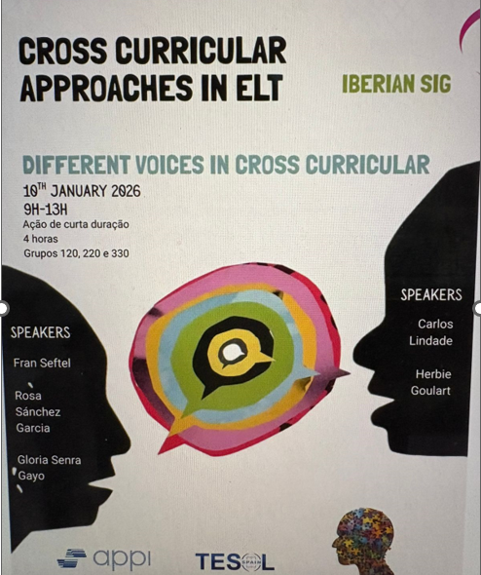
More information about the event and registration:
https://www.appi.pt/appiforma-cpd-centre/annual-pd-programme

https://www.appi.pt/acd-cross-curricular-approaches-elt-iberian-sig

