

Three Voices from Pavilion

Voice 1
Damien Herlihy explores how you can master giving instructions to young learners.
How can you deliver clear and effective instructions to young learners? In this vlog, Damien Herlihy dives into ETpedia Young Learners to explore how you can master giving instructions to avoid confusion and chaos in your young learners classroom.

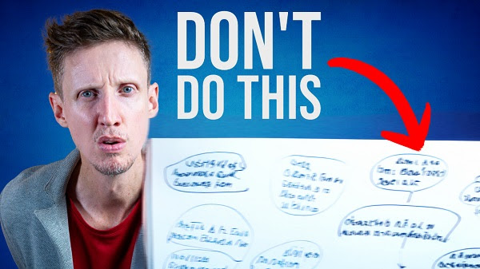

To watch the video use the link here

Voice 2
Blog – Is Santa real? The gift of giving anonymously



As we start to approach Christmas, children are keenly awaiting Santa, and adults vary from excited to dreading the money they might need to spend. In this blog, Gerhard Erasmus looks at Santa from a different perspective, and suggests why we must keep Santa alive, not just for Christmas, but for the whole year.
Read here

Choosing a coursebook: What checklists don’t tell you
Gerhard Erasmus looks at what a good checklist for selecting a course book should cover, and what is often absent from checklists, and we tell you about our upcoming MET Spotlight webinar with Gareth Davies which will shine a spotlight on spotting and converting learning opportunities from your materials.
This content is available on our new Modern English Teacher website! We hope you enjoy taking a look around.

Blog
We want to change materials. We have to change materials because the book is no longer in print or available. Or we are starting a new course, and we need a book.

School and academic managers are often tasked with selecting a new course book, or choosing materials. And while there are many checklists available, what do they not tell you? In this blog, Gerhard Erasmus looks at what a good checklist should cover, and what is often absent from checklists.
Read more here

“It’s time to level up!” - A spotlight on improving our teaching of teens



Thursday 11th December 2025 | 3-4pm (London time)
The questions we shall focus on in this interactive webinar are: How can we get better after that initial period of two, five or even ten years of teaching teens? What is advanced methodology for teens teaching, if even there such a thing?
By the end of the session, participants will have a clear set of directions in which to take their own teens teaching should they choose to do so, or options to suggest to their teachers, if they occupy a supporting role such as co-ordinator, senior teacher, director of studies or school owner. Suitable for all language teachers of teenagers, including those who teach languages other than English, and all experience levels, including new teachers and seasoned veterans.

Sign up for free here
Please check the Pilgrims in Segovia Teacher Training courses 2026 at Pilgrims website.

