Bell School Closing Down

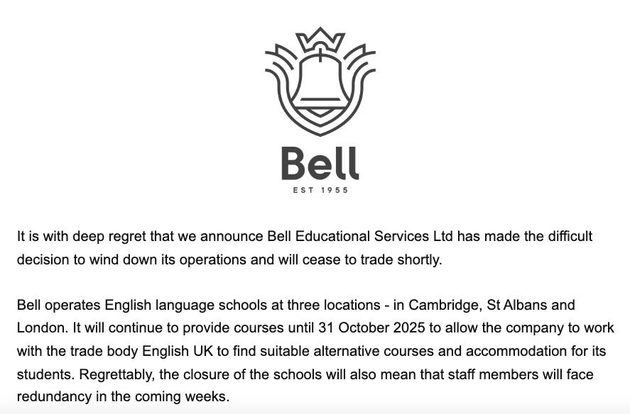
FB
Bell English, the UK-based English language school chain, closed its three London, Cambridge, and St Albans locations on October 31, 2025, due to financial difficulties, including cashflow challenges and the lingering impact of the COVID-19 pandemic. Despite attempts to find a buyer, the schools ceased operations, leading to redundancies for staff and requiring students to find alternative courses. The Swiss branch of Bell remains open and operates independently. Reasons for closure many like cashflow issues, covid impact and inability to find a buyer. Also, Brexit and the fact that the UK is no longer in the Erasmus+ project must have been a nail to the coffin as well.
It was founded by Frank Bell and his wife Elisabeth. He was a teacher who established Bell UK language school in Cambridge in 1955. During World War II, as a prisoner of war he created a "secret university", teaching Spanish and French.

Frank Bell (1916-1989)
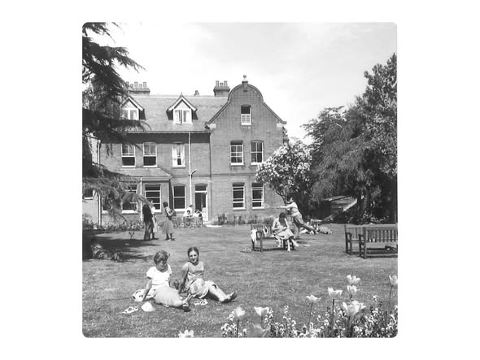
Bell's very first school on Cranmer Road in Cambridge
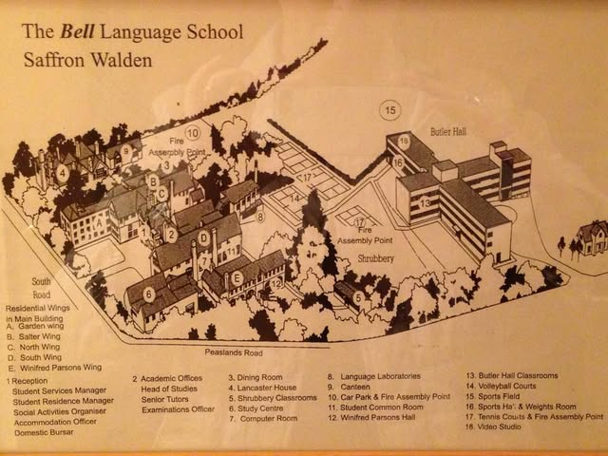

Alan Maley, Rod Bolitho, Silvana Richardson, Anna Young. Françoise Votocek, Chaz Pugliese, Adrian Underhill, Susan Sheerin are some of the Pilgrims friends and colleagues who trained at Bell teachers from all over the world.
I was with Bell in Cambridge and Saffron Walden as Senior Tutor and Director of Studies from 1977 to 1980. It was a formative period for me career-wise, and I made connections and friendships which have lasted through the years. What impressed me about the Trust was the idealistic human values on which it was built. I was fortunate enough to get to know Frank Bell - a unique man whose kindness and belief in his mission were there for all to see. He would have been very sad to see all that collapsing in the face of the corporate, profit-driven attitudes that now dominate private education.
Rod Bolitho
We are deeply saddened by the news that Bell English will close its doors on 31 October after 70 years of inspiring language learners around the world.
Bell has been a pioneer in English language teaching. Its contribution to our industry and to generations of students and teachers cannot be overstated.
English UK is working closely with Bell management and nearby centres to support affected students through the Student Emergency Support (SES) scheme, ensuring their studies can continue with minimal disruption.
Study Travel FB
Very interesting news. Sad because of the history. Bell has always been ' a friendly competitor'.
PD
Terrible news that the Bell School of English is closing down. One of the top pioneering institutions in ELT, it was founded by the extraordinary Frank Bell (1916-1989) whose interest in teaching began when he was a prisoner of war in Borneo in the Second World War. He organised a 'secret university' to provide educational opportunities for his fellow prisoners.
KW
The atmosphere in the teachers' room was always friendly. (…)What surprises me most about the closure is that they had a very large year-round language school. And a lovely campus in Cambridge. Very sad especially for the teachers/trainers who are losing their full-time jobs.
LY
You can find more comments and memories of Bell here and here

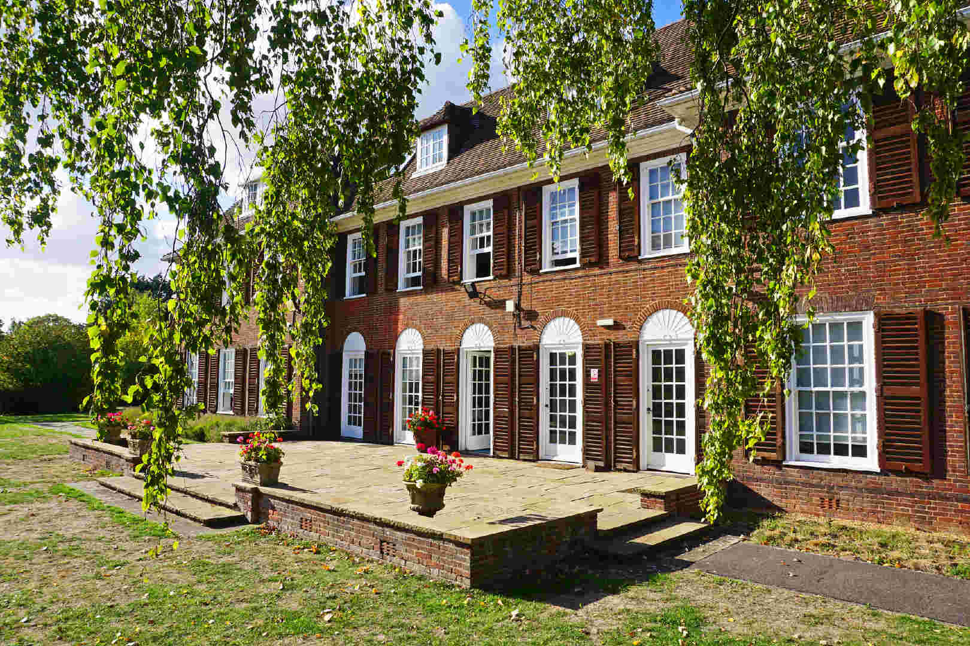
Bell Cambridge 2025

