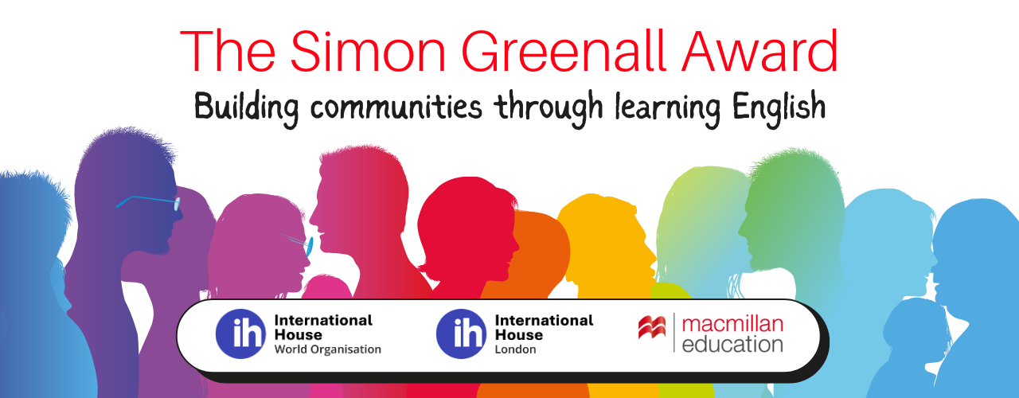

The Simon Greenall Award 2026 is now open for applications.
The purpose of this Award is to support a language project which builds communities through learning English.

The award offers six hours of mentoring, help in developing the project, promotion of global visibility, and a small grant for equipment and expenses.
Link for guidelines and application https://www.macmillanenglish.com/simon-greenall-award-2025
Closing date for application: 28th Feb 2026

The award celebrates the life and work of Simon Greenall OBE, teacher, trainer, materials writer, President of IATEFL, trustee of International House. It is sponsored by Macmillan Education, International House London and International House World Organisation.
In the course of his work, Simon travelled around the world, and wherever he went, he made friends. He was a great communicator and the award reflects his wish to build communities through learning English.
The winner of the first award in 2021, was the Dau Dau project run by Sirhajwan Idek and Nurazilah Othman of Keningau College in Sabah, Borneo, Malaysia. Their work uses folk tales to bring together the different peoples of Malaysia with their different traditions and languages. Storytelling, dance, puppetry, theatre, and song are all part of the rich mix. The mentors were Jill and Charlie Hadfield. Jill, a materials writer and trainer, and Charlie worked on British Council teacher development projects.
The winner of the second award in 2024 was Happy Teachers based in Jamaica, run by Venice Irving. They pair experienced teachers in Jamaica with new teachers in Tanzania who are keen to learn and develop their careers but don’t have the networking opportunities and resources. Happy Teachers offers six months coaching to assist in achieving these aims. The mentor was Annie Thomson, teacher and trainer at International House London.

Closing date 28th Feb 2026.
Application website https://www.macmillanenglish.com/simon-greenall-award-2026

