Pilgrims: New Times - Responding to Our New Realities

Phil Dexter, Teacher Trainer Coordinator and Editor of The Pilgrims Teacher Trainer Journal

In what are some challenging times for all ELT and training providers what matters is not the extent of the challenge – rather it is how we can respond positively to challenges we face.
For 50 years Pilgrims had been in Canterbury, UK and many of you reading this will have attended a course in our glorious summers at Kent University or in your country at other times of the year experiencing the meaning of humanistic and creative approaches to teaching and learning.
Nothing, though, is forever and to continue ensuring that Pilgrims remains a shining light in humanist approaches we are adapting to our new reality.
What are some of the elements of our adaption?
1. In person training is central to our DNA in creating, developing and ensuring a sense of community in our relationships with teachers. As teachers in the EU are our main audience we moved hosting our training to Segovia in Spain and in summer 2024 and 2025 we successfully held training which has been very much discussed through the pages of HLT. More information on this as well as our offer for 2026 can be found through this link in the Pilgrims website. Pilgrims in Segovia Teacher Training courses 2026

2. Working with and collaborating with partners is an important and necessary feature of our new reality and in August this year we were very pleased to host training with Learn & Lead Innovation in Segovia. We are also collaborating in many ways with Learn & Lead Innovation – a report on my participation in the 2024 Learn & Lead business conference can be found at https://www.hltmag.co.uk/dec24/learn-lead-innovation-business-conference

3. While in person training is definitely central to our Pilgrims DNA we are now planning an online offer. Our team is currently planning a full offer for 2026. More information will be available soon on the Pilgrims website.

4. A unique feature of Pilgrims is our digital magazines. Humanising Language Teaching and our sister magazine the Pilgrims Teacher Trainer which I edit. https://pilgrimsttj.com Both HLT and TTJ reach thousands of teachers and teacher educators across the world with a huge archive and giving voice to many who may not be published in more academic journals. Our journals remain free to access for everyone and will continue to be so.

5. One new innovation that has begun firstly with the current issue of teacher trainer journal is with sponsored adverts and advertorials and we are pleased to highlight the work of Macenta Publishing and Digital Solutions with The Globals work they are doing based around the UN Sustainable Goals. We would be delighted to highlight other organisations work through sponsored pages and if you are interested please contact Hania hania.kryszewska@pilgrimsteachertraining.eu or Phil phil.dexter@pilgrimsttj.com
Below you can read the TTJ offer. The HLT the offer will be officially announced in the first issue of HLT in 2026.

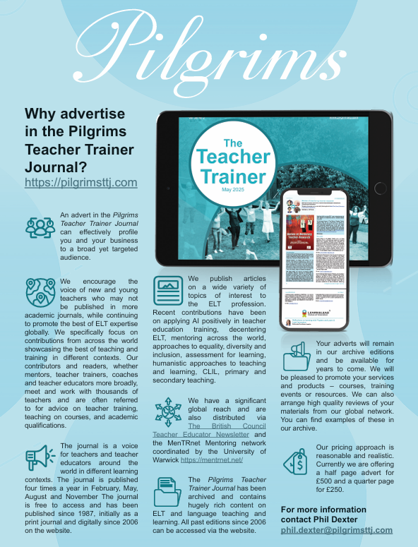

To sum up..
Nothing is guaranteed though we believe our multiple ways of adapting to our new realities will ensure that Pilgrims will continue and thrive and we look forward to working with you in ways that are good for you whether in person or digitally.

