Internationalizing the (Legal Spanish) Curriculum – Three Activities to Nurture Motivation and Intercultural Competence

Veronika De Azevedo Camacho, the Czech Republic

Veronika de Azevedo Camacho is a teacher of Legal, Business and Academic Spanish at Masaryk University Language Centre, Brno, Czech Republic. Her current professional interests are applied linguistics, methodology, intercultural communication and translatology. Email: camacho@econ.muni.cz

Introduction

Studying and teaching professional language/ESP brings quite a few challenges, both for the content creators as well as for the students, who are confronted with a new register and often a relatively different syntactic system. The general knowledge of the language that they have acquired so far is suddenly insufficient. They have to make a great effort to learn the basic principles of legal Spanish, and it is not uncommon for them to lose motivation. However, one of the motivational tools that can make this process easier, more pleasant, and “real” is the inclusion of intercultural elements in teaching combined with the use of experts from international practice.

The aim of this article is to present three specific activities and projects implemented in the legal Spanish course at Masaryk University, Czech Republic, the common denominator of which is the intercultural international element. This text is therefore intended as inspiration and a sharing of experience for teachers who are considering incorporating motivational activities into the study of legal language using experts and/or international students at their home university and can be applicable to any other (ESP) course at a minimum level of B1+.

Activity 1 – online interview with an expert

Description and individual phases

In the first part of the course, the students become familiar with basic legal terminology and the definition of law, as well as the sources of law, branches of law, historical concepts of legal systems, and the professions that can be pursued after completing law studies. In order to put these introductory theoretical topics into practice and so that the students can test their knowledge of these foundational legal terms and concepts, an online interview was held with a currently practicing Spanish lawyer. The aim of this activity was to apply the acquired knowledge in a real situation with a native speaker and expert. The preparation took place in three stages.

Two weeks prior to the interview – independent work

1. The students first had the task of finding as much information as possible about the law office of the named lawyer and entering this information into a shared document on Google Drive created for this purpose for all students of the course.

2. Furthermore, the students had to prepare 10 questions each to ask the lawyer during the interview and write them down in a shared document.

One week prior to the interview – in-class group work

- The students themselves then grouped the questions into thematic areas according to the teacher’s instructions, and finally the groups agreed on a script for conducting the interview. The teacher corrected linguistic and factual aspects but was otherwise minimally involved in the preparation of the scenario. The resulting list of thematic areas compiled by the students contained seven items.

Entrevista – preguntas (Interview – thematic areas for questions)
1 estudios de derecho (area of law studies in Spain)
2 su carrera (the course of her professional career)
3 casos de su bufete (cases handled by her law firm)
4 retos, dificultades (challenges, difficulties in her daily activities)
5 diferencias entre España y EU/Rep. Checa (differences between Spain/EU and the Czech Republic)
6 política lingüística de su despacho (language policy in her law firm)
7 Covid-19 y su trabajo (Covid-19 and its impact on her work)

Table 1. Students’ final list of thematic areas for the interview

The lesson of the interview

The students received two additional tasks from the teacher which they were also supposed to focus on during the interview. This assignment already targeted specifically the legal terminology related to the branches and division of law.

I. Students were asked to write down all the branches of law mentioned during the interview and, for each branch commented on, all the specific cases that the lawyer handled with her clients. Students were also invited to notice whether the lawyer mentioned any branch of law that does not exist in the Czech Republic or that is not customary.

The resulting table, completed after the activity, looked like this:

What branches of law did the lawyer mention, what specific cases did she handle?/ What geographical and cultural differences in the cases did you notice?

Rama de derecho/ Branch | Caso 1/ Case 1 | Caso 2/ Case 2 | Caso 3/ Case 3
penal | violación | robo | maltrato
marítimo | hundimiento del barco | capitán - derechos | barco sobrecargado
laboral | despido improcedente | mobbing | contrato basura
civil | divorcio
mercantil | banco Santander
Table 2 Example of a completed table

2. Virtual dictionary
In a shared document, students were asked to each write five new terms they learned. It was necessary to write a translation for each term and to use the given word or phrase in a sentence in a wider context. The vocabulary contained in this virtual dictionary was part of the final lexical test at the end of the semester.

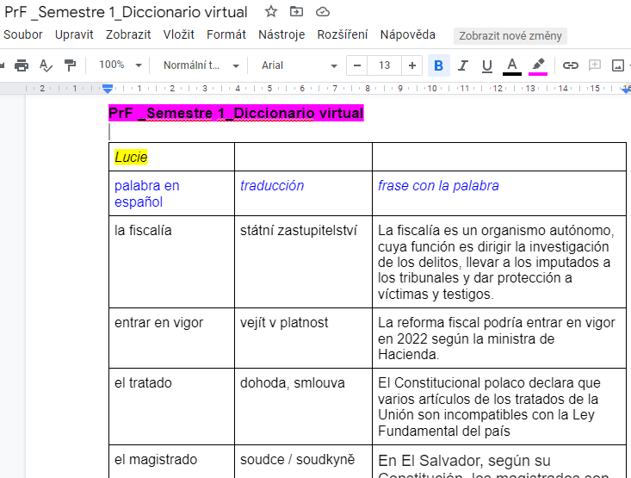

Table 3. Example entry in the virtual dictionary

Follow-up activities – homework

After finishing the interview, the students received the last task, namely the linguistic mediation-summarizing activity. The aim of this task was to summarize the information obtained and mediate the differences in writing.

The instructions for this activity were as follows:

Summary – mediation activity
Write a summary of the interview with the Spanish lawyer (300–400 words). Focus in particular on mediating the differences in practicing the profession in Spain and the Czech Republic, on cultural and social differences (working hours, language policy, foreign languages used, dealing with clients, working environment, studies required to practice law, the necessity of experience/professional exams, etc.).

Follow-up activities – at the beginning of the next lesson

In the following seminar, students had the opportunity to practice the new vocabulary in a series of interactive exercises tailored by the teacher in the online teaching tool Wordwall.

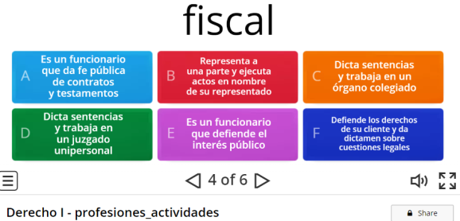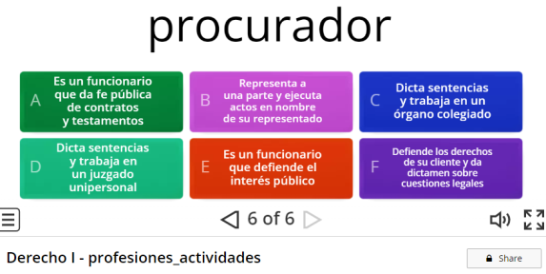
Table 4. Example activity to practice vocabulary

Practical issues

To ensure the smooth running of the whole interview, all the details needed to be agreed in advance with the Spanish lawyer, with whom two online preparatory meetings took place. The teacher familiarized the lawyer with the tasks that the students received, with the script of the interview, and also with the concept of the entire task. The interview itself took place online via ZOOM video conference during the seminar. The language level of this group of students was B1+/B2.

Tips where to find experts/lawyers

Although in this case the interviewee was the teacher’s personal contact, another option may be to use the contacts of former Erasmus students already working but still in contact with the teacher. It is also possible to use the ERASMUS + program to invite a professional to the class, based on, for example, institutional or professional contacts.

Outcomes and feedback

In the final course evaluation, the students appreciated especially the linguistic and factual dimension of this activity. In particular, they valued the opportunity to communicate in a real situation on real topics. Students were pleased to understand most of the conversation with the lawyer and many of them appreciated that the lawyer was willing to share with them also negative experiences as well as advice for novice lawyers.

From the teacher’s point of view, it is necessary to emphasize mainly the motivational aspect of the whole activity, as well as its intercultural dimension. Some information was surprisingly not expected by the students at all, for example that the lawyer has undergone special training in the area of ​​naval law and that about half of her cases de facto fall into this area, such as piracy, kidnapping, and vessel insurance. Another widely debated issue was the question of language policy, as the law firm is located in the autonomous area of ​​Catalonia, where the co-official language is Catalan. It was interesting to follow the discussion that arose on current topics such as the unity of Spain and its policies concerning autonomous communities. The attorney also emphasized the importance of knowledge of other foreign languages, perceiving it as a competitive advantage on the market, since she herself deals also with English and French speaking clients. In addition to the intercultural differences, students were also confronted with terminological issues, such as so-called false friends between the two languages ​​(the similarity of expressions such as prosecutor (EN)/procurador (ES)/prokurátor (CZE), a word that was used in the Czech legal system during the communist era but nowadays a different term is used).

Activity 2 – Workshop given by an expart: lawyer linguist from the Court of Justice of the EU

Description and preparatory phase

The portfolio of law faculty students is very diverse, and it is not uncommon that students are not clear about their future legal profession when they come to the faculty. They might be very well equipped linguistically and therefore find the combination of law and the use of a foreign language as an ideal choice for their future profession.

As the result of a long-term cooperation with the Czech legal translation unit at the Court of Justice of the European Union, we decided to incorporate a workshop on legal translation for the EU into the third semester of the legal Spanish course. We originally intended to organize the seminar face-to-face, as part of the ERASMUS + programme supporting inclusion of experts in teaching. However, the Covid-19 pandemic made this impossible, and therefore online cooperation was agreed upon. Through a Czech lawyer translator, a former graduate of the Spanish and French courses at the MU Law Faculty, a Spanish lawyer–translator was approached, who was willing to share with the students his experience as a translator at the Court of Justice. The seminar was scheduled for when the topic of international law and EU institutions was to be discussed. The language level of this group of students was B2/C1.

The workshop itself was preceded by two preparatory activities.

1. Two lessons prior to the workshop

First, the students were divided into groups. Their task was to introduce one European institution of their choice. Specifically, they were asked to prepare a presentation, search for a short video about the institution, prepare questions for a short discussion in the seminar preceding the workshop, and seek information about language policy implemented in the institution. The students presented information about the Court of Justice of the European Union, European Parliament, European Council, Council of the EU, European Commission, and European Central Bank. The aim of this task was to actively master the basic Spanish terminology used in European institutions.

2. One lesson prior to the workshop – homework

As a second task, students were asked for homework to find one international regulation or treaty that came into force during the Covid-19 pandemic. For that purpose they were directed to the website https://eur-lex.europa.eu/ and were also asked to look for the English and Spanish versions of the respective document. The aim of this activity was to get acquainted with the official website of the European Union and to try searching for internationally valid legislation and at the same time compare the use of international legal terminology in individual language mutations. We believe that this knowledge may come in handy in their future studies and possibly also in their future profession.

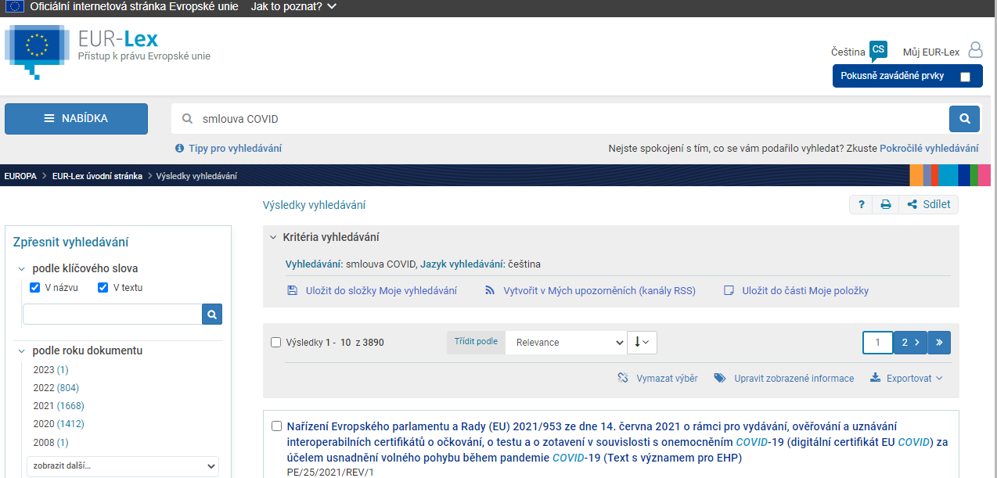
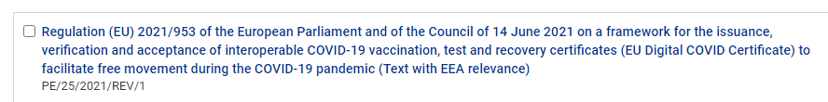
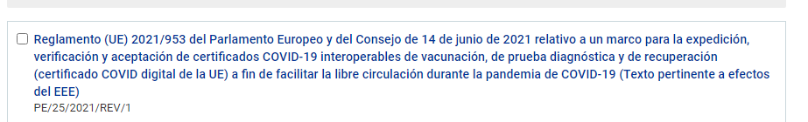

Table 5. Example international legal document found by students (Czech, English and Spanish)

Preparatory phase for the teacher

It was very important that the topic was presented in a clear and straightforward manner and that it did not include too many technical details that could be too confusing for the students. For this reason, the teacher and the lawyer met virtually in advance and discussed the entire workshop together. Based on this meeting, the teacher also compiled an auxiliary dictionary, which the students received in advance.

Workshop

The workshop consisted first of a description of the entire multilingual functioning of the Court of Justice. Then a concrete example of the procedure for using pivot languages was presented. Finally, a demonstration of the typology of translated documents and a description of the daily routine completed the whole mosaic of the translator’s work. What the students were also very interested in were the technical aspects of the translations as well as the mechanism of assigning individual translations. The entire workshop and subsequent discussion took place online via ZOOM video conference during the regularly scheduled seminar and lasted 90 minutes.

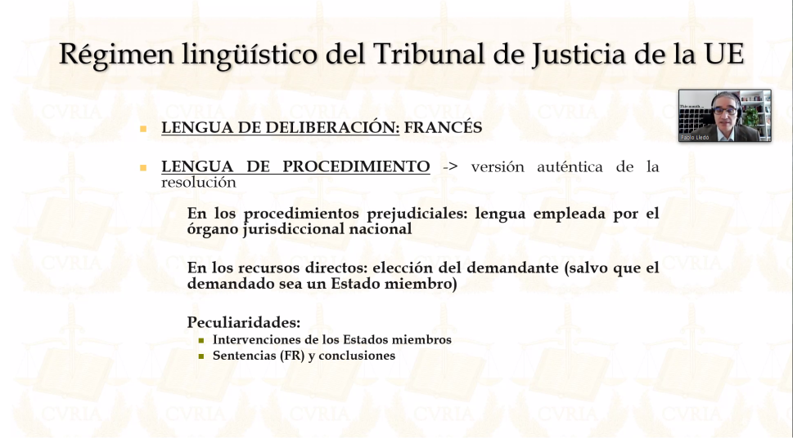

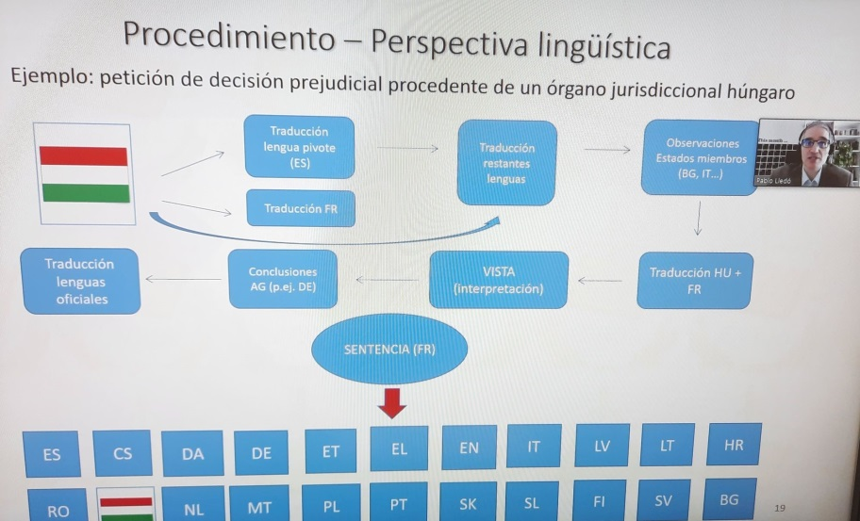
Figure 1. Sample images from the expert’s presentation

Outcomes and evaluation

The debate was lively and natural. The feedback from the students was entirely positive, and a sense of surprise prevailed over the possibility of this interesting combination of legal and language education. Moreover, the students better recognize the importance of developing and strengthening their plurilingual competences, and we believe that the inclusion of this activity in teaching has notably supported this trend. Afterall, the value thereof has been demonstrated in practice by an expert showing how the intermingling of languages and legal terminology across languages forms a harmonious and integrated whole and thus how one’s expertise in combination with foreign languages can be a significant currency for law graduates. The lecture broadened the students’ professional horizons and offered other alternatives for purposeful employment on the labour market.

Activity 3 – Mexican LSP teaching assistant

Description and preparation phase

Foreign students who come to study at Masaryk University and who are at the same time interested in getting involved in the teaching of their mother tongue and thereby conveying their field of study to their Czech colleagues of the same study area can register for the specially created LA and LSP teaching assistant course. This kind of collaboration between Spanish teachers and exchange or full-time foreign students has had a long tradition with excellent results. The greatest benefits of their involvement are the motivation for Czech students, mediation of a different culture and different concept of the studied field abroad, and finally also the interactive mode of student-to-student communication.

A concrete example of such involvement was a presentation by a Mexican student of law about the Mexican legal system, Mexican constitution, and protection of the rights of indigenous peoples in Mexico. The presentation was included in the topic of the distribution of power in the state, constitutional law, and judicial organization of the state.

The goal of this activity, in addition to the obvious provision of factual information about the relatively different legal system and origin and history of this non-European country, was also the mediation of an authentic Mexican perspective on the current political and social issues of Latin American countries.

Before the actual presentation, the students received two tasks.

Homework – two weeks before the lesson

First, they were asked to take an online quiz about Mexico and could choose between two options (https://www.profedeele.es/actividad/test-mexico/ or https://www.youtube.com/watch?v=no14Aa2gHfA).

The aim was to learn general information about this country, its culture, linguistic and ethnic situation, and basic political-historical background.

Homework – one week before the lesson

The second task was a group task focused on legal issues. In groups, the students had to prepare 5-minute mini-presentations on the following topics:
1 the Czech, Spanish and Mexican constitutions – basic information;
2 distribution of power in the Czech Republic and EU countries – comparison; and
3 the rights of minorities and ethnic groups in the Czech Republic – any available information on the legal protection of minorities in the state.

Preparatory phase for the teacher

The Mexican student worked with the teacher for the entire semester, and therefore the preparation was continuous and the student was familiar with the current level of Spanish of the Czech students in the seminar group. This fact facilitated the preparation of the topic and the level of complexity of the presentation. The Mexican student was given the opportunity to choose the topic herself and to grasp it autonomously in her own way. We consider this very important, as student collaboration in teaching should be creative and innovative as well as authentic. The teacher received the lesson outline with slides in advance but did not influence the factual content.

The final versions of the preparatory tasks I and II above were determined by both the assistant and the teacher based on the final version of the presentation provided to the teacher in advance by the assistant.

The lesson

The seminar started with the group presentations on the topics assigned in preparatory activity 1. These short presentations formed a sort of springboard for raising the topic which was subsequently the content of the prepared presentation by the Mexican assistant. First, basic geographic and political information about Mexico was provided.

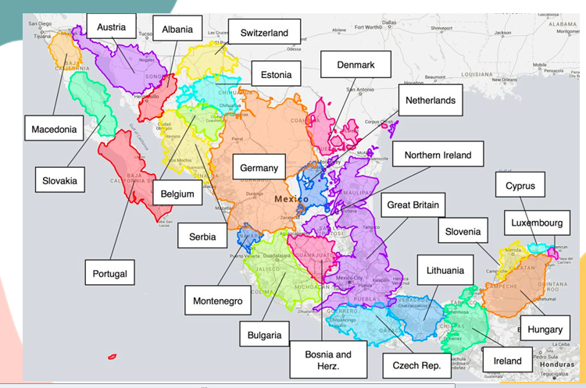
Sample 1 from the assistant’s presentation

Next, the assistant presented the Czech students with information about the origin and creation of the independent state of Mexico, creation of the Mexican constitution, and division of judicial power in Mexico. A discussion was then started based on the information that the groups had previously presented regarding the constitution in their home country. This discussion was moderated by the Mexican assistant.

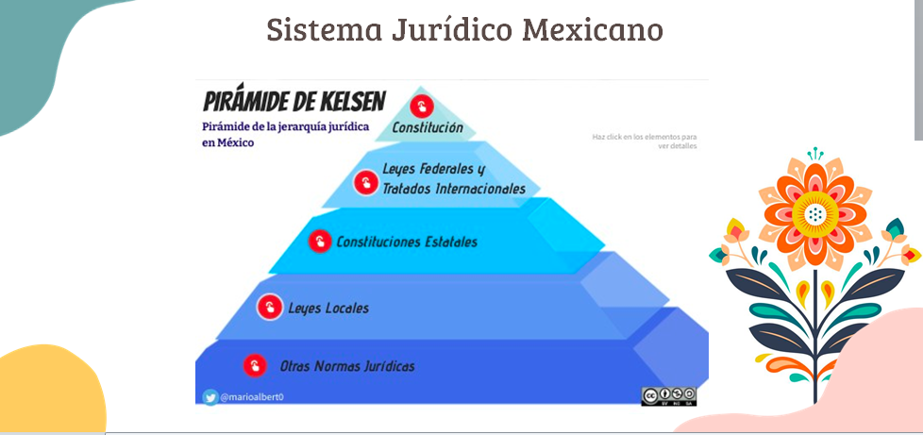
Sample 2 from the assistant’s presentation

As a final point, the assistant presented to the Czech students the issue of ethnic and linguistic diversity and richness in her country and also demonstrated how the rights of indigenous ethnic groups are protected by the constitution and what the current situation is with respect to their rights. These issues sparked a lively discussion, during which the Czech students also presented the information they had prepared in advance on this topic.

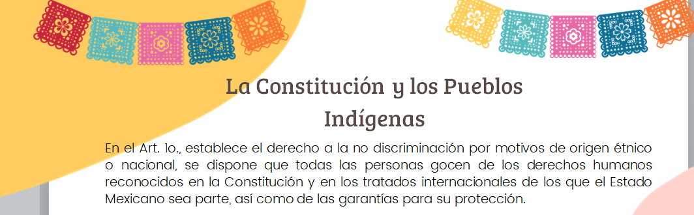
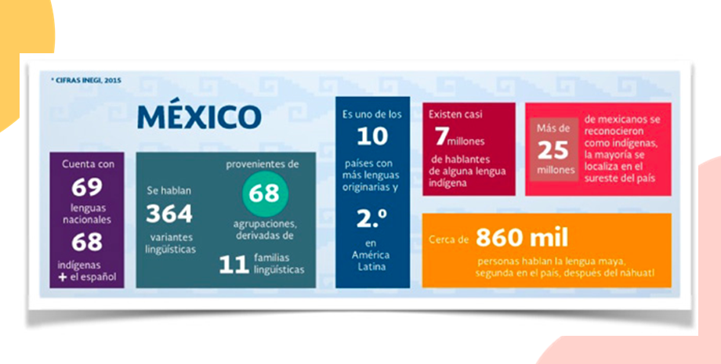
Sample 3 from the assistant’s presentation

Outcomes and evaluation

This task was one of a series of activities prepared by foreign teaching assistants. Students perceive the presence of assistants at seminars very positively and often as a challenge, as they frequently have to step out of their comfort zones during the constant interaction. This is especially needed for law school students. The involvement of foreign teaching assistants supports group cooperation, increases intercultural awareness and, above all, motivates students in the study and application of a foreign language. Moreover, these activities are also suitable for students with a lower level of a foreign language (A2+/B1).

Final thoughts

All the activities described above share a common denominator, namely the intercultural international motivational element. We believe that nowadays higher education, if it is to reflect the needs of contemporary society, must include multilingual and plurilingual forms of teaching and include a repertoire of authentic activities connected with the respective professional field. We hope that the presented activities, or at least some parts thereof, can contribute to this and possibly motivate the introduction of similar projects into the language teaching of various fields.

Please check the Pilgrims f2f courses at Pilgrims website.
Please check the Pilgrims online courses at Pilgrims website.

