
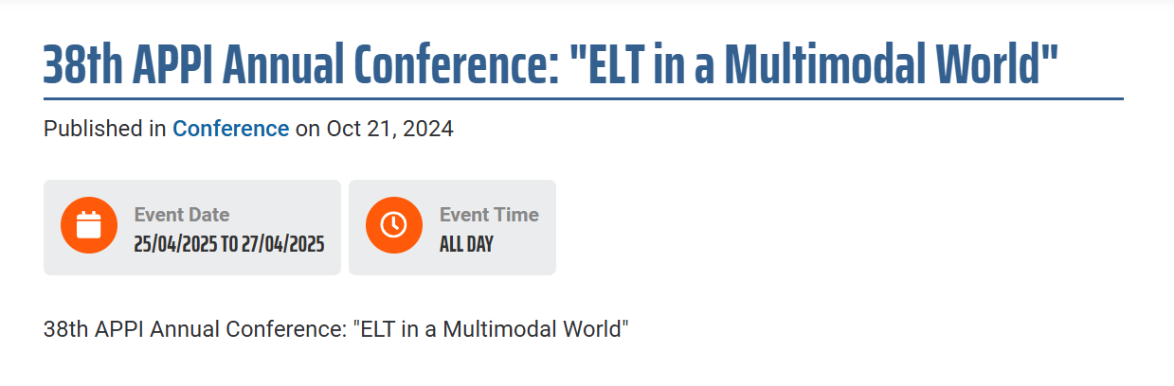
The APPI Executive Board is delighted to inform that the 38th Annual APPI Conference “ELT in a Multimodal World” will take place at ISCTE, in Lisbon. Once again, ISCTE - University Institute of Lisbon will host our largest Annual gathering on April 25th, 26th and 27th, 2025.
This year, we aim to further develop the Conference topic “ELT in a Multimodal World”, by inviting speakers and experts in this field to share ideas and approaches on how to develop Multimodal literacy with students, reinforcing the importance of communication skills in this digital era. We also encourage discussions on activities that raise awareness of real world issues, such as the UN’s Sustainable Development Goals (SDGs).
Registrations will open soon! | Registration Fees
Confirmed Plenary Speakers: Gabriel Diaz Maggioli, George Kokolas, Nayr Ibrahim, Nik Peachey, Rose Aylett, Sandie Mourão

I’ve got a speaker proposal in and waiting for confirmation. We’re also doing a mini sponsorship - no stand but we will have a flyer in the programme and bags I think. I no nothing really happens in Southern Europe until after 6th January and I’ll follow up during the week. We’re paying for the flyer. So, I suppose you can also mention our participation.
Contact:
Sónia Ferreirinha
APPI President
Tel.: +351 969570805
Email: appiconf@gmail.com
https://www.appi.pt/event/38th-appi-annual-conference-elt-multimodal-world

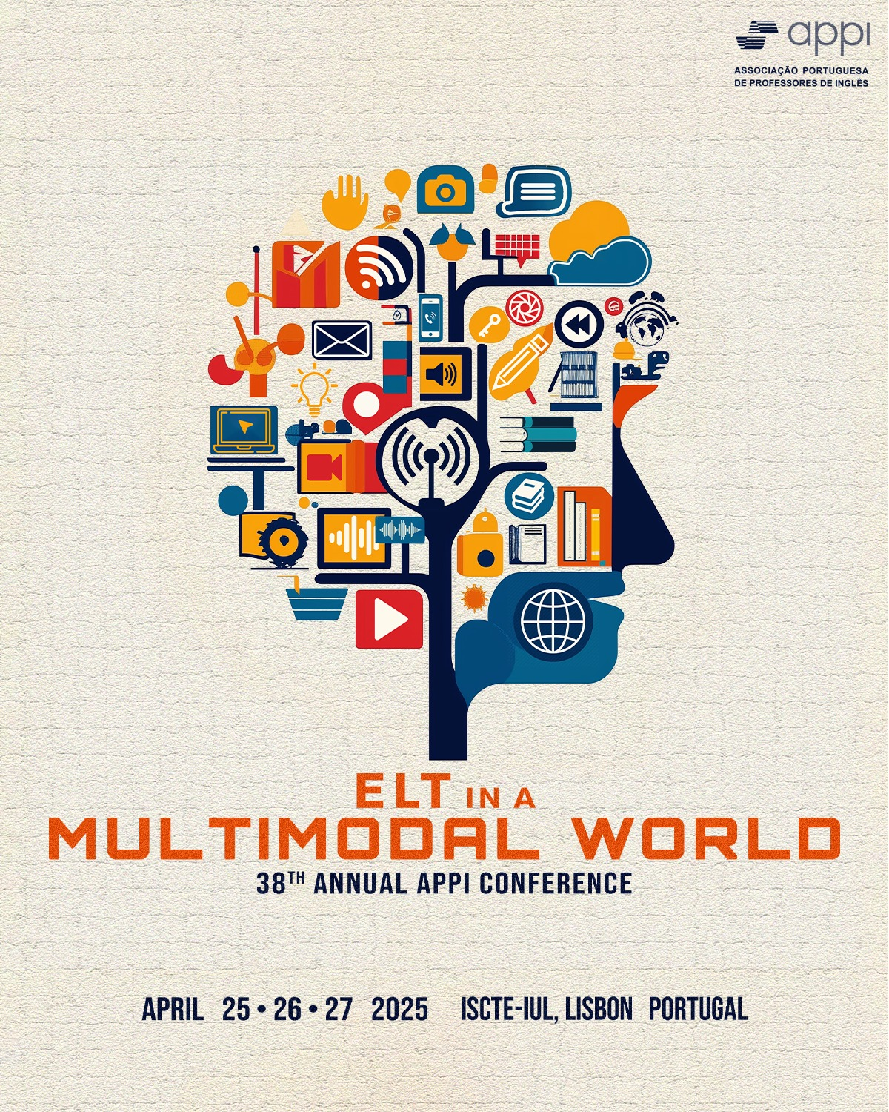
Sónia Ferreirinha
APPI President
Tel.: +351 969570805
e mail: appi@appi.pt
www.appi.pt

