The 49th.Annual TESOL -Italy Convention

Stephania Ballotto, Pilgrims
The 49th.Annual TESOL -Italy Convention held in Rome this year was a much-awaited return to a face -to-face event after five long years. It provided a wonderful opportunity for educators, linguists and language enthusiasts to reconnect and share insights on the ever-evolving field of TESOL.

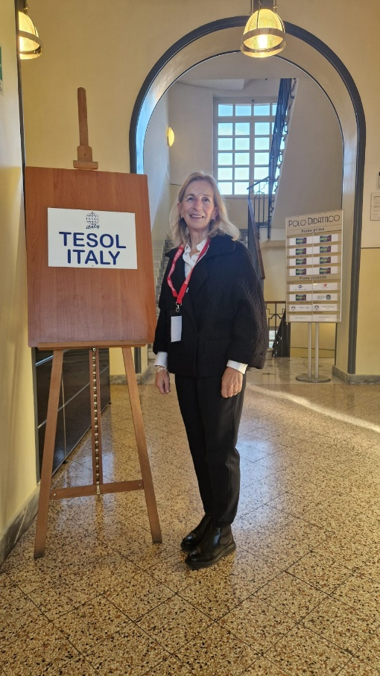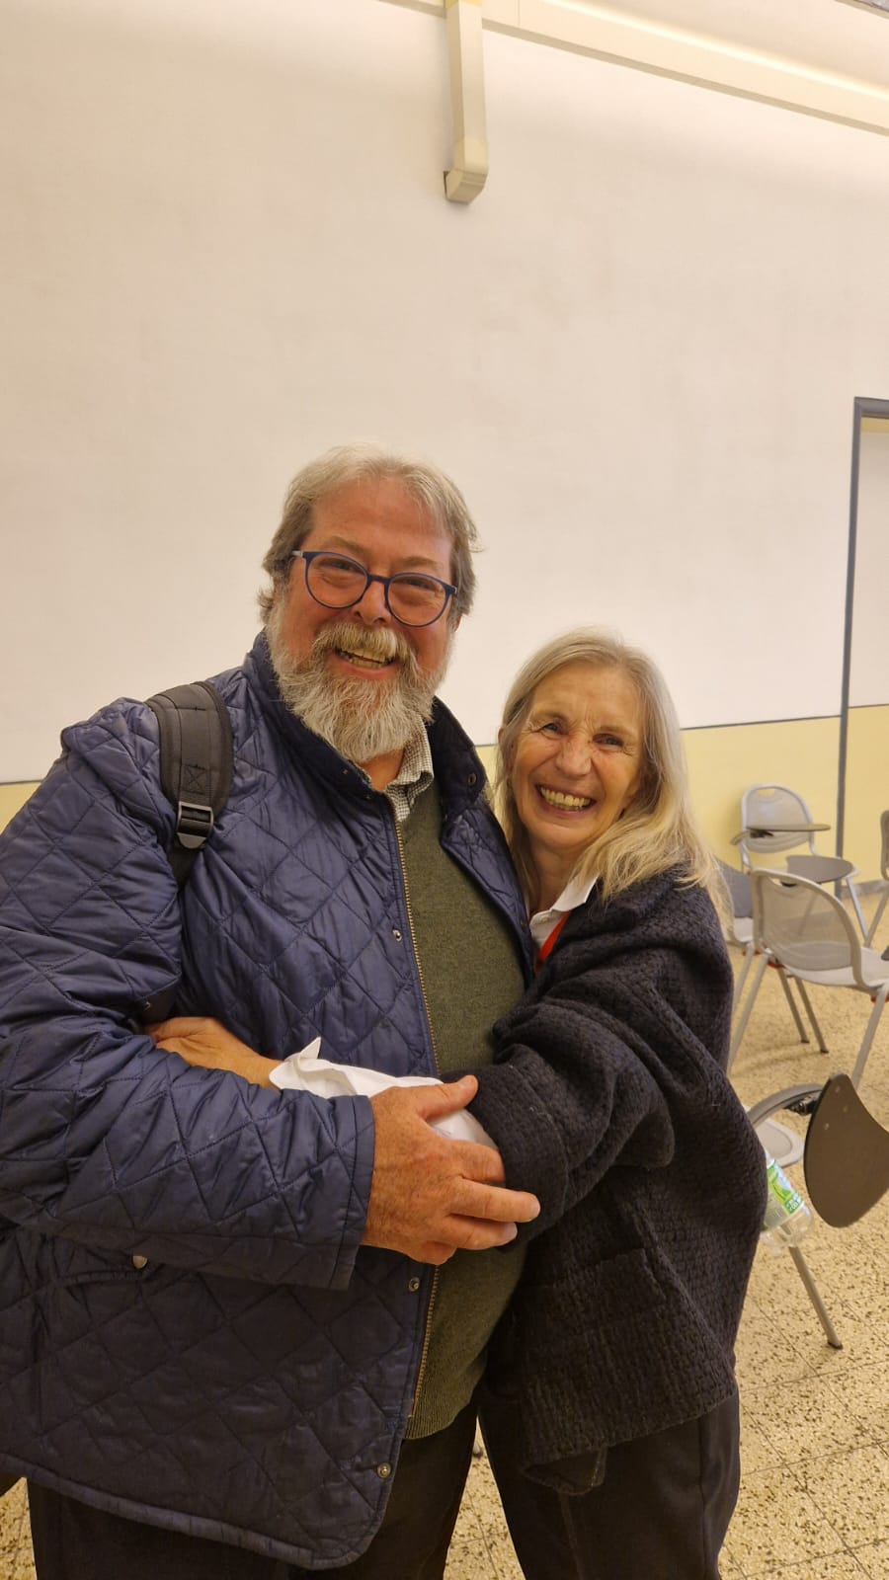

The venue was in the proximity of The City of Rome with its ancient ruins which are a testament to the power of culture, language and history, making this event more than just an academic one. It was a celebration to our ability to come “Together here”
The theme, “Connecting Languages, Connecting People Togetthere” perfectly captured the essence of this event. One of the main features of the conference was its focus on the broader role that teachers of English can play in raising awareness of critical issues. It was a reminder that as educators, we are not just teaching a language-we are also guiding our students through the challenges of the world today.
These themes were particularly reflective of the values shared during Pilgrims courses. The atmosphere was electric from the start, reminiscent of the warmth of a family reunion, much like the inviting spirt one experiences at Pilgrims.This also due to the fact that a vast number of speakers and attendees at the conference have had a Pilgrims experience starting from the president of Tesol Rome.
Another core message was the power of language to connect people across cultures and backgrounds, again this aligns with the philosophy of Pilgrims courses, where educators create inclusive environments where every voice matters.
The well-being of teachers was another key topic at the convention. The importance of human connection was also highlighted.

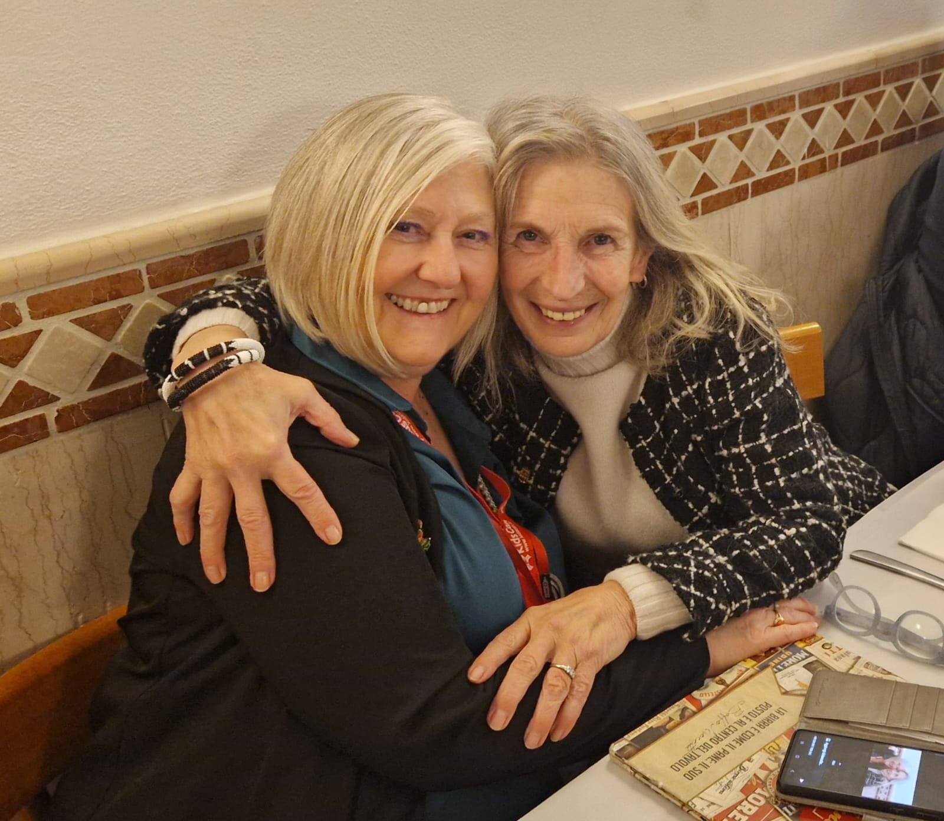

Sustainability emerged as a powerful and timely topic and the conference emphasised the responsibility, we have in preparing our students to be conscientious global citizens. Practical ways we teachers can raise awareness about various social issues, such as inequality,and climate change were also discussed.
I am grateful for having had the opportunity to represent Pilgrims with my presentation, “Making the world a better place” at this two- day conference blending professional growth with important social themes and reminding us that language education remains a force for good in a rapidly changing world.
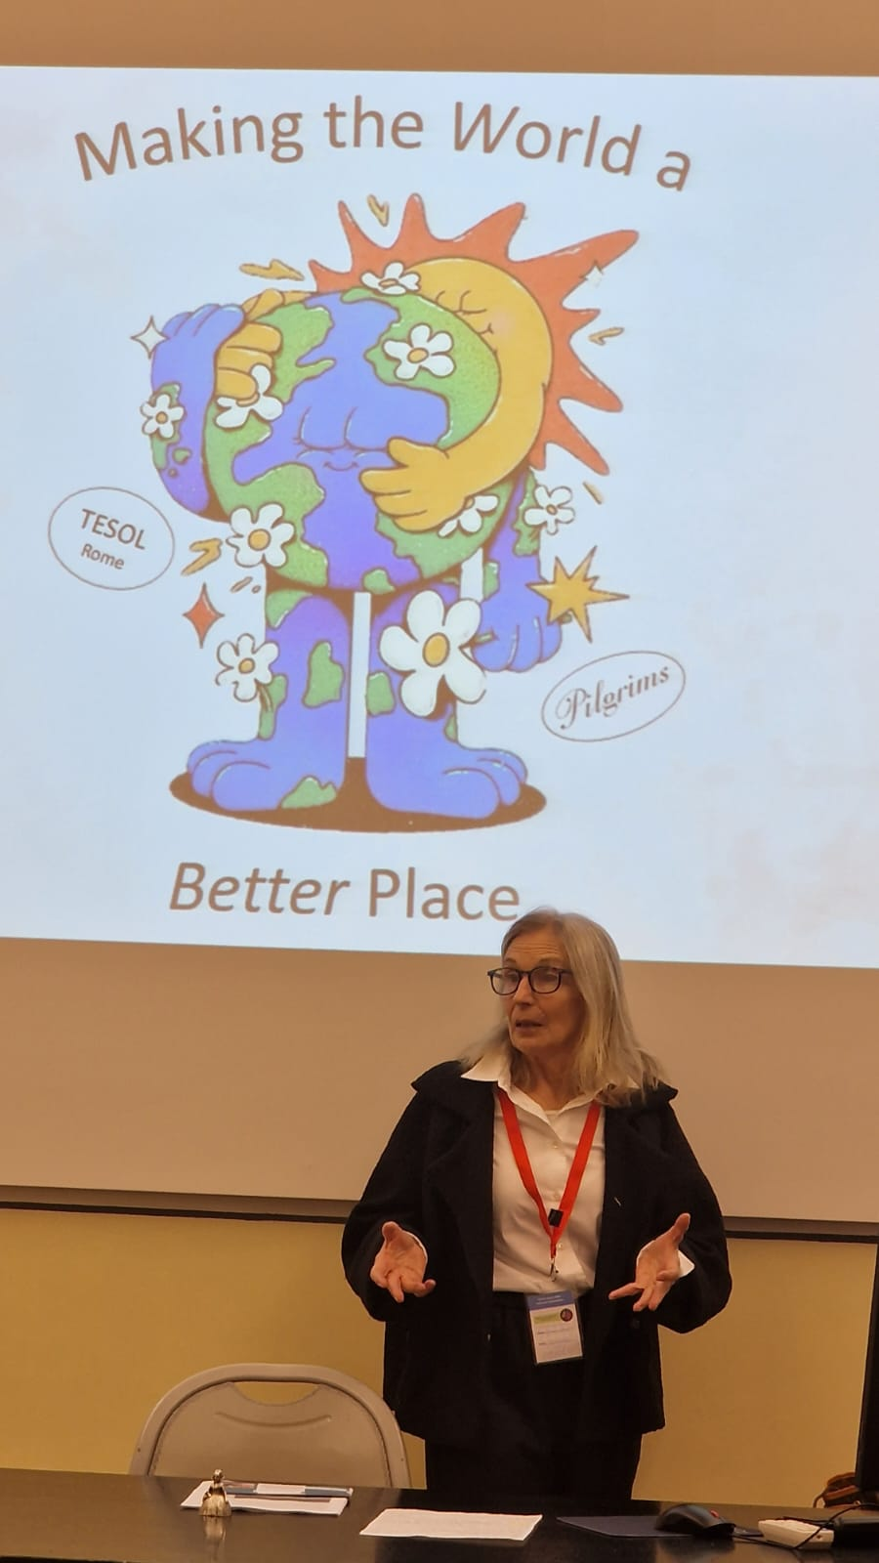

Thank you to PILGRIMS
Thank you to TESOL – Rome -Italy.
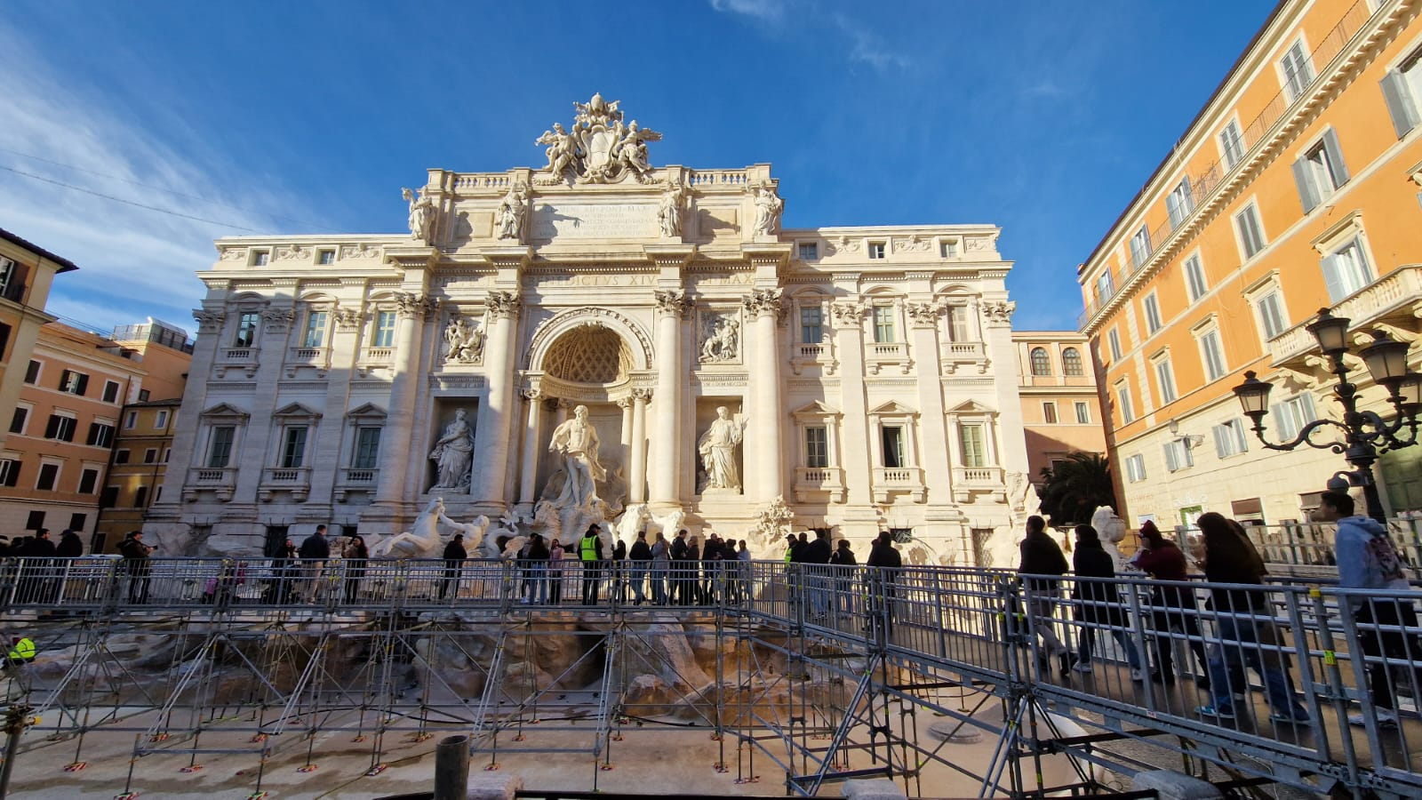

Please check the Pilgrims in Segovia Teacher Training courses 2025 at Pilgrims website.

Please check the Pilgrims f2f courses at Pilgrims website.

