View this email in your browser



PRESS RELEASE | 15th April 2024

“This handbook provides teachers with a superbly curated set of new activities for students, which are organised upon the original VESPA structure but are shaped to address the new normal in the classroom. It's an essential resource for anyone trying to boost students’ commitment to their studies.”
– John Tomsett, erstwhile head teacher, consultant and author

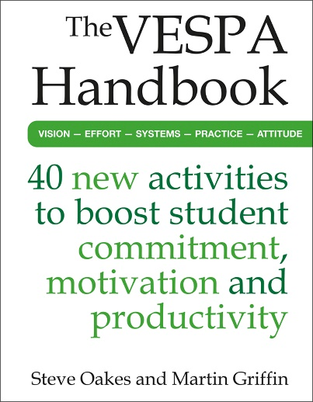
The VESPA Handbook: 40 new activities to boost student commitment, motivation and productivity
by Steve Oakes and Martin Griffin
ISBN: 9781785837104
Price: £19.99
Published by: Crown House Publishing
Date of publication: 30th April 2024

Offers 40 concrete, practical tools and activities that will supercharge learners’ ambition, organisation, persistence and determination.

The five key characteristics that students need to succeed

A recent study from Beattie, Laliberté and Oreopoulos on using non-academic measures to predict educational success and failure¹ found that, from a survey of just over three thousand first-year students, the low-performing ‘divers’, averaging 40% in their exams and often having to re-sit, and the high-performing ‘thrivers’, who, by contrast, outperformed their peers with an average score of 81%, could be differentiated by a re-occurring pattern that suggested five characteristics were the key to success; vision, effort, systems, practice and attitude.
These same five characteristics are examined in this practical new book by experts in teaching, leading and coaching, Steve Oakes and Martin Griffin. Building on the success of The A Level Mindset and The GCSE Mindset, the next instalment in the series, The VESPA Handbook: 40 new activities to boost student commitment, motivation and productivity, is the perfect introduction to the VESPA (vision, effort, systems, practice and attitude) approach. It will help teachers develop those key characteristics and behaviours that learners require in order to regulate their own learning. The ability of students to have a vision, commit the effort, be organised, practise and revise well and have a positive attitude and a good work ethic is vital to their success.
Where some education books focus on how individual teachers might sequence and deliver pieces of information in the clearest, most helpful and supportive way, engaging as many learners as possible, this book is different. The VESPA Handbook will empower learners to unlock their potential, overcome obstacles and take control of their own knowledge and skills.
This practical book looks at how teachers can help learners manage their workload and take control of their own knowledge and skills. It explores the characteristics, qualities and habits of successful students and shares 40 replicable tools and tactics that all students can use immediately, both in and out of the classroom – activities that will help them to set goals, work more efficiently, organise their resources, revise more effectively and solve problems.

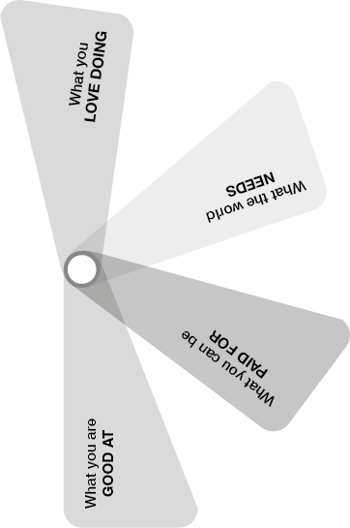
The 40 activities included are set out clearly and categorised thematically under the VESPA umbrella, making them easy to navigate and use in any setting. Each activity can be delivered one-to-one, to a tutor group or to a whole cohort, and is designed to take fifteen to twenty minutes to complete. The VESPA Handbook has been written with students in mind and includes spaces for them to record and reflect on their answers and organise their thought processes. It offers a comprehensive toolkit of study techniques, strategies, and approaches that can be applied for effective learning, planning, organisation, and execution.

If you’re a head of Year 9 wanting a curriculum of tutorial study to prepare students for their GCSE years, this book is for you. If you’re a head of Year 11 looking for a series of resources that focus attention and encourage a greater commitment to out-of-class study, this book is for you. If you’rea head of sixth form looking to improve the levels of proactive independent learning in your Year 13 cohort – well, you get the idea. Assistant heads charged with improving learning outcomes at particular key stages might get something from the material here, as might deputy heads keen to strengthen pastoral support or teaching and learning. Steve and Martin share practical advice and valuable insights for teachers looking to improve their students’ resilience and ambition, based on their combined 40-plus years of experience in teaching and coaching. So, whatever it is that interests you, whatever change you’re trying to make and whatever ambitions you have for your learners, there will be something useful for you here.

Suitable for teachers, tutors and parents who want to boost academic outcomes in 14–18-year-olds and equip them with powerful tools and techniques in preparation for further education and employment.

¹ G. Beattie, J.W. Laliberté, P. Oreopoulos, ‘Thrivers and Divers: Using Non-Academic Measures to Predict College Success and Failure’, National Bureau Of Economic Research, 2016, Thrivers and Divers: Using Non-Academic Measures to Predict College Success and Failure (nber.org)

“I really like the fact that it’s rooted in reality and is extremely useful for the teacher who has concerns for all their students. The advice and direction offered to teachers is exemplary, privileging honest attainment and success at a human level, which, in turn, makes the handbook indispensable.”
– Hywel Roberts, teacher and writer

Articles and interviews available
Steve and Martin are available for interview, expert comment or by-lined articles on a range of topics, such as:
- The five key traits and behaviours that all students need in order to achieve their goals
- The non-academic skills that determine academic success
- What do successful students do to succeed?
- Metacognition
- Self-regulated learning


Steve Oakes has over 20 years’ experience as a teacher and leader, and has been a Head of Sixth Form at two successful schools in the UK and the UAE. As a current Head of Sixth Form, he works closely with students to maximise levels of engagement and commitment, designing high-impact interventions and practical tools for improving academic performance.


Martin Griffin has over 20 years’ experience teaching and coaching post-16 students. He was a Head of Sixth Form and Deputy Head at a successful comprehensive school for eight years, and has worked with hundreds of schools and colleges in the UK and beyond to design and implement study skills, character development and mindset programmes.

For a review copy, a by-lined article or an interview with the authors, please contact:
Ella Simpson | esimpson@crownhouse.co.uk | 01267 211345







