Musings of an Academic Manager

Jim Fuller, Spain

Editorial
The original text appeared on https://spongeelt.org/2024/09/01/musings-of-an-academic-manager-2023-24-in-review/


Jim Fuller is a teacher, trainer, manager based in Spain. His interests lie in Second Language Acquisition, incorporating task-based language teaching into syllabi, and teacher education. You can find him blogging about his experiences at spongeelt.org.

“The mind is like a sponge, soaking up endless drops of knowledge."
Robert M. Hensel

It’s now September, and I’ve finally had some time to sit down and write again. The last academic year has been particularly busy, and one of the things that I usually ‘cut out’ is the blog, unfortunately. This being said, now that I’m in relax mode (kind of – tomorrow I start back in the academy!), I think it’s time to write some short reflections on the year. In this post, I’ll write about ‘manager’ me, and will try to do another for ‘trainer’ me later (stay posted!).
The manager I’d like to be
Over the last few years, I’ve been completing these self-assessment ‘tables’ called The manager I’d like to be – an idea I stole from Wright and Bolitho’s book, Trainer Development (it was originally for teachers, but then I adjusted it for trainers and managers). Here was the table I completed for the 23/24 academic year. The Manager I’d Like To Be – Jim 23_24Download (ed. Don’t miss it!)

Three highlights
For some reason, I’m a big fan of threes, if you hadn’t noticed already. There were of course more than three highlights from the year, but I’m going to outline three of the more important ones
1 – Positive metrics
Since I moved into management, I’ve been insistent on collecting feedback and metrics from a high number of ‘sources’ (e.g., teachers, parents, learners, etc.). This year was no different, and I was happy to see very positive numbers all-round. However, not all metrics are created equal, and no one metric is king. With this in mind, let’s take a look at some of the metrics we’ve used/measured/collected over the last academic year:
- Learner drop outs: This is perhaps one of the most important performance metrics for the academy, mainly because at the end of the day, a language teaching organisation (LTO) is a business, and “bums on seats” are important for keeping the business running. We feel that this number is so important that we have established this as a Key Performance Indicator (KPI) for our teaching staff, and this year we set a target number of drop outs by the end of Term 2, and we met this target (which was lower than the number of drop outs we had in the previous year). As a result, all of our teachers received a paid day off that did not come out of their holidays.
- Net Promoter Score (NPS): The NPS is a classic performance metric used in pretty much all sectors. In essence, your external customers (i.e., learners and parents) rate how likely they are to recommend the LTO to other people. Every week, we collect data from a set number of parents/learners, and one of the questions asks them exactly that – How likely are they to recommend the academy to other people? We use a five-point Likert scale, and I was really happy to see that overall we had close to 5 (we complete this per teacher and then average the scores). This is not a perfect metric, but it is an important one in my eyes.
- Learner improvement over the year: Every term, our learners conduct some type of proficiency assessment (as we are a Cambridge Learning Partner, these generally involve mock Cambridge exams, but not exclusively, as we also have task-based assessments). At the end of the year, I take a look at all of these results, and then compare improvement over the course of the year for each teacher, and then for the academy as a whole. What was interesting to see is that progress was certainly not linear, but overall there were extremely positive trends in the data. In short, over the course of the year, the majority of learners improved significantly. Below is an example of one of the ways in which we looked at this data. Now, whilst many teachers may look at this and think this is a little scary – it’s normal for teachers to think that this might not be fair as there are of course many other variables that come into play! However, these numbers are not used as ‘assessment’ tools in our context; rather, they are one set of data that is used to look at the performance of the LTO as a whole.
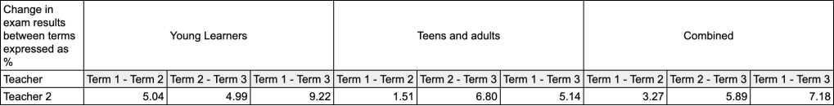
- Teacher satisfaction and work-life balance: Whilst it is important to ensure the learning experience and results are positive, it is even more vital to ensure that your teaching staff – the people who keep the business running, effectively – are satisfied, feel safe at work, and feel that they have a good work-life balance! This year, I was happy to see that all our teachers rated their satisfaction and work-life balance as ‘high’.
There are many other metrics we looked at as well, but perhaps there is an article/blog post in there some where, exploring these metrics (e.g., customer acquisition cost, teaching hours expenditure, etc.)?
2 – Task-supported syllabus implementation
One of the things I’m most proud of is our task-supported syllabus – this year was our first in the implementation phrase (you can read a post about this here), and whilst there were some bumps in the road, overall we received really positive feedback from both teachers and learners. I said that I would write up a few more posts about how the syllabus is going, so I will save more of the juicy info for those more detailed posts, but for now here are a few reasons why I’ve got this in my highlights:
- I’ve found that, overall, the task-supported syllabus lessons have been rated as the most interesting lessons for learners – they get them away from their course books, and involve them in something truly unique. This uniqueness (that just so happens to align with findings from Second Language Acquisition!) is something I hope to exploit from a marketing and sales perspective once the implementation phase is over.
- As we’ve included task-based language teaching training (e.g., how to deliver focus-on-form/corrective feedback) and task-based lesson observations, my teaching staff’s awareness and understanding of TBLT has increased significantly. It’s not uncommon for teachers to be talking and using metalanguage like ‘focus-on-form’ and ‘task completion’. Furthermore, it’s clear that their abilities to teach task-based lessons have improved also!
- The task-supported syllabus has impacted how teachers ‘teach’ their ‘normal’ classes. In short, teachers are implementing more tasks in their teaching outside of the task-based lessons, which for me is amazing! I even have one teacher who has just written an article about taskifying her course book.
3 – An increase in my abilities to manage strategically
Within an LTO, there are broadly two levels of ‘management’: tactical and strategic. Now, for all you management nerds out there, I am well aware that there are many more classifications and levels, but let’s keep things simple White et al. (2008) talk about these two levels of management in terms of senior and middle management, or long- and medium-term outlooks. In short, the DoS generally to focuses on tactical management decisions – organising timetables, measuring academic performance, ensuring teaching quality, etc. The Director or senior management team, then, deal with more big picture aspects of the LTO – long term ‘business’ stuff, basically. Now, in smaller LTOs, there is usually a lot of crossover (in my experience), and I’m extremely lucky in that my management team allow me to take on and be involved in both the tactical and strategic management decisions. This year, I finally feel like I’ve got a good grasp on the strategic management stuff (and this is after four years of being in management!). These last few years have been a wild learning curve, but this year, things just clicked, and I felt much more confident in engaging with the management team on strategic decisions, and making sure that the strategic and tactical levels of the LTO are ‘in-line’. I know this sounds quite vague, and even now as I’m writing this I’m finding it difficult to concisely highlight what this means. However, if I were to summarise, now I feel more confident in running the business, as opposed to running the academic team. Having said that, there is still so much to learn and improve in (more on this now).
Three major learning curves
As one would expect, the year wasn’t ‘perfect’ – is there ever such a thing as a perfect year? A perfect anything? In fact, this year had some of the most important learning curves for me as a manager – here are three of my ‘favourites’ (although it feels weird calling them that).
1 – Communication problems with a teacher
Coming from a military background, I understand the importance of the ‘team’, and establishing a positive rapport with teaching staff – and ensuring that this is genuine! I would say that this is one of aspects of management that I’m most ‘worried’ about in the sense that I dedicate a fair amount of my time to ensuring that these positive dynamics that I’m looking for are present, and that the culture of the LTO is conducive to learning, teaching and being a ‘team’. In my first year of managing teachers, I discovered it was one of the most difficult aspects of management to wrap my head around. Now, jump forward to this year, I was shocked when one of the feedback forms I sent out to teachers came back with some negative comments about how I communicated with one of the team. These feedback forms are anonymous, but the teacher made it clear who they were and I wanted to ensure the feedback went answered, so I approached the teacher and asked them when it would be ok to speak about the feedback they provided. In the end, we sat down and spoke through the issues (one of the emails I sent was too direct regarding classroom cleanliness, and the teacher felt this was unfair), and I had my eyes opened. I had assumed that my communications with this member of staff were clear and that there were no issues. Thankfully, the member of staff felt confident enough to express their thoughts about this in the feedback form (in one sense, I see this as a win for the LTO, as this means that staff don’t feel too worried about management ‘vengeance’), and once we had cleared the air, so to speak, things were much more positive.
So, what was my takeaway here? I think there are two. One, the old adage “assumption is the mother of all *fudge* ups” rings true – as managers, whilst we may have put in a lot of work, we need to continually be re-assessing the impact of our actions over time, and to check that what we believe is true, is actually true in the eyes of our colleagues. Two, written communication with staff is fraught with all sorts of dangers. In this case, I wanted to convey that something was not up to standard, but I felt that I did it in a way that was going to received well, ‘lightly’ even. However, when I sat down and read the email again after having spoken with the teacher, I could see how what I wrote could be interpreted in a different manner.
2 – Marketing guru progress not what I expected
One of my ‘like to be-s’ was to be a marketing guru. I’ve identified that one of my weakest areas as a manager is a good understanding of marketing and sales theory and theory-applied. This year, I wanted to increase my knowledge in this area to a point where I would feel comfortable in any marketing or sales conversation; however, whilst I did gain some knowledge and feel more confident, my progress was not as I wanted it do be.
As a team, in fact, we’ve reflected on this and have identified it is an area of weakness that we all need to improve in. In fact, when we completed the EAQUALS management team self-assessment, the competency area Quality and customer service, marketing came up as one of the lowest scoring areas. You can see a picture below of the overall assessment of our team (we hope to improve this over time!).

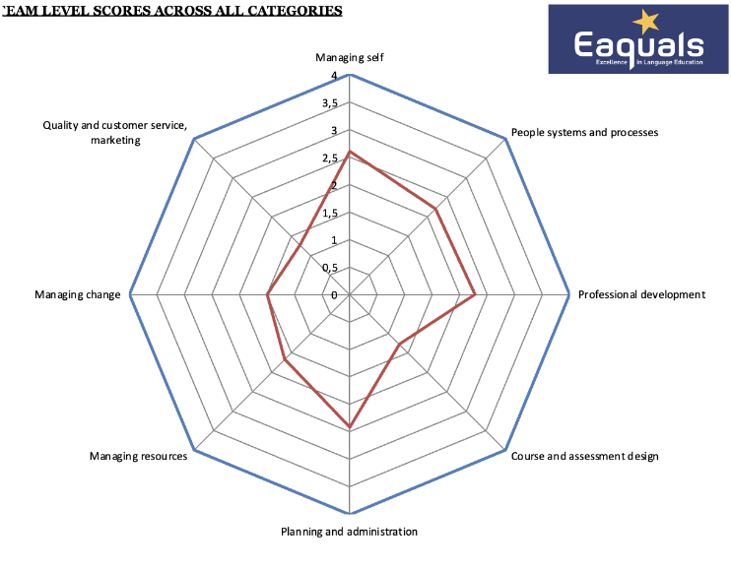
So, in short, marketing and sales are still two areas that I personally need and want to explore further, and become more confident in. I won’t lie – I’m not starting from zero, but looking at how important they are for the business (for any business, really), I feel that they are worthwhile exploring more, and I wish I’d seen more progress this year.
3 – Lower numbers than the previous academic year
This year, we saw a drop in learner numbers, despite all the good things we were doing. I think there are a few reasons for this:
- Economic climate and price increase: With various variables making life more expensive for everyone, it’s normal to expect parents to stop taking their children to extracurricular activities such as English. On top of this, as things have become more expensive as an academy (e.g., the cost of power has basically doubled in the last 48 months!), we’ve had to increase what we charge for our lessons. These two things combined, I believe had an impact on our learner numbers, and perhaps myself and the management team could have planned better for these unknowables?
- Sales has been ok; Marketing has improved by not enough: The number of learners we have is of course a reflection of many things, such as quality of teaching, customer service, etc. That being said, if we are looking to increase our numbers, than marketing and sales need to be on point. Looking back at what we did at the end of 22/23, I would say (and I think our management team would agree) that we didn’t invest enough time in marketing at the right time, or exploring newer marketing tools (e.g., Google Adwords). Luckily, this year, we have changed this, I feel we’ve got a good grip on things, but only time will tell.
It’s always interesting when we get to July/August and look at how many learners we have signed up for September – the last two years have seen the highest numbers ever, but last year we didn’t reach the number we were hoping, and this year – well, we haven’t started yet, and we are well on the way to our objective, but you never know. My personal thoughts are that we need to be more data-driven in these important areas, and analyse what’s going on in our interactions with potential customers.
The Manager I’d Like to Be 24/25
The Manager I’d Like To Be – Jim 24_25Download (ed. Don’t miss it!)
So, as you can see, I’ve taken a way quite a few things, but not because I think I’m ‘done’ with them. I recognise that I still need to improve in all of those areas, but I’d like to prioritise a few specific areas this year (at least different areas).
- Communication with staff: I’ve kept this area as I think it is still an area where I have a long way to go – at least to be at the level where I’m happy. This year’s incident with the email has proven to me that whilst I have made progress, I still need to be careful with these communications and pay closer attention to how teachers and members of staff receive my messages.
- Being comfortable with the finances: I’ve kept this on here as this is still an area where I feel like I’m swimming in an ocean of unknowns. It is true that basic accounting is, in reality, very easy if you have the numbers. But, I want to be better at being able to analyse the numbers, and using these as predictors and measures of success. Also, being confident with financials is a major part of strategic management!
- Being empathetic with teachers: Another point that stays as I feel that this is one of the most important elements of being an effective manager.
- Marketing: I think it’s clear why this is here – I’m hoping that this year lots of movement occurs here
- Change management: This is a big area of management that I really wasn’t aware of until about two years ago, and I feel that this is an area that I really ‘enjoy’ but still need to become more proficient in (and I’ll have plenty of opportunities to practise, I believe).
- Sponsorship: The last three years have been quite interesting from a mentor-mentee perspective, as I’ve implemented mentoring programmes in the academy. One thing that has evolved, for lack of a better word, is how I ‘sponsor’ teachers. I can’t remember where I saw the term used first, but in essence it referred to the idea that a mentor is not just someone who supports development, they are someone who brings the person/teacher into the world of ELT. Now, this might mean introducing them to someone, helping them prepare for a conference, assisting them in writing their first article, etc. And, you know what? I’ve found that this type of support is one of the most rewarding! So, I’d like to explore this a little more, and get better at identifying what types of sponsorship is best for certain teachers.
Final notes
The 23/24 year was, overall, a huge success in my eyes. That being said, there were many learning curves and takeaways. I hope that I’ve included something of interest to you all here, or at least encouraged you to reflect on your own management contexts. But, that’s enough from me – I’d love to hear from my manager brethren out there – what were your successes/learning points from the year?
References
White, R., Hockley, A., van der Horst Jansen, J. & Laughner, M.S. (2008). From Teacher to Manager – Managing Language Teaching Organisations. Cambridge: Cambridge University Press.

Please check the Pilgrims in Segovia Teacher Training courses 2025 at Pilgrims website.

Please check the Pilgrims f2f courses at Pilgrims website.

