Addressing Human Trafficking and Modern Slavery Through Non-sensationalist, Age-appropriate and Respectful Lesson Plans

Judy Boyle, Greece

Judy Boyle is the founder of The NO Project, an award-winning, arts-based, global educational campaign against modern slavery and human trafficking. She has been involved in anti-slavery educational actions for over 23 years. Judy is a teacher, trainer, researcher and author. Her background also includes professional theatre and filmmaking. In 2022, Judy directed and produced It’s Just Business, an award-winning, surreal short film against modern slavery based on a spoken-word poem by a 16-year-old high school student. We would love to hear from you – please contact us at info@thenoproject.org

The NO Project award-winning lesson plans

The NO Project has created free, downloadable lesson plans on different forms of human trafficking and modern slavery. Each lesson is based on a true narrative and is approached with dignity, sensitivity and respect. Designed for upper secondary, young adult and adult learners, The NO Project lessons are ideal for both on-line teaching and in the classroom. Each unit includes slides, artwork, authentic interviews, videos, lexical input, original listening material, and a gentle step-by-step teacher’s guide. Also provided are student autonomous learning resources with suggestions for project-based actions beyond the class. These teaching resources have been featured in the Master’s in Education Program at Havard Graduate School of Education and are being used by thousands of educators worldwide.
The teaching material was created in partnership with The Rights Lab, Nottingham University, UK. Email: judy@thenoproject.org

The article

Based on a true story, today’s article focuses on human trafficking for the purpose of forced criminal activity. This involves the recruitment of both adults and children who are forced to carry out illegal activities for the financial gain of traffickers. Adult trafficking victims can be forced to carry out cybercrimes, such as online scamming or financial fraud, whereas children may be forced to carry out criminal activities, such as theft and pickpocketing.

To find this free downloadable lesson plan go to The NO Project site and download ‘The Letter’ under the homepage option, Lesson Plans. https://www.thenoproject.org/lesson-plans/

Allow time for the students to digest the content

The initial goal is to spark the student’s curiosity, creativity and to facilitate both emotional and cognitive engagement in a non-judgmental space. Don’t be afraid to take your time. This is new information about a confronting, disturbing crime. Allow silence if needed. There’s no need to fill it with teacher talk.

(On a personal note, it was an honour to pilot ‘The Letter’ with lovely 14 and 15- year-old students - and to have the school director/owner be take part in the lesson too.)

Suggested stages of the lesson

Please read through the Teacher’s Guide for more details. Of course, this is just one suggested approach which can be easily adapted according to your students’ needs and interest.
Slowly, present these slides one at a time – allowing time for ideas and feedback between each slide. Please remember – there is no ‘right’ or ‘wrong’ answer. This initial stage is to engage the student’s curiosity.

Slightly off topic, to this very day, I can still recall some (mature and intriguing) ideas that students came up with. One thought was that ‘Nicu’ was standing at his mother’s grave. Another was that Nicu was in prison, and a third suggestion was that he had moved to another country for a job and felt homesick. Interestingly however, all students imagined Nicu to be an adult.

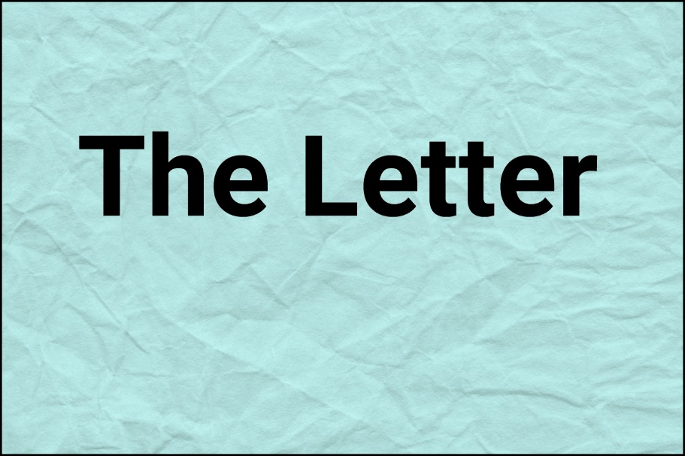

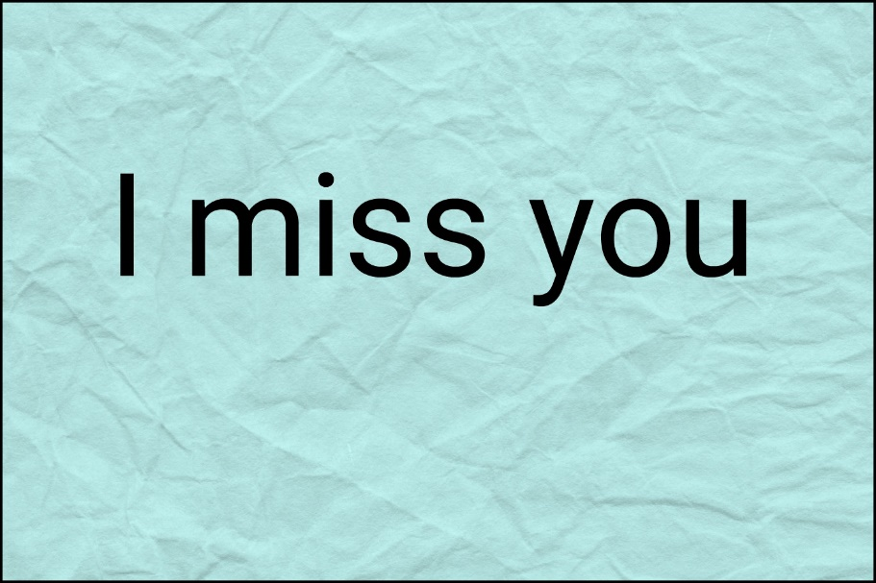

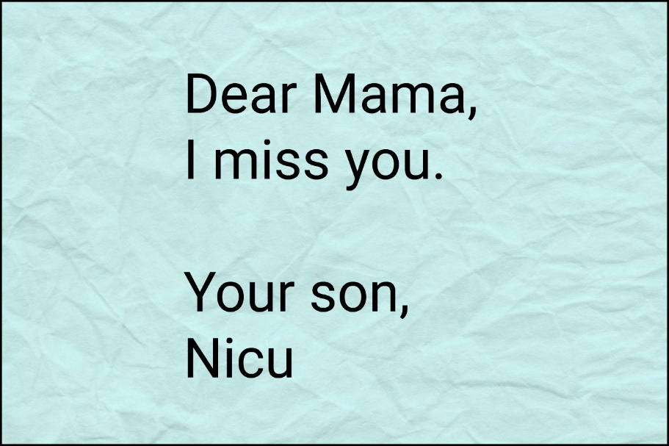

Now things start to shift in the lesson – and get more specific. Still, we do not see Nicu.
Explain to your students that these are six statements that are in the letter he has written to his mother. Allow time for discussion and sharing of ideas.

Feel free to draw attention to the last statement. This is where there is a more emotional ‘voice’ of Nicu – as the other five pieces of information focus what he has been doing.

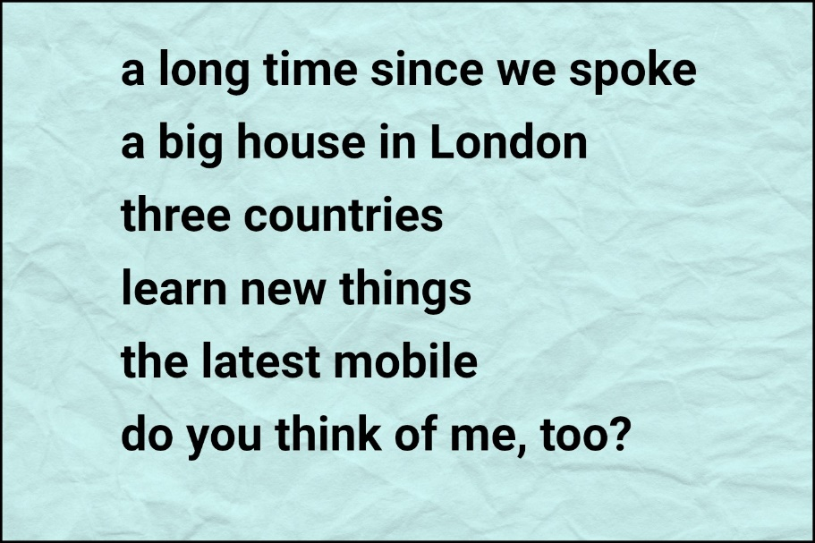

The next image is likely to create quite a range of thoughts and emotions. Now that there is new information and we see that Nicu is a young child, allow time for the students to re-assess their knowledge and to re-frame the narrative they may have created.
Please note! This is NOT the real Nicu - it is a young actor who plays the role of ‘Nicu’ in the short film video based on the true story of the young trafficking victim.

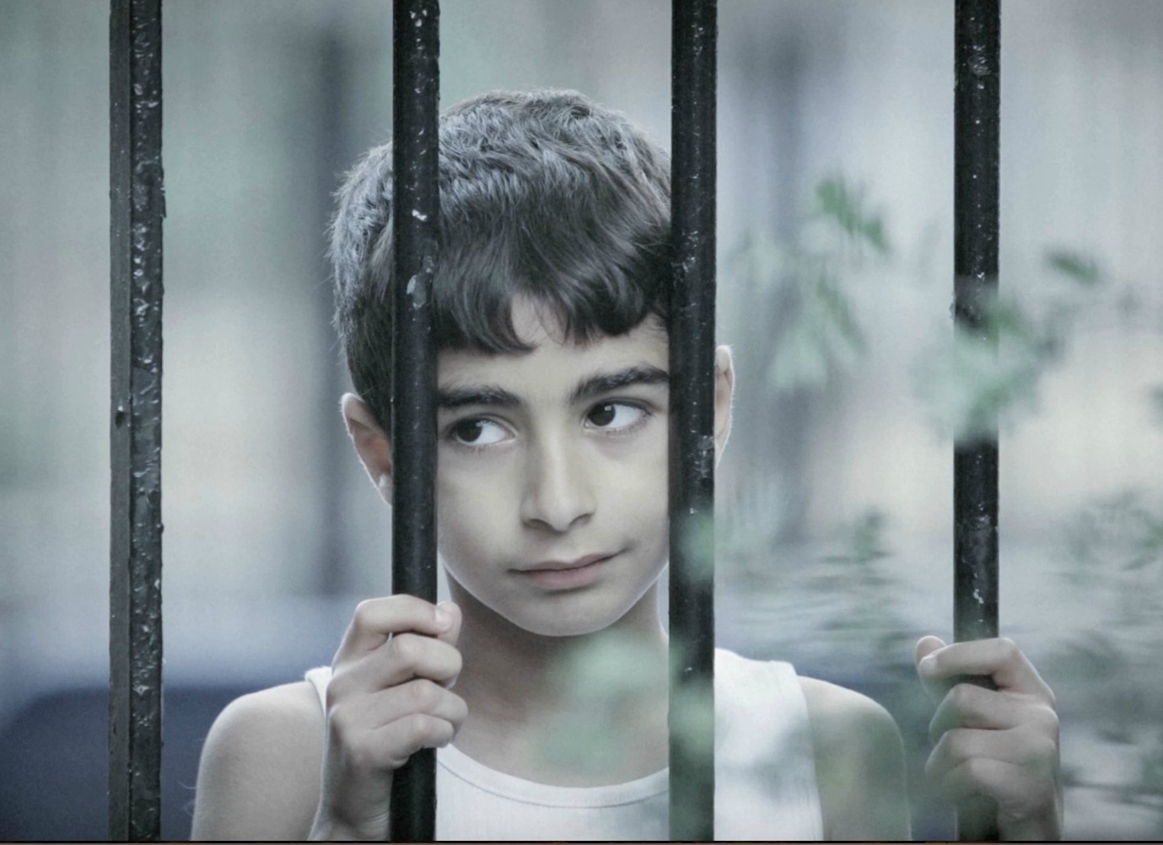

So, how to proceed from here? The choice is yours.

You could 1) view the video or 2) close reading of the letter that Nicu letter to his mother. Whatever the case, the profound contradiction between the information in the letter and Nicu’s daily reality needs to be focused on. For learners who find written content challenging, provide additional support so that they realise that the content in Nicu’s imaginary letter is not real.

The Letter: Nicu’s imaginary letter to his mother
Please do go to The NO Project site and download all the resources provided with this lesson – but in the meantime here is the letter in full. Then watch the video Nicu on YouTube – link provided below.

Dear Mama,
I am sorry it has been a long time since we spoke. Is Papa getting better? I hope he is. And you and Marius are okay? I picture you all sitting in the sun eating cherries from the tree – and I bet Marius is kicking his football against the wall till bedtime. He must be really good at scoring goals now. Maybe as good as me. Tell him I think of him every time I see a Manchester shirt.
We had to move from Spain, so now we live in this big house in London with lots and lots of friends. Can you believe it Mama, that, including home, I have been already to three countries. I am working with my friend Andre. He is always making jokes and teaching me lots. So, the dream for me to learn new things is coming true.
You don’t have to worry about me. I can take care of myself and get lots of money. And I can have anything I want. Anything. You know – expensive things that only rich people have, even gold watches. Yes, Mama your son tells the time in gold.
I’ve worked from morning till night – even longer than Papa used to. Sometimes I am too tired to eat or see anymore or even call you. Though I can have the latest mobile if I want it, it’s just hard for me with my job. I am sorry, I want to hear your voice I really want to. It’s just.... I promise I will send you all some money when I can and I hope this will make you proud of me. I have to go now. I love you and I miss you. Though I don’t speak with you, I think of you lots - every day. You know Mama, sometimes I’m sure I see you here. For a split second I believe it’s you. I wonder, do you think of me, too? I miss you and Papa. I miss playing with my little brother – football. I love you and I miss you, and I wish I was home. I wish I was home with you. I wish we were all together – together by the cherry tree.

Note: This letter from the short film Nicu, is based on a true story of a 9-year-old trafficked boy. This film is solely for non- commercial, non-profit, educational use to raise awareness of human trafficking and modern slavery. The NO Project does not own the copyright of the film. We acknowledge and thank the director and all the production team who created Nicu. https://www.youtube.com/watch?v=vcBLq6P5pkY&t=3s
Unexpected, intriguing, heartfelt student responses

A few days after the lesson, I received two letters from the teacher. Neither their teacher nor I had set any ‘homework’. This was the students’ personal choice. What a remarkable way to process their response to human trafficking. What tasks might you follow up with?

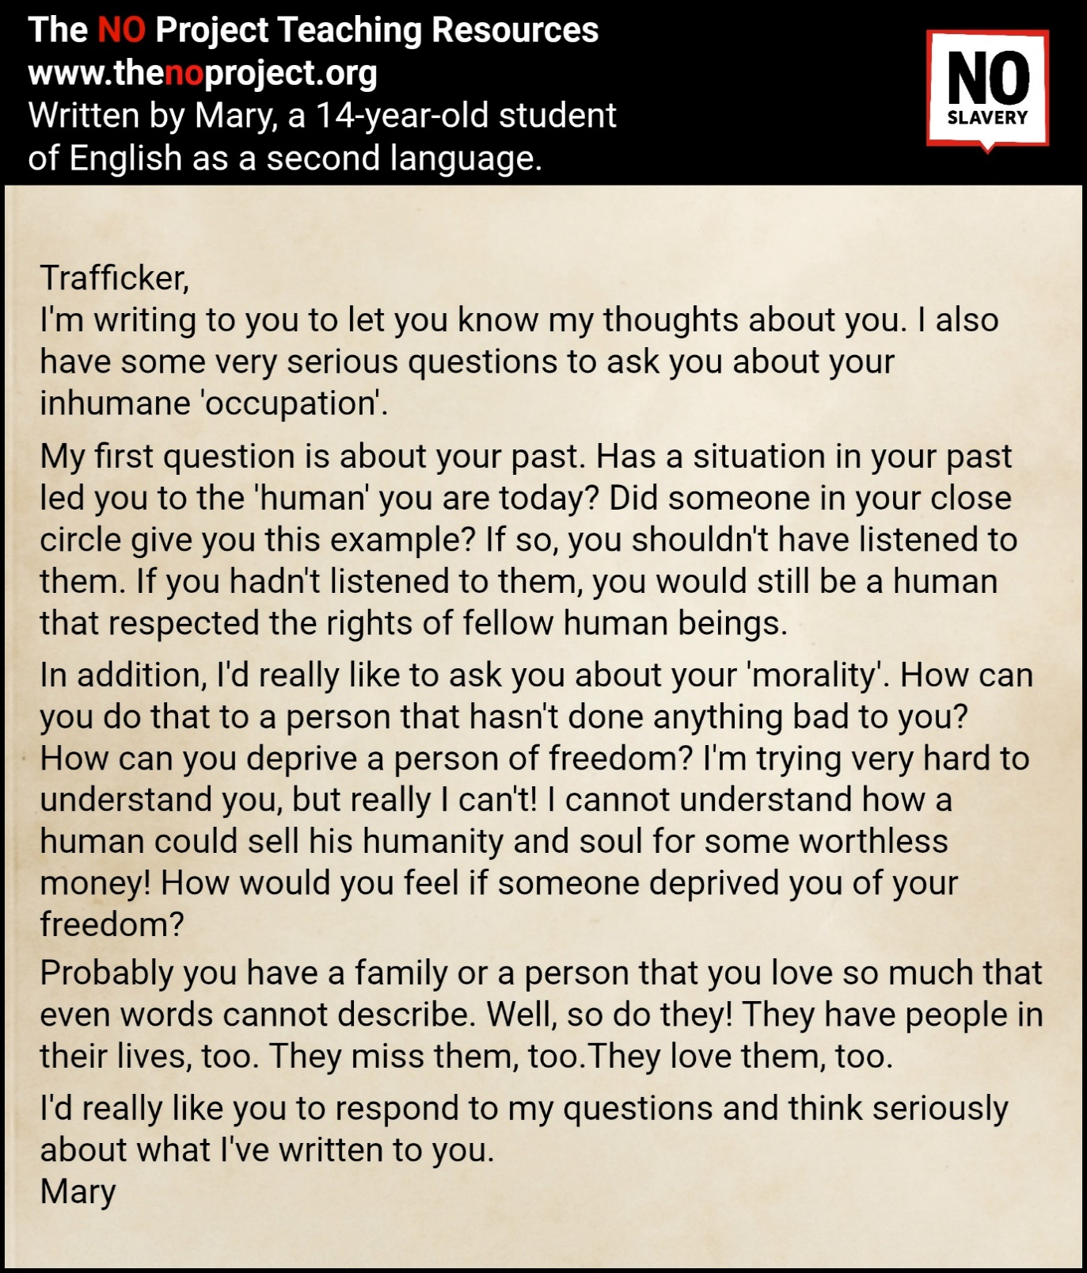

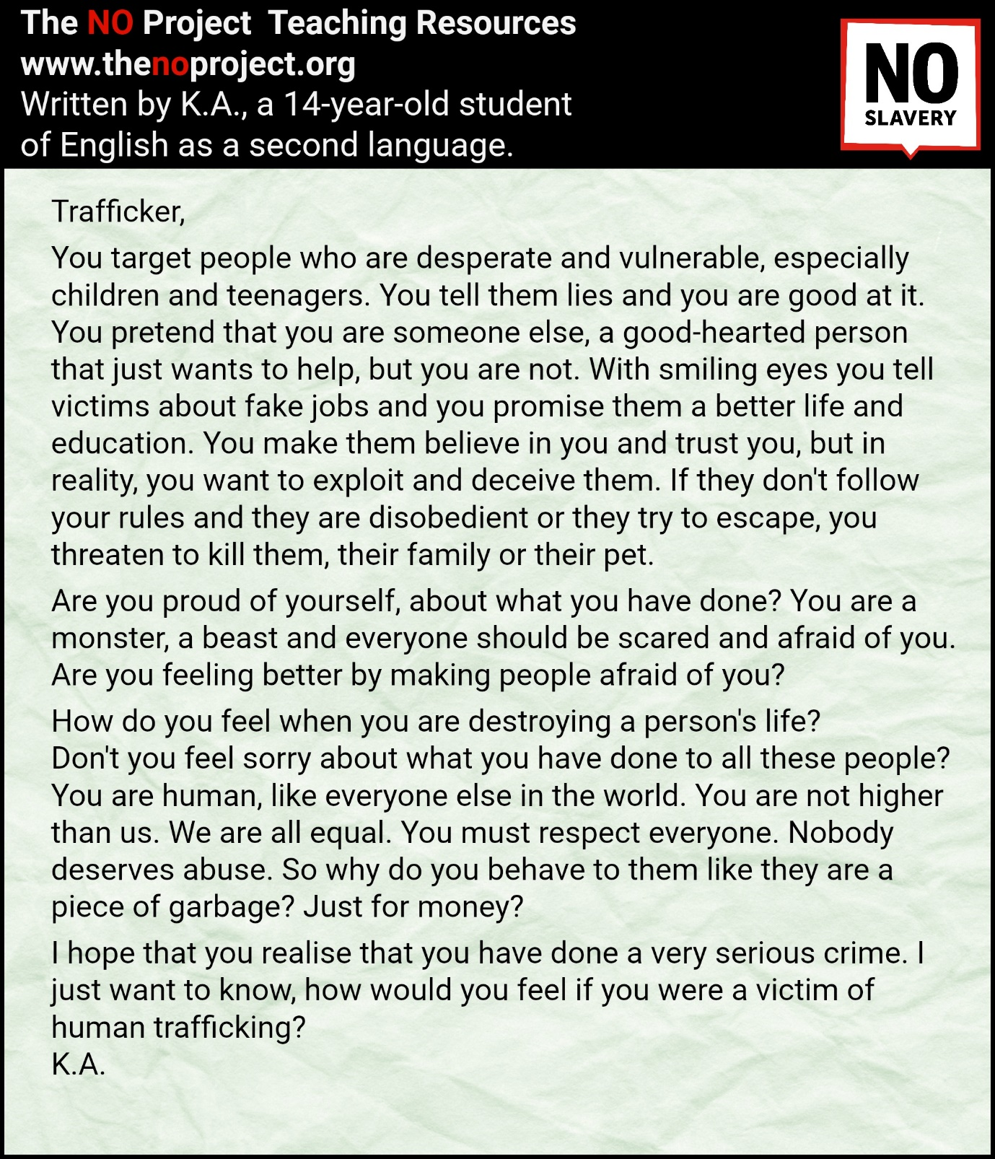

Acknowledgements

Papademetriou Language School, Athens, Greece
Niki Anastasi, creator of short film, Nicu

Please check the Pilgrims in Segovia Teacher Training courses 2026 at Pilgrims website.

