The Art of Sensitivity in Awareness: an Extract from "Is AI making our kids stupid?”

Roy J Andersen, UK



Roy Andersen is a distinguished educationalist, well recognised for his easy style of writing that enables all to fully understand the complications of education and learning. He is the author of 18 books that explore the intricate relationship between society, education and the evolving world of AI. Email: roy@andersenroy.com, https://andersenroy.com/



Note

The following is a copyrighted extract from "Is AI making our kids stupid? Tips to help kids get smart again"

The story of Mathew will help you to understand not just how students develop poorer skills, but more importantly, how you can dramatically improve their ability in these through understanding how they came about.

This will help you understand the importance of “sensitivity in awareness,” both in the way you introduce and guide the development of information to your students, and in how you can better encourage them to be more aware of the need for sensitivity in their interactions and explanations. The following account was taken from our book “Mediation: Crafting the Ability of the Child for School.” In this and other books where we discuss Mathew (this is not his real name), I did not discuss another problem he had, which I would like to bring to your attention here. He was said to be dyslexic.

The section you are about to read will give you a hands-on understanding of the meaning and the value of the art of sensitivity in awareness, when it fails, and the value of it when it is developed in the student.

When I first met Mathew, he was 17 years old. I remember being very impressed with the way he explained his mind. He introduced himself very politely and with a clear manner of confidence. As soon as we exchanged formalities, he began immediately to inquire into my life and experiences. He wanted to know the countries I had been to, and what I thought about this and about that. He was very well-versed in current events.

The image he projected was of a confident and very able young man. In fact, I was confused why I had been asked to meet him by his mother, but I thought it was polite to encourage the meeting, and so I asked the student to write a few sentences for me.

Now, I can usually understand in five or ten lines all the grammatical problems a student has, but this gives insight into how they explain themselves and how they think to relate their thinking to others.. However, as soon as Mathew picked up a pen, the whole character of this young man changed. It was like watching a Jekyll and Hyde movie, except that instead of becoming a monster, the student transformed into a highly nervous and very stressed human being.

While I noticed a few simple grammar mistakes as word followed word, it was not this that startled me, but the grip with which he held the pen. As I watched, white patches on the surface of his skin appeared with the pressure he applied, and I noticed how these coincided with his attempt to write a vowel.

His hand seemed relaxed for other letters, but when he came to a vowel, he displayed great tension in his hand. It was also interesting to see that the vowel was barely legible. Other letters were clearly written, but the vowels were written much smaller and much disguised. So, it was difficult to easily see if it was an “a” “e” or “o”. Also, letters appeared with no conformity. One letter could be twice the size of the one it followed, and selected from a different model than the one it would precede.

Watching the stress build up in this young man as he struggled with the task of writing, I noticed how the end letters to a word would be hastily scribbled, as he urgently strove to conclude it. So, each word would begin clearly, but by the end it would be illegible.

His parents had been told he had a motor tremor and had been told by doctors that he would always be like this. They were told that nothing could be done. His mother had told me how he was the problem child in a class, the burden of every teacher. I was not interested in the account of his class behaviour. I understood that Mathew’s bad behaviour was simply his way of objecting to a system that he saw as poorly classifying him in relation to others he was forced to learn with. His bad behaviour was simply an act of self-defiance, rather than one of inadequacy. Yet, what, I wondered, was the cause of this inadequacy?

I had listened to the explanation of his motor tremor, but I had noticed that this tremor only occurred before a vowel and towards the end of a word, and was, therefore, in some way related to the meaning of stress. This aside, I had witnessed how he demonstrated a high degree of finger dexterity in various tasks I had seen him involved with. Putting this tremor explanation aside, I began to study how he held a pen and made a relation to the paper with this.

Now, if I were to ask you to pick up a pen with your eyes closed, you would feel for the correct position of the pen within your fingers and make an adjustment until it was right for you.

Each of us has our own way of holding and making use of a pen. When this young man held a pen, it was so close to the tip that he retarded any operation of dexterity that he might make in describing a character. I asked him to try to accept a different hold on the pen he was using. While such new positioning was unnatural for him, he was more able to elaborate on the description of a character. Why, I pondered, should the form of letters be so inconsistent?

All learning in school, as we have explained, is based upon rules. We may understand, for the moment, the rules the infant has to learn to write letters. So, they will listen to the teacher and also watch other children to see how they will copy from their teacher. In this way, they will become familiar with a sheet of paper and learn how to write upon it.

Thus, the infant will learn to compartmentalise the paper into potential lines and spaces. As they decide where the left-hand margin will be, they also decide where the right-hand margin will lie, and so the point at which their writing will move to a lower line. If the paper has no lines, they will learn how to write across the page by constantly referring to past letters, marks higher up the page, and the potential space to the right, so that the line of their writing is even and balanced. When the paper is marked into lines, as it more often is, they will learn to create an imaginary line that sets the height of letters, so all will appear of a uniform height when they rest them upon the inked line.

This writing may seem automatic, but it is, however, learned through such rules. With experience, the child automatically and now naturally scans for the height and width of each character before they make it. With every act of performance, no matter how small or how irrelevant it may seem, it had to be learned at one time.

* Learning requires a degree of sensitivity in how to perform

the actions of another, as they learn from them.

In the same way that you may verbally talk to yourself when you learn to change gears in a car for the first time, and then no longer need to do this as you progress to automatically perform this action, so the child in school is minutely conscious of small details when they first learn a task.

You only have to watch an infant watch the one they are sitting next to, to see how they watch and mimic their actions as they pick up a pencil and write a letter. They will see how the pencil is held and examine the letter that has been drawn. Then, they will draw their personalised version of this, as they constantly check how it compares to their friends' version, as they give it their shape.

So, while we think about the words we are to write, we must remember that we learned to know that when “a” followed “i” that it was to be kept at the same height, while an “l”, “t”, or “h” was to be taken to twice this height. Therefore, our mind constantly seeks reference points, where it searches backwards and forwards to know how to adjust the size and form of each new character to make such a uniform presentation. This is something that we learn to do, and like riding a bicycle, we are not normally aware of how we do this. We just do it. Nevertheless, it is a learned operation based upon rules.

However, this 17-year-old did not know these rules! He did not see how one letter needed to be related to the one it followed, just as this would set the stage for those to come. The question in my mind was “Why did he not see this, and why were the vowels disguised”?

As we worked together to learn this skill, Mathew explained to me how he had been taunted for being fat when he first began school, and how he hated to be in that class, because he was always picked on by the other children. When we met him, Mathew, he was not so, but I could understand from the way he explained his feelings that the first years of school life had been quite traumatic for him. Knowing this brought sense to why he had hated to be in school earlier in his life, and so why he tried everything he could think of to escape from it.

When his teacher was explaining the vowels and phonetically sounding them out, Mathew was not paying attention. Because of this, he became confused when he should write an “e” or an “a”. One teacher had smacked his hand for not concentrating, and a student laughed at him.

One teacher tried to help him, but he was too conscious of the other students, who were ready to ridicule him, to clearly think about what the teacher was saying. Then, later in his schooling, he was said to be dyslexic, and teachers mistakenly took this to mean his natural ability was limited and he should not be pressurised to learn what he was not able to do. So, his way was accepted by the teachers, but Mathew always felt embarrassed, because he could never do what other students could do.

It was also the case with the scale of letters. When others took note of the scale of letters at the beginning of their school life, Mathew’s mind was closed, because he felt hurt for being laughed at. In being so distracted, he only half noticed what others took more note of. This caused him to take less care and be less aware of what was happening. (Can you see here what we mean by sensitivity in awareness?) As time went by, the inability he showed to make such uniform presentation became more and more accepted as “his” way, just as his confusion with vowels.

As we know from the principles we discussed in “Brain Plasticity: How the Brain learns Through the Mind to Create Intelligence”, the behavioural experiences Mathew had did not just affect his way of understanding other children, but they also conditioned his academic ability. So, while he was in primary school, much of what he was taught —the basic rules that enable a student to achieve a level of proficiency —fell on deaf ears.

He so much hated to be in his class that he could not focus on his learning, and so developed a very bad structure to engage with information. Perhaps, to consider the complexity of the human mind, he may have done this purposely simply to demonstrate his rejection of a world that gave him pain.

However, with all this understood, I began by giving him confidence not to worry about mistakes. I told him, 'I make many mistakes, just like any human being does.' He smiled a bit when I told him this. Once, and only once, a “level of trust” with him had been gained, I began to help him learn the differences between the vowels. Not that this was easy, for at 17, he had much to reconstruct.

The important point was that Mathew began to believe that he could learn this task (because I had gained his friendship and trust), and he began to learn how to do it better. He learnt not to get stressed if he wrote the wrong vowel, but to reflect more if it was the correct one, with the model examples I had given him.

Then, we discussed the rules of character formation and relationships to help him understand the correct size of letters. By making a small mark at the appropriate height in between the inked lines on the right side of the paper, he learned to devise an imaginary line that extended from the letters on the left, so that he could define a particular size for each letter he was about to write. This was much easier for him, and within less than an hour of practice, he had written abcde in joined-up writing with a precision that was remarkable.

As Mathew came to recognise his own improvement and his now greater possibilities, he put more effort into his studies and less effort into disturbing the class, because he had found a new way to be recognised as an achiever.

The explanation for Mathew’s very distinctive change in performance came not simply from someone showing him how to do something, but from the quality of language shared between the teacher and the taught that enabled the psychology to change the physiology. In other words, as I more simply say,

“If you want to open the mind of a student,

You must first open their heart.”

The point I wish to make here is that while Mathew's limitation, and his placement in a variation of ability with others, had always been thought to be a natural ability and thus rooted in some genetic explanation, it was proven not to be so. In other words, he simply needed more patience and love from his teachers to improve his performance, but more importantly, their effort to seek how to rebuild what he had not understood in earlier times.

It was heartwarming to receive a letter from his mother many years later, telling me how Mathew got a job as a journalist after leaving school!

We can more simply explain this very prevalent problem in school through the following example. Below you can see part of an essay written by a girl who had been in school for eight years. For eight years and with eight successive teachers, her effort was taken as “her ability,” and she was awarded average marks in a class. We might think of 5/10 to 6/10. Now, in this example, there is no error in her work, except in the manner in which it is presented. Her facts are correct, but the writing is very difficult to read, and she is marked in comparison to the effort displayed by the other students in her class.

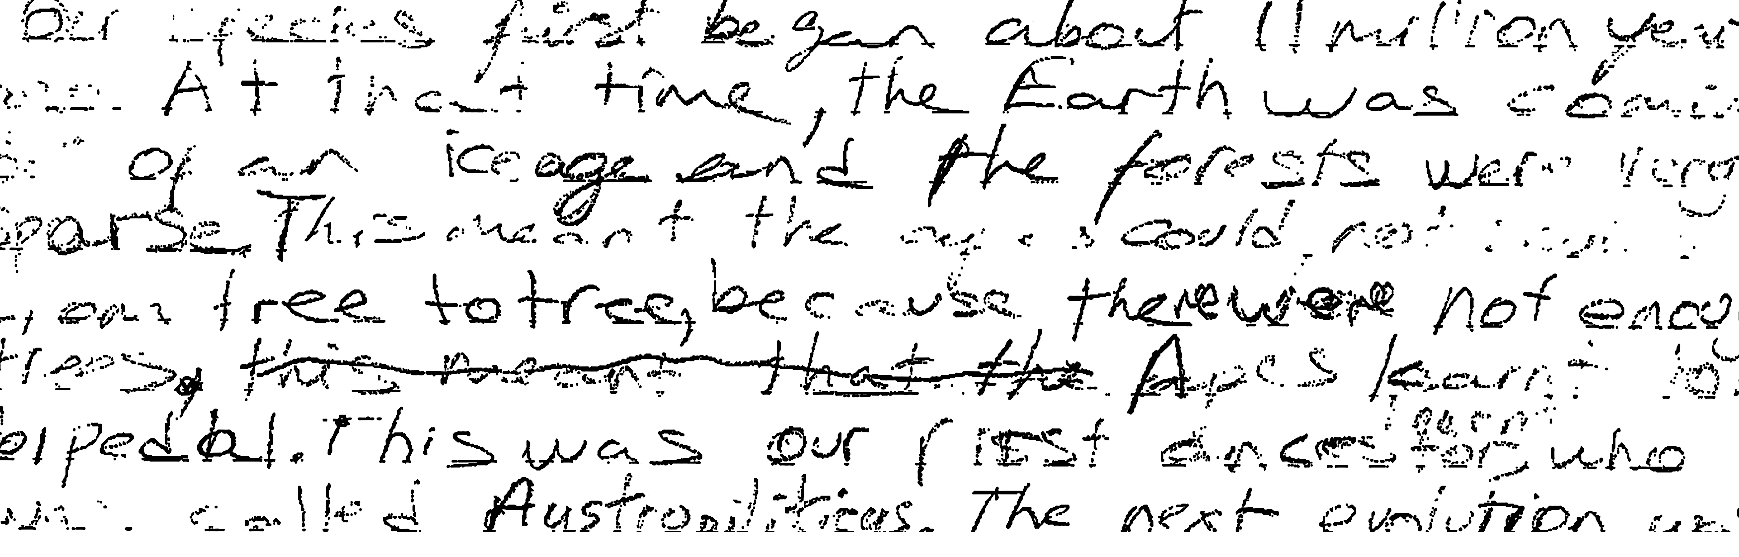

So, the girl always gets an average grade. She trusts the mark given to her by her teacher, and in her mind, she sees herself as average. She does not think she will ever get a higher grade, and therefore does not believe in her ability to do so. The fact that a student does not believe in their ability to develop is another serious failure of the teaching and learning process that we discuss in many of our books.

However, I wanted to change this self-recognition in the girl, so I began teaching her calligraphy. For five minutes here and ten minutes there, I would demonstrate how letters can be so beautifully written. As I showed the girl my writing, she remarked on how beautiful the letters were. When I heard her say this, I knew she had “her purpose” to want to put her effort into her writing. We practised together in breaks and lunch time, and after two weeks, she produced the following.

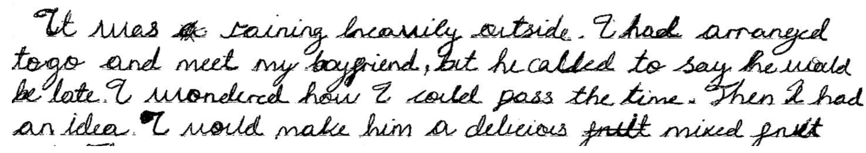

From this moment onwards, the girl began to get top marks. Her belief in herself changed. She saw challenges to be overcome, and she now knew that she would leave school to become the doctor she had always wanted to be. A dream she had been deprived of by teachers too ready to mark what they saw, and never gave thought to the art of sensitivity in awareness.

We can see here how a student was easily and fully corrected in their poor ability, and we can imagine the change in her opportunities that came through this.

Yet, we should bear in mind that although these examples relate to letter formation, they do, in fact, explain all the means by which a student appears to be different in how they develop to remember information and how they learn to share their mind.

You can read more here.

Please check the Pilgrims in Segovia Teacher Training courses 2026 at Pilgrims website.

