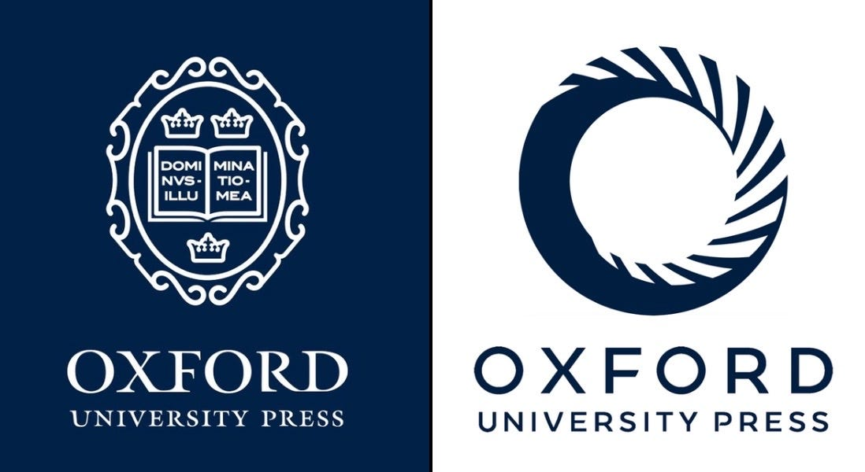

Message from Oxford University Press

We’re thrilled to share some great news with you!

English File Fifth Edition

More components of English File Fifth Edition - one of our most popular course books - are now available for purchase.

Plus, the latest series of the Talking ELT podcast is live, and we’ve released a brand-new Choose Oxford video featuring an inspiring teacher from Morocco.



The upper levels of English File Fifth Edition are coming!

Many components of the upper four levels of English File Fifth Edition are now available for purchase!

Each lesson is enriched with dynamic, embedded videos that make language learning engaging and practical – inside and outside the classroom. Every File includes authentic texts and videos focusing on Grammar, Vocabulary, Pronunciation, and skills development, keeping learners motivated with contemporary topics and proven methodology.

The print Student Book comes with access to Skills Confidence (Beginner, Elementary) and Exam Confidence (Pre-Intermediate to Advanced Plus). With more video than ever before, updated content, and a focus on communication, English File Fifth Edition helps your students keep talking!

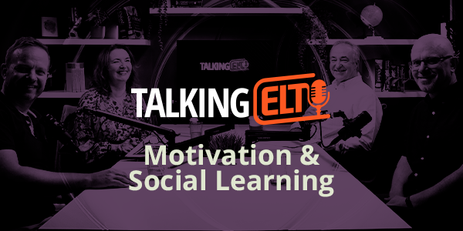

New Talking ELT podcast series

After the success of the most recent special episode of Talking ELT on Content Creation and Microlearning which has more than 280,000 views, we're back with a new series!
This time Ben Knight is back in the driving seat seeking to answer two key questions: what truly motivates language learners and how can teachers harness the power of social connection to support them?

Our new four-part podcast series, inspired by the OUP position paper The Human Connection: Motivation and Social Learning, dives into these questions with ELT experts Nick Thorner, Fiona Mauchline, and OUP's very own Edmund Dudley.

From classroom culture to the evolving digital landscape, each episode offers practical strategies and thought-provoking insights for ELT professionals.

Watch the series

The Human Connection: For future-ready educators

Following on from our first video with customers in Czechia, this second story celebrates teacher Oumaima's professional development journey and shows her energy and passion as she teaches adult learners at the Ministry of Handicraft and teenagers at the American Language Center, Rabat, Morocco.

It is a story of partnership, support, and aspirations, and of how OUP's quality materials and renowned Professional Development resources allow educators around the world find progress and support their learners to achieve.

Watch Oumaima's video here.



