Chat & Chill Café - Who are we?

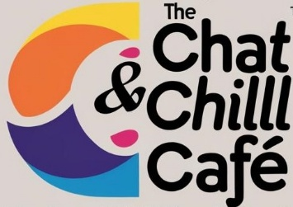

The Chat & Chill Café opened its virtual doors on January 25th 2025
Hosted by Annie Altamirano from Argentina (based in Spain) and Elizabeth Cicconi from Scotland (based in Italy) and rooted in a humanistic perspective on life and education, this monthly online café is a space where educators, creatives, and curious minds can come together to connect, share, and have fun in a relaxed, friendly space.

💡 What is the Chat & Chill Café?
It’s a friendly, informal online meetup where you can:
✨ Share ideas and connect with like-minded people.
✨ Enjoy interviews with ELT specialists, poets, writers, and more.
✨ Dive into short talks, literature, music, and creative discussions.
✨ Meet new friends, catch up with old ones, and most importantly... Have Fun!
🎶 It’s interactive, welcoming, and completely free!
No membership or registration required
⚠️ Note: Places are limited - entry is first come, first served!
When?
Every month, on a Saturday, from 3 p.m. UK / 4:00 p.m. CET
📍 Where?
The café is hosted on Zoom.
just drop a message at chatchillcafe@gmail.com and we’ll send you the link.
💬 So, mark your calendars and join our community from wherever you are.
Let's Chat. Let's Chill.
👉 Be on the lookout for more details coming soon! We’ll be sharing updates on LinkedIn, Instagram and Facebook.
We can’t wait to meet you! 🧡

What’s coming up?

We’ve got some brilliant guests lined up for the next few months at Chat & Chill Café, each bringing a different perspective and plenty of ideas to spark conversation.

 Roger Robinson 
An inspiring session centred on poetry, voice, and the power of words.

 Sophia Mavrdidi & Carlos Lindade  
A lively conversation around digital pedagogy and teaching in tech-rich classrooms.

 Romulo Neves & Anne Margaret Smith 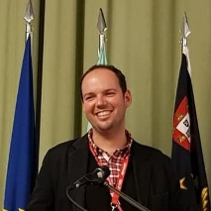 
A thoughtful session focusing on SEN, inclusion, and supporting diverse learners.

Remember 3.00 p.m. UK / 4.00 p.m. CET
On Zoom – no registration needed
Send us a message to chatchillcafe@gmail.com
And we’ll send you the link!

Just bring a cup of something warm and your curiosity.

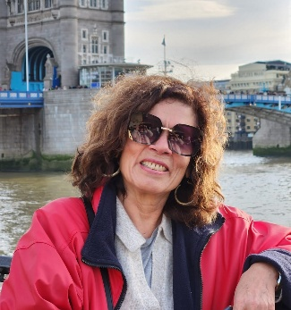

Hope to see you there!
Annie Altamirano & Elizabeth Cicconi

