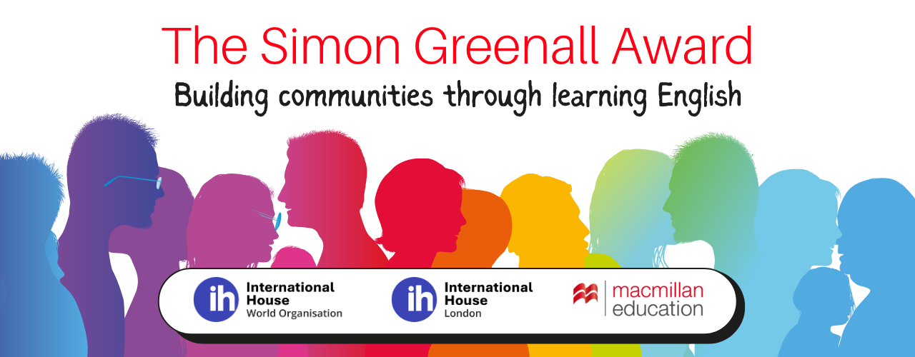

The Simon Greenall Award 2026 is now open for applications.
The purpose of this Award is to support a language project which builds communities through learning English.

The award offers six hours of mentoring, help in developing the project, promotion of global visibility, and a small grant for equipment and expenses.
Link for guidelines and application https://www.macmillanenglish.com/simon-greenall-award-2025
Closing date for application: 28th Feb 2026

The award celebrates the life and work of Simon Greenall OBE, teacher, trainer, materials writer, President of IATEFL, trustee of International House. It is sponsored by Macmillan Education, International House London and International House World Organisation.
In the course of his work, Simon travelled around the world, and wherever he went, he made friends. He was a great communicator and the award reflects his wish to build communities through learning English.
The winner of the first award in 2021, was the Dau Dau project run by Sirhajwan Idek and Nurazilah Othman of Keningau College in Sabah, Borneo, Malaysia. Their work uses folk tales to bring together the different peoples of Malaysia with their different traditions and languages. Storytelling, dance, puppetry, theatre, and song are all part of the rich mix. The mentors were Jill and Charlie Hadfield. Jill, a materials writer and trainer, and Charlie worked on British Council teacher development projects.
The winner of the second award in 2024 was Happy Teachers based in Jamaica, run by Venice Irving. They pair experienced teachers in Jamaica with new teachers in Tanzania who are keen to learn and develop their careers but don’t have the networking opportunities and resources. Happy Teachers offers six months coaching to assist in achieving these aims. The mentor was Annie Thomson, teacher and trainer at International House London.

Closing date 28th Feb 2026.
Application website https://www.macmillanenglish.com/simon-greenall-award-2026

More here.

The Simon Greenall Award

Simon Greenall, OBE, friend of the global ELT community, passed away in September 2018. Simon described himself as traveller, writer, chef and full time friend. Many in the ELT community knew Simon through his publishing activities, his Presidency of IATEFL, his engagement with global issues in ELT, his training activities in many countries, and his friendship. You probably know of Simon’s deep commitment to bringing people together through learning, particularly learning English.

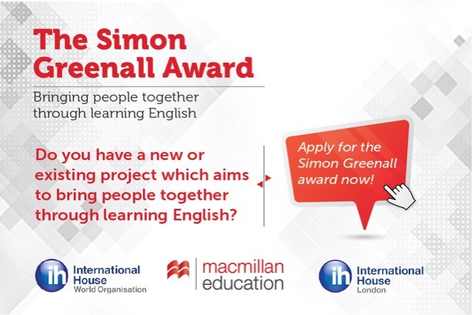

This Award is inspired by Simon’s life and work and is sponsored by three partners with whom Simon was deeply connected: Macmillan Education, International House World Organisation and International House London.
If you have a language project which brings people together through learning English, which may already be ongoing or yet to start, online or face-to-face, you may be interested in this award. Illustrative examples of such projects might be:
- Designing materials in an area which lacks resources
- Planning an educational podcast series
- Running a creative writing project with output that could be used in classes
- Starting an online drama or extensive reading group
- Having high impact through low, remote technology.

The purpose of the Award is to enable an outstanding new project to run, or an existing project to become established and sustainable.

The award aims to help and support the project through mentoring, publicity and visibility, funding as and if appropriate, and making the impacts available to the wider ELT community. The precise mix will depend on the nature and needs of the project.

To enter the competition visit the competition web page to complete the application form and upload a video describing how your project works and how it brings people together through learning English.

Important dates:
- 1st Feb – 31st March 2021: Submit your application
- 31st March – 15th April 2021: The three finalists present their projects to a panel
- Mid May 2021: The winner is selected and announced

