

News from DELTA Publishing

50 Ways to include…

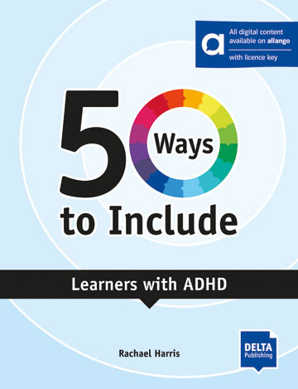

Dip into our latest book of the series "50 Ways to include ..." by Rachael Harris . Every learner has their own unique needs, and this book will show you how to make all of your students feel included and valued . The ways the author suggests will not only help specific learners but will also benefit the whole class.

50 Ways to Include Learners with ADHD

This title will help you to find your way to including learners with ADHD in your class by:
• offering quick solutions to the challenge of including a learner with ADHD in your class
• suggesting specific ways to include and support learners with ADHD as you move through
• the stages of teaching from identifying students’ needs to assessment.
• providing opportunities for reflection and action planning

More information here.
More titles by the author can be found here.



One Day in New York: Reader with audios and digital extras
ISBN 9783125011816 | Pages 102
Immediately something strange happens to you, and you find yourself in an adventure you didn't plan to be in. In order to escape, you'll need to solve eight enigmas. As you face these challenges, you'll find yourself exploring some of New York's most famous places in search of clues to help you escape…
In every DELTA Escape Adventure you find yourself in a situation which you need to escape from. And in order to escape, you need to read each chapter, understand the situation, and solve the problems you encounter along the way. You may need to think hard to solve the problems, but there are clues at hand to help …
This month’s teaching tip can be used with any reader which is set in a different country to the one you are teaching in. The activity can be used with a class reader or with a student’s individually chosen reader. Not registered yet? Don't hesitate to sign up here!

