Letter 1
 | 
  International Publishers Exhibitions
WE WISH YOU A HAPPY, HEALTHY AND PROSPEROUS NEW YEAR!

UPCOMING EXHIBITIONS IN GREECE:
Spring '26 Thessaloniki IP Exhibition, Sunday, 22 March 2026, The MET Hotel
Spring ’26 Athens IP Exhibition, Saturday/Sunday, 28/29 March 2026, Divani Caravel Hotel

We are looking forward to meeting you again!

Enjoy the holidays!

DCS
Avgeropoulou 20
17342 Agios Dimitrios
Greece

Letter 2
 Prof. Emily Nordmann

Wikipedia has a newish "Signs of AI writing" page and it's so good at describing the slop of AI writing, which I often find difficult to verbalise beyond a long sigh of despair.
https://lnkd.in/eQPgxhMT

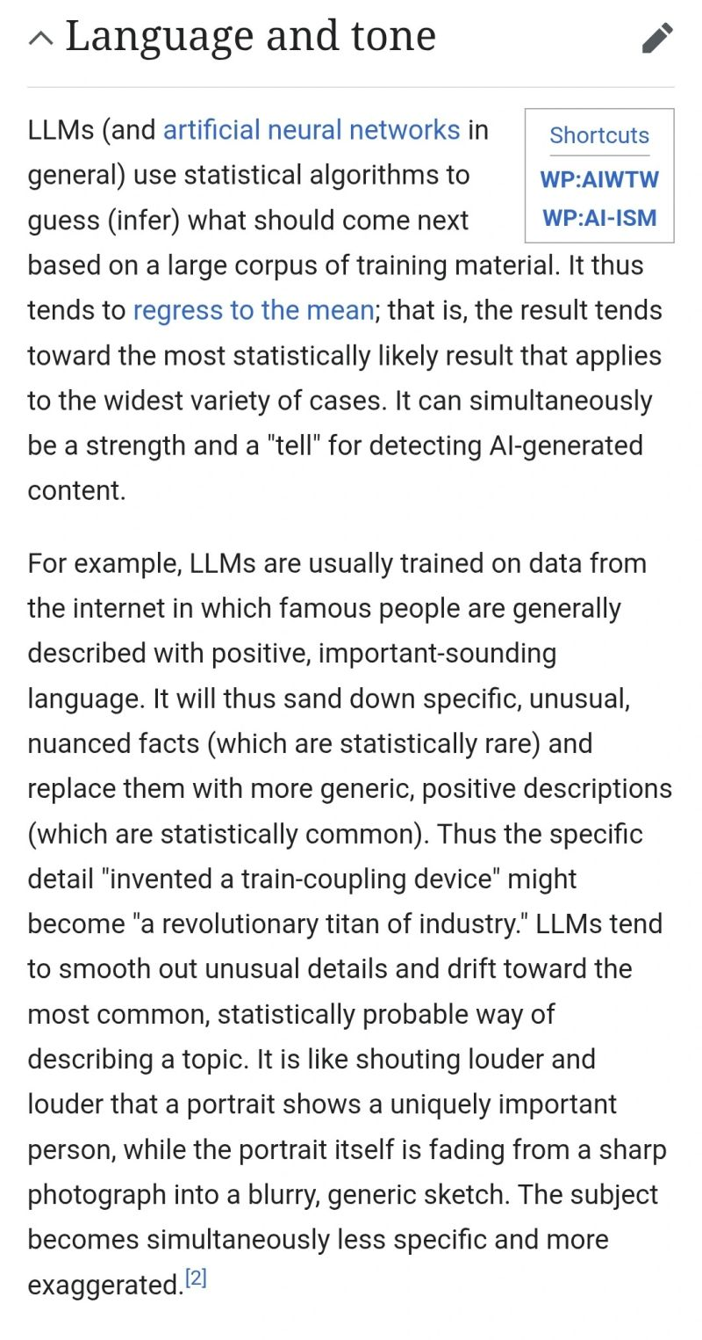

Letter 3

Spine-chilling. And interestingly, not a word about the environmental impact of AI.

Alan M

‘It’s going much too fast’: the inside story of the race to create the ultimate AI

 | ‘It’s going much too fast’: the inside story of the race to create the u...  In Silicon Valley, rival companies are spending trillions of dollars to reach a goal that could change humanity ...

Letter 4

Trinity expands access to its English language portfolio with ISE Digital global roll out
Trinity College London has confirmed the global roll out of ISE Digital, with the fully digital English language qualification becoming available across international markets from this month through to March 2026.
ISE Digital – part of the Integrated Skills in English qualification – builds on Trinity’s longstanding reputation for excellence in English language assessment, offering a flexible and innovative certification that recognises the skills learners need not only to succeed academically, but also to thrive in the modern workplace.

The new comprehensive assessment will launch progressively across Trinity's global network, offering candidates increased choice and one of the shortest four-skills regulated tests available via computer-based testing.

“ISE Digital represents our commitment to meeting evolving learner needs through innovative assessment technology,” said Erez Tocker, Chief Executive of Trinity College London. “This global expansion ensures educators and students worldwide can access rigorous, practical English language qualifications that reflect real-life communication demands.”
Teachers preparing students for ISE Digital will receive complimentary access to a comprehensive support package. The resources include two full-timed example tests at levels B1-B2 or C1-C2 and extensive teaching materials covering all four language skills.
Also available are Trinity’s How to prepare for ISE Digital resource packages which offer classroom activities to support the exam’s integrated skills approach.

ISE Digital is a 105-minute computer-based adaptive test assessing all four language skills individually and through integrated tasks. The exam includes “Summarising a talk or conversation” and “Writing from sources”, reflecting real-world communication scenarios.

The speaking module uses a digital avatar to guide candidates through four progressive tasks, from conversation questions to interactive presentation and scenarios. Writing includes online communication exercises and academic writing which build skills beyond language proficiency, such as digital literacy, critical thinking, and the ability to synthesise and repurpose information. This mirrors both workplace and academic communication demands.

Candidates receive detailed module-specific scoring and feedback alongside overall certification, enabling targeted future learning. The assessment supports academic, professional, and immigration requirements with secure digital certificates available via weblink, PDF, or QR code.

Sally Bolton, owner and director at Valley Language Centre Macael in Spain, trialled ISE Digital with her students. She said that: “The students really appreciated the avatar-guided format - they found it less intimidating than traditional face-to-face examining. They loved typing their responses instead of handwriting and were impressed by receiving results and digital certificates just four days after taking the exam.”
Trinity's staged global rollout ensures comprehensive centre training and technical support across all markets. The qualification is designed for state and private schools, language centres, and higher education institutions seeking flexible assessment solutions.

Registration information and market-specific launch dates will be available through Trinity's approved centres and regional offices.
To discover more about ISE Digital, access the free tests, the ‘How to prepare’ resources, and watch the four skills guidance videos, please visit: Discover ISE Digital | Trinity College London

ENDS

For further information: Mark Cooper, GK & Partners, 0203 763 2703

Trinity College London, established in 1872, is a leading international regulated awarding organisation, publisher, and education charity. The organisation assesses over 700,000 candidates annually across 74 countries in music, drama, and English language qualifications.
Mark Cooper
GK & Partners
Good Space
4 Lonsdale Road
London NW6 6RD

www.gkandpartners.com

Letter 5
Walter Pichler
Fri, Nov 28, 4:51 PM
to

Mein neuester Titel ist online!

https://youtu.be/DfsfHbF1Z50

