Short Book Reviews
Hanna Kryszewska, Poland
Hanna Kryszewska is a teacher, teacher trainer, trainer of trainers. She was a senior lecturer at the University of Gdańsk, Poland. She is co-author of resource books: Learner Based Teaching, OUP, Towards Teaching, Heinemann, The Standby Book, CUP, Language Activities for Teenagers, CUP, The Company Words Keep, DELTA Publishing, and a course book series for secondary schools: ForMat, Macmillan. She is also co-author of a video-based teacher training course: Observing English Lessons, and online course for Orient Black Swan on 21st Century Skills and Teaching the whole person: Humanising language teaching. Hania is a Pilgrims trainer, OTA trainer and editor of HLT Magazine.
Email: hania.kryszewska@pilgrimsteachertrainig.eu

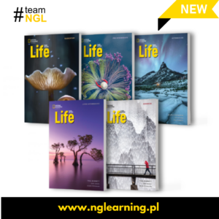

Life. Third Edition. Pre-intermediate. J. Hughes, H. Stephenson and P. Dummet. National Geographic Learning.(2025). ISBN 97821418069-4, pp.190. The course is a series of coursebooks for teenagers, young adults, students, and adults. It comes in 6 levels (from A1+ to C1). The topics in the books are interesting and have a multi-faceted approach for example in the Pre-Intermediate level the unit on lifestyle includes skydiving, secrets of a long life, sleep, communing with nature, illnesses etc accompanied by beautiful photography. Look at some other samples below.

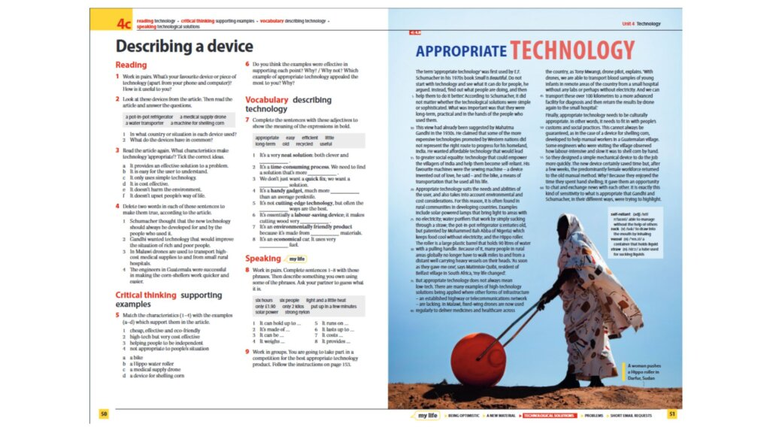

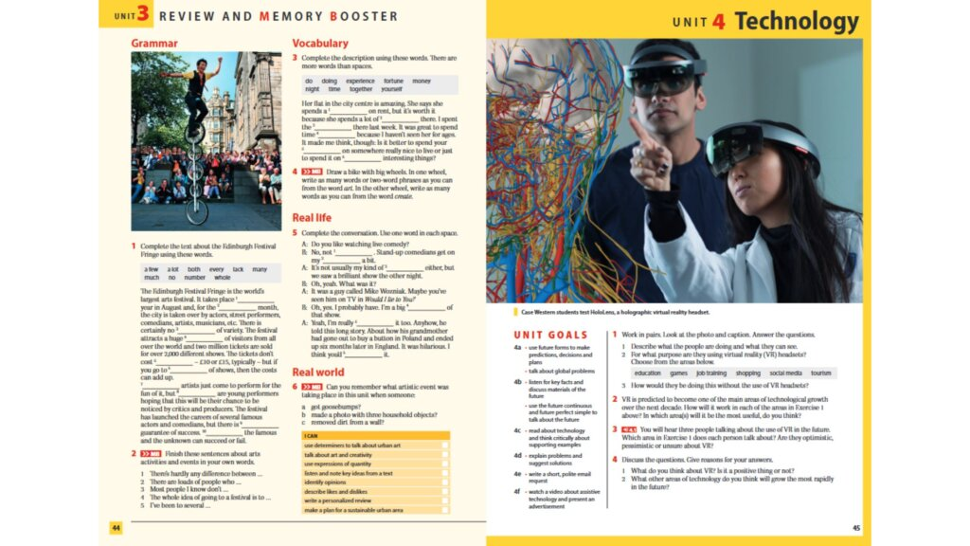

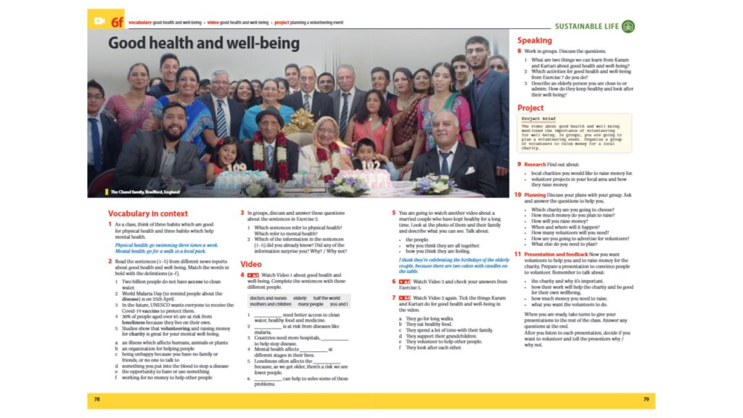

The secret formula lies in a combination of developing critical thinking skills, preparing for academic and professional success, learning the language through authentic materials and a global perspective through addressing global issues.

The third edition of the course has a strong element of sustainable development through stories from National Geographic Explorers which raise issues of global challenges and encourage action. The project-based approach used in the books makes students analyze problems, plan, find solutions, collaborate, give presentations and take part in discussions. The course not only develops language skills, but also shapes the attitudes of young leaders who hopefully one day will bring about a positive change to the world.

A unique feature in the course is the Spark platform – which the publishers describe as “modernity at your fingertips”. Thanks to the Spark platform and a dedicated app, students and teachers can use interactive activities and tests, track progress, have constant access to audio and video, work with the e-book anywhere and anytime. Teachers have access to presentation tools (CPT), printable materials, and interactive resources that facilitate teaching. Wow!

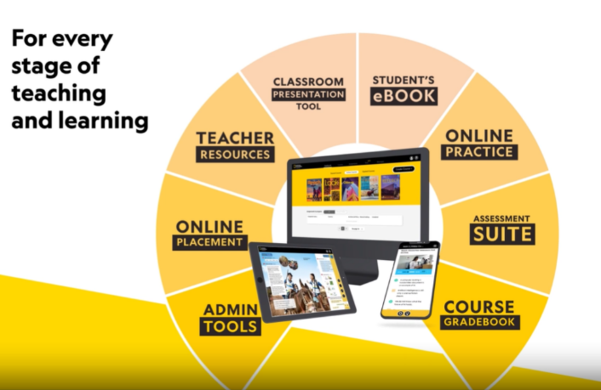

This is a truly innovative course. For more go here.

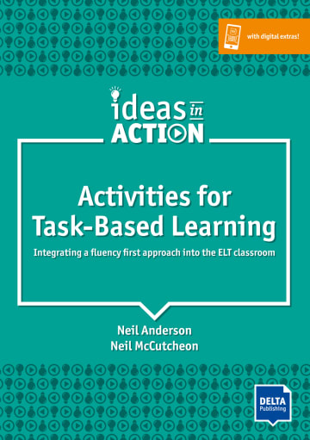

Activities for Task-Based Learning. Integrating a fluency first approach into the ELT classroom. N. Anderson and N. McCutcheon. (2019) DELTA Publishing. ISBN-978-3-12-5017016, pp 152. This book has been published in the DELTA Ideas in Action series. The aim of the series is to build a bridge between theory and practice in language teaching. It looks at how theoretical ideas can be illustrated by practical, motivating and enjoyable ideas for classroom activities. The book provides a theoretical background to TBL - short, informative and accessible, and around forty practical activities ranging from A2 to C2 levels according CEFR. The activities fall into six groups: categorising, opinion gaps, problem-solving, sharing personal experiences, creative (design) tasks and text reconstruction activities. The procedures are described very clearly and are easy to follow; they offer rational, variations, and where necessary accompanied by visual materials, texts and even places to take notes. For the audio tracks you need to download and use the free DELTA Augmented app.

The book also contains an extra section on micro strategies and tools – pre-task micro strategies, on-task micro strategies, post-task micro-strategies, tools and designing your own tasks, which will be helpful if you want to design your own activities along the lines so of TBL.

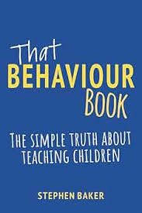

That Behaviour Book: The simple truth about teaching children. S. Baker. (2023). Crown House Publishing. ISBN-9781785836688, pp.192.This book is not intended for language teachers, but for all teachers with varying degrees of experience as long as they work with kids, educators, and to some extent even for parents or family members. Children’s behaviour can be challenging and stressful. So, the author eases the tension by means of relevant and sometimes funny anecdotes, practical advice as well as golden rules. To ease the tension of disruptive behaviour and to harness negative energies, we need to build healthy and effective routines, and create a healthy classroom atmosphere through safe and reliable strategies. These days we know very well that rigid punishment does not work. According to the author a teacher should go beyond ‘managing’ behaviour. Instead, we need to lead them but not in a one-sided way as this leadership must go in both directions: teacher-student and student-teacher.

There are 10 chapters in the book: values, responding to inappropriate behaviour, styles, routines, relationships, expectations, modelling, praise, rewards etc, reflections and appendix. There are between 8 to 14 short sections in each chapter. Fantastic for just dipping in and then reflecting. Most chapters end with takeaways which are one to two sentence long pieces of advice. Sometimes there is a Try this section. The most powerful part of the book is its emphases on values, positive expectations, appreciation and approval, and how to bring out the best out of people.
You can read a sample of the book here.

Please check the Pilgrims in Segovia Teacher Training courses 2026 at Pilgrims website.

