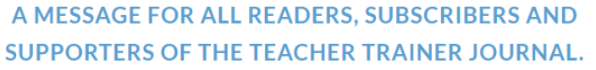
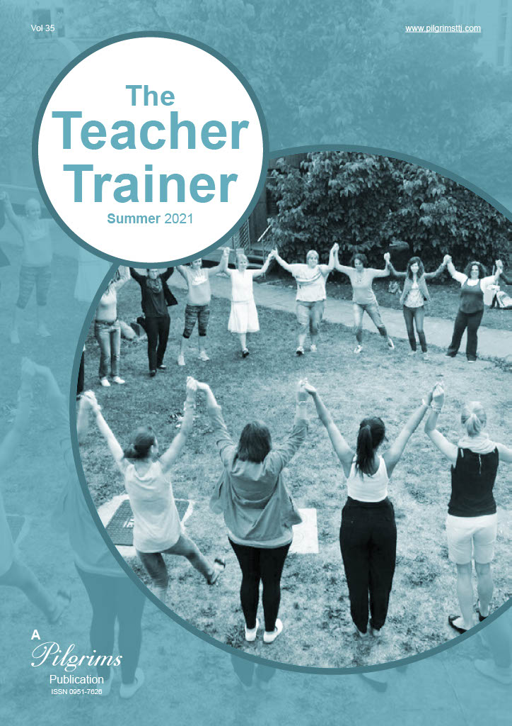

I am very pleased to welcome you to the latest issue of the new digital Pilgrims Teacher Training Journal.
The latest issue of the Teacher Trainer Journal is now live via the usual link https://pilgrimsttj.com
To access the Teacher Trainer Journal click on the link to the journal. The first time you open the link you may see a site map. Click on continue and this will disappear and you will continue to the flip book version of the journal.
When you have opened the journal you can scroll back and forward through the journal pages. Any links in the articles or the references can also be accessed. If you are looking for the archive go to the menu on the top right-hand side of the page. For the time being, more recent issues of the journal are directly available at the bottom of this page in PDF format.
Enjoy and do share with your various networks when you can.
Phil Dexter
TTTJ Editor

