Twelve Top Approaches to Quality Teaching and Learning – Applying Inclusive Teaching and Learning in School Contexts

Phil Dexter, UK

Phil Dexter worked for the British Council from 1987–2019 as a teacher, trainer, project manager and since 2011 as a specialist in the area of special educational needs and disability (SEND) for the British Council English in Educational Systems team in teacher development and inclusive practices. Phil is now freelance and continues to support governments in projects supporting quality inclusive teaching and learning practices – most recently on the Teaching for All Project – embedding inclusive education in teacher professional development in South Africa. Phil is also editor of The Pilgrims Teacher Trainer Journal.
Email: phil.dexter@pilgrimsttj.com



Note

The text was originally published in the Teacher Trainer Journal Autumn 2022. Vol 36 no.2
Pilgrims Teacher Trainer Journal Autumn 2022

Introduction

In thinking about inclusive teaching and learning, good practice involves understanding but also moving beyond concepts such as special educational needs and disability (SEND) or additional learning needs through a medical/clinical paradigm. In supporting teachers, a practical model of support from an educational and learning perspective is one way that teacher educators can give practical advice to teachers. In this contribution, I am suggesting some ideas for how we can reframe the inclusion paradigm through a practical strategy which I call, “the top twelve approaches to quality teaching and learning”.

As this is aimed at teacher trainers and teacher educators, the format of this discussion is in three parts – firstly, some general background on what is meant by the difference between medical model thinking and social model thinking, looking at ways of redefining our thinking away from clinical based solutions to educational ones. Secondly, a description of the twelve approaches, modelled as slices of a “pizza”, and how they work, and thirdly some examples of activities based on the twelve approaches. It is not possible to cover all twelve approaches, though I hope there will be enough activities for you to be inspired to think of others that are appropriate in your context. While there is good research and practice into inclusive teaching and learning, all solutions need to be local and relevant to context. Given this, I am also not providing ready made answers – it’s for you to engage with “the pizza” in ways that are meaningful for you and find ways that you can support teachers in developing their thinking on how to apply and implement inclusive teaching and learning practices.

Background

To SEND or not to SEND – a positive dilemma in understanding inclusion and teaching/ learning inclusive practices

Inclusion has become a buzz word in education systems across the world and is highlighted in education policies and in curricula and syllabuses. Teachers often feel they have inadequate understanding, knowledge and skills. This is often because SEND needs and support are framed through a medical lens.

Understanding of the medical model and advocacy of the social model are fundamental to the notion of inclusion and why implementation of a social rather than medical models in policy and practice is the basis of a good practice approach. Medical models place the responsibility on the learner to conform to the perceived norm. Emphasis is placed on “helping” or “curing” people so that they can join their peers in learning – usually through classroom learning. The emphasis is therefore on the need for the learner to fit into existing systems, structures and pedagogies. This approach is based on an assumption that our systems and structures are basically “OK” and that we need to help others who are “not OK” to fit into the systems.

The Social Model applied to education and teaching and learning is a more positive learning focused approach in advocating inclusive practices. It starts from a strengths-based approach focused on what learners can do rather than what they can’t do! It also focuses on understanding the learner and learning differences. The emphasis is on the need to adapt current structures and pedagogies to better meet a diversity of needs. Typically, this could be through the provision of whole school training for staff or the introduction of additional resources to make classrooms more accessible and engaging for specific learning needs. The social model is essentially a social justice and rights-based approach where society positively evolves and changes.

Medical Model Thinking | Social Model Thinking
The learner is faulty | The learner is valued
Diagnosis and treatment | Focus on the removal of barriers
Labelling and categorising | Acceptance of the individual and individual differences
Inputs identified from diagnosis and delivered | Outcomes identified and planned towards achievement for everyone
Therapy programmes are central | Resources available in reaching everyone and towards achievement for all
Segregation and alternative services as well as different expectations of learning outcomes | Fully integrated services towards inclusion – though not a one size fits all approach as there are different models of inclusion based on different learning needs
Professional services identify the needs | Individual rights and needs are expressed
Isolation and exclusion predominate | Diversity and difference are welcomed and encouraged
Society remains unchanged | Society evolves

Figure 1: Difference in medical model and social model thinking
https://www.scope.org.uk/about-us/social-model-of-disability/

Redefining special education needs and disability (SEND) for educational contexts

Given an understanding of the above, we can look at redefining our understanding of approaches to special educational needs and disability (SEND) through a more inclusive paradigm for educational contexts and, in this way, support teachers in developing their confidence in delivering inclusive education.
SEND is based on medical model thinking. There may be at times the need for clinical interventions, however, in considering teaching and learning in schools, and also more specifically in English language teaching and learning, it is more helpful to redefine learners’ needs as follows:
Cognition and learning
This may include SEND categories or labels such as dyslexia, dyscalculia, dyspraxia, gifted and talented.
Behavioural, emotional and social development
This may include SEND categories or labels such as ADHD, social, emotional and mental health.
Communication and interaction
This may include SEND categories or labels such as autism spectrum, speech and language.
Sensory and/or physical
This may include SEND categories such as visual, hearing and physical or mobility needs.
Societal marginalising and exclusion factors
This goes beyond SEND categories and labels as such and may include gender inequality, social displacement due to movement of peoples and other factors such as different models of families, culture and those factors external to school that may impact on learning and achievement.
Developing an inclusive language learning environment in schools

There is a long tradition in English language education of using learner-centred methodologies, such as communicative language teaching (CLT) or a task-based approach. These methodologies, which rely on student-to-student communication, foster collaboration and cooperation between learners. When it comes to developing inclusive practices, English language teachers can often build upon the CLT training they have already received and the teaching skills they have already developed in the classroom. In essence, good practice in teaching and learning is good inclusive teaching and learning! One way of working with this good practice approach is through “the top twelve approaches to quality teaching and learning”.

The top twelve approaches to quality inclusive teaching and learning

The top twelve approaches to quality inclusive teaching and learning are in the form of a pizza showing twelve different aspects of inclusive practices or “slices” of the pizza – see the image below. This pizza is not intended to be a recipe or “magic solution” for success, but rather examples of what might work. Working with the pizza, teacher educators can work with teachers in trying out ideas in their own settings and decide for themselves if they might work well. Inevitably, they will require adaptions for context as appropriate. The different slices are, though, interconnected.

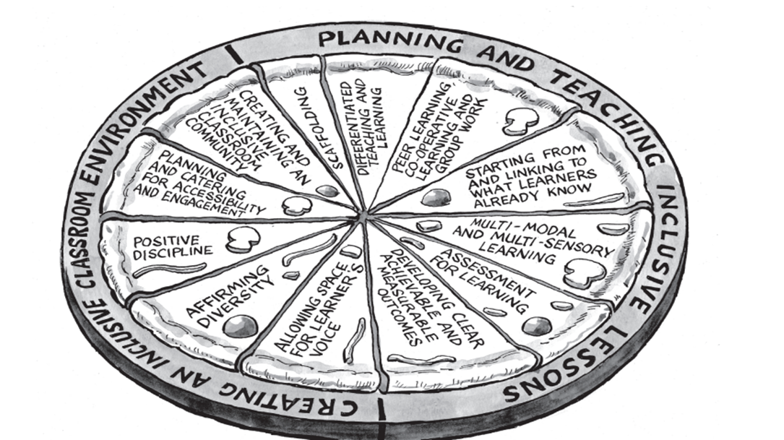

Figure 2: The top twelve approaches to quality inclusive teaching and learning https://www.britishcouncil.org/partner/international-development/news-and-events/nov-2017/teaching-all-mainstreaming-inclusive-education-south-africa#:

The twelve approaches

The twelve approaches can be subdivided into:

1. Planning and teaching inclusive lessons and
2. Creating an inclusive classroom environment.

However. I’m suggesting one way of doing this and you may have your own view of this subdivision.

1 Planning and teaching inclusive lessons

Scaffolding

Scaffolding involves promoting confidence and providing achievable and reachable aims. Scaffolding also promotes a concept of “learning for understanding” and approaches that encourage learner/learning independence in a supportive and understandable way. Scaffolding is not only about “structuring”, but also about providing the space within the structure for learning to happen.

Differentiated teaching and learning

Differentiation is supported by scaffolding and involves providing appropriate learning routes for everyone based upon their learning needs, while focusing on achieving similar outcomes. There are different ways of differentiating – adapting the task itself, using different tasks, different types of content and different ways of responding to tasks. There are lots of different types of differentiation, many that the teacher can do – but perhaps the most effective differentiation is where learners have a range of options and they, in fact, choose the differentiation.

Peer learning, cooperative learning and group work

Peer learning involves learners learning from each other and promotes interpersonal skills, collaboration, increases confidence and improves learning outcomes. Cooperative learning involves working together in group work to accomplish shared goals.

Starting from and linking to what is already known

This involves starting from what is already understood or from an area of interest and what needs to be understood for deeper learning in meeting a learning aim. This is sometimes called “a constructivist approach to learning”.

Multi-modal and multi-sensory learning

Most people learn through a combination of linguistic, verbal, visual, auditory or kinaesthetic channels, though most have a preference. When we integrate multi-modal approaches, we are supporting an inclusive approach. The importance of multi-sensory approaches is that they allow for a range of options in reaching learners. If content is only delivered through a single sensory channel, then we are less likely to meet both individual and group needs.

Include assessment for learning

An inclusive learning assessment approach starts from an “assessment for learning” rather than an “assessment of learning” approach. It is collaborative between learners and teachers and based on a concept of positive affirmation of what someone can do rather than what they can’t do.

2 Creating an inclusive classroom environment

Allowing space for the learner’s voice

In considering the learner’s voice, we are concerned with the experiences of the individuals participating in learning. How can we allow appropriate time and space for learners to make connections between learning and their own experiences, and express these?

Affirming diversity

Affirming diversity is primarily concerned with understanding that we are different and have different ways and preferences in how we learn. Affirming diversity also involves ensuring positive contributions from everyone, whatever the learning differences and difficulties and where special educational needs may have been noticed and identified. This, of course, links with creating and maintaining an inclusive classroom community where the unique contribution of everyone is valued and expressed through materials and resources and also represented through visuals, texts, images, audio, etc. Encouraging learners to engage in a variety of ways in their learning is affirming diversity.

Positive discipline

This may involve understanding the underlying reason for any behaviour, developing and teaching predictable classroom routines, being consistent in responses, giving clear feedback and positive praise, creating norms for emphasising collaboration and cooperation.

Plan and cater for accessibility, access needs and engagement

Accessibility is concerned with ensuring that physical conditions allow for inclusion and equality of access to learning. This may involve issues regarding the room layout and how to ensure that the physical space does not become a barrier to learning. This may also involve access via technology. Access needs are much more related to addressing the specific needs of the individual to support learning. For example, for learners with visual impairment, use of braille versions or screen readers may be supportive. For dyslexia support there are dyslexic-friendly fonts. Also, resources for individuals with speech and language difficulties are available.

Creating and maintaining an inclusive classroom community

This involves creating a safe, welcoming classroom. In a welcoming classroom, every learner will be able to learn and develop in their own individual way and feel equally valued for their contribution. This may not strike you as important, but it certainly is! The way you make your learners feel in your class will directly impact the way they learn.
Developing clear and achievable measurable outcomes

A learning outcome-based approach will ensure that everyone can positively participate, and learning can be measured according to appropriate and agreed criteria. Everyone works to agreed learning outcomes – perhaps taking different paths or routes depending upon the learning needs identified. A good place to start is with what learners “can do”. Beginning with learning intentions may be a better place to begin than learning outcomes.

Now let’s look at some of the tasks that can be used to implement the twelve approaches.

Creating and maintaining an inclusive classroom community

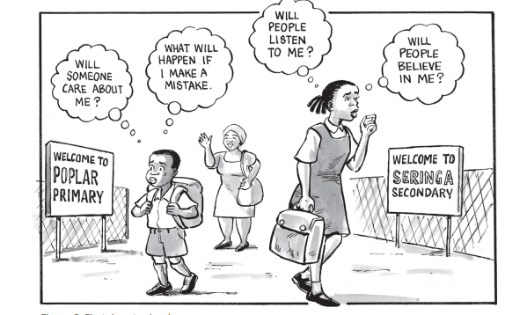
Thinking about the classroom as a community is a major part of creating the learning environment. The term “learning environment” is used broadly and includes the physical space; the resources and teaching methods used; the cultural context; and the educational approach.
Task
How could you develop an inclusive classroom community? How do you go about developing this sense of classroom community? Which type of environment would you aim to create as most conducive to inclusive education.
What values are likely to be important? Complete the table below and discuss with others.
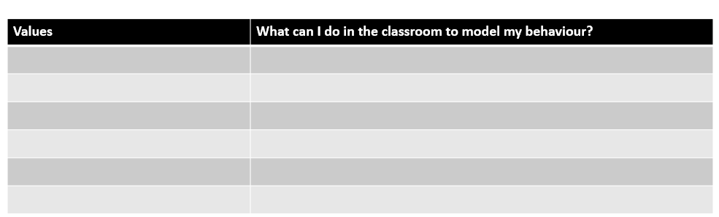

Planning and catering for accessibility and engagement

This strategy refers to the environmental conditions that may need attention for individual learners to be able to gain equitable access to learning. You may need to make adjustments to:

• Classroom layout, e.g. furniture, seating, seating plans
• Materials provided, e.g. presenting content and tasks through worksheets and technology, assistive technology.

Remember, these adjustments are the starting point for equity. They give the learners the means to progress at the same rate of learning as other learners, but they don’t guarantee progress; that is dependent on how learning and teaching happen in your classroom.

The physical environment of your classroom contributes greatly to your learners’ ability to learn. Even in a full class with limited resources there are creative ways to arrange your classroom to ensure that your learners can move around, interact and engage fully in all learning opportunities.

Reflect on what you are trying to accomplish and make your space work for you rather than against you. Also bear in mind that learners with specific learning needs may require particular placement in the classroom to increase visibility, improve access, or minimise distractions. For example, in a large class, a hearing-impaired child or one who struggles to concentrate may find it difficult to focus in a noisy class if seated at the back of the room.

Here are some guiding questions that can be used when planning your classroom arrangement:

Visibility

Are there areas of the classroom where learners cannot easily see the board or screen? If so, consider using these areas for small-group work or storage. Arrange your room so you can have eye contact with all your learners, and make sure that each learner is able to see the board.

Proximity

Can you easily reach each learner in the room to provide extra instructional support? Can you circulate round the classroom during whole-class teaching? Keep proximity between learners in mind as well. Can learners easily move into peer groups when necessary? One way of ensuring this is to arrange the desks in two loops — an interior and exterior loop. This arrangement gives you proximity to all learners and allows learners to move into peer groups easily. In a subject-specific classroom, where learners may need to share equipment and work easily in pairs or groups, you might consider the arrangements below.

Here are some classroom layouts – how might they contribute to supporting accessibility and engagement in learning?
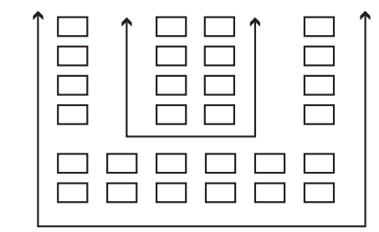
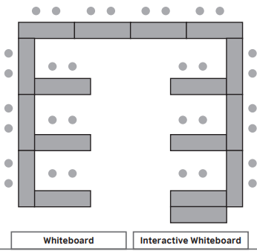
Figure 3: Classroom layouts supporting different learning tasks

Visualise a typical classroom you have taught in by drawing the classroom layout. Determine the grade and subject (if applicable). Draw the layout you think will work best to meet the following requirements:
• All learners can see you and the board
• Learners can easily move into groups for group work
• Activity or workstations are included
• Materials and resources are easily accessible
• Wall space is utilised well
• Individual learners are seated in ways that best support their learning

Task

How will the layout contribute to positive learning? You may wish to draw an alternative layout and explain how it will support inclusive teaching and learning.

Developing clear and achievable measurable outcomes

Look at the Assess-Plan-Do-Review model which is one way we can constantly review and improve our classroom practice. An explanation of each “stage” is given below. Consider what this means for inclusive teaching and learning practices.

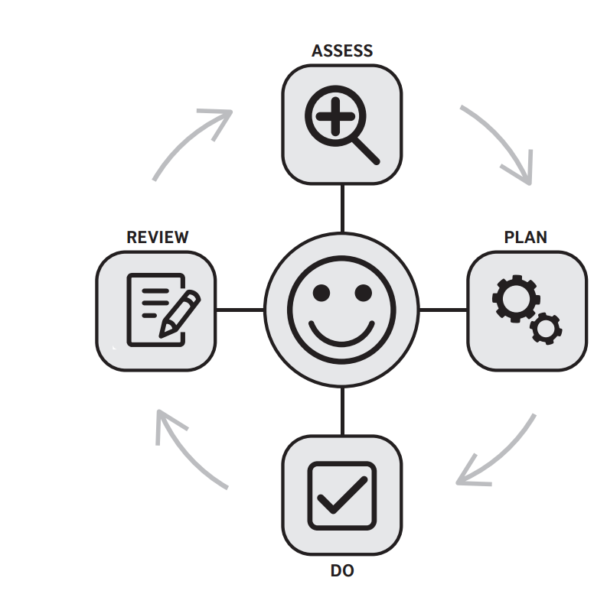
Figure 4: A model for effective lesson planning, lesson delivery and reflection

ASSESS–PLAN–DO–REVIEW
Use the “Assess–Plan–Do–Review” cycle to constantly review and improve your classroom practice.

Assess

Assessment relates both to your teaching and your learners’ learning. Teacher can be assessing learners informally and getting to know them better all the time. This will inform the way lessons are planned. What are you noticing about how you teach? Does your teaching facilitate effective learning? What part of your practice do you think needs attention? What do you hope to achieve as a result of making the change?

Plan

Which approach is best to help you make this change? What can you do to introduce the approach gradually so that it will make a difference to your practice without overloading you? How will you use the approach in your lesson/s — when and how will you use it, what will you need to say and do, what resources do you need to prepare, what organisational arrangements do you need to put in place? You may plan to try the approach in one lesson or in a series of lessons, depending on your context.

Do

Put your plan into action by trying out the approach in your lessons.

Review

Reflection is key to learning. Remember, you will be moving from conscious incompetence towards conscious competence (and eventually unconscious competence). This can be an uncomfortable journey, and mistakes are inevitable. Reflection on your experience, though, will help you to improve. Questions you could ask are:
- What went well?
- How can I build on what went well?
- Where were the challenges?
- How did I, or could I, overcome these?
- To what extent did I achieve the changes that I hoped for — both in relation to my practice and to my learners’ learning?
- What could I do differently next time?
- Does reflecting on this point bring up any other areas of practice that I think might need attention next?

Task

Work with teachers in thinking of a class they have worked with and a subject they have taught, Make a plan outline using the assess-plan-do-review framework. Outcomes, are, of course, not just final end state outcomes. Consider how what you are planning promotes inclusive teaching and learning practices.

Starting from and linking to what learners already know
Look at the model below for four levels of competence and ask teachers to think about which level they consider they are at in understanding and applying inclusive teaching and learning practices.
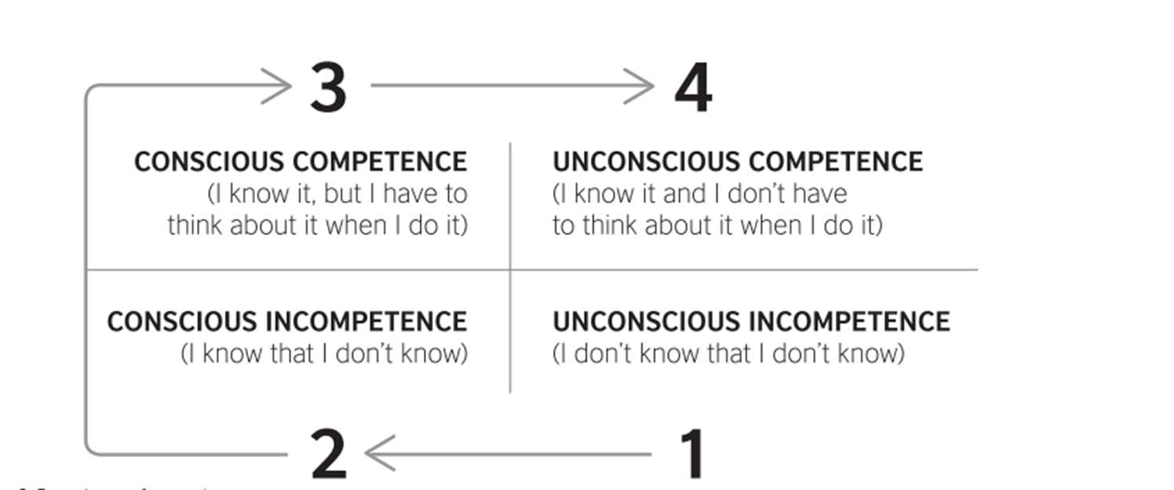

Figure 5: A four level learning competence model for stages of learning

In thinking about where teachers might place themselves, has anything changed now they have engaged with inclusive teaching and learning practices and used “the pizza”? If so, ask teachers how they are feeling about changes in their competence? Where did they begin and where do they believe they are now? What has brought about this change? Of course, teacher educators can think about this, too. Even if they started at the “unconscious incompetence” stage it is very unlikely that someone starts from “knowing nothing”. How can we link what they do know – even if it is rather limited – to what they need to know and learn?

When teachers are trying out different strategies of the pizza, they will be going through a learning process. We can look at all four-stages of the learning process. In learning anything, we are developing skills and knowledge and then we embed these skills and knowledge. It’s important, though, that we are able to reflect and consider how we are learning and what we need to do to ensure that that these skills are embeded. It’s worth remembering from Henry Ford, “If we always do what we’ve always done, we always get what we’ve always got.” If what we are doing is working, then let’s do more of that – if not, we need to try something else. The slices of the pizza are not separate but integrated – this takes us to look again at “clear and achievable measurable outcomes” and the Assess-Plan-Do-Review model.

You might like to work with teachers on this activity.

Here is an example of what is called a KWL or KWHL chart about animals in the North and South Poles:

What do I know? | What do I need to know? | How will I find out? | What have I learnt?
Polar bears and penguins live in very cold parts of the world. | What other animals live there? | A class project | See lions, birds seals live there, too.
Penguins can’t fly. | Do they all fight, or do they get on? | Do my own internet research | Penguins only live at the South Pole and polar bears only live at the North Pole.
Emperor penguins are the biggest penguins. | Are there different sorts of polar bears? | Find out what others in the class/school know. | There is only one main type of polar bear but lots of different penguins.
 | Can all of these animals swim? | TV programme

Figure 6: Example of a KW(H)L chart

This activity can give you experience of working with a KWHL chart. Think of a topic more relevant to your context in teaching and learning. Complete the chart.
What do I know? | What do I need to know? | How will I find out? | What have I learnt?

Figure 7: A KW(H)L chart for participant completion

Task

Reflecting on your learning, you might like to make notes here on how you have used this slice of the pizza.

Scaffolding, differentiation, and multi-modal and multi-sensory approaches

This is an approach to engage with the slices of the pizza in an even more integrated way as all of these slices strongly interconnect.

What is scaffolding?

In construction, a scaffold is a temporary structure that is erected around an unfinished building, supporting the structure until it is sufficiently stable to stand on its own.

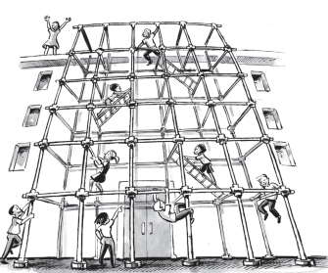

Figure 8: Understanding scaffolding

If you’ve learnt to ride a bike, you’ll remember that someone probably helped you at first, by holding on to the bike and then letting go as you became more confident. Scaffolding in teaching is similar to this, and to the scaffolding used in building construction. Instructional scaffolds are temporary support structures teachers put in place to help learners in mastering new tasks and concepts they can’t master on their own. A teacher can build supports based on what learners already know, as new skills or concepts are introduced. As they work on tasks, learners become less dependent on these support structures, which can be removed gradually.

A teacher using scaffolding might break down a lesson into a series of “mini-lessons”. The first mini-lessons might contain more scaffolded support, for example:

- Building on prior knowledge and learner experience
- Modelling what the learners need to do or achieve
- Breaking down the learning into steps (often called “chunking”)
- Giving step-by-step instructions
- Providing cue cards (reminders of key information that learners need to reach the learning outcome, including vocabulary, sentence starters, formulae, questions for discussion)
- Encouraging use of first language in discussion or thinking processes to increase understanding
- Pre-learning vocabulary needed for later in the learning
- Using graphic organisers
- Using visual cues like gestures, pictures, diagrams
- Using short excerpts of a longer text as a basis for discussion — the longer text is introduced later in the learning process
- Verbalising the thinking process while solving a problem (sometimes called “think-alouds”)
- Giving hints — suggestions and clues, e.g. “Maybe add the water before the acid”, “How about starting that sentence with ‘As a result …’?”
- Giving time to practise chunks of learning before moving on to new chunks. As the “mini-lessons” progress, the teacher reduces the amount of scaffolding and gradually hands over more independence to the learners as their confidence grows.

What is differentiation?

Differentiation is a bit different (but will likely include scaffolding) in what teachers and learners do. Teachers create the conditions and environment for learners to make choices, so increasing their: ownership of learning; agency; decision-making; and independent learning skills.

Learners may encounter a range of challenges throughout the learning process. These might arise from:
- curriculum content and language
- classroom organisation
- teaching methodologies
- pace of teaching
- lack of time available to complete the curriculum
- teaching and learning support materials and assessment.

The overall aim of differentiation is equity: ensuring that everyone in the classroom can equally take part, and succeed, in learning. A strong inclusive approach for differentiation that supports equity is one where everyone works towards the same learning outcome, but learners are given choices about how they respond, either within a given medium or by being able to choose from a variety of media.

Implementing differentiated teaching and learning

Many models of differentiation have been developed over the years, each with its unique range of strategies. Carol Tomlinson and Tonya Moon (Tomlinson & Moon, 2013) use this diagram to explain their concept of differentiation:
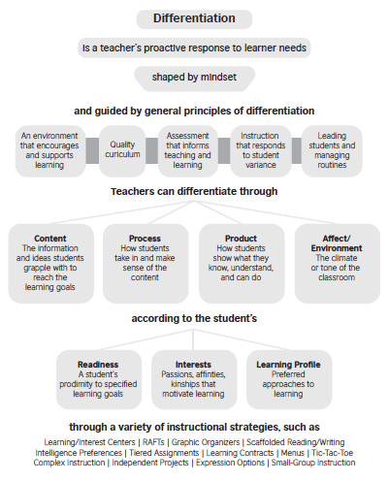
Figure 9: Understanding the principles of inclusive differentiation

Let’s focus on just one aspect of Tomlinson and Moon’s differentiation implementation model:

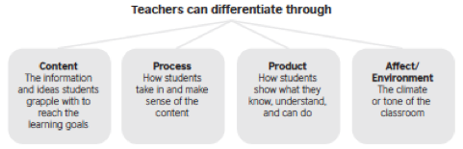

Ask teachers to consider these four areas of Content, Process, Product, Affect/Environment. Ask them to note down as many ideas for making differentiation happen in each area. Use a table like the template below if this is helpful.

I can differentiate ... | How can I differentiate in these areas?
Content
Process
Product
Environment

Figure 10 below is a worked example:

I can differentiate ... | How can I differentiate in these areas?
Content | I can include relevant images that support text in my materials.
Process | In maths, I can give students a choice of how they practice addition – for example pen and paper, using fingers, using bottle tops.
Product | For a language comprehension exercise, I can give learners a choice between writing what they understand and drawing a series of pictures.
Environment | I can make it clear that different ways of learning are valued through feedback to the whole class.

Figure 10: Examples of differentiating strategies in a classroom

Now consider what learners can do themselves in applying differentiation.
I can differentiate ... | How can I differentiate in these areas?
Content
Process
Product
Environment

What are multi-modal and multi-sensory approaches?

A mode is a form of communication, for example, visual, speech, audio, text, movement, digital. A multi-modal approach is one that includes more than one mode of communication in the way that:
- teachers present their information to learners.
- learners make meaning of and learn this information.
- learners present their learning as a product.

Recent advances in technology mean that we are increasingly exposed to multi-modal forms of communication. These forms of communication have also led to shifts in communication itself, for example, through emojis and gifs. As teachers of learners who are growing up with ever-increasing exposure to more sophisticated multi-modal forms of communication, using multi-modal approaches in the classroom is important as a way of maintaining learners’ interest and attention.

A multi-modal approach can also bring other positive benefits for learners. For example, by combining modes, the range of ways in which learners can access information is increased, and learning is more likely to “stick”. In addition, complex concepts can often be explained more effectively by using different modes of communication.

Traditionally, teaching focuses on the use of two senses — sight and hearing. Learners read text (sight) and listen to the teacher (hearing). As we have seen, not all children learn effectively using only these two senses. Some learners may even experience difficulties with visual or auditory processing.

A multi-sensory approach to teaching encourages opportunities to engage more than these two senses in learning. It gives learners more than one way to make connections and learn concepts. If learners engage with information using more than one sense, the information is more likely to stay with them.

Choice boards

Multi-modal and multisensory teaching and learning is essentially about choice.

A choice board is therefore a good way of giving options for learning. Choice boards give learners the power to choose how they will demonstrate understanding of a particular subject or concept. This freedom encourages learners to be more responsible, accountable and independent, and to discover the learning for themselves. They are also able to work on the activities at their own pace. The boards also use learner interests and preferences to stimulate active learning and learner engagement.

Here is an example of a choice board menu for which the class have been reading the same story:

A choice board menu: Reading
Draw a picture of the main character. | Perform a play that shows the ending of the story. | Write a song about one of the main events in the story or a character. | Write a poem about two main events in the story.
Make a poster that shows the order of events in the story. | Show your understanding of reading by designing a scene with models or the use of lego or similar material. | Name and draw a person you know who is like one of the characters in the story. | Create a Venn diagram comparing and contrasting three characters in the story.
Use a sequence cartoon or a timeline to describe at least six events in the story. | Write the story based on the reading. | Make a digital presentation. | Write a new ending for the story.

Figure 11: Example of a choice board

Tips for designing a choice board

- Identify the core concept or learning goal that the learners need to understand/achieve.
- Plan activities so that the choice board provides learners with a variety of ways of learning the concept.
- Identify learners’ interests, preferences and levels of readiness.
- Design the activities at different levels of complexity and arrange them on the board in an increasing order of difficulty.
- Give additional instructions for each task, including whether to complete the task individually, in pairs or in groups.
- Make one or more squares a “free choice”.
- Include a variety of ways through which learners can make meaning — writing, drawing, talking, acting, making music, making up a game, etc.

Now ask teachers to choose a grade, subject and topic of their choice and design a choice board applying a multi-sensory approach.

A choice board menu:
Assessment for learning
Assessment of learning is the traditional way of testing a learner’s knowledge. It involves an assessment, usually by the teacher, of what the learner has learnt so far. It occurs at the end of the learning module, week, term, year. It is summative, which means the learner’s mark is taken as an evaluation of their learning.

Assessment for learning (AFL) is a collaborative process between the teacher and their learners. It involves the learner in identifying what they already know, and enables them to take an active part in assessing: a. their progress, and b. what they still need to do to improve against their own goals and not against the results of others.

AFL is formative and guides learners to set their own goals. It is primarily concerned with supporting learning and therefore focuses more on progress than “end” assessment (whether this is at the end of a week, term or year). However, AFL strongly contributes to developing skills for end assessments.

A main issue in understanding assessment for learning is the ingrained concept of “normal”: the bell curve.

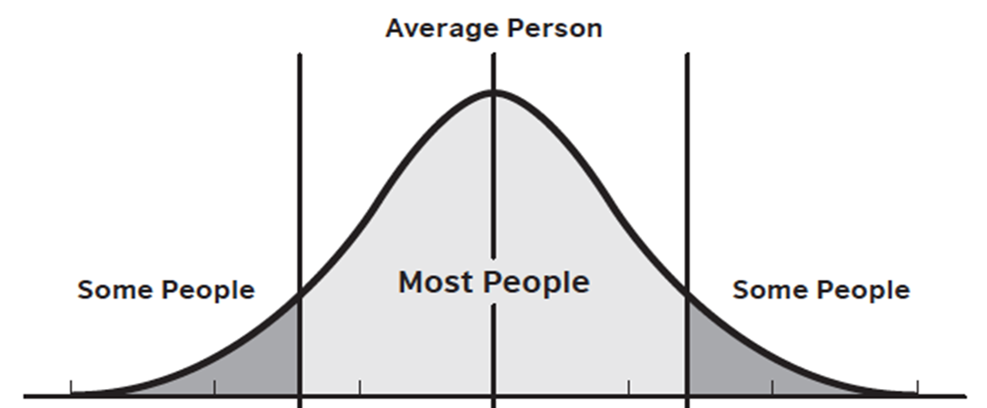

Figure 12: Explaining the bell curve and standardised testing

“So many people believe that the bell curve represents the way things are in nature, the idea of a normal distribution has become naturalized in education.”
(Fendler, L. and Muffazar, I. 2008)

In understanding and applying assessment for learning, we can begin to change our thinking about standardised testing and how this relates to inclusion and exclusion in education.

Show teachers this cartoon and ask if this is a reality in their context? What are the implications of this?
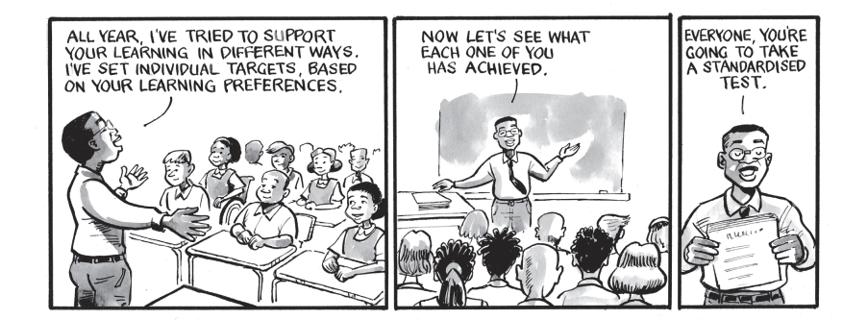

Ask teachers: “What are the main differences between assessment of learning and assessment for learning?” They can summarise these in the space below to share with the large group.

Implementing assessment for learning

There are some key changes in thinking to be made to move from assessment of to assessment for learning, as this table shows:

From assessment OF learning | To assessment FOR learning
Assessment that is disconnected from teaching and learning | Assessment that reflects the curriculum and what is taught
Assessment in one-size-fits-all formats | Flexible ways of getting the information, knowledge, understanding and skills that show what the learner can do
Learners are not aware of what they are being assessed on | Learners know what they are expected to demonstrate
All assessments and assignments count towards marks | Some assessments and assignments count towards marks and others are for formative information for both teachers and learners
Learners are passive participants in the assessment process | Learners understand assessment as part of their learning experience
Learners are not aware of what they are good at and what they need to work on until they get their marks | Learners are able to identify their strengths and areas for development and improvement

Figure 13: The difference between assessment of learning and assessment for learning

To help make this change and design effective AFL in an inclusive way, there are some key guiding questions you can ask yourself when planning:

- What forms of evidence would enable learners to show what they have learnt?
- Am I excluding anybody from being able to show what they have learnt with these forms of evidence?
- How will I collect this evidence?
- How will I evaluate this evidence?
- How will I record this evidence?
- How will I use the evidence to inform my future differentiation of teaching and learning?
You can also put yourself in the shoes of the learner when designing AFL, by asking:

- What am I learning today?
- Why am I learning this?
- How will I know that I have learned it?

You can also encourage learners to ask themselves these questions, as they will help learners be really clear about their learning and how to assess their own progress.

In the same way as teachers plan differentiated learning in inclusive classrooms, they also plan differentiated AFL. Here are some strategies to use when planning differentiated AFL:

- Utilise technology, assistive devices or make other arrangements to enable all learners to participate in assessment tasks.
- Vary the form of assessment (e.g., printed text, visual or auditory representations; written tasks; oral responses).
- Encourage self-assessment: Learners gain skills to self-monitor, recognise their learning needs and answer questions such as: “What do I know?” “What do I want to know?” “Where am I now?” “Where am I going?” “How can I close the gap?”
- Use peer assessment: Learners learn from their peers who generally speak a language they can easily understand. Give differentiated assessment options so that learners can choose tasks at the right level for them, for example:
- incorporate a range of assessment questions of different complexities
- create multi-level or tiered assessments, for example, in geography, locate provinces on the map, or locate provinces on the map and identify the main city in each province
- individualise the timeline for completing a task.

Does all assessment when focused on assessment for learning have to be “academic”? What about including …?

Personal and non-academic quality that can be measured – not usually assessed

compassion cooperation courage creativity determination
empathy and compassion endurance humour leadership persistence reliability resilience sense of wonder spontaneity

Ask teachers to select a learning outcome relevant to their subject and context. Ask them to design a small, multi-level assessment task that supports the learning of all learners in the class. They can consider the following in their planning:
- How can you ensure that the learning is demonstrated in ways that acknowledge the achievement of every learner?
- What can you do to make sure that everyone can participate and no one is marginalised?

Use the space below to design your assessment task. Of course, we can link back and integrate with the “Developing clear and achievable measurable outcomes” pizza slice.

Conclusion: How do we use the top twelve approaches to quality learning and inclusion?

In conclusion, let’s look again at the pizza and how to use it.

The top twelve approaches make a large pizza and eating all the slices at once will likely lead to “indigestion”!
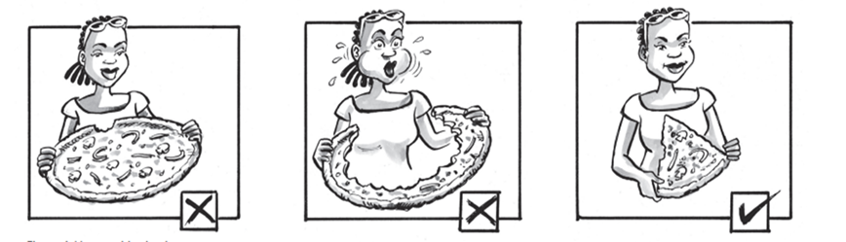

Teachers can take a slice at a time and explore these areas for themselves in their classrooms – which could be through a training workshop/online event, doing some reading around the issue, trying out ideas with learners, discussing issues in a classroom or on an online forum. This is all good practice CPD. It is important to understand that it is not necessary to work through the slices in a numbered linear way – any starting pointing that suits your context is possible.

Phil’s pizza suggestions

As mentioned above, my pizza suggestions are just that – suggestions. I hope you will like to work with teachers and support them in having a go so they might feel inspired to choose their own slices and perhaps all of them, eventually. The ideas and activities have to be yours and your teachers’ based on your context, though I hope you find this a helpful framework in understanding inclusive teaching and learning practices.

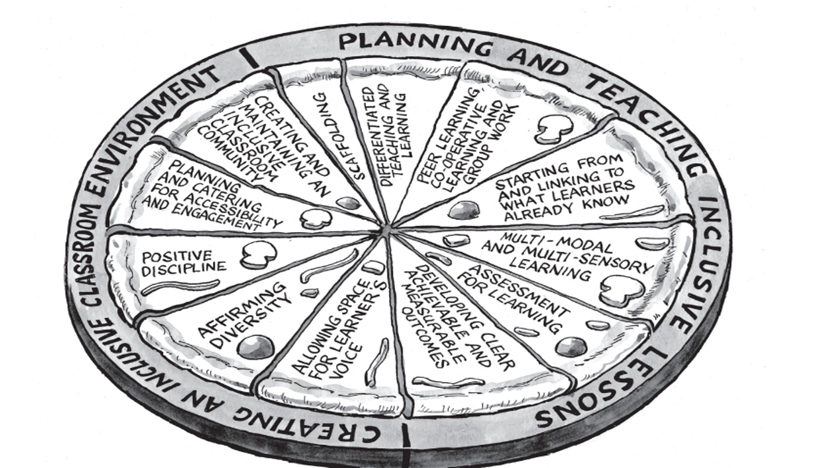

Figure 14: The teaching and learning pizza revisited

As a final word – the image below represents what inclusion is. Also, the slices of the pizza cannot be implemented all at once and teacher educators working with teachers and schools can make it happen if everyone is committed to having a go – and we will all learn. So have a go!

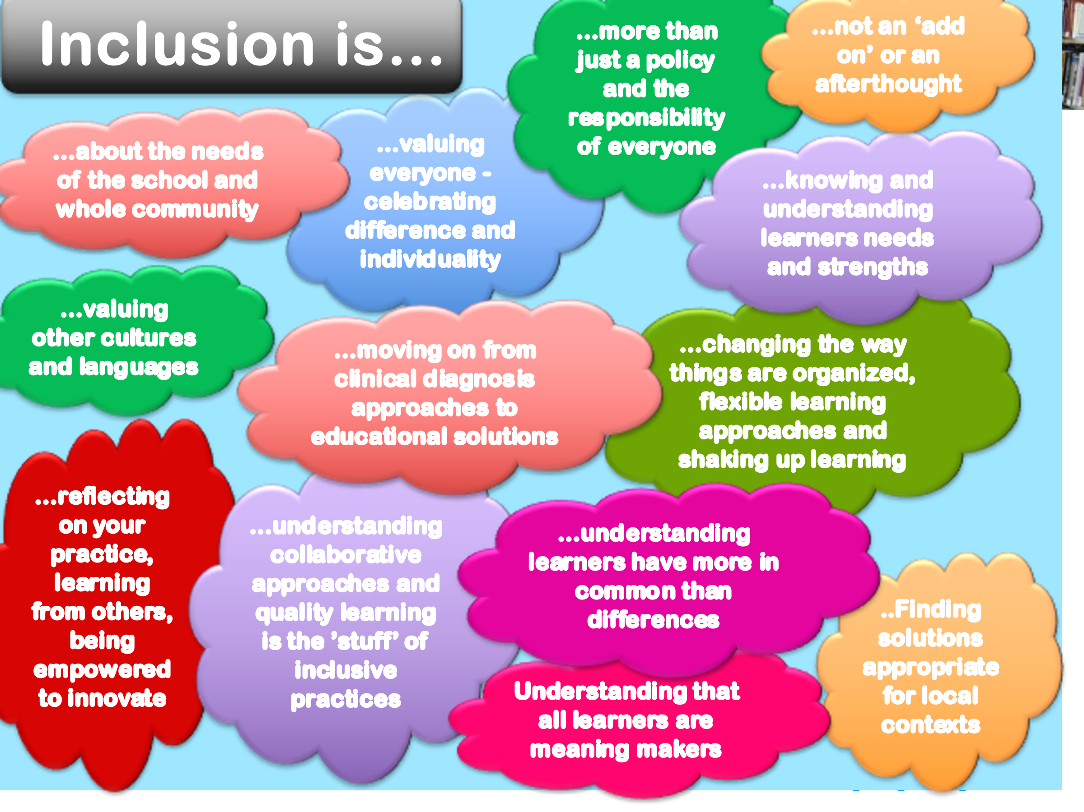

Figure 15: An overview of what inclusion in schools involves

References

British Council, (2017). Teaching for All – Mainstreaming inclusive education in South Africa. https://www.britishcouncil.org/partner/international-development/news-and-events/nov-2017/teaching-all-mainstreaming-inclusive-education-south-africa#

Fendler, L. & Muffazar, I. (2008). The history of the bell curve: Sorting and the idea of normal. Educational Theory. 58. 63–82. 10.1111/j.1741-5446.2007.0276.x.

SCOPE, (nd). Social model of disability. https://www.scope.org.uk/about-us/social-model-of-disability/

Tomlinson, C. A., & Moon, T. R. (2013). Assessment and Student Success in a Differentiated Classroom. Alexandria, VA: Association for Supervision and Curriculum Development.

Please check the Pilgrims f2f courses at Pilgrims website.

Please check the Pilgrims online courses at Pilgrims website.

