CLIL Teacher Training: The Theories Underpinning CLIL

Aleksandra Zaparucha, Poland

Aleksandra Zaparucha is a Geography and English teacher with over 30 years of experience in Geography and EFL teaching, teacher training, translating, examining and materials writing, including over 20 years of CLIL. For more information, check her CLIL Matters website at https://clilmatters.com/



The need for theoretical background

Every teacher trainer would agree that including a theoretical background in teacher training sessions is essential. Familiarising teachers with educational theories and practices would add rationale to what is happening in the classroom. Although studying theories might be viewed by (some) teachers and teacher training participants as boring, it may help teachers become more confident in their abilities and provide a sense of purpose and direction in teaching practice. Finally, it may help teachers stay up-to-date with the latest trends in education and direct them towards developing and using the best strategies and techniques available.
Considering the above, the question remains: How can teacher trainers accommodate all these needs without being prescriptive or lecturing? This question is especially crucial when we deal with CLIL teachers, specifically secondary ones, as they are used to dealing with the methodological specificity of their subjects. When engaging in CLIL, they must face a new approach to their day-to-day practice. Familiarising themselves with language learning theories, combined with a general theory of learning, may prove very helpful. The following sequence of tasks, practised several times with subject teachers in Kazakhstan, France, and the Netherlands, offers a potential solution to the above question and thus may satisfy both teachers and teacher trainers.

Teacher training session materials

For this face-to-face training session, the following materials should be prepared:
- enough of the copies of the texts on the three theories (Fig. 1),
- sheets of A3 paper,
- coloured markers.

Teacher training session procedure

On the day preceding the session on Theories in CLIL.

The participants are divided into three groups, A, B, and C, each assigned one text. Their task is to familiarise themselves with their text, highlight the most essential ideas, and prepare for a group discussion the following day. Time permitting, these two stages can be done in the classroom at the beginning of the session on Theories in CLIL.

1. Constructivism
Constructivism states that learning is an active, constructive process. The learner constructs new knowledge by building on prior knowledge and/or life experience. This active learning and problem-solving process initially needs support or scaffolding, which is gradually removed so learners can work independently.
Key principles of constructivism
- Active learning. Learners should be actively involved in learning and then apply new knowledge to new situations.
- Ladders of tasks. Learners should start with tasks that require lower-order thinking skills (LOTS), such as remembering or defining. They must use higher-order thinking skills (HOTS), such as analysis and evaluation, for deeper learning and understanding.
- Making learning fun. Learners need to be engaged and cognitively involved for learning to be effective.
2. Bilingualism
Bilingualism helps people learn a new language because the first language (L1) provides the framework for learning the second language (L2). The more advanced a language learner is in their native language, the easier learning the second language is. However, a learner needs to read or write in their first language to learn those skills in the second language.
Besides, studies show bilingual children:
- show a better understanding of the mind than monolingual children, e.g., in understanding the beliefs and attitudes of others,
- and are better at abstract thinking and self-regulation.
3. Second Language Acquisition
Second Language Acquisition (SLA) theory is about how people learning a second language (L2) use their first language (L1).
What SLA says about the input:
- the input given to learners needs to be meaningful, relevant and realistic,
- it should be at a slightly higher level than the learner's current level,
- learners understand more language than they can produce in the target language (L2),
- learners need to be exposed to L2 frequently, and they need time to process it.
What SLA says about the output:
- to learn L2, learners must produce it; by speaking or writing, learners notice the difference between what they can and want to produce,
- learners must be creative and make mistakes, as experimenting with language production is critical to learning it.
Fig. 1. Texts on the theories in CLIL

During the session on Theories in CLIL

Stage 1: Preparing mini-posters

Participants get into groups A, B and C, subdivided into teams of 3-4 for better communication. During the allocated time, they share their understanding of their theory and decide which three practical takeaways they would like to share with other subject teachers.
In the next step, the participants are regrouped into teams of three, each member representing a different letter: A, B, and C. If the trainer decides the participants need more support, these can be groups of six, with two members representing each letter, although group communication may be more challenging. The task is to teach other group members about their theory and the takeaways. Once the group discussion is finalised, participants are instructed to prepare a mini poster with a mind map representing all three theories with their non-linguistic (visual) representations.
The trainer elicits the takeaways and draws a simple mind map on the board (Fig. 2) or screen to support participants in organising their information. While doing so, the trainer can check their understanding of the theories and elicit the reasons for choosing specific takeaways.

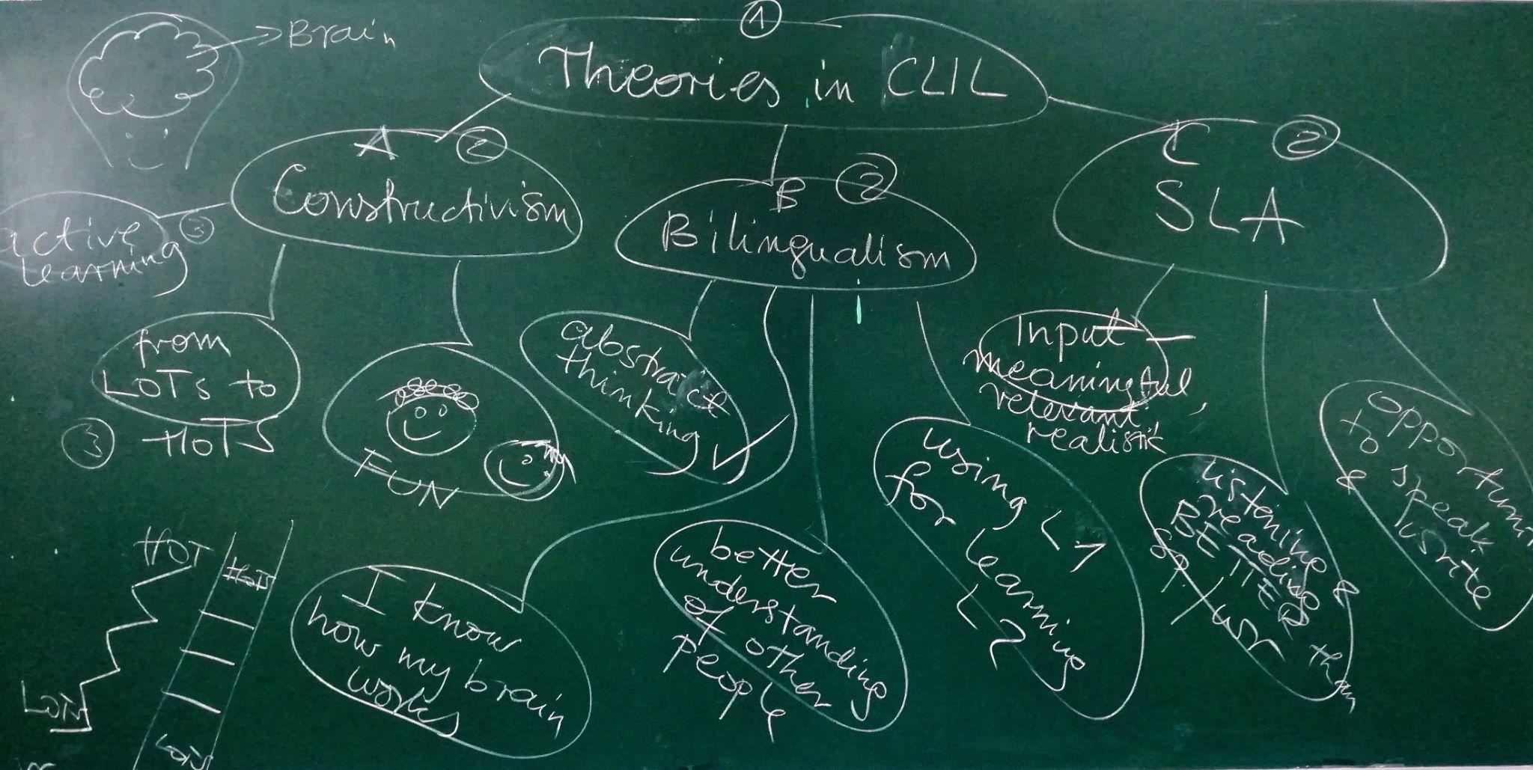
Fig. 2.

As the example posters in Figure 3 show, each group took a completely different approach to the task regarding the choice of colour, organisation on the page, and visual representation of ideas. It is also clear that more guidance would be needed in future instances of such a task, as there are multiple cases of unnecessary decorative elements (flowers and flowery patterns).
Once the mini posters are finished, they are displayed for everyone to compare.

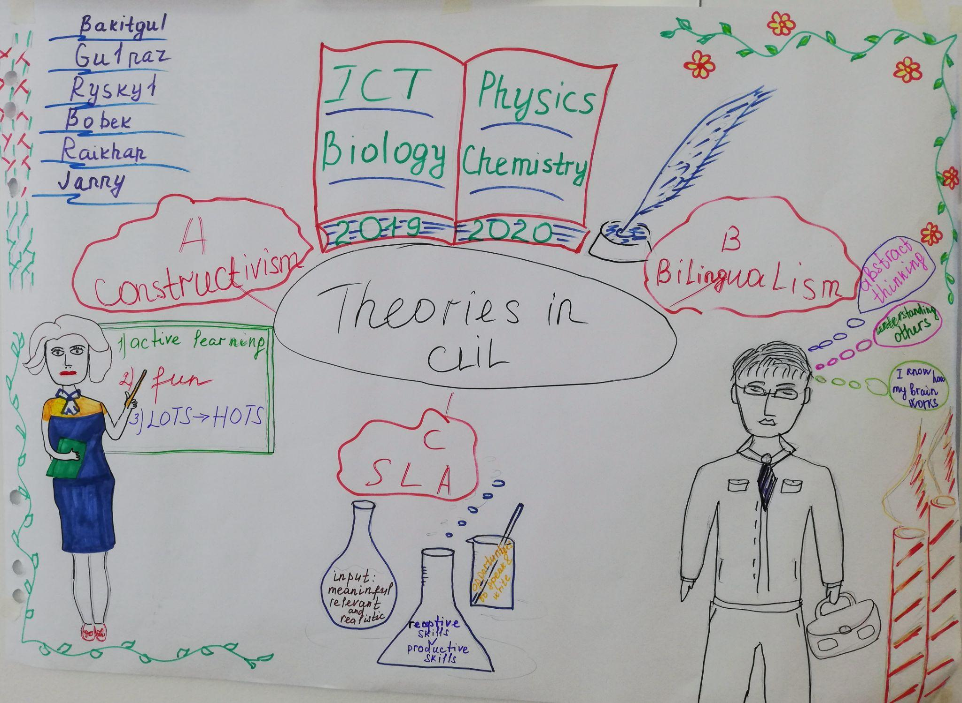 | 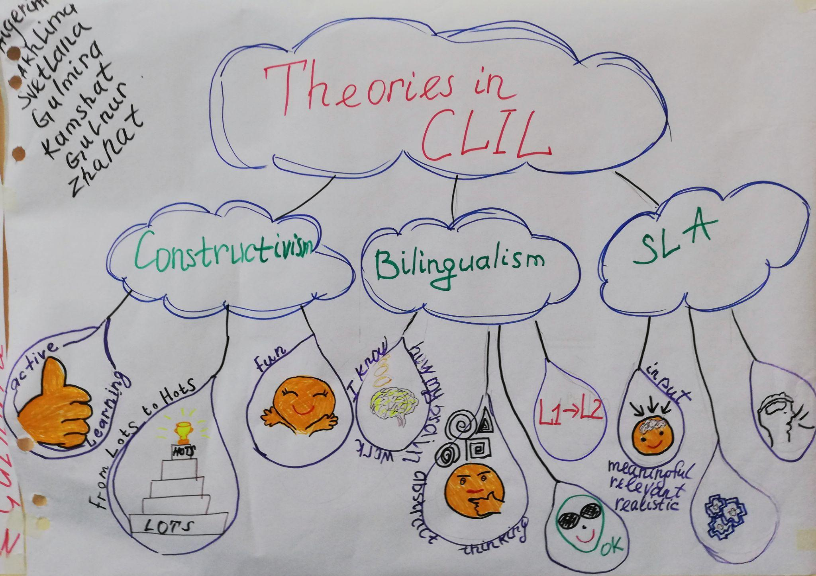
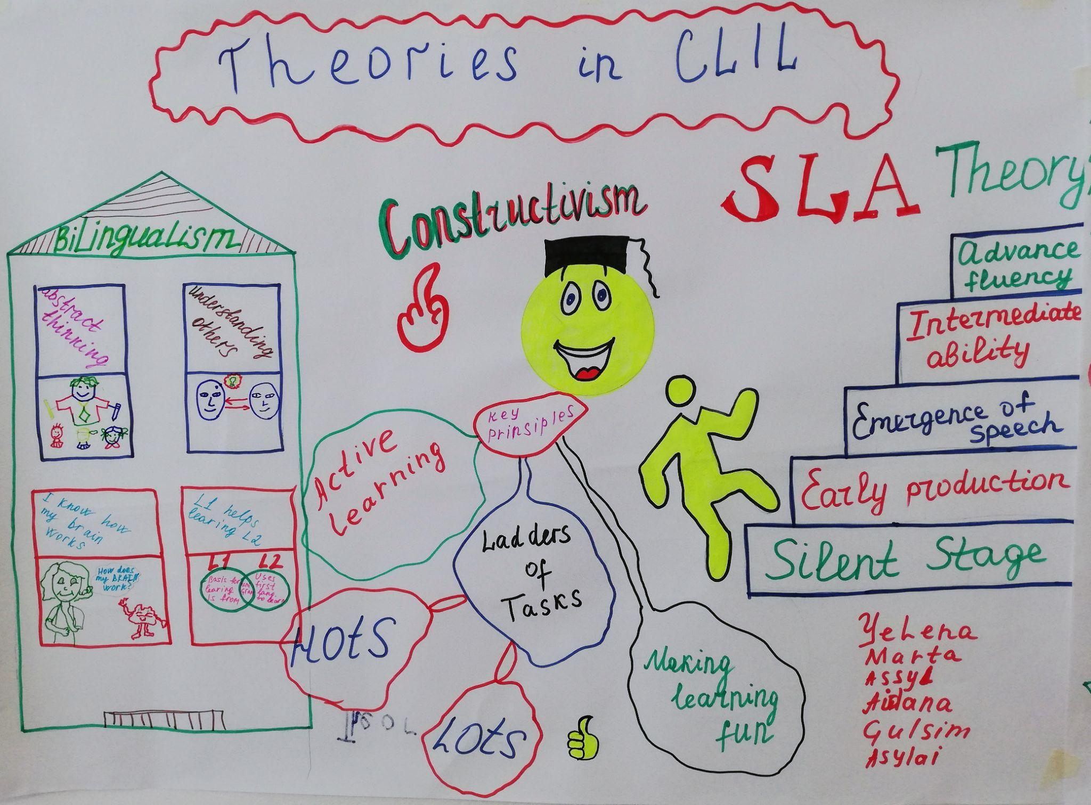 | 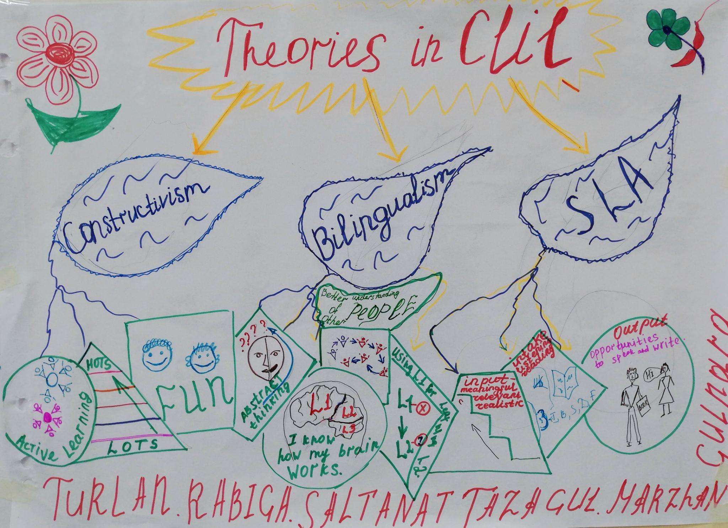
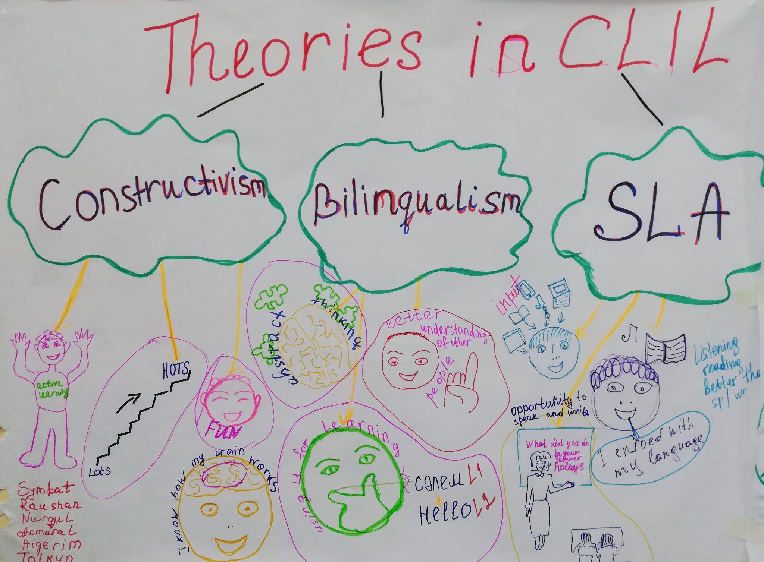 | 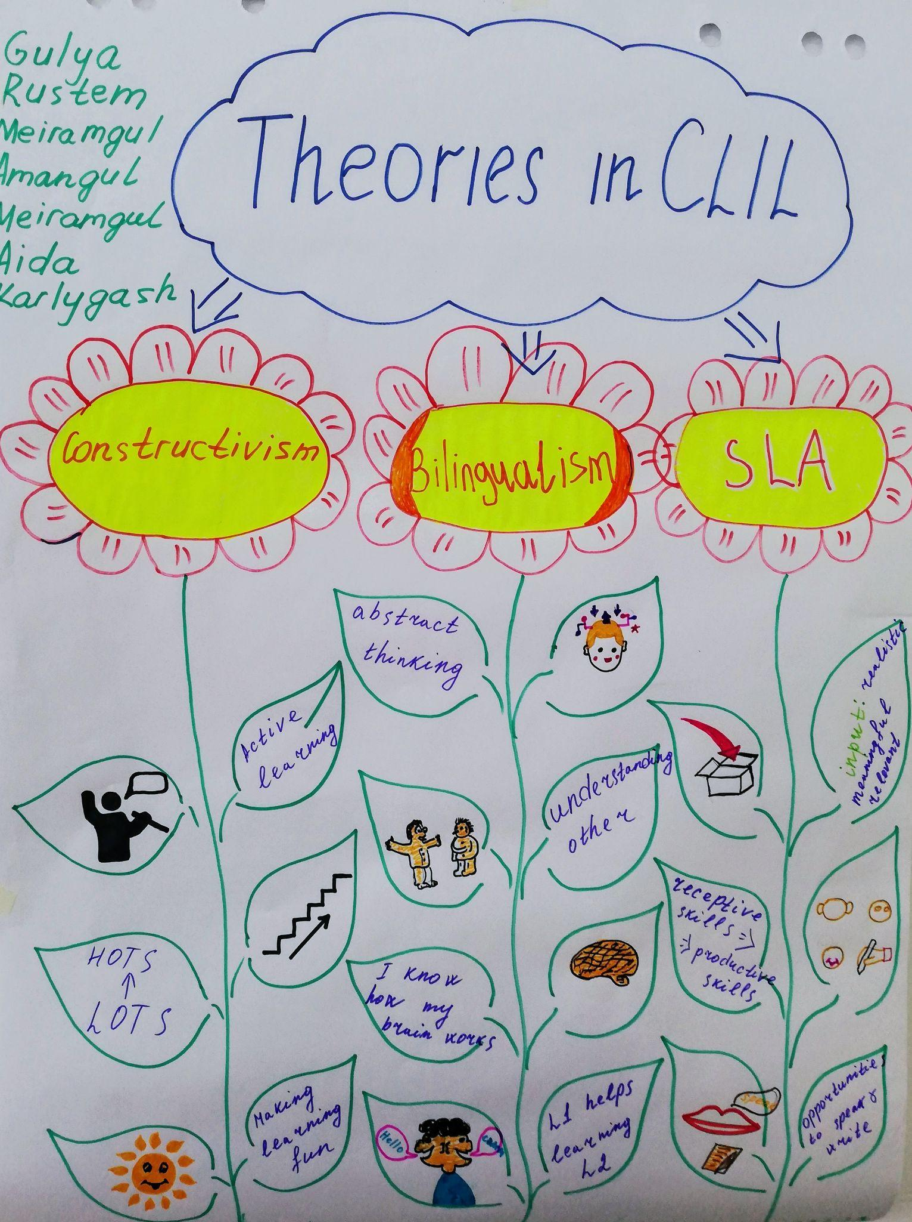
Fig. 3. Example posters made by CLIL course participants

Stage 2: Follow-up looping discussion

In the follow-up, the participants reflect on the takeaways from their texts, as visible in the posters and the need to include them in their lesson planning and delivery. This especially refers to the need to accommodate for increased student engagement and student-student interaction.
Finally, participants are asked to recreate the session stages and discuss their usefulness in their teaching practice. These may include the following: information gap (groups get different texts), flipped classroom (if selected, participants work individually on the given text the day before), rehearsal and discussion time while working in groups, regrouping strategies, teaching each other, working on one product as a group, importance of the visuals drawn by participants, comparing and contrasting posters (with the notion that the product is less important than the process).

Please check the Pilgrims f2f courses at Pilgrims website.

Please check the Pilgrims online courses at Pilgrims website.

