Student-generated Flashcards (SGFs)

Jamie Keddie, Spain


From the Editor
Twice a month, Jamie Keddie sends out the LessonStream Post – a story or storytelling idea for the classroom. It's free to sign up and you can do so here: https://lessonstream.com
Here is an example of what you might get…
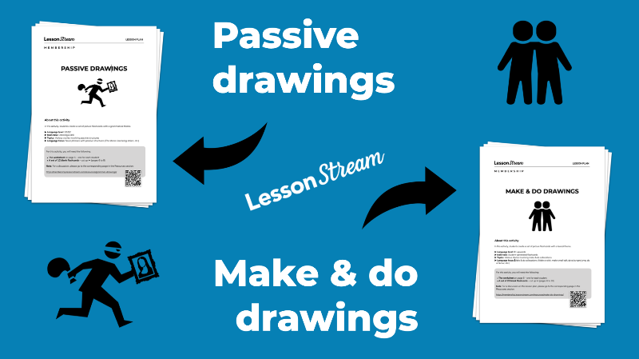
Every summer, I go to Norwich to run my Video, Image and Story course at NILE (Norwich Institute for Language Education). This is something that I have been doing since 2008. And over the years, I have accumulated hundreds of student-generated flashcards (SGFs).
SGF is a term that I first used in my book Images (OUP, 2008). The idea is simple – instead of using published sets of picture flashcards to teach language items, we get students to create their own.
Before I explain the reasons for doing this, let me show you some examples. Unfortunately, I am unable to credit the artists. I have worked with hundreds of teachers of the years and it didn't ever occur to me to keep a record of who drew what.

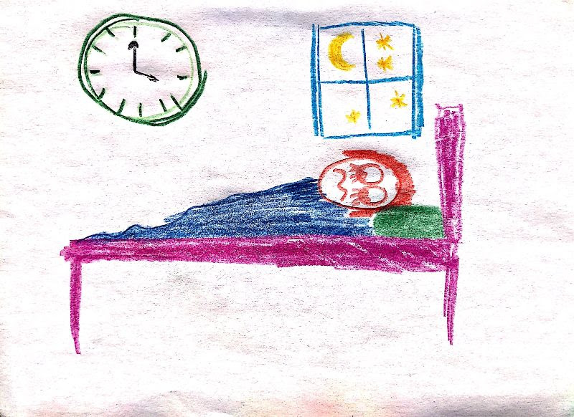

"Wide awake when you should be fast asleep"
In my classes, most SGFs come out of emergent language – things that students have said. In this case, a student wanted to express the idea of being completely awake but lacked the appropriate collocation.

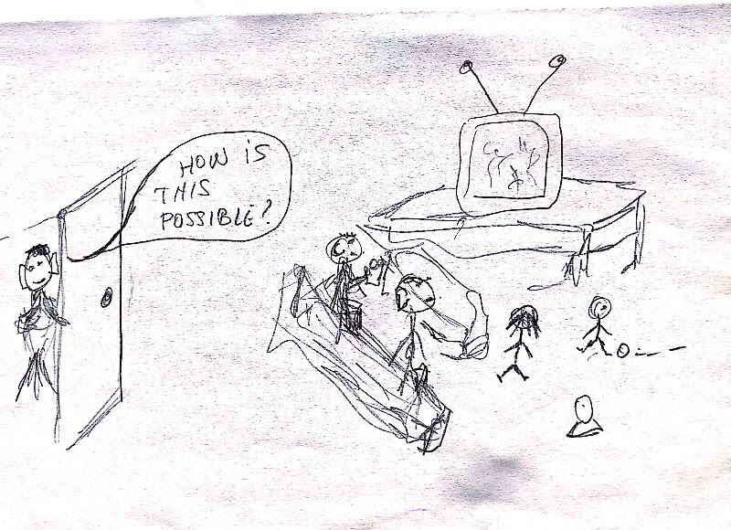
"When I got home, my kids were still up."
Another piece of emergent language. In this case a student was unaware that the adverb up can mean "out of bed" or "not in bed".

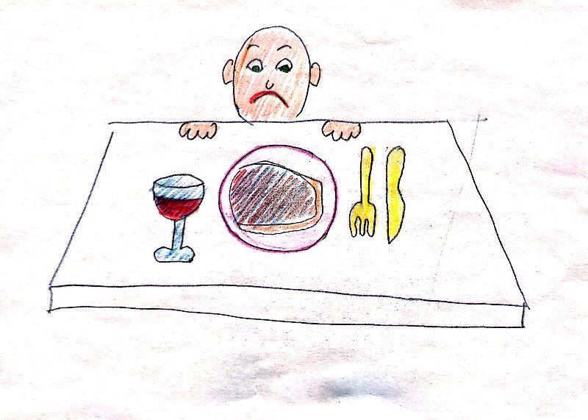
Hello teachers –
I have just got back to Barcelona from my annual trip to the UK and I've brought something quite special to show you.
First, an explanation:
Every summer, I go to Norwich to run my Video, Image and Story course at NILE (Norwich Institute for Language Education). This is something that I have been doing since 2008. And over the years, I have accumulated hundreds of student-generated flashcards (SGFs).
SGF is a term that I first used in my book Images (OUP, 2008). The idea is simple – instead of using published sets of picture flashcards to teach language items, we get students to create their own.
Before I explain the reasons for doing this, let me show you some examples. Unfortunately, I am unable to credit the artists. I have worked with hundreds of teachers of the years and it didn't ever occur to me to keep a record of who drew what.

"Wide awake when you should be fast asleep"
In my classes, most SGFs come out of emergent language – things that students have said. In this case, a student wanted to express the idea of being completely awake but lacked the appropriate collocation.

"When I got home, my kids were still up."
Another piece of emergent language. In this case a student was unaware that the adverb up can mean "out of bed" or "not in bed".

"I ordered a steak by mistake!"
I like to look for images which will help students to remember the pronunciation of problematic words. Hopefully this one will help them remember that steak is pronounced /steɪk/ and not /stɪk/.

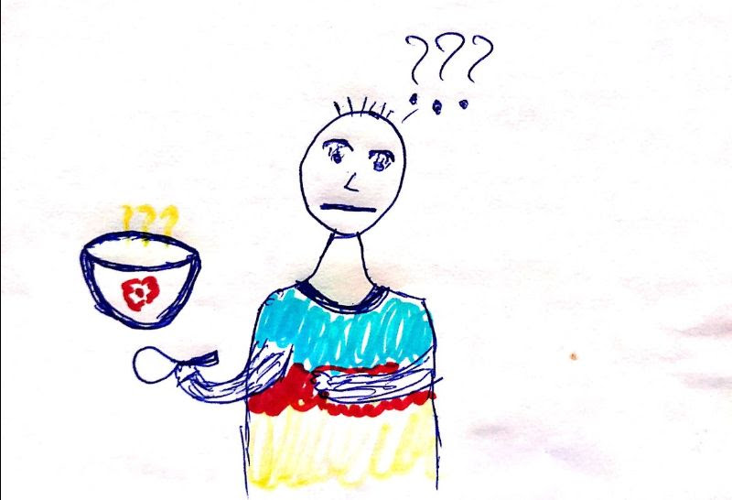
"This soup tastes funny."
A reminder that funny has two meanings: funny (ha ha) and funny (strange).

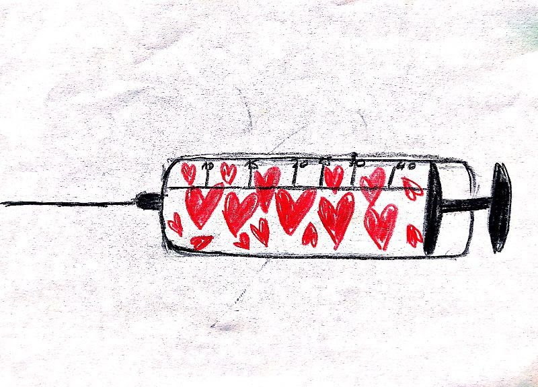
 "You might as well face it, you're addicted to love."
This song lyric by Robert Palmer provides a nice illustration of "might as well" – a phrase that I happen to be fond of teaching.

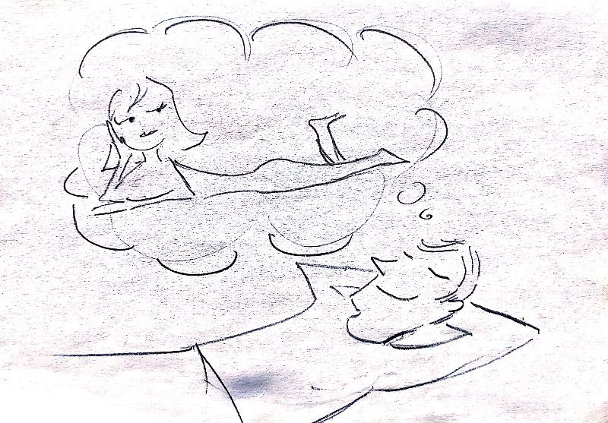
"Oh baby, I'm dreaming about your body."
Another song lyric, this one from Bobby McFerrin. I like to draw students' attention to this line in response to a standard L1 error: "to dream with someone".

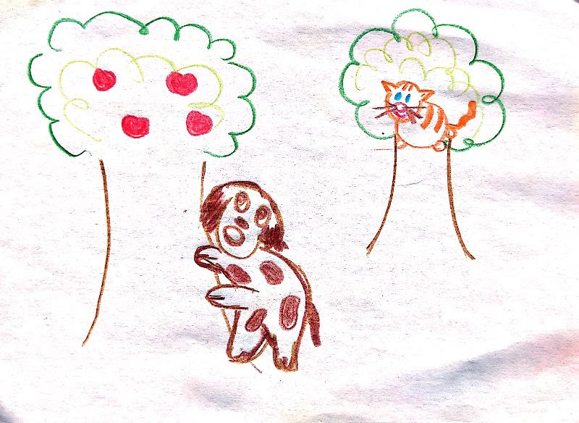
"Barking up the wrong tree"
This image comes from a lesson plan that I will be sharing in the LessonStream membership very soon – visual idioms.

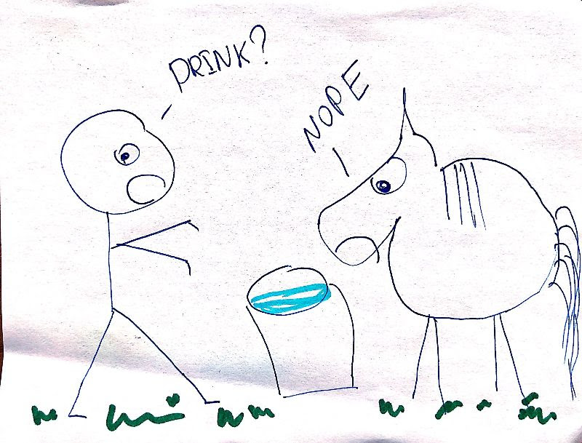
"You can lead a horse to water but you can't make it drink."
Another visual idiom.


"Please bear with me."
As a language teacher and teacher trainer, one of my mottos is: "There is no text without an image and no image without a text." In other words, there is no piece of language that cannot be represented visually. And as you can see here, this also applies to functional phrases.

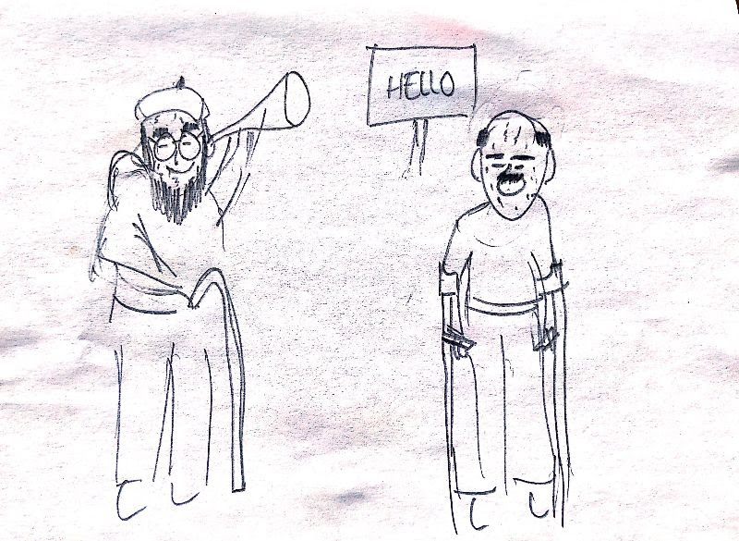
"Long time, no see!"
Another functional phrase.

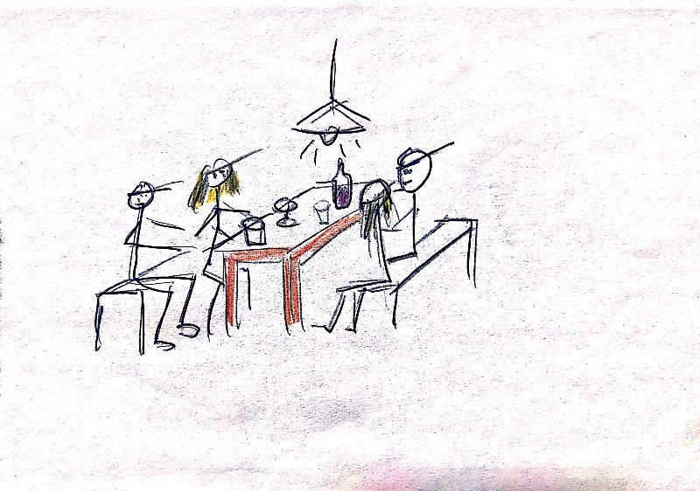
"Two friends out on a double date."
This is a scene from Love & karaoke – a storytelling activity in the LessonStream Membership. The idea is that after the story, students work with the story text and identify words, phrases, collocations and structures that they would like to remember. After that, we look for ways to capture the items visually. In this case, one student liked the phrase "out on a double date."

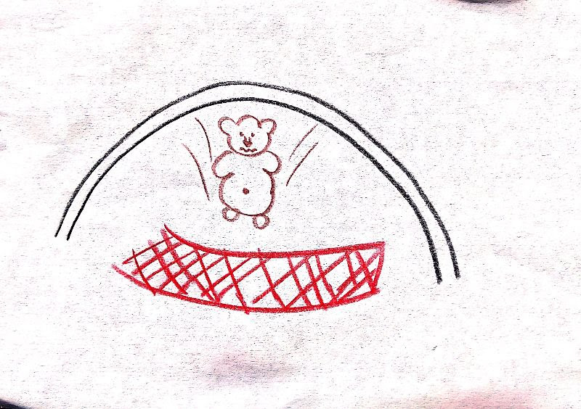
"Bob was pushed off the ledge and into the net."
Another selected phrase from a story. This one comes from "The blob on the bridge" – an activity from the old days of LessonStream. You might remember it. (New version coming soon.)

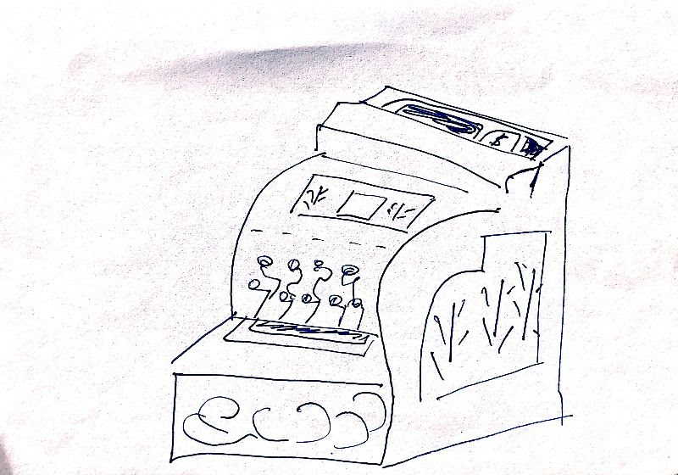
"An old-fashioned cash register"
One of my students liked the compound adjective "old fashioned" which appears in "The story of Matthew & David" (aka "Blind Luck") from my book Videotelling.

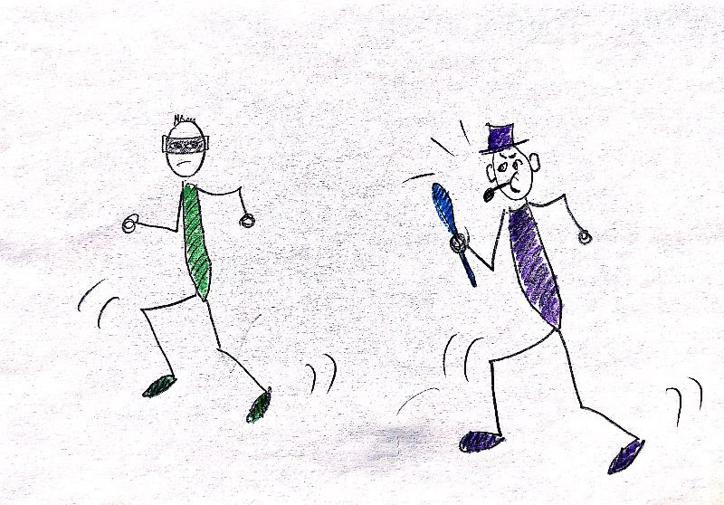
"A bank robber being chased by the police"
This image comes from "Passive Drawings" – a newly-updated lesson plan in the LessonStream Membership.

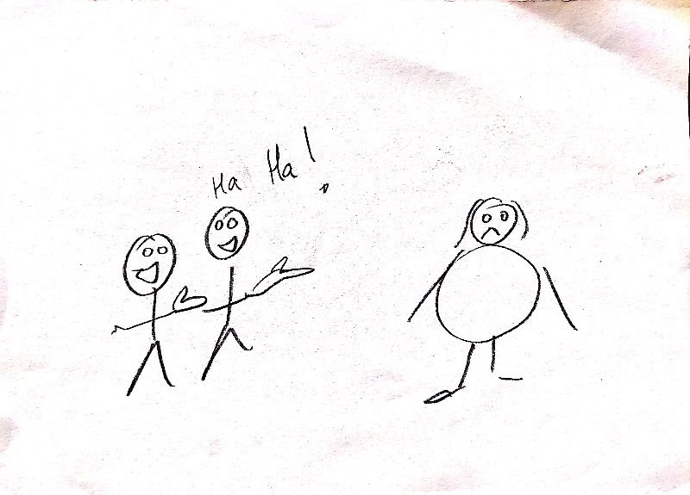
"Making fun of someone for being different"

Why use SGFs?
Although we might associate drawing with young learners, all of the images in this post were created by adults. And although there will always be some reluctant artists, they will usually change their minds once they see why you are asking them to draw.
As you can probably see from the pictures in this post, drawing is fun. It will often result in laughter.
Importantly, when we get students to supply the images, they personalise the language and make it memorable. We don't have to be limited to the familiar lexical themes provided by standard picture flashcards (animals, actions, clothes, daily routines, etc.) With a bit of imagination, there is virtually no grammatical structure or lexical item that cannot be represented visually.
Finally, there is so much we can do with SGFs. There are games, follow up activities, revision possibilities and more.
If you would like to comment join the discussion at the LessonStream Facebook group.

Please check the Pilgrims f2f courses at Pilgrims website.

Please check the Pilgrims online courses at Pilgrims website.

