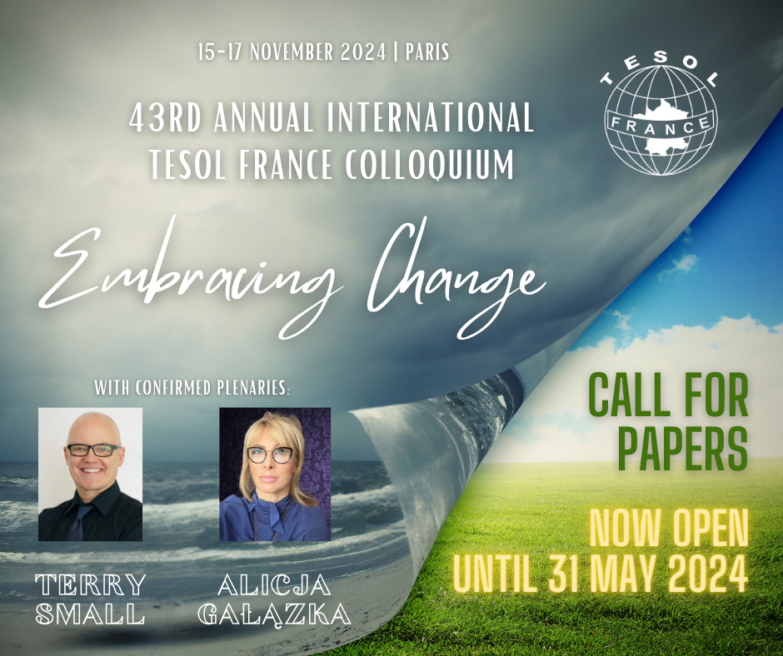

43rd Annual International TESOL France Colloquium
Embracing Change
Dates:
15th November, 2024
16th November, 2024
17th November, 2024
Venue:
Cité Scolaire Internationale Honoré-de-Balzac, 118 Bd Bessières, 75017 Paris

We welcome you to be part of the 43rd Annual International TESOL France Colloquium for 2024. We are delighted to welcome Terry Small and Alicja Gałązka as two of our confirmed plenary speakers this year.

Submitting for the call for papers means that your speaker proposal will be included in the selection process. You can see the details in the timeline and selection procedure below. When you fill out the form, please read carefully and follow all requests with as much detail as possible.

TIMELINE AND SELECTION PROCEDURE
- The deadline for submitting speaker and poster proposals is 31 May, midnight.
- After this date, a review of all abstracts and summaries will be carried out by a designated committee composed of members who are familiar with the preferences of TESOL France conference-goers. The committee reserves the right to reject any proposal that does not follow the guidelines detailed above.
- Prospective speakers and poster presenters will be notified around the end of June / beginning of July. The preliminary schedule of the event will be posted on our website in September.
- If accepted, speakers and poster presenters are kindly asked to register for the conference using the separate Online Registration Form. Submitting a proposal DOES NOT mean you have registered for the event. Registering online for the conference will be considered your acceptance and confirmation of attendance as a speaker/ poster presenter. A lack of communication or response on your part by the end of August will signal to the Colloquium Organizing team that you wish to withdraw your participation in the conference.
- All contact emails will be sent from (colloquium@tesol-france.org) To ensure a smooth communication exchange, we strongly recommend that you make sure that this address is on your accepted sender's list so that our notification will not be blocked by your email spam filters.
- Should you require a letter of invitation, you will need to file the request in the application form below. Be sure to include your full name as you would like it to appear on the letter, complete address and presentation title (if applicable). Letters of invitation not requested via the form below may result in delays.

CALL FOR PROPOSALS INFORMATION
Please take a moment to read the following information before submitting your proposal.
Based on previous conference feedback, we encourage speakers to use interactive formats that engage the audience and focus on specific, practical classroom techniques, or applicable research ideas. In this Call for Proposals, we welcome proposals that include suggestions, models, or success stories from today's classroom and beyond. Not only do we wish to explore ELT in France but also the world of ELT as a whole. Our goal is to open the way for in-depth discussions, debates, and classroom enlightenment.
Welcomed ELT fields are:
- Adult Learners  - Young learners  - Young Adult Learners  - French Learners of English  - Higher Education  - Business English  - English for Specific Purposes  - Technology in the Classroom  - Teacher Training and Development  - Reflective Practices  - Language Testing  - Corpus in the Classroom  - Drama Techniques Development  - French New Educational Reforms  - Digital Learning and Technologies  - Content & Language-Integrated Approaches | - Humor in the Classroom  - Listening Skills  - Reading Skills  - Writing Skills  - Speaking Skills  - Grammar and Vocabulary  - Pronunciation/intonation  - Materials Design and Publishing  - Multilevel classrooms  - Cultural and Intercultural issues  - Classroom Management  - Working conditions  - Dogme in the Classroom  - Project and task based Learning  - Evaluation/ Assessment  - Language Learning & Literacies  - Materials Development & Publishing
An important note on commercial presentations:
The Proposal Committee and participants at TESOL France conferences are particularly sensitive to the distinction between commercial and practical presentations and very much prefer the latter. If the committee feels your talk is too commercial they may choose to turn it down or ask for it to be modified. A commercial presentation is designed to promote a particular product or service, such as a (course)book, publisher, author, school, test, training establishment etc. Please indicate what service or product you are endorsing and it will be taken into consideration.
Language:
Talks can take place in English or in French.
Choose a clear title for your talk:
Past conferences have shown that many attendees choose the talks they wish to attend based on the title alone. Therefore, we encourage you to submit a short title that states the main idea of your presentation and is 100% clear for the conference goer. For example: Role Plays: A rehearsal for Real Life
Submit a clear, concise and well-written abstract and summary:
The purpose of the abstract and summary is to inform the proposals committee and conference goers the main objectives of your talk. The committee reserves the right to reject abstracts and summaries that are vague, unclear, try to cover too much in a 1-hour session, poorly written and/or contain typographical errors.
Be very careful not to mention your name or your affiliation in the abstract or summary.
The Selection Process will be carried out entirely blind. The committee receives only the titles, abstracts and summaries. The name and bio of the speaker is left out of the selection process.
The committee also reserves the right to request that your title and/or abstract be modified.
Abstract:
Your 100-word abstract will appear in the Colloquium Program and it is on the basis of this abstract that delegates will choose whether they wish to attend your session or come to view your poster. It should therefore accurately reflect the content of your presentation. Abstracts cannot be more than 100 words in length.
Summary:
All proposers are required to submit a 150 word max summary. Proposers should outline exactly what you are going to talk about in the session and how the session will be structured. The summary will be read by the Proposals Committee as a basis for selection. The summaries will not appear in the Colloquium Program.
Important: The online form is designed to refuse the submission of any abstract or summary that is longer than the requirements (500 characters max). Please note that extra spaces can be counted as characters.
Presenting a poster instead of a talk:
If we receive more proposals than we have space for, the committee may invite the speaker to give a poster presentation instead. The topic on which we receive the most abstracts has been Technology.
- Poster presenters are kindly asked to bring their own laptops, extra batteries for power, poster and handouts.
- Due to constraints at the venue, we cannot provide a power outlet for your computer or a portable projector. If your poster involves showing delegates' websites, we strongly recommend you bring screenshots of those sites so you can show them offline. Please bring your own speakers if your poster includes sound. We can provide poster presenters with wall space, tape, thumbtacks, Blutack, and a table.

Publication:
TESOL France magazine, Teaching Times, may contact speakers and poster presenters to submit a 300-1500 word paper highlighting the key aspects of their talk. If you are interested in participating, please contact editor@tesol-france.org or tesolfrance@gmail.com as soon as possible.
Financial information:
The conference fee is waived for all TESOL France members. However, it's important to note that TESOL France does not offer financial assistance for travel or accommodation expenses. Additionally, we regret to inform you that scholarships are not available.
Logistical Information:
- Talks will be scheduled to last 60 minutes each. Please be sure your talk starts and finishes on time.
- Delegates are encouraged to enter a talk even if it has already started.
- Please bring your laptop (PC or Mac). Due to technical constraints at the venue, we are unable to provide computers in the rooms.
- Each room is equipped with a projector, speakers, etc.
- Please bring your own photocopies. A photocopier is not available at the venue.
Our past conferences have followed a schedule similar to the one outlined below. While we cannot guarantee an identical schedule for the upcoming event, we've provided it to offer you a better understanding of the anticipated timing.
Preliminary Conference Times
Friday | 17:00 to 18.00 | Opening
Friday | 18:15 to 19.15 | 4-5 Conference Talks
Friday | 19.15 to 20.15 | Evening event and stands
Saturday | 9.00 to 18.30 | 20+ Conference Talks and Plenary Session(s)
Saturday | 18.30 to 19.30 | Reception, Poster session, Visiting stands
Saturday | 19:30 to 21.30 | Evening event
Sunday | 9:30 to 16:00 | 20+ Talks, Plenary Session(s), Panel Q&A, Prize Draw

To submit your abstract for the Colloquium, please fill out the Call for Papers online form.
Prospective Speakers and Poster Session Presenters are kindly asked to fill out separate forms.
The conference fee (or membership fee) includes welcome reception, registration, access to plenary and parallel sessions, various educational documents and gifts, coffee breaks, cocktail party (Saturday evening), etc.
To stay up-to-date on conference news, we recommend you keep an eye on our website or our TESOL France Facebook page or LinkedIn .

Register at https://www.tesol-france.org/en/call_for_papers.html

