Idioms for Losing Weight

Hania (Hanna) Kryszewska, Poland

Introduction

Years back Paul Davis sent me this snippet with a comment “I am sure you will know what to do with it”. This was the time we started working on our book on lexical chunks. (The book took us 10 years to write and edit. It is called “The Company Words Keep”.)

This press cutting was so simple and so cute. Idioms which involved movement and jokingly added calorie-burning info per each.

Indeed, it turned into an activity but never found its was to the book. So here it is.

The activity

Step 1

1 Ask the students to brainstorm ways to lose weight.
2 Pool the ideas focus on the verbs, e.g. jump, turn, twist, run, walk, stretch, walk etc.

Step 2

1 Present the ideas of idioms that help lose weight.
2 Ask students to underline the verbs.

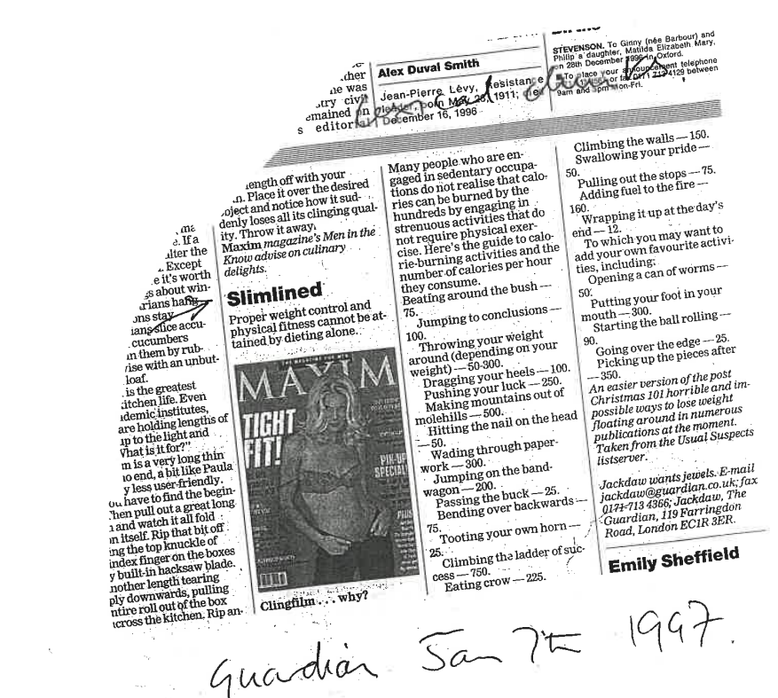

3 Then they check in pairs if they know the idioms. If necessary they use dictionaries.
4 Finally, they decide if they agree with the proposed calorie-burning information per each idiom.

Step 3

1 Remind them of the verbs from Step 1.
2 In pairs the students have to come up with their own idioms for losing weight, following the principle form the cutting, for example

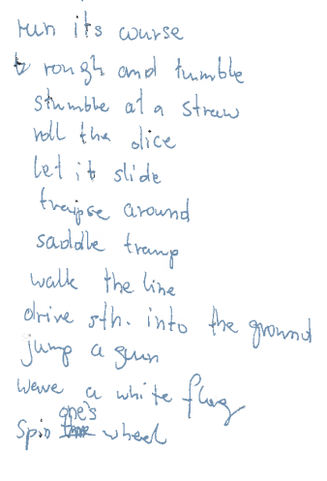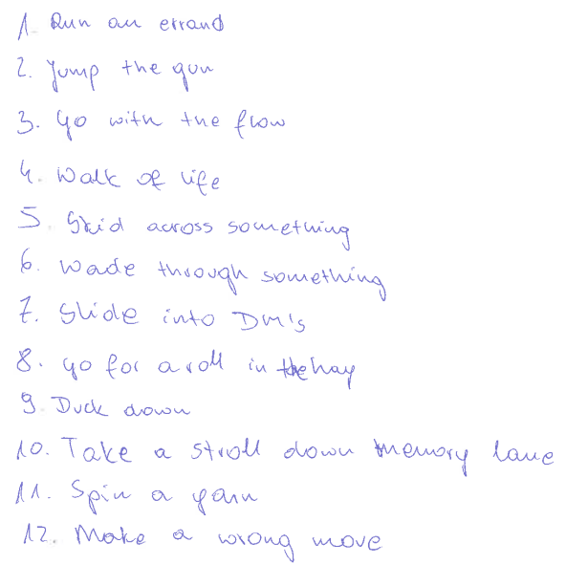

Set 1 Set 2

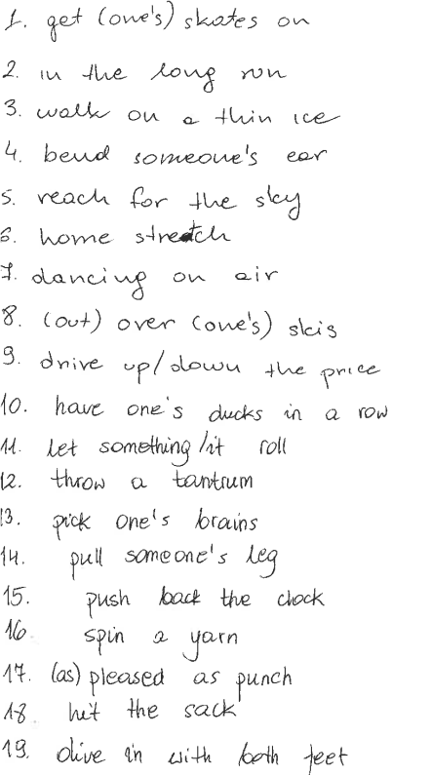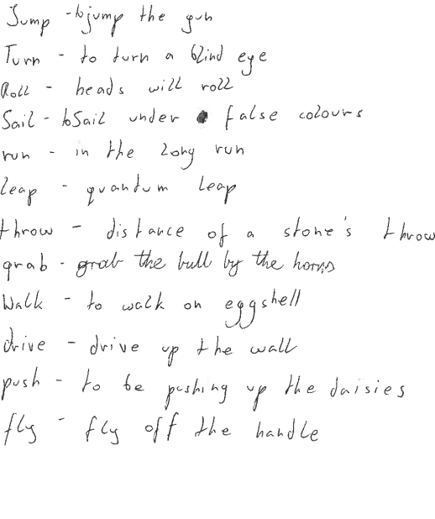
Set 3 Set 4

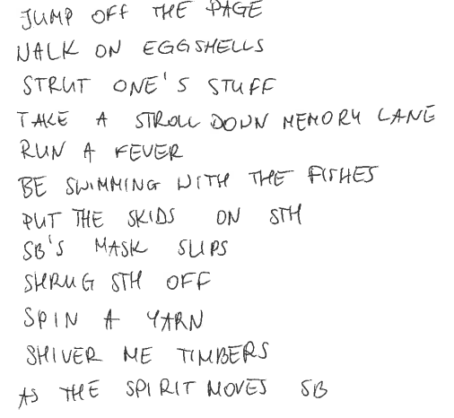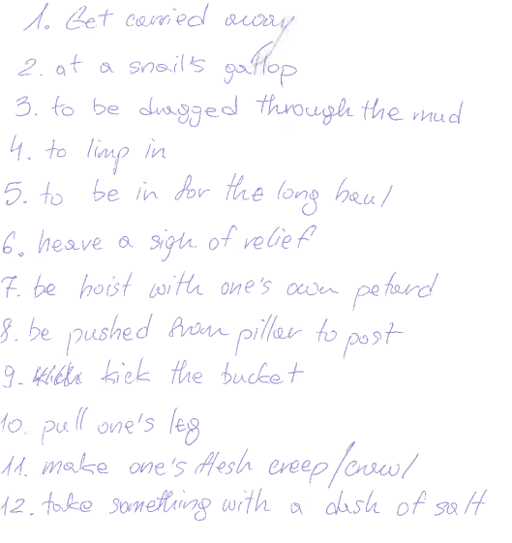

Set 5 Set 6

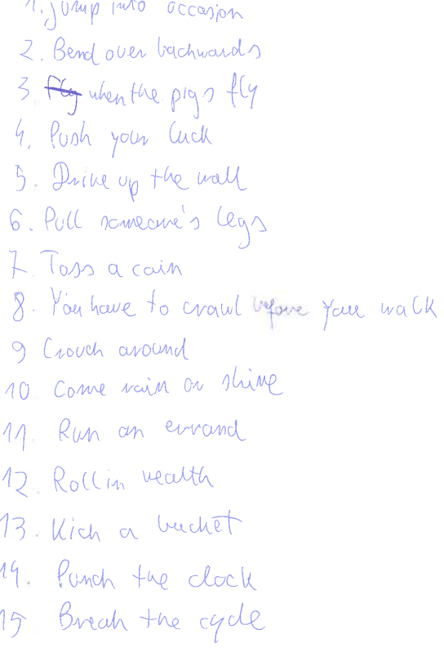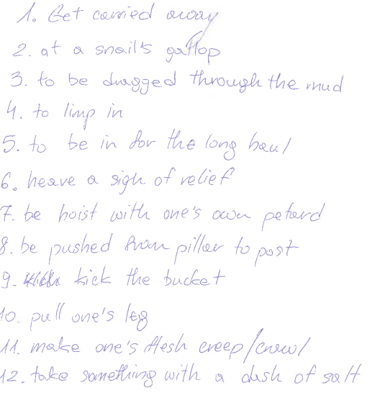
Set 7 Set 8

3 Tell them it is a competition. They have a time limit of say 5 minutes to come up with or find as many idioms as they can.
4 Redistribute the lists. Students score 1 point for each correct idiom which is used in English.
5 Announce the winner.

Step 4

1 The whole class puts together their own favourite idioms for losing weight.
2 Then they jointly decide on the calorie-burning info for each of them.
3 Display the list.

Please check the Pilgrims f2f courses at Pilgrims website.

Please check the Pilgrims online courses at Pilgrims website.

