An Inclusive Approach to Leadership for Teachers in ELT

Mercedes Pérez Berbain, Argentina

Mercedes Pérez Berbain is an educational consultant and teacher educator at ESSARP, INFoD Argentina, and Pilgrims, UK. She holds an MA in Education with distinction from Oxford Brookes University, UK. She has written educational materials and courses for Pearson, Orient BlackSwan and OUP, and has co-edited a volume on Diversity in ELT for Palgrave. She has also published and is a reviewer for several educational journals. Her research interests include teacher education, leadership, inclusion, and young learners.



Abstract

This article argues that with a leaderly and inclusive view of English language teaching all learners can learn how to develop agency, value diversity, and expand their interactive competence in English. This approach may contribute to building more equitable and just societies.

Teaching English is a skill. As with many other skills, such as playing a musical instrument or painting, the practitioners of those skills need to be in-tune with their audience to be able to hone their skill. As an English language teacher, I had identified fear, disengagement, and opposition in my classes, as well as disparity, insensitivity, and a need for recognition. With those quandaries in mind, I turned to the literature of leadership and inclusion in search of guidance. I selected and implemented leadership ideas such as setting a shared goal, building and nurturing relationships, designing structures, simplifying tasks (Leithwood et al., 2020; Kouzes & Posner, 2012) and planning for all learners in my lessons (Black-Hawkins et al., 2021). Meanwhile, I explored the impact this inclusive and leaderly approach to teaching had on the learning of my nine-year-old learners by means of initial and final small group interviews. In this article I will first conceptualise leadership for teachers and an inclusive approach to English Language teaching (ELT), then I will mention a few strategies I used, and conclude with some of my learnings and the possible implications of employing a leaderly and inclusive approach in ELT.

Leadership for teachers

Teachers are leaders of their classes. Leadership for teachers takes leadership ideas and enacts them into the classroom (Lambert, 2003). Leadership is not about alluring students to participate in the lesson with strategies such as offering rewards. Leadership is a deep-seated endeavour which aims to discover what drives each person, what they want, how they feel, which their flairs are, how they build relationships, how they learn and achieve what they want (DePree, 2004, 2008; Groves et al., 2017; Kouzes & Posner, 2012; Robinson, 2015). Leadership for teachers is also helping learners to be themselves, to be fulfilled individuals, and active, compassionate citizens (Robinson, 2018).

Leadership for teachers and teacher leadership

At first sight ‘leadership for teachers’ and ‘teacher leadership’ may seem to refer to the same. They do not. As stated above ‘leadership for teachers’ refers to how teachers lead their own learners in class whereas ‘teacher leadership’ refers to the influence classroom-based teachers have on the larger school community rather than on the class they are teaching (York-Barr & Duke, 2004; Schott, et al. 2020; Webber & Andrews, 2023). Although teacher leadership may also be desirable, leadership for teachers i.e. teachers reaching out to all learners in their classrooms helping them to rise to challenges they meet, constitutes a real “step up” (Conway, 2023 p. ii). At the heart of effective leadership for teachers is enabling all learners to learn, honouring their human diversity.

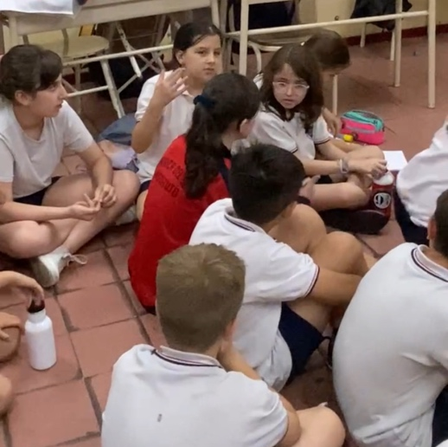
Year 4 children interacting in English

An inclusive approach to leadership for teachers

Leaderly teaching can hardly be called effective unless all learners are on board, unless there is equity. No teaching can be called effective unless it is inclusive. Inclusion entails viewing the education of all learners as having equal importance (Stadler-Heer, 2019) regardless of race, ethnicity, age, gender, sexual orientation, ability, religion, socio-economic background and any other aspect which may cause segregation. Inclusion as a principle runs through policies, curriculums, teaching, organisation, resources and assessment (Ainscow, 2020; UNESCO, 2017). Therefore, an inclusive approach to leadership for teachers in ELT begins with recognising uniqueness in every learner. It involves creating a classroom environment where every student develops agency, feels valued and empowered to welcome the challenge of learning to interact in English, for instance. Inclusive leadership often requires teacher intervention when there is oppression (Banegas et al., 2021), as well as listening empathically to help learners to express themselves. Moreover, there is inclusion when teachers think of tasks for all children rather than for most children and then find adapted or extra tasks for the rest (Black-Hawkins et al., 2021). As a result of an inclusive approach to ELT, all children learn how to work collaboratively (OECD, 2017). Children value their peers’ viewpoints and learn to distinguish peer collaboration from friendship. Most importantly, children learn to help others and live side by side with people who may see things in a different way.

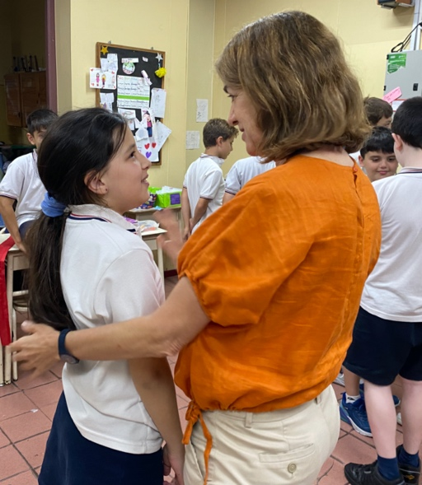
A child getting undivided attention

A leaderly and inclusive ELT approach in action

My starting point to have every learner on board in my class was finding a yearly goal which would challenge all learners equally. In this case it was “interacting in English”, understood by children as “having any idea and saying it in English”. This may sound self-evident in an ELT lesson but in my experience few children have explicitly heard and bought into the goal of interacting in English. Although there is truth in welcoming learners’ other languages, children often need a clear purpose if they are to commit to it and rise to the challenge of mastering a skill such as interaction (CEFR, 2020).

One strategy I used was varying the criteria to group learners for every task to offer diverse opportunities to collaborate. It was helpful to group learners from different ages (if we worked with other classes), degrees of linguistic competence, learning styles, backgrounds, values, likes, and so on. There were also other times when I grouped learners who were similar in some respects as well for a change. I kept trying out different groupings and observing how learners worked. The names of the group members were previously written on a small piece of paper. This prevented children from going through the awkward moment of finding the right group to work with. Moreover, children mentioned this constant change of previously arranged groups as beneficial. Indeed, they learnt how to be more inclusive by having to work with different peers task after task.

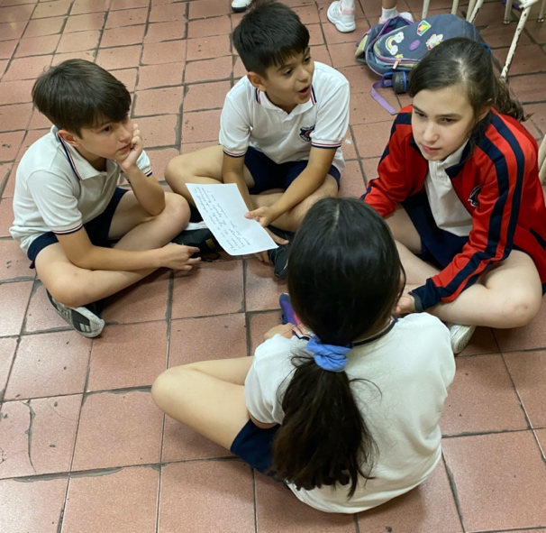
Children grouped according to a certain criteria

A second strategy I implemented was designing a learning structure with the learners at the start of the year i.e. we all agreed on when, where and how learners would engage in each type of task. For example, every Friday children would have storytelling. That involved making a circle of chairs and contributing with ideas when there was a pause from the teacher and at the end of the story. Every Tuesday learners would hand in their homework by placing the worksheet in the box labeled In-box. Learners were also aware of where each resource was, such as blank sheets of paper or the scissors, so they were also responsible for keeping the learning system up and running. Creating this learning structure with the learners contributed towards their building a sense of belonging and agency.

A third strategy I used was having class conversations with children seated in a circle during or after sharing a story, for instance. This dynamic created a collaborative thread of discussion where every participant added to the common plot at their own level and pace while looking one another in the eye. This uninterrupted stream of interaction, which encourages children to pick up from other speakers, follow peers’ ideas and build on them is crucial today in a world of often disconnected messages which make it more difficult for learners to develop communicative competence.

A fourth strategy I used was thinking of games and activities where all learners could engage in their own way, not just the more able ones. For example playing charades by having to guess a sentence from a story which was being dramatised. At the start of the game, I drew as many dashes on the board as words in the sentence performed. As children in groups or pairs guessed each word being dramatised, the word would be written on the corresponding blank on the board. In this way all children could see how the sentence was formed rather than having to hold the guessed words in their memories. In this way every learner felt part of the game.

A fifth strategy was selecting relevant picturebooks to use for collective storytelling to reflect on inclusion. For example, Stuck by Oliver Jeffers, How to be a Lion by Ed Vere, The Day War Came by Nicola Davies, The Suitcase by Chris Naylor-Ballesteros, I Want my Hat Back by Jon Klassen, and Green Lizards and Red Rectangles and the Blue Ball by Steve Antony, to mention but a few. These stories enabled learners to meet and discuss different characters and plots which dealt with inclusion in diverse contexts.

Last, we regularly assessed learning with reflective accounts and surveys, which included simple instructions, such as ‘Draw a moment when you felt included and one when you did not’, or questions in English, such as ‘Did you feel included in this task?’; ‘How/Why?’; ‘Were you able to interact in English?’. Additionally, as well as engaging in self-assessment and giving and receiving feedback, children often confronted what they were doing to our yearly goal to see if they were making good use of their time.

Conclusion and implications

With a leaderly and inclusive approach to ELT, learners developed agency, deepened their understanding of inclusion, and expanded their interactive communicative competence. Children reported feeling more at ease while engaged in the tasks, especially in group work, and having a sense of purpose and achievement. In addition, children learnt more about themselves and how to collaborate with others. They also became more aware of how they could act in the event of witnessing an act of discrimination, however subtle this was. Learners who have experienced a leaderly and inclusive stance of learning English as an additional language may be in a better position to advocate for social justice. Considering this implication beyond the classroom, ELT educators who implement a leaderly and inclusive approach can contribute to building more equitable, inclusive, and empowered societies.

References

Ainscow, M. (2020). Promoting inclusion and equity in education: lessons from international experiences, Nordic Journal of Studies in Educational Policy, 6(1), 7-16.
Banegas, D., Beacon, G., & Pérez Berbain, M. (Eds.) (2021). International Perspectives on Diversity in ELT. Palgrave.
Black-Hawkins, K. Maguire, L. & Kershner, R. (2021). Developing inclusive classroom communities: what matters to children in their experiences of inclusive classroom learning? Education, 3-13.
Chua, F., Perkins, D., & Wilson, D. (2021). Leading learning that matters. Project Zero, Harvard School of Education.
Conway, J.M. (2023). Teacher leadership: An exploration of teachers leading in many ways across varying school contexts. Leading & Managing, 29(1), pp. ii-iv.
Council of Europe (2020). Common european framework of reference for languages: learning, teaching, assessment – Companion volume, Council of Europe Publishing. www.coe.int/lang-cefr
DePree, M. (2004). Leadership is an art. Bantam Doubleday Dell Publishing Group.
DePree, M. (2008). Leadership jazz. Crown Business.
Groves, M., Hobbs, A., & West-Burnham, J. (2017). Leadership for tomorrow. Crown House Publishing.
Kouzes, J., & Posner, B. (2012). The leadership challenges: how to make extraordinary things happen in organizations. Jossey-Bass.
Lambert, L. (2003). Leadership redefined: an evocative context for teacher leadership. School
Leadership and Management, 23(4), 421-430.
Leithwood, K., Harris, A., & Hopkins, D. (2019). Seven strong claims about successful school leadership revisited. School Leadership and Management, 40(1), 5-22. https://doi.org/10.1080/13632434.2019.1596077
Organisation for Economic Co-operation and Development. (2017). PISA 2015 results (Volume V): Collaborative problem solving, OECD Publishing. http://dx.doi.org/10.1787/9789264285521-en
Robinson, K. (2015). Creative schools. Allen Lane.
Robinson, K. (2018). You, your child and school. Viking.
Schott, C., van Roekel, H., & Tummers, L. (2020). Teacher leadership: A systematic review, methodological quality assessment and conceptual framework. Educational Research Review 31(3). 100352. https://doi.org/10.1016/j.edurev.2020.100352
Stadler-Heer, S. (2019). Inclusion. ELT Journal, 73(2), 219-222.
Webber, C. F. (2023). Teacher leaders: profiles of difference and conviction. Leading and Managing, 29(1), 84-93. https://www.acel.org.au/ACELWEB/Publications/Leading_and_Managing/2023/LM_29_1.aspx
UNESCO (2017). A guide for ensuring inclusion and equity in education. UNESCO.
York-Barr, J., & Duke, K. (2004). What do we know about teacher leadership? Findings from two decades of scholarship. Review of Educational Research, 74(3), 255-316. https://doi.org/10.3102/0034654307 4003255

Please check the Pilgrims f2f courses at Pilgrims website.

Please check the Pilgrims online courses at Pilgrims website.

