

Reflections on learning with Pilgrims and Learn & Lead Innovation

Mercedes Pérez Berbain, Argentina

Mercedes Pérez Berbain has been involved in teacher education for more than 30 years. Her focus is leadership for educators with a humanistic perspective. She is a faculty member at Pilgrims Teacher Training (UK) and ESSARP (Argentina). She is a reviewer for several educational journals, such as LACLIL and AJAL. She holds an M.A. in Education with Distinction from Oxford Brookes University, UK. She has written materials for Pearson and OUP, and co-edited for Palgrave Macmillan International Perspectives on Diversity in ELT (2021). She has designed on-line courses for Orient BlackSwan on leadership and humanistic education. Her research interests include leadership, inclusion and young learners.
Email: mercedesperezberbain@gmail.com, LinkedIn https://www.linkedin.com/in/mercedesperezberbain/, IG @leadership4educators



Introduction
Being a Pilgrims trainer to me means learning all the time. I learn from colleagues, such as Robert Gillan or Stefy Ballotto, with course participants, and from leaders, such as Mario Rinvolucri, Jim Wright, Till Gins and Phil Dexter. I learn formally while training or attending a talk, and often I also learn informally, over meals, on walks and even while shopping. Pilgrims is a learning organisation – learning is constant and transformation almost inevitable.

Some learning moments come clearly signposted, like engaging in an on-line café, team teaching a school staff in Segovia (our present training centre), or meeting the Pilgrims team for a weekend to plan ahead, as we did last August in Newbury. Yet, there have been other moments when I have found myself learning with Pilgrims in the least expected way. One such occasion is what I reflect on in this article. Namely, learning with Pilgrims during what was called “Learn & Lead Innovation induction to Pilgrims teacher training: The essentials of communication and new leadership.”

Background

This learning journey took place in Segovia from March 9th–13th 2025. It was offered by a partnership between Learn & Lead Innovation and Pilgrims Teacher Training. Many aspects indicated that we were in for a unique learning experience: a very diverse class of business people, high-calibre ELT trainers and decision-makers; relevant content core to humanistic learning (Pilgrims’ ethos), such as whole-person development and self-leadership; and two passionate trainers, Jana Chynoradská and Phil Dexter who inspired us to reflect on ways to transform education.

The learning journey

During the learning experience, there were many instances to listen to one another, contrast views and contexts, challenge our present beliefs, listen to ourselves through others and create new ideas. The catalyst was the group diversity in terms of backgrounds – Argentina, Cyprus, Hungary, Italy, France, Portugal, Spain, Slovakia, South Africa, UK, and work contexts – schools, universities, businesses (See Figure. 1). Also, there was a tacit commitment to rethink our practices and make the most of the time we had blocked out for that purpose. I would like to believe we have all achieved that goal individually and that, thanks to Pilgrims, a true learning organisation, education in our many different parts of the world is being transformed as I type these reflections. Having said that, my main regret is that having built and strengthened our relationships, we did not create something collective of great consequence there and then.

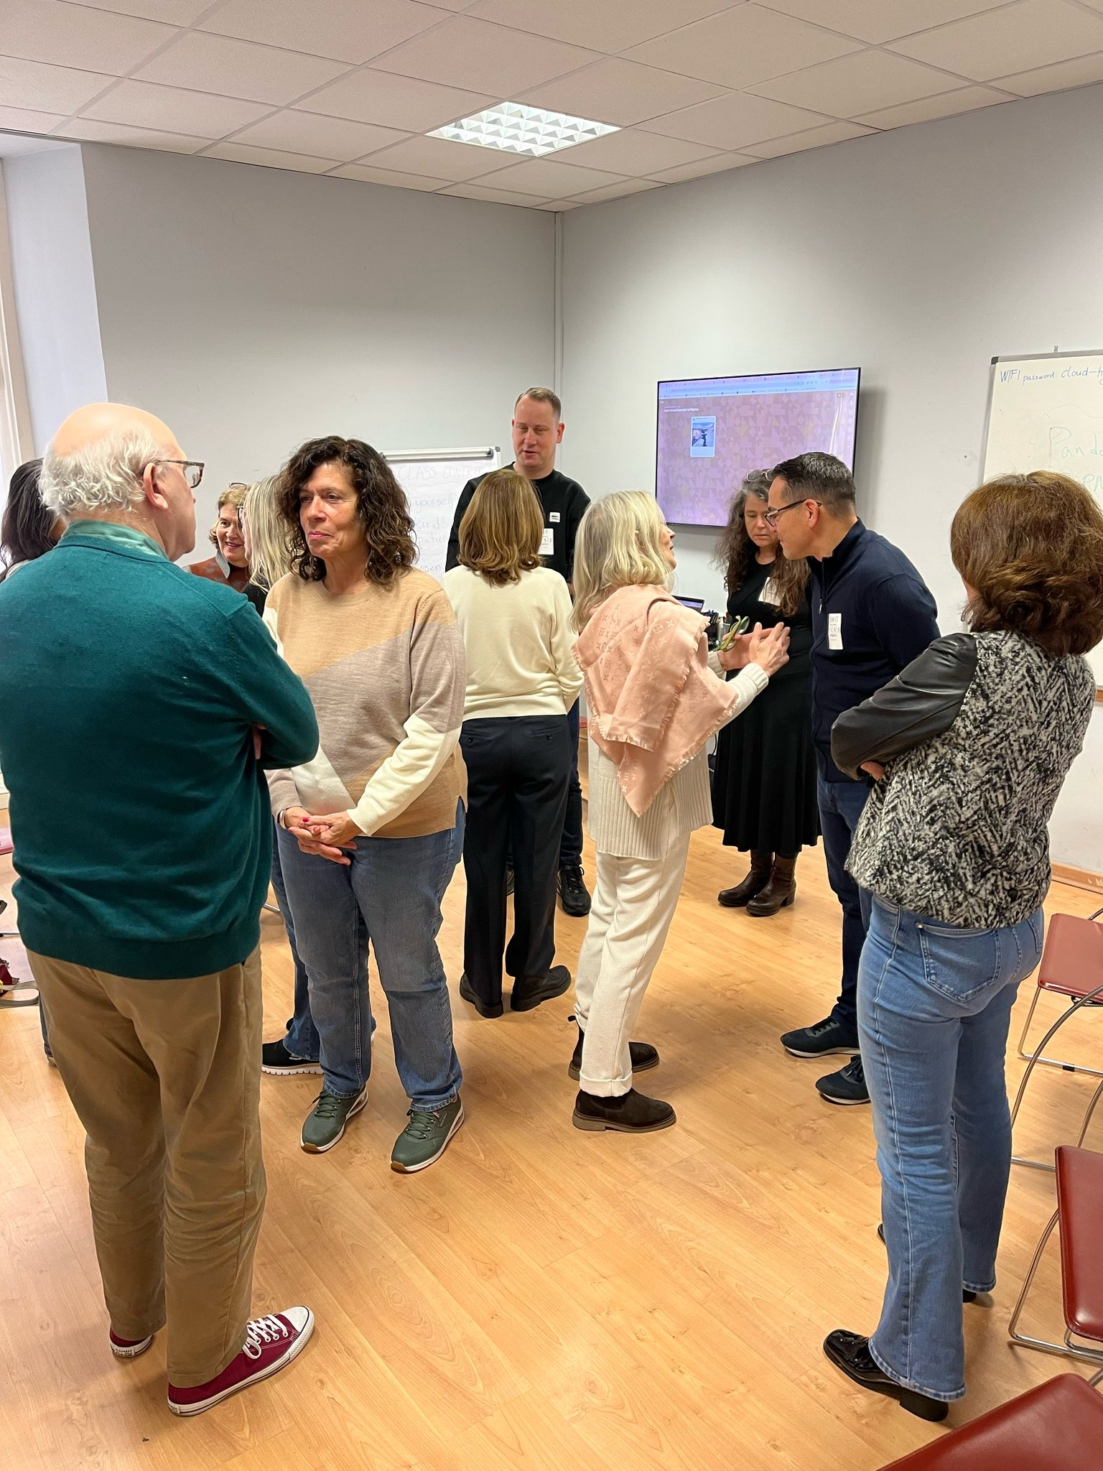
Figure. 1. Interacting in a diverse group of trainers

Memorable stops
As I look back on the journey, some learning experiences stand out, either because they prompted insight among the participants or because they triggered some ‘Aha’ moment in me. Below I mention some of such moments.

Sharing the destination
I became aware of the crucial role of setting a shared destination both in teaching and leading. That realisation came about as I was leading a colleague whose eyes were closed through the school. I am not sure what the content of that activity was. It could have been clear communication and trust. To me, it was being clear of our goals. And now I am thinking, how different would it have been if we, the participants of that class, had set ourselves the goal of designing a joint project to transform world education by the end of the course?

What active listening feels like
I learnt for the umpteenth time what active listening means to us and how it can make us feel. If only we remembered that every time we interact with a colleague or learner. Figure 2 shows experimenting with listening to understand rather than waiting for our turn to say what we have in mind.

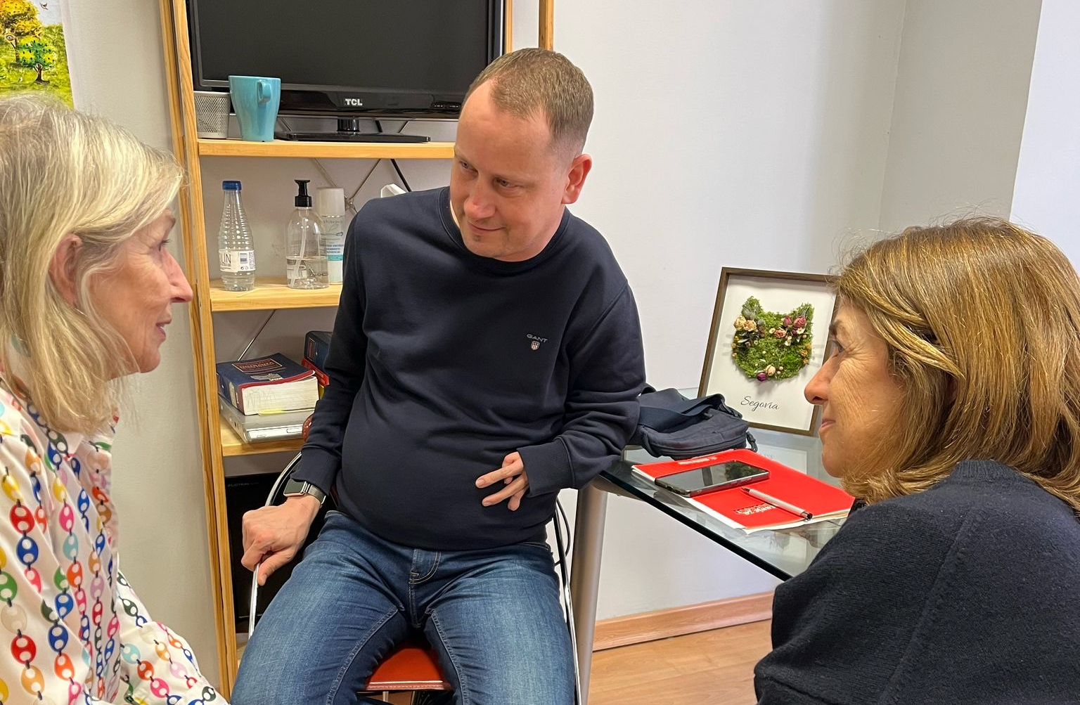
Figure 2: What active listening feels like

How to express appreciation
Expressing appreciation to somebody and receiving appreciation are known to be key in any relationship. Yet, in education, we either force it with what could be felt as an intimidating public activity or take appreciation for granted and never give room to it. This time we experienced a very safe way of engaging with appreciation by drawing a gift to somebody from the group whose name had been given to us previously on a slip of paper and accounting for our gift choice in reference to what we valued in that person (see Figure 3).
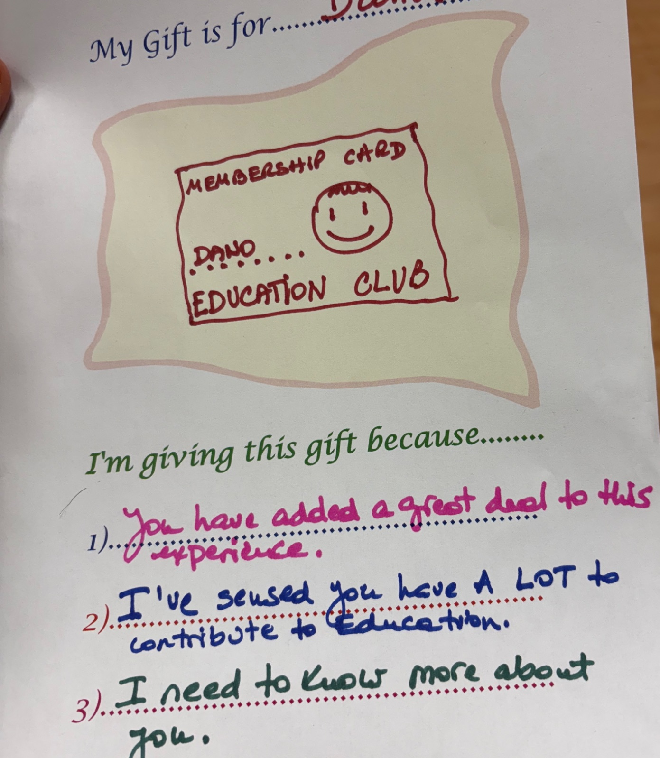
Figure 3 Expressing appreciation safely

Mario Rinvolucri
On the topic of appreciation, we dedicated the very beginning of our learning experience to acknowledging the legacy of Mario Rinvolucri to Pilgrims and to the ELT world (see Joint tribute, 2025). Through each of the accounts we heard, I took stock of the marks this unique educator left by daring to be himself, embodying a truly learning-centred approach, and directing his efforts to understanding the human dimension in the teaching of languages.

Real scenarios to flesh out competencies
As we acted out emotional and social competences (see Figures 4 and 5), I was reminded that all social behaviour springs from personal emotions and self-regulation or no regulation (Goleman, 2006; Satir, 2010). Of course, we cannot overlook the influence of culture and context. If we are to develop social competencies we need to experiment with real scenarios. We educators seem in need of more examples to flesh out concepts such as conflict management, empathy or emotional balance. As never before, there is a need to make sense of our practice. Mario Rinvolucri was a maestro of learning from his own experience. He would call it “mutual super-vision”, and I had the privilege to experience that with him in 2019.

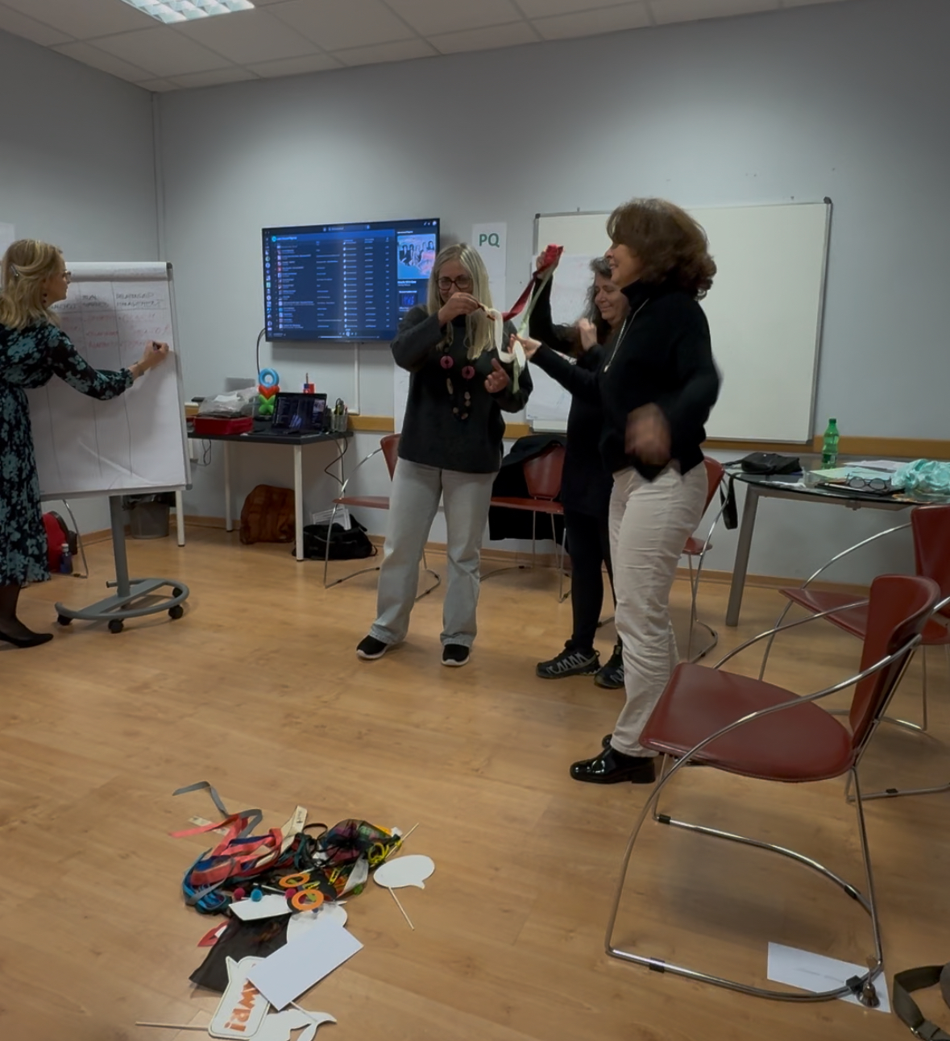 Figure 4 Acting out emotional and social competencies

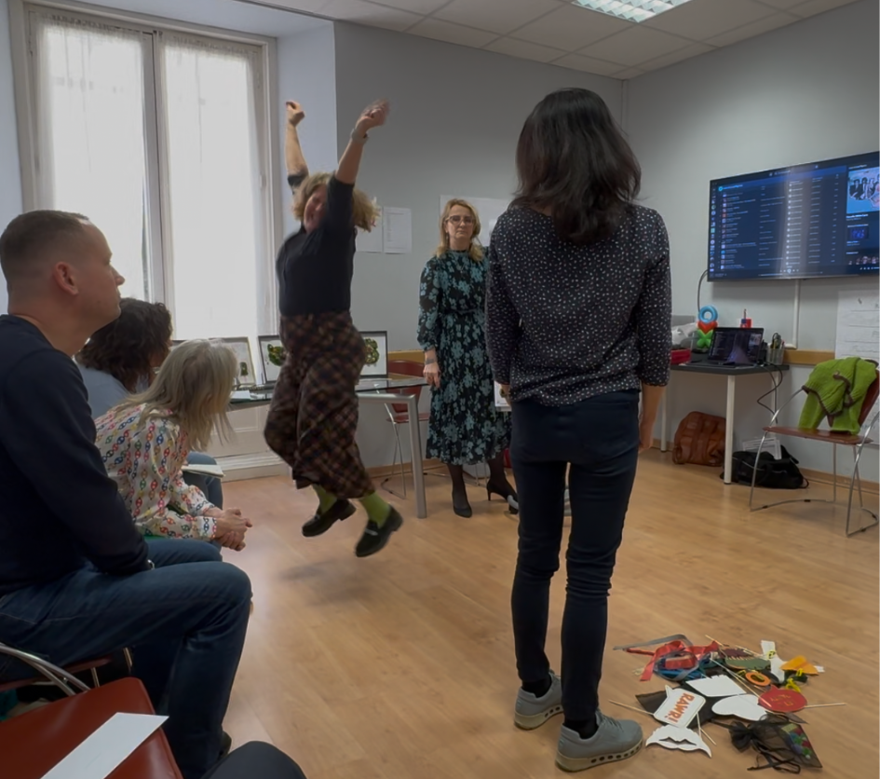
Figure 5 Acting out emotional and social competencies

Roles in education
Through an experiential guided activity (see Figure 6), we identified different roles in the educational arena: the learner, the teacher, the leader and the developer. Such roles and relationships are present in every learning act; yet they are not always differentiated or embodied by different people. Many times, the teacher is the leader, as well as the developer. In any case, the gist seemed to be the alignment which is needed between the different roles working in education. Are they all going in the same direction? Do they have clarity of purpose and are they directing their energy towards a common goal?
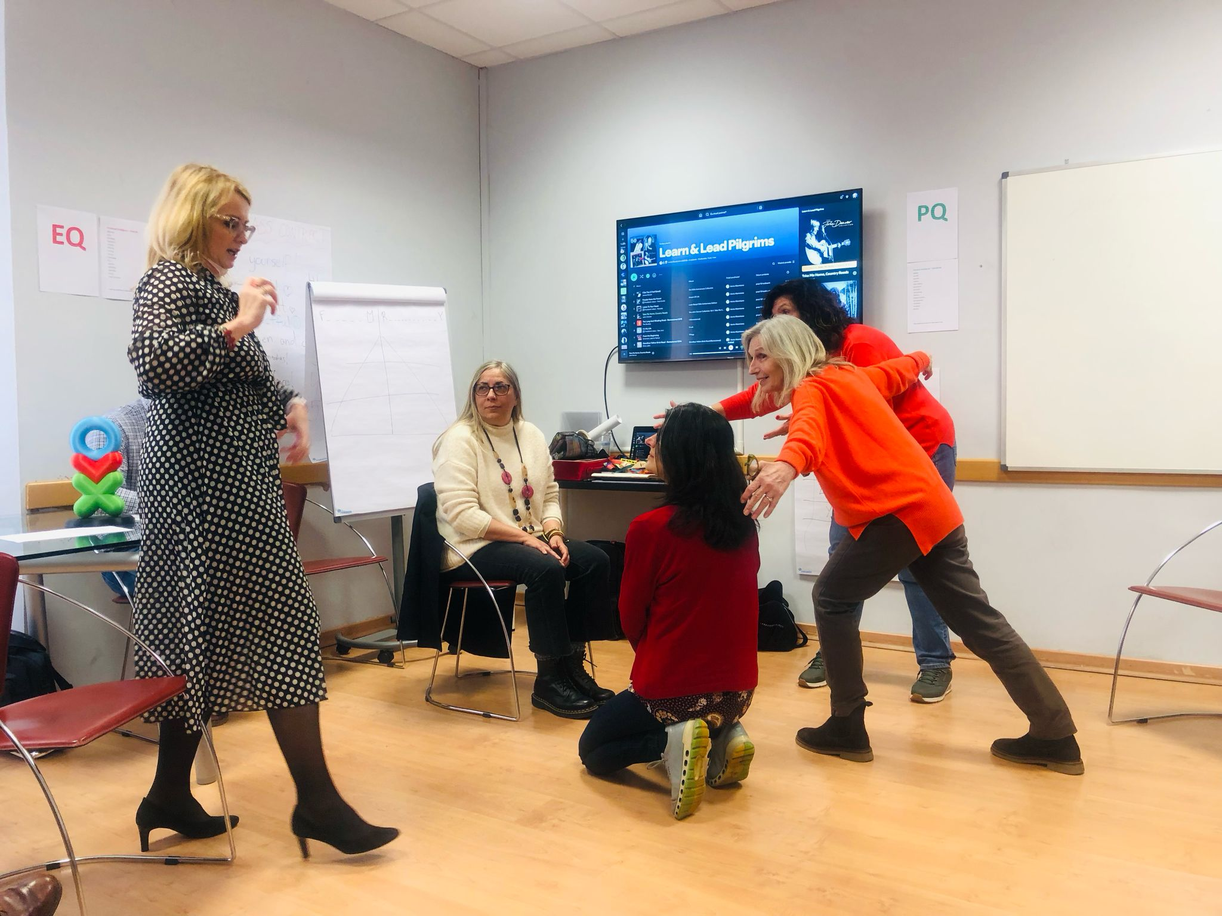
Figure 6 Roles in education

The teaching persona
Out of the blue, or while waiting for something, Anna Pires, a colleague in the group volunteered to share a strategy which is meaningful for her and the young learners she teaches. To the beat of Get Lucky by Daft Punk she demonstrated a masterful way of teaching activities such as having breakfast in the morning or going for a walk. What made this a memorable experience was not so much the technique itself but Anna’s presence, conviction and joy while leading the game, which were catching and are still tingling in my body as I recall that moment. The fact that Anna felt like sharing something dear to her there and then speaks volumes of the learning atmosphere we had created from day one, agreeing to be ourselves, being kind to one another, and challenging ourselves with curiosity and openness.

Collaborative transformation
The last memory, and perhaps the most vivid, is building the school of our dreams. We did this in groups and with the help of Cuisenaire rods and buttons which were handed out to us. We all participated: trainers and decision-makers (see Figures 7 and 8). We engaged in deep conversation and presented our views to the rest. We bore witness to how business and education are human endeavours grounded in the same solid principles: integrity, compassion, courage, proactivity, confidence, persistence, open-mindedness and collaboration. Both business and education require enhanced competencies and the conviction that learning is what is at the heart of being human (Senge, 1990).

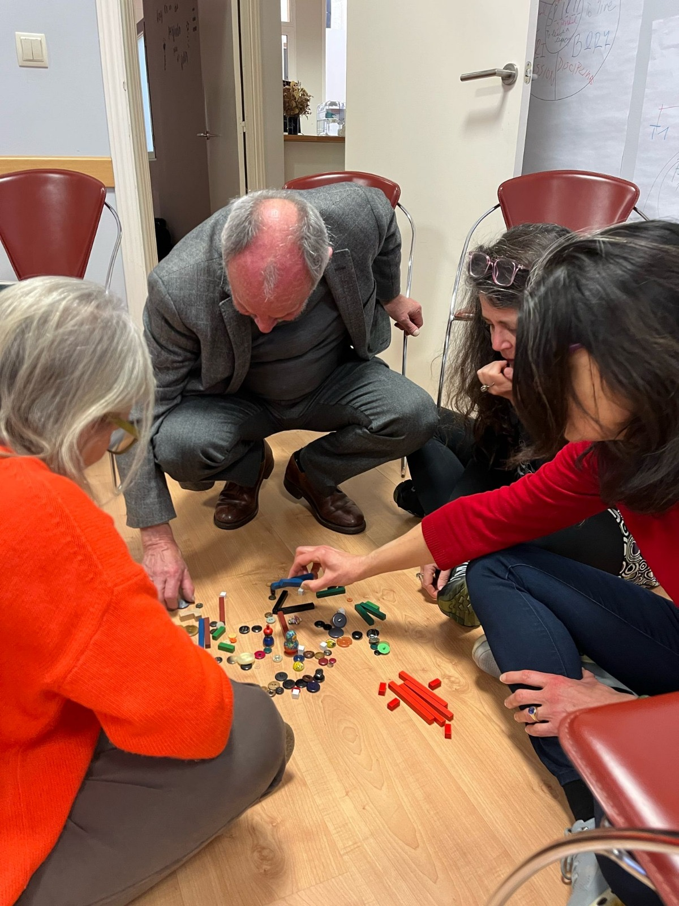
Figure 7 Collaborative transformation with rods and buttons

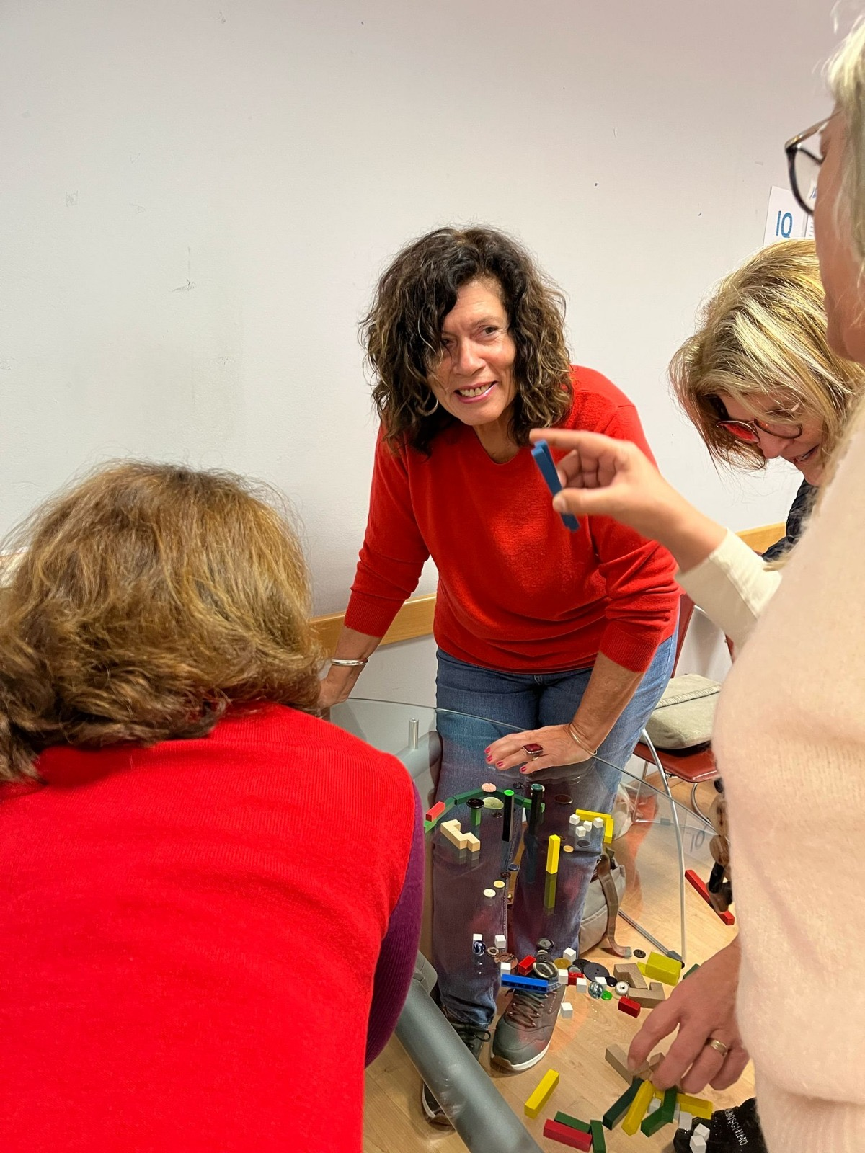
Figure 8 Collaborative transformation with rods and buttons

Conclusion
I have reflected on learning with Pilgrims during an in-person professional development activity held in Segovia. Perhaps the most innovative part of this learning experience was that 15 people from all over the world met to learn and as a consequence of their learning, the education of many learners will be enhanced. This will not happen automatically, but as we continue to challenge ourselves day in day out when we teach and lead. Training at Pilgrims and coming to Pilgrims to develop your skills are two sides of the same coin. Pilgrims is life-long, humanistic learning, as was illustrated during this joint venture between Learn & Lead Innovation and Pilgrims Teacher Training.

References
Goleman, D. (2006). Social intelligence: The new science of human relationships. New York: Bantam Books.

Joint tribute (2025). Remembering Mario Rinvolucri: A Collection of Voices. HLT, 27(2). https://www.hltmag.co.uk/apr25/remembering-mario-rinvolucri

Satir, V. (1988). The new peoplemaking. Mountain View, California: Science and Behavior Books.

Senge, P. M. (1990). The Fifth Discipline: The Art & Practice of the Learning Organization. New York: Doubleday.

Please check the Pilgrims in Segovia Teacher Training courses 2025 at Pilgrims website.

Please check the Pilgrims f2f courses at Pilgrims website.

