The 48th Annual Conference of TESOL Spain

Judit Fehér, Hungary

Judit Fehér is a freelance teacher, teacher trainer and materials writer. Her professional interests are HLT, CLIL, global education and global skills, materials writing, creativity and the arts. As a teacher trainer, Judit has worked internationally, most notably for Pilgrims, British Study Centres, the Bridge and Europass Teachers Academy. Most of her teaching materials target secondary students. She is the co-author of Creative Resources with Bonnie Tsai (IAL, Atlanta, 2004). Email: jr.feher@gmail.com, https://www.linkedin.com/in/judit-feh%C3%A9r-37151b19/

Introduction

The 48th Annual National Convention of TESOL Spain was held from 14th to16th of March in Burgos. For me, the conference started earlier in Segovia. The new training centre of Pilgrims is in Segovia, and with some of my Pilgrims colleagues, I travelled to Burgos from Segovia. We were waiting for the Segovia – Burgos express and chatting as language teachers do when a kind young woman asked us, “Are you travelling to the conference in Burgos, too?” In the train, there were several more colleagues and a friendly, ‘feel at home’ atmosphere that continued all the way through the conference.

The theme of the conference was brilliantly summed up by this witty title: “Evolving Paths: Roots and Routes”. This is how the organisers elaborate on the theme in their introductory message on the conference website: “It suggests a progression, an ongoing process where the 'roots' represent the foundational knowledge and cultural heritage that each individual brings to the learning environment.” The poster image suggests that our new routes are created by tapping into and being fed by the many roots we share. From plenaries to workshops, different aspects of these fundamental ideas were discussed and demonstrated in a lot of engaging and instructive ways.

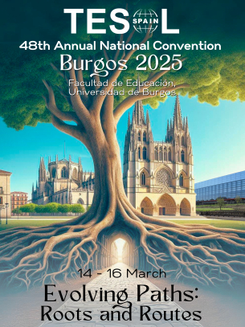

Conference poster https://www.tesolspainburgos2025.com/home

A. Talks and workshops https://www.tesolspainburgos2025.com/timetable

1. Plenaries

a. The opening plenary was given by Darío Luis Banegas titled ‘Roots and Routes in Social Justice in English Language Teaching: Who’s on Board?’ The talk revolved around social justice in the language classroom, with real life examples from projects in Argentina and the Basque Country. We learnt about the four pillars of social justice in education, which are: 1. Inclusion – who’s on board? 2. Relevance - the local community; 3. Democracy – participation 4. Teacher Agency – driving force.

b. The mid-conference plenary, ‘Transformative teaching: seven principles for a critical language pedagogy’ was delivered by Rose Aylett. Rose based her talk on Paolo Freire’s work, which initiated critical pedagogy, and considered teaching as a political act. She posed the question: ‘What could critical language pedagogy look like?’ In her answer to this question she discussed and demonstrated the seven principals of critical language pedagogy, which are: 1. Contextualized – learner’s context and values; 2. Socio-political – relevant global issues included or not?; 3. Problem-posing - posing knowledge as a problem; 4. Participatory - active involvement of learners; 5. Dialogic – teacher-learner power equality: knowledge is mediated; 6. Collaborative – projects, process evaluation; 7. Action-oriented - activism, acting on what is learned.

c. Mina Patel’s closing plenary, ‘The future of English: what’s in it for the Gens?’ was an engaging mix of her personal experience and a British Council research the aim of which was to find answers to the question in the title, and which Mina participated in. The findings were summarised in the research paper ‘Future of English: Global Perspectives’ (2023) https://mktgfiles.britishcouncil.org/hubfs/FoE_Research%20Summary_single%20page_for%20download_revisedV2.pdf of which Mina is a co-author. Both the research paper and Mina’s plenary boil the findings down to eight thematic questions, which together offer a framework for further research, reflection and decision making. These questions relate to the future popularity of English, its role in multilingualism and as the medium of education, teacher relevance and AI, public and private English language provision, equity gap and the effect of technology on it, and finally the effect of employment requirements.

2. Simultaneous workshops and talks

There were 14 time slots for the parallel workshops and talks, and each timeslot had a keynote speaker, whose presentation was live streamed and recorded. These keynote presentations had different focuses from the plenaries, and covered important topics such as materials writing, teacher wellbeing, understanding and working with teenagers, gender bias, pronunciation, AI, visuals, diversity, mediation, and inclusion.
Let me share with you some takeaways and tips from a couple of talks I attended.

a. If you teach higher level students, who might be tempted to hand in research papers and essays created by an AI tool as their own work, Jennifer McCoy & Judy Wren’s advice from their talk, ‘Fostering Critical Thinkers in the Age of AI’ may be useful: Ask students to use AI and then critically evaluate AI’s contribution. Regarding assessment, process is over product: assess different stages of documents, and how your students could critically evaluate, modify and improve them. Use peer reviewing.

b. Two tips from Burçin Gizem Gökçay & Benan Rifaioğlu Alahdab’s talk titled
‘Fostering Intercultural Understanding through Language-Learning Activities’: 1. You can use the iceberg activity as an introduction to discussing issues; give a list of related concepts such as personal space, nature of relationships, religious rituals, understanding the natural world, rules of social etiquette; ask students to place them on the iceberg’s visible and invisible parts, and give their reasons. 2. Global pen-friends and on-line cultural exchange; use this website: www.epals.com

c. More and more teachers teach multicultural and multi-lingual groups, often using CLIL methodology, which means that they need to manage the use of multiple languages and cultural norms. In her talk, ‘Using CLIL and Bilingualism to Foster Global Competence’, Reena Rana recommended using the strategy of translanguaging, which basically means that we use learners’ whole linguistic repertoire, e.g. Students use their mother tongue or stronger language for discussion and the target language for presentation.

d. What Marcus Siconolfi in his talk, ‘AI who? Getting back to the human touch’ said may be comforting for those who are worried that AI will outmaster us as teachers. He claims that as AI lacks the human touch, so it can’t create a great teacher impact we can. How? Using our empathy, creativity, adaptability, our tones of voices, giving and acting upon subtle clues, building human connections: communicating with all our human faculties. “Education is not the filling of a pale but the lighting of fire. “ Plutarch

B. Pilgrims presence

I’m proud to say that Pilgrims had a very strong and positive presence at the conference, which had three main components: a stand, many great presentations by Pilgrims trainers and Pilgrims acting as a sponsor of the event.

1.The Stand

The stand operated as a ‘home base’ for us, where we could welcome many teachers. Some came to say hello to Pilgrims staff and chat about fond memories from past Pilgrims courses and also about new developments at Pilgrims; others were totally new to Pilgrims and needed information about the courses we run this summer in Segovia, the training centre and the city, as well as Erasmus funding. Many came to remember Mario and pay their tribute by writing their thoughts about him and his legacy on a wall poster by the stand.

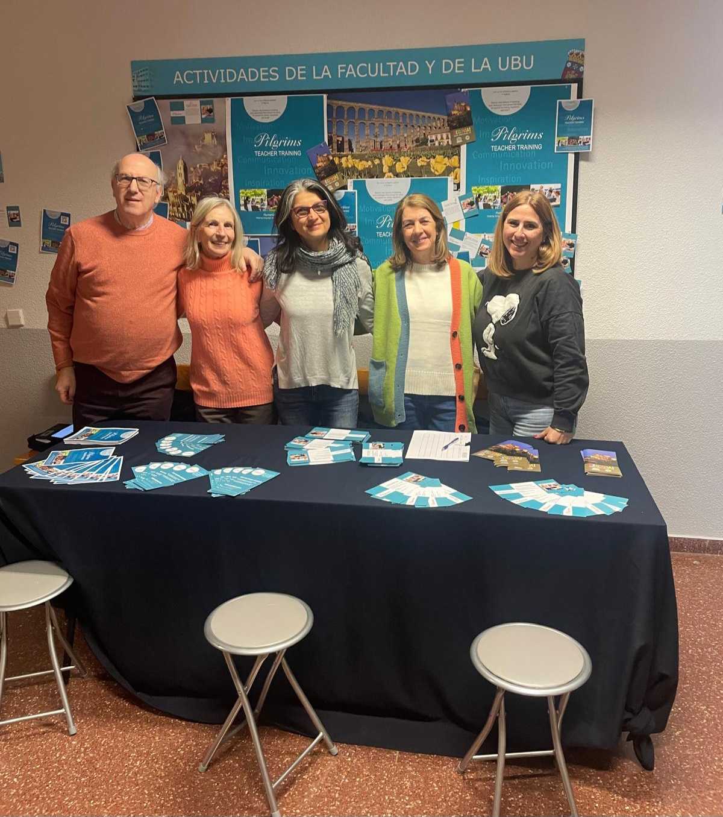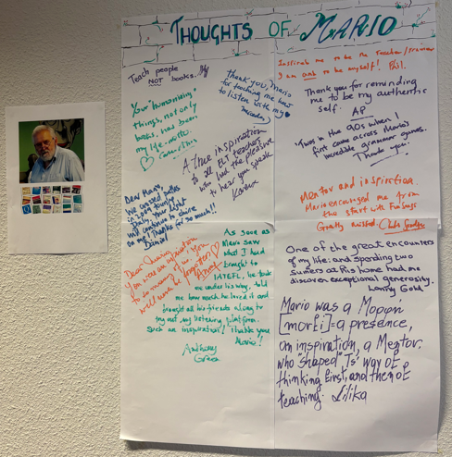

2. Talks and workshops by Pilgrims trainers

Out of the fourteen keynote presentations, two were given by Pilgrims trainers, and three other trainers gave workshops.

a. Phil Dexter Keynote presentation
‘Inclusive Learning Practices: creating effective learning environments for everyone’

Phil started his talk with the big picture: How, over 30 years after the UNESCO Salamanca Statement on inclusive education (1994) was wildly endorsed, classroom practice has not as yet managed to fully live up to it. He then talked about the most important features of effective inclusive classroom practice, first in general and then specially about some of what he called ‘special educational needs labels’ such as autism, etc. Now I’d like to share some concise, mantra-like tips he shared: ”Every learner matters and matters equally.” “In order to teach them, you need to reach them.” ”Let’s start from what the leaner can do; work through the ‘cans!” “Celebrate neurodiversity (cognitive difference)!”

b. Anna Pires Keynote presentation
‘Unlocking the Power of Visuals: teaching with music video’

In the title, Anna promised unlocking the power of visuals of music videos, and that’s exactly what she did, or even more as she worked with the music, too. I’d never seen anyone before to exploit a music video so much, use it in so many different ways. Let me list some of them: 1. Mindfulness: e.g. ‘Where do you feel the music in your body?’ 2. Sensory multimodality: ‘Describe the video using the senses’; 3. Work with the sound, the visual, the story, the meaning, e.g. clothes, people in the video, movements, facial expressions, discuss font types used in the video - why that? Culture related images from a video: what I see, what I think it means. This kind of complex work requires that the teacher knows a lot about the music, the lyrics and the visual aspect, too. Anna shared this link to a website where you can find songs with their lyrics and information about them: https://www.lyricslayers.com/.

c. Stefania Ballotto’s workshop
What about us, teachers? Activities to avoid burnout

Talking about professional burnout is depressing, isn’t it? No, definitely not when Stefy is in charge. After some personal chats and welcomes she gave us our first task: ‘Think of three beautiful things you saw on the way and tell your partner’. With this starting, in the first five minutes everyone had seven reasons to smile, and four implied pieces of good advice what to do not to experience burnout: be kind to people, observe and notice the good things, share the good you experience with others, receive the good shared with you. Stefy then shared with us the basics of the science of burnout and discussed what stress is and what stress is good and what is bad. Using the inventory by Christina Maslach, she then taught us what the symptoms of educators’ burnout are. We also heard about hormones that increase our good mood and how to trigger them. She also shared with us how her educator’s fire has been burning bright for a long time, what resources she relied on not to have burnout. Some other useful advice includes: massage, breathing exercises, meditation, speedwriting, yoga, doodling, doing something you’ve never done before.

d. Shawn Severson & Anabel Reis’s talk
Creative Learning Routes: engaging through active exploration

Anabel and Shawn shared with us many different methods of working with images in an exploratory way, meaning that the picture is created in a way and / or presented and worked with in a way that the image is open to multiple interpretations. Let’s see some of them! 1. Zoom in - zoom out of the picture and students guess what the image might contain, or what might be beyond the frame. 2. Picture dictation: Teacher has an image and describes as students are drawing the image. Then students dictate it back to the teacher, who draws it on the board. The drawings then can be used for speaking or writing tasks. 3. Using a combination of Visual Thinking Strategy (VTS) and the See, Think, Wonder (STW) framework: Start with the first question of VTS: “ What’s going on in this picture?” and continue the exploration with the STW framework. 4. Doodling: Ss are given a doodle and these instructions: Use your imagination to finish the picture. Remember to add details. There are no right answers. This is NOT e.g. a cloud. Then another student gets the finished doodle and writes what it is and two more sentences to describe it. The presenters recommended this website: https://artsandculture.google.com/play, where you can play with images, create, design, describe and interpret them collaborating or competing with AI.

e. Judit Fehér’s workshop
What do you do, teacher?

Yes, I also had a workshop, the aim of which was to reflect on and talk about the broader context of our work, and its impact on this broader context. We started by working with our own values, completing this sentence starter: I teach so that my students … , and then using the NLP method of chunking-up, we found our core value regarding the aim of teaching. Based on this and using quotations and an activity featuring hyenas, we had a chance to look at ourselves as humanistic teachers, who care for the individuals and who work to enrich their lives. Next, using the Children’s Manifesto https://www.theguardian.com/education/2011/may/03/school-i-would-like-childrens-manifesto, which summarises the basic findings of the Guardian survey that asked children this question: ‘What kind of school do you want?’, we listened to children’s opinions and compared them with our ideas. These ideal interpretations of education were then briefly contrasted with the social – political context of education following Noam Chomsky’s opinion that ”Education is a system of indoctrination of the young.” Reflection and research question to all of us: How has education contributed to the major conflicts we face today?

3. Pilgrims as a sponsor of the event

The main prize of the conference raffle was granted by Pilgrims: a free one-week course in Segovia this summer.

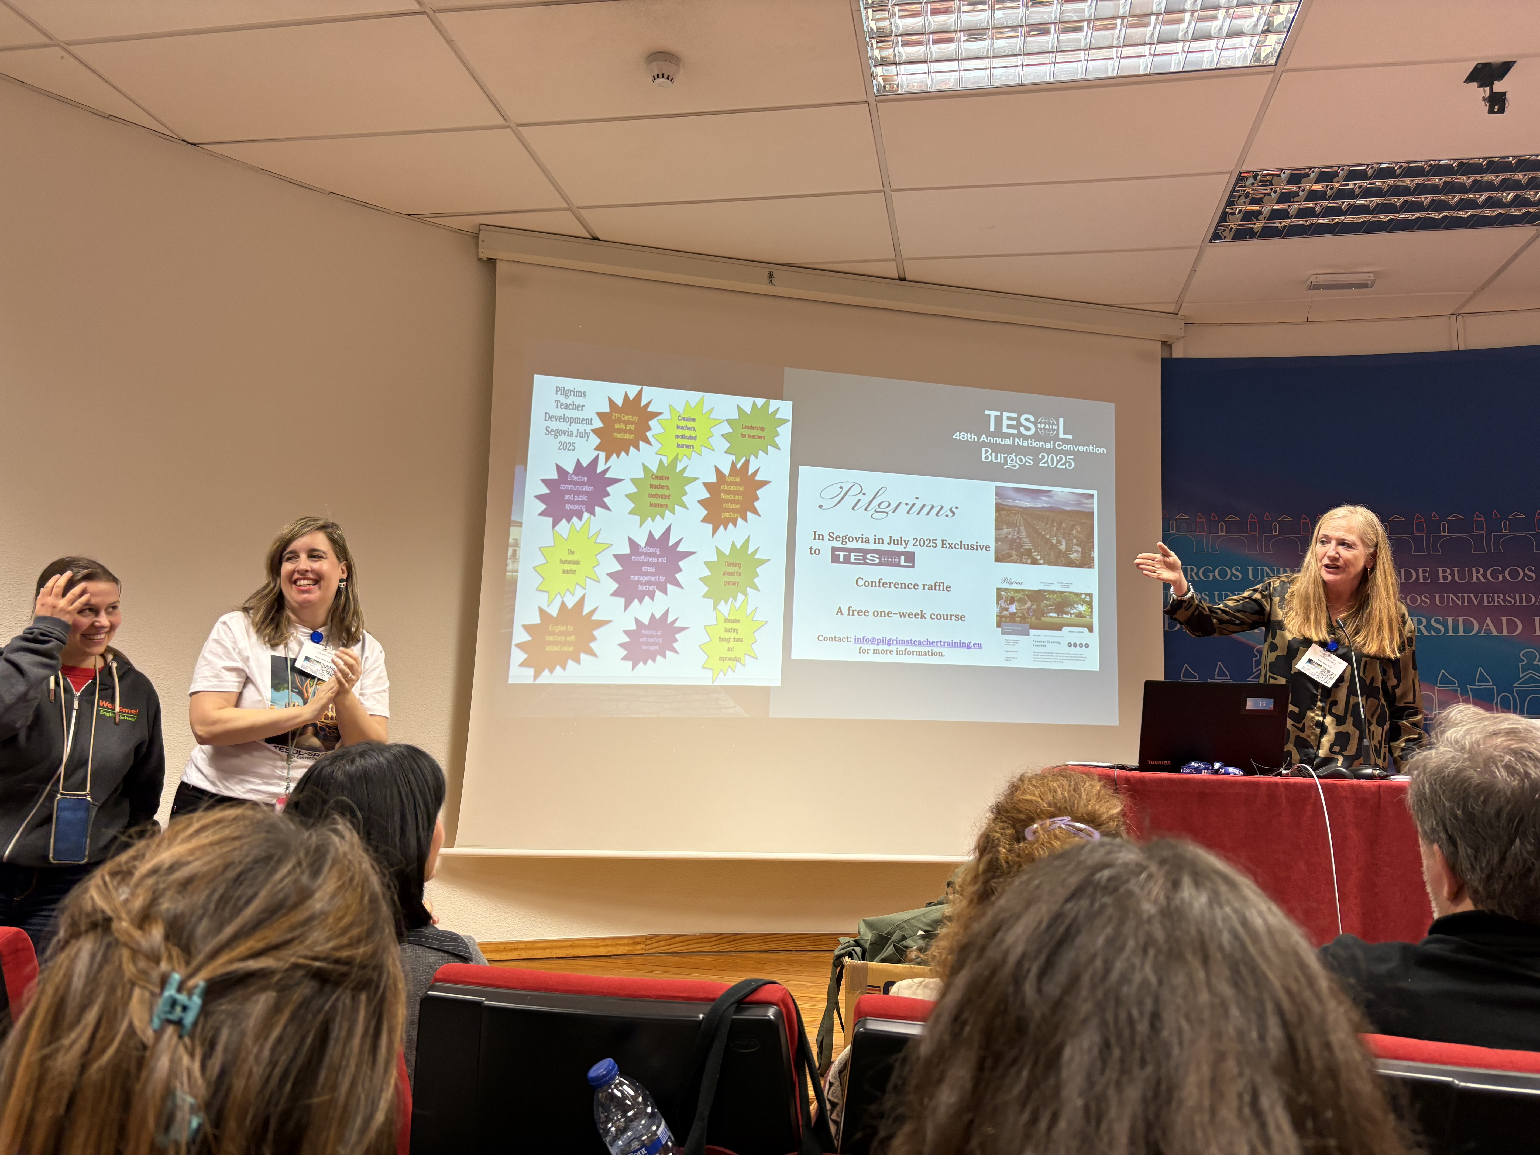

The 48th Annual National Convention of TESOL Spain was a great event both on a personal and professional level. I have learnt a lot and enjoyed the event, the people, the city and the culture immensely. A big thank you to the organisers, the volunteers and everyone else who made this event possible with their work, support, participation and presence. Thank you!

And finally, special thanks to my colleagues who took the photos and let me use them here.

Please check the Pilgrims in Segovia Teacher Training courses 2025 at Pilgrims website.

Please check the Pilgrims f2f courses at Pilgrims website.

