Ruby’s Story
Chrysa Papalazarou, Greece
Chrysa is currently involved in the administrative side of education, but before that she has taught English to students of all ages for more than twenty years alongside writing, presenting and publishing about her endeavours to use art and foster the development of creative thinking in the ELT classroom. She is interested in how artworks can introduce wider world issues to students, promote values, and contribute to a more thoughtful and creative flow in English language teaching and learning. Chrysa has created Art Least, a site on art, thinking and creativity in ELT. Chrysa is a member of the C Group and the Visual Arts Circle. She is also a member of “Worlds into Words”, an international creative writing group. Email: hryspap@yahoo.gr
Introduction
This article describes and reflects on a learning scenario for a group of 10-year-old 5th graders (A1+ language level). The scenario involved carefully observing Norman Rockwell’s painting “The Problem we All Live With”, describing, guessing, telling and writing a short story, and doing some relevant interactive work. The aim was to draw attention to the lack of tolerance towards difference as central in issues of intolerance and racism.
Background
“All about stories” is the topic of the specific coursebook unit aimed at young learners of English in the 5th grade of primary school. It introduces the past progressive verb tense and revises the past simple verb tense through the framework of stories. Fairy tales, a ghost story, a detective story, the story of the Titanic were some samples of story excerpts used in the unit.
Stories are powerful. They grab attention, make students curious, they make them think. Still, I felt that there was scope for making more of the power of stories, beyond the text material presented in the coursebook. This is when the idea came to mind to bring into class the story of Ruby Bridges; the vehicle being Norman Rockwell’s painting “The problem we all live with”.
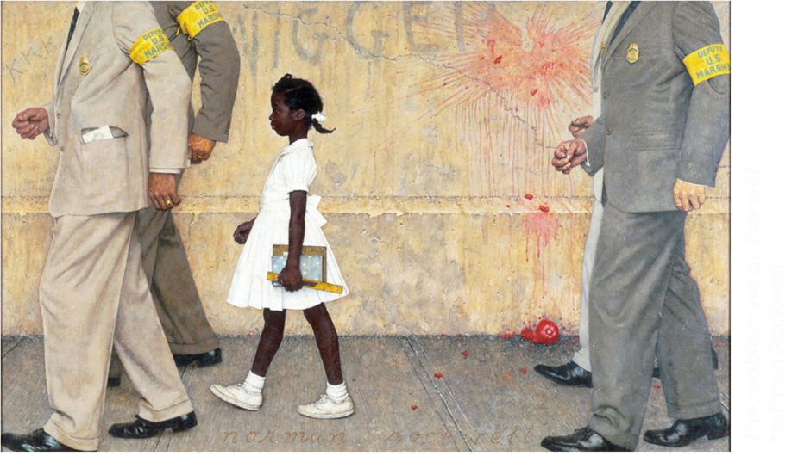
Figure A: The problem we all live with (1964) by Norman Rockwell
“The problem we all live with” is an iconic image of the Civil Rights Movement in the USA. It depicts Ruby Bridges. She was the first African-American child to attend the all-white William Frantz Elementary School, in the state of Louisiana, during the New Orleans school desegregation crisis in 1960.
Building the story
I initially framed the procedure as a viewing/describing activity towards collaboratively building the story through prompts. For the prompts I used the typical journalistic questions: Who? What? Where? How? Why?
I first introduced the painting by saying: “Well, this is Ruby…”, and then invited the children to go on with the story, prompting them to respond by providing answers to the questions:
- Who was she?
- What was she doing/carrying/holding/wearing?
- Where was she going?
- How did she look?
- Was she walking alone?
- Who was walking with Ruby?
- Why do you think they were walking with her?
This was a speaking, listening and note-taking phase. The students were speaking, listening to their classmates’ ideas and they were taking notes. I used the board throughout this time and jotted down key words or phrases that came up during the activity so as to aid students in a) orally narrating the story and b) the note-taking process. The story was built gradually. Individual students narrated it from the start, repeating the body of the story that had already been told so far and adding each time the new elements that came up after a new question was posed.
So, what started as “Ruby was a little black girl” after all the questions were posed, took the form of a short story, Ruby’s story, as seen and understood through students’ viewing and describing the elements of the artwork.
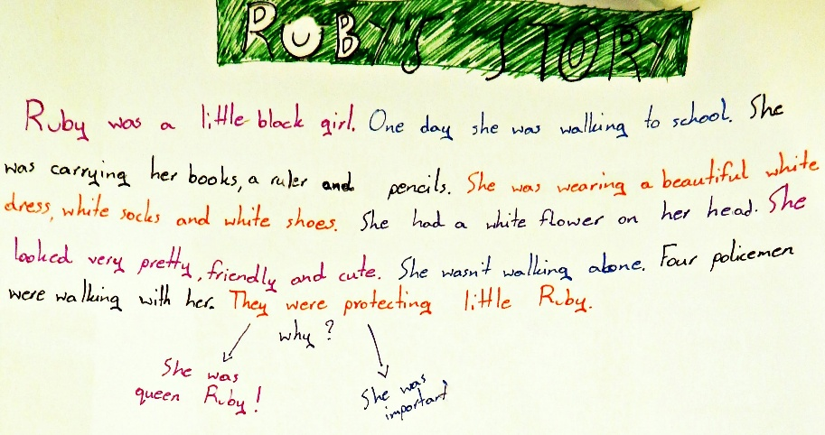
Figure B: student writing
Students were very happy and curious with Ruby’s story. They liked the painting and they also liked this beautiful little black girl.
They were also curious about the four policemen walking with Ruby and came to the conclusion that they were protecting her because she was an important person, a queen or even maybe the president’s daughter, making associations with a former USA president.
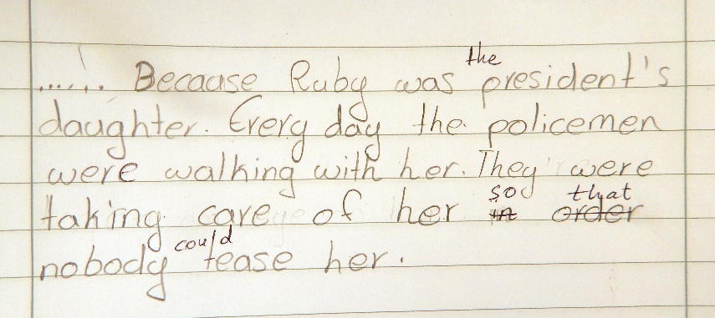
Figure C: student writing
What more can we find? Ruby’s real story unfolds
Then I started drawing their attention to other details in the painting by asking:
- Look carefully, what more can we find?
We started developing the real story. They first noticed the tomato splash on the wall and the tomato on the ground. I asked them:
- What do you think about that?
- What was happening?
Students were surprised to realise that “Oh! people were throwing tomatoes”. Then they noticed the word Nigger on the wall above Ruby and they asked: “What is a Nigger?” I explained in simple terms that this is a racist word to talk about black people. They finally noticed the letters KKK on the top left corner of the painting and again they wanted to know what they stand for. I said that it is an organisation in the USA that terrorises black people.
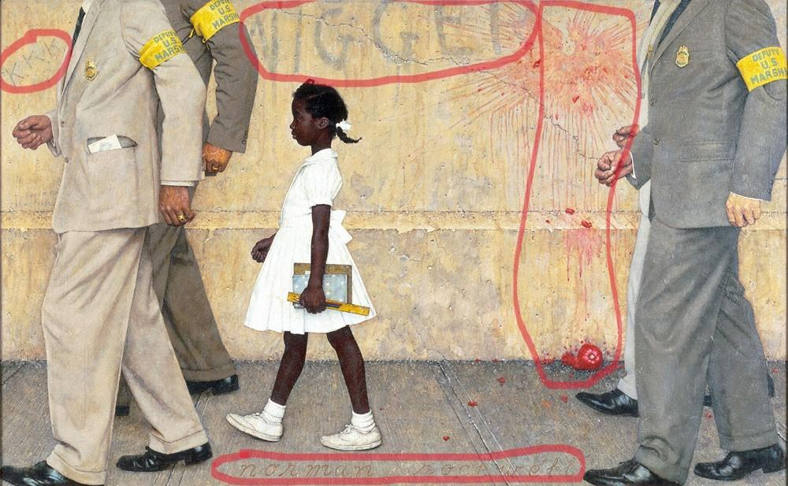
Figure D: details in the painting
The new pieces of information were added to our initial notes about Ruby. It was at this moment that the students were shocked. They felt sad and angry at the same time. They had grown to like Ruby so much that when the actual story unfolded in front of their eyes, they felt it was unfair. It was an apt moment to ask:
- Why do you think that people were reacting like that?
It seemed the students intuitively remarked that this had happened ‘because she wasn’t white, she was different’.
I then told them where and when the incident took place.
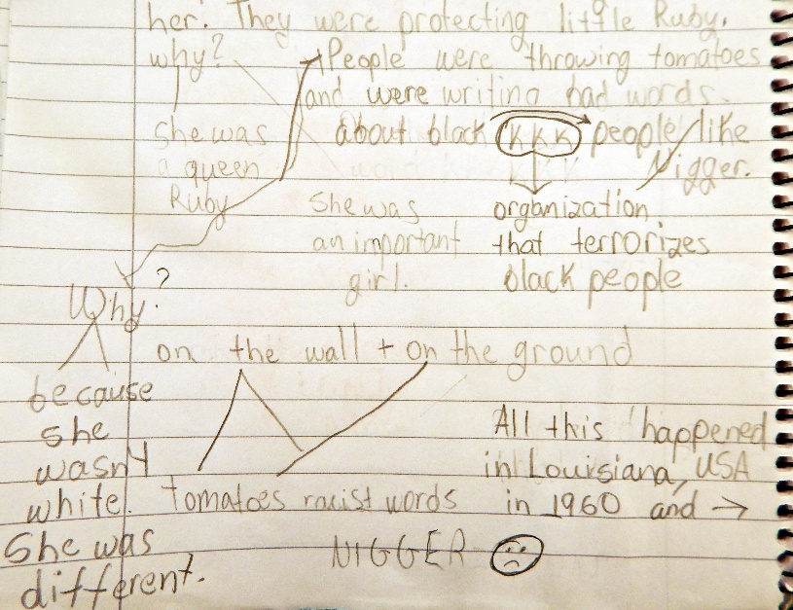
Figure E: student notes
We also moved from racial intolerance to the racism of our everyday life. I asked them to look at each other and notice how different we are in terms of height, weight, whether we are strong or less strong, the things we like and so on. We are all different. It was about raising awareness of intolerance towards difference: the more “different” the other is perceived, the stronger the fears and negative feelings tend to be.
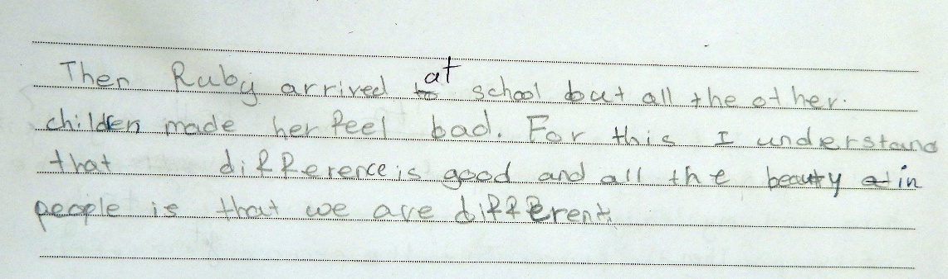
Figure F: student writing
Interactive work on Ruby’s story
I developed a course presentation with interactive slides (12 slides with 8 micro-activities) to provide further opportunities for students to:
- consolidate and revise relevant language
- build empathy and understanding of multiple perspectives
- expand their knowledge on Ruby Bridges, the state of Lοuisiana and the painter Norman Rockwell
Slides 1-7 involve self-assessment vocabulary activities (drag and drop), reading comprehension activities (multiple choice, gap fill), and focus on language structures (Past Progressive identification and Past Simple & Past Progressive gap fill).
Slide 8 is an interactive video (hotspots with questions and information) where Ruby Bridges talks about herself and the painting.
Slide 9 is group work with the aim to build understanding of multiple perspectives.
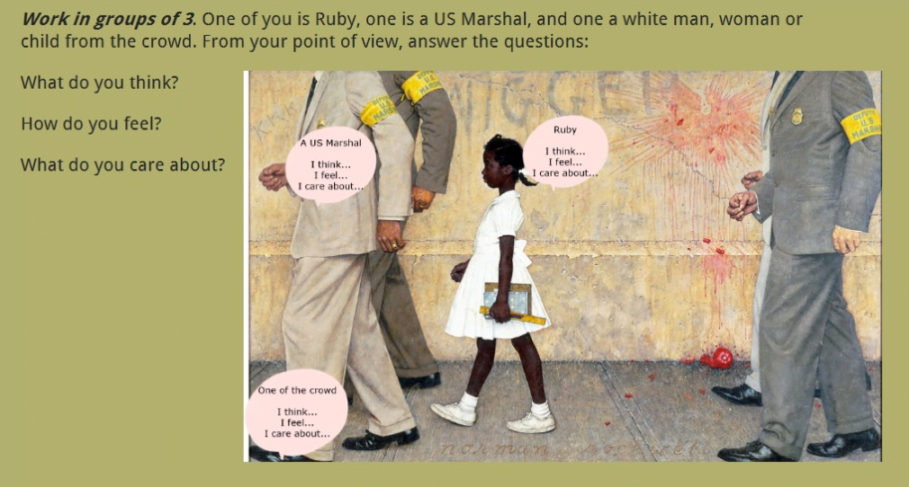
Figure G: slide activity
Slides 11-12 ask students to prepare a word doc or a ppt presentation about Louisiana or Norman Rockwell.
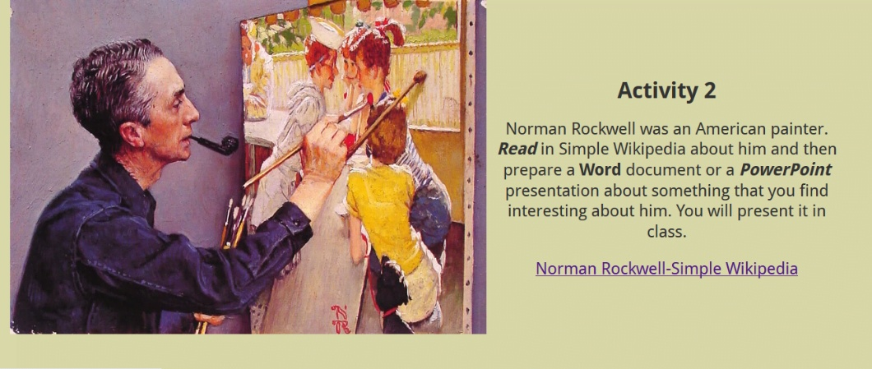
Figure H: slide activity
The interactive course presentation can be accessed here: The problem we all live with

The fabric of this learning experience
This learning experience combined language, art, visual literacy, and social awareness. Learning points included the following:
In terms of language:
- eliciting and introducing vocabulary relevant to the artwork
- using Past Simple and Past Progressive to narrate a story
- encouraging speaking and active listening i.e. listening that utilises their classmates’ ideas and opinions
- practising note-taking and realising its importance as supportive material in writing activities
- collaboratively building a story
- fostering students’ writing skills through paragraph writing
- having students self-assess relevant language through a series of interactive activities
- fostering a cross-thematic approach by linking English with Art, History, Geography and Social Studies
In terms of visual literacy:
- encouraging visual literacy micro-skills of careful viewing, observing, describing and analysing (artwork details)
- encouraging students’ visual literacy micro-skills of visual thinking and visual representing by allowing meaning-making through both modes i.e. images and language, as observed in their notes, stories and posters
In terms of art and creativity:
- encouraging students’ creative expression
- helping students understand how art and artists are often influenced by their socio-political context
In terms of social awareness:
- raising awareness of the importance of tolerance towards difference
- developing students’ critical thinking so as to approach issues relevant to equality and social justice with an open mind
In conclusion
Ruby’s story is a real story and real stories help students develop real world connections. They trigger curiosity, self-initiated work and further research. My students made booklets with illustrations, handmade word clouds, and little posters. I think what happened to Ruby spoke highly to children’s hearts and minds.
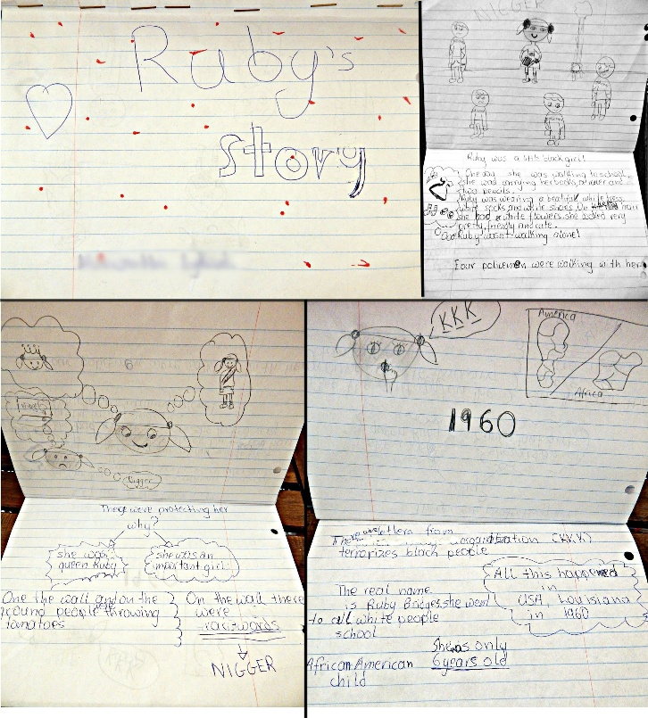
Figure I: student booklet with Ruby’s story, handmade
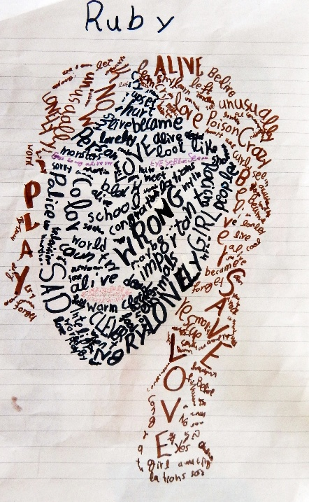
Figure J: student word cloud, handmade

Please check the Pilgrims in Segovia Teacher Training courses 2025 at Pilgrims website.

Please check the Pilgrims f2f courses at Pilgrims website.

