TESOL Greece Annual International Convention 2025: A Photo Diary

Hanna Kryszewska, Pilgrims trainer

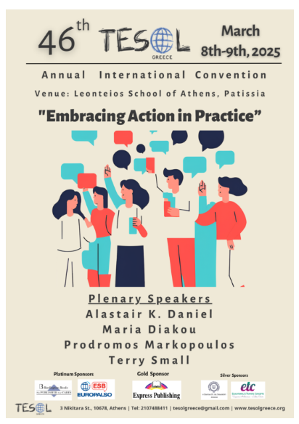

Actually, the event started on the Friday, the evening before, with a Speaker’s Dinner in one of the Plaka restaurants. This was also our first view of the Acropolis. Later we saw the whole area flood lit.

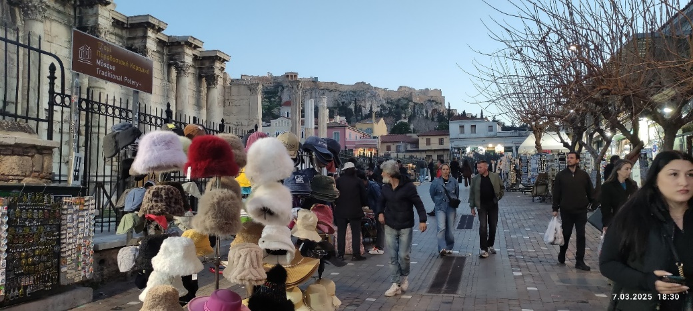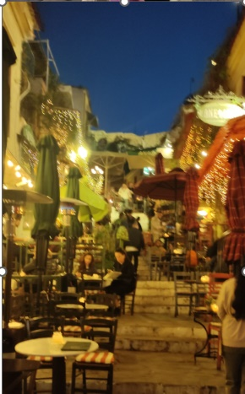

The event was great with fantastic atmosphere and delicious grilled meats and other traditional Greek dishes.

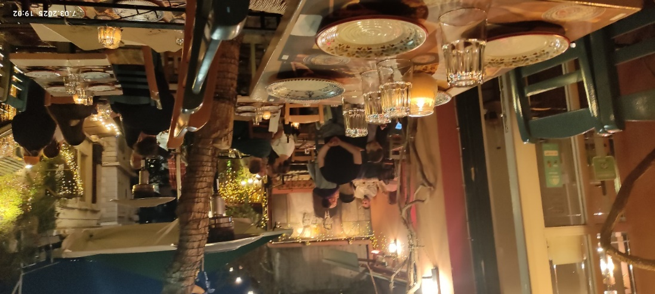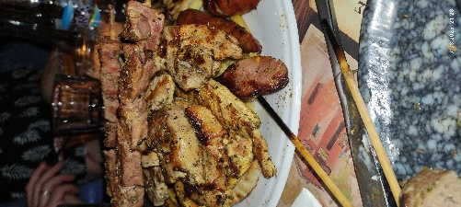

And of course… some dancing to Greek music, and endless chats. What a lovely way to bond before the conference!

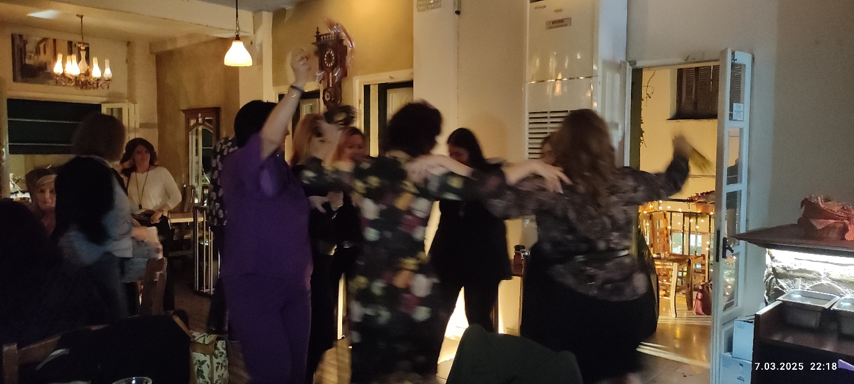

The next day, on Saturday morning, the conference started. The venue like at TESOL Paris was a secondary school, which gives the event a nice air of authenticity and reminds us of what teaching is all about.

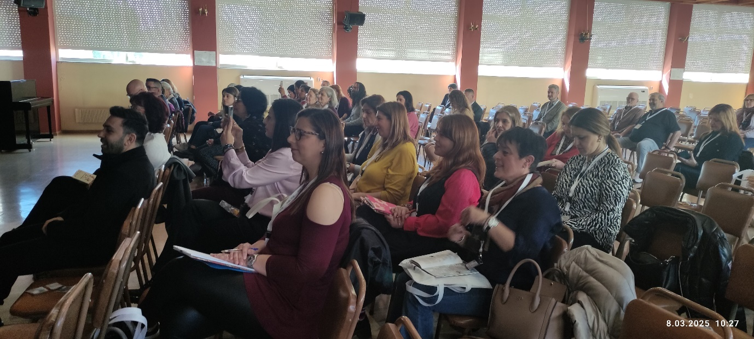

As for the sessions I will just mention a few but believe me it is really difficult to decide which ones to focus on and write about.

Prodromos Markopoulos talked about STEAM in Action. As the representative of Lego Education Academy he talked about the advantages and principles of teaching with Lego.

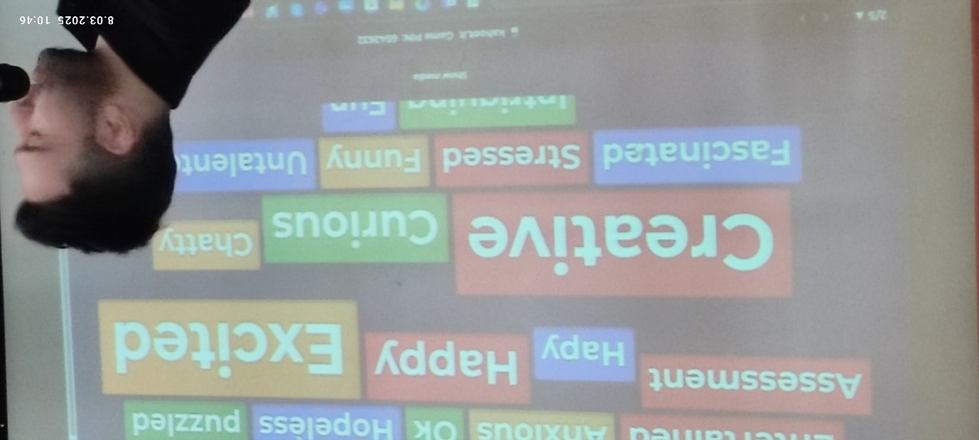

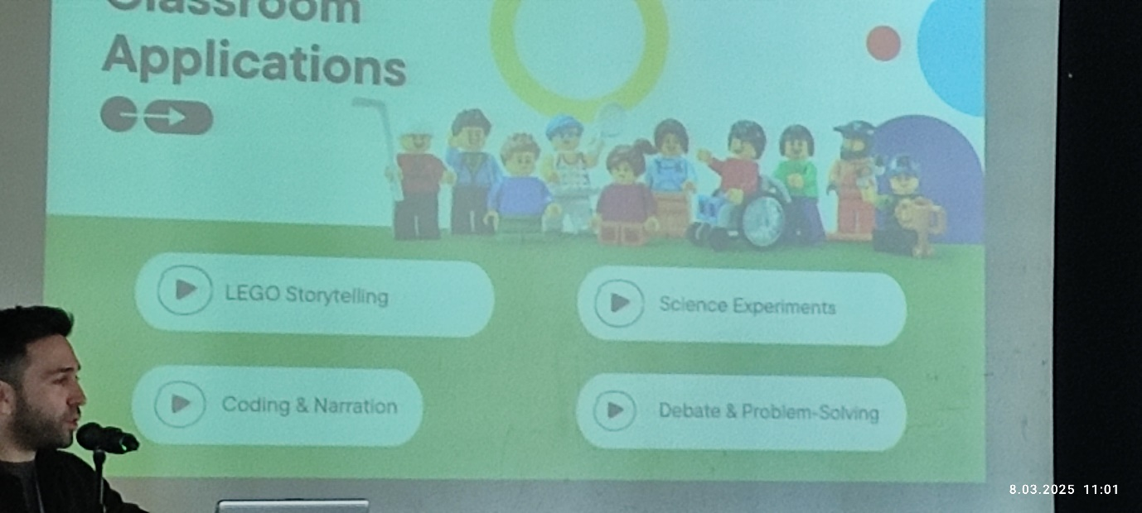

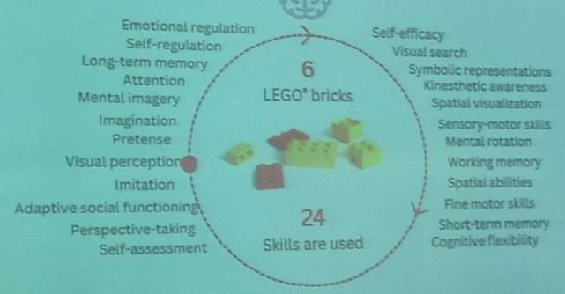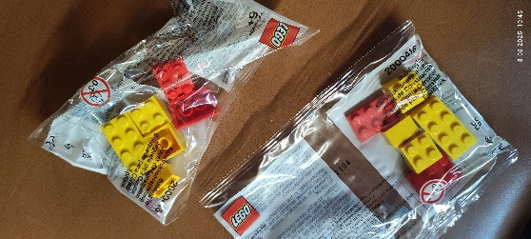

Needless to say, we were all given a small bag with a set of Lego blocks and had a task to do: build a duck from six blocks. It was amazing how the birds differed from each other and how much they proved the point about creativity and problem solving.
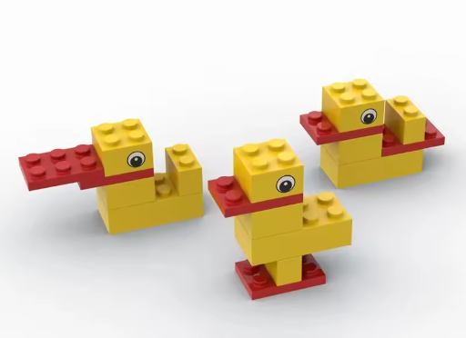

A session that I found very interesting was the one by Susan Stetson-Tiligadas who gave a talk on using AI to plan lessons. She talked us through her experience, her own development and the development of her technique and skills, various traps she encountered and how she educates pre-service and in-service teachers to be critical of what AI offers and how to take advantage of what it offers. She presented a number of lesson plans, and I hope that she will agree to run a column for HLTmag readers on how to plan lessons with AI.

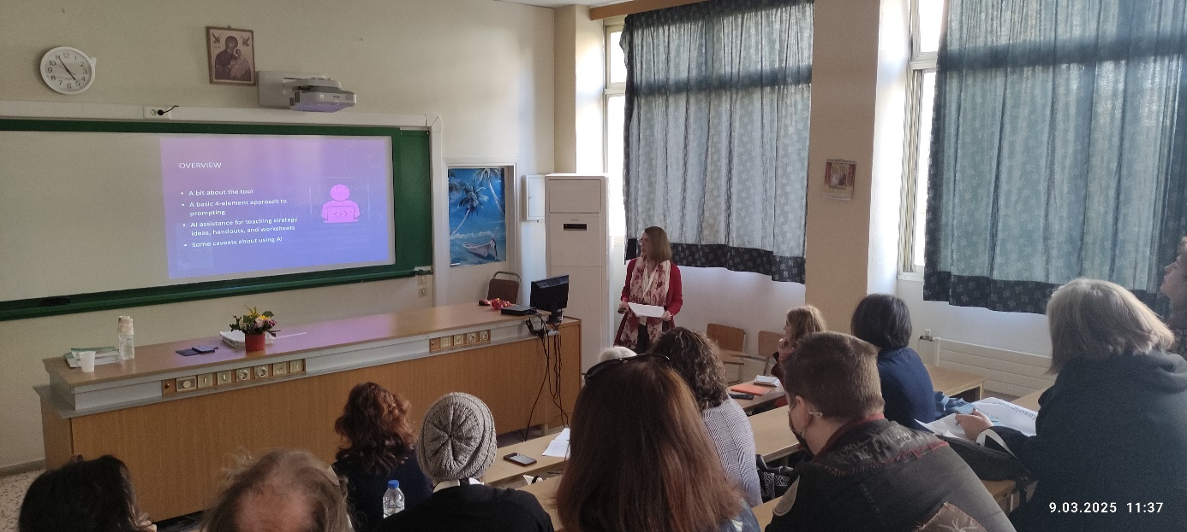

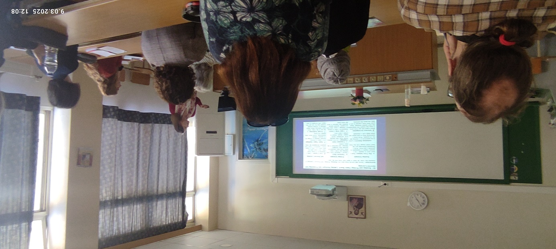

Alistair Kevin Daniel’s session on story telling was a real treat. Not only was it very informative but he also gave us a sample of his art when it comes to story telling.

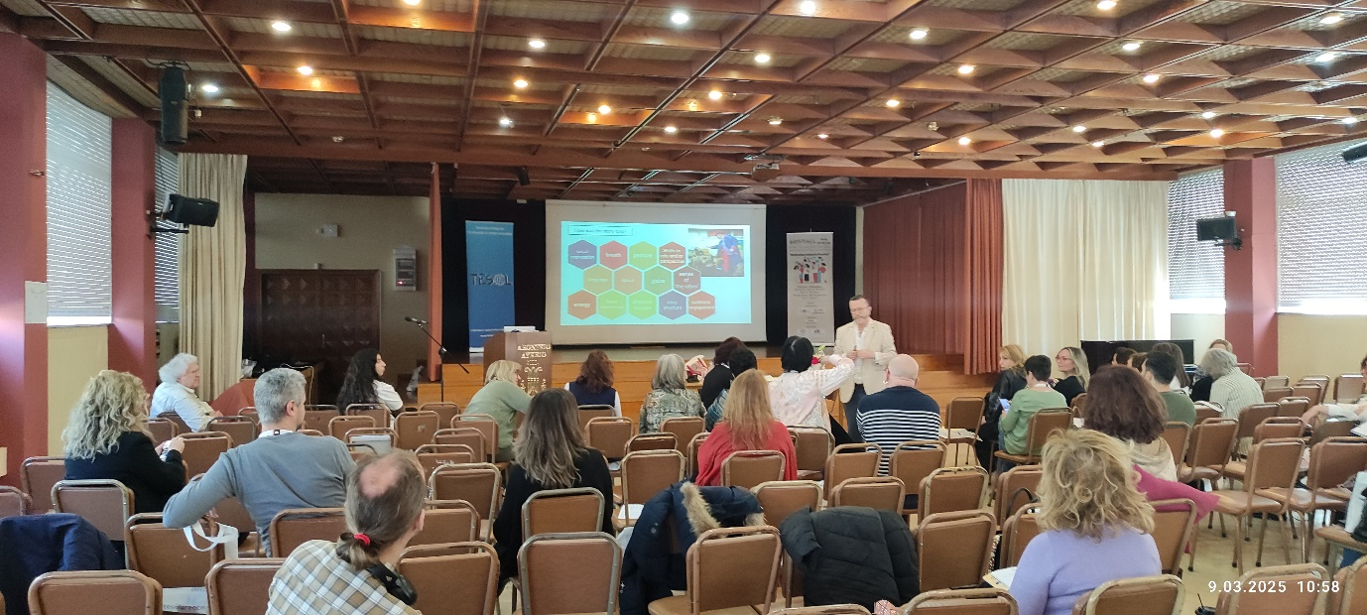

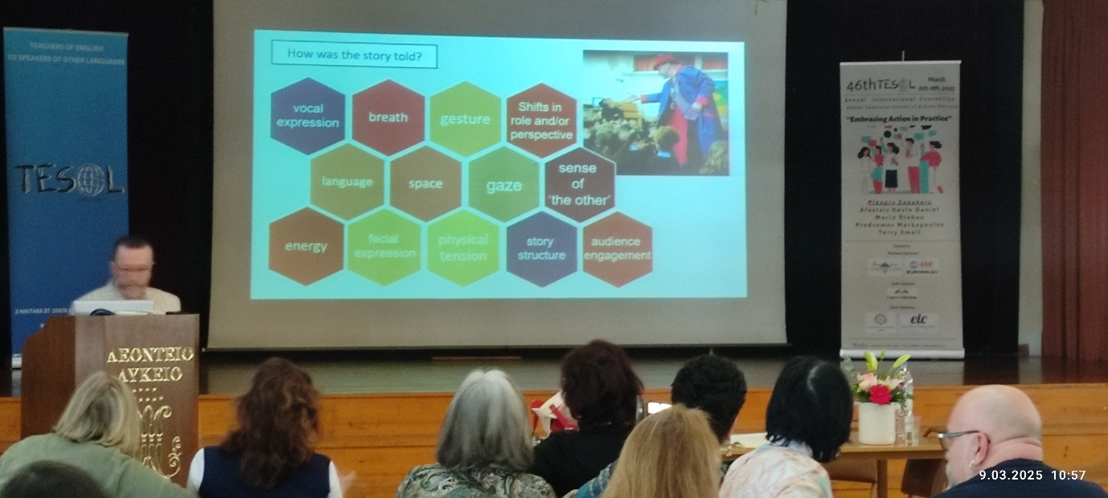

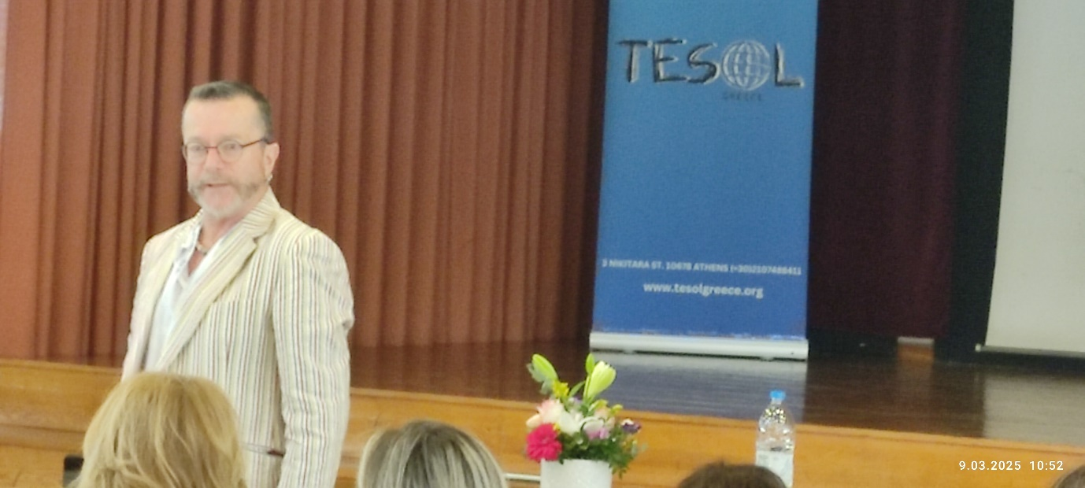
As usual it was great to meet good all friends, to touch base and make plans for the future.

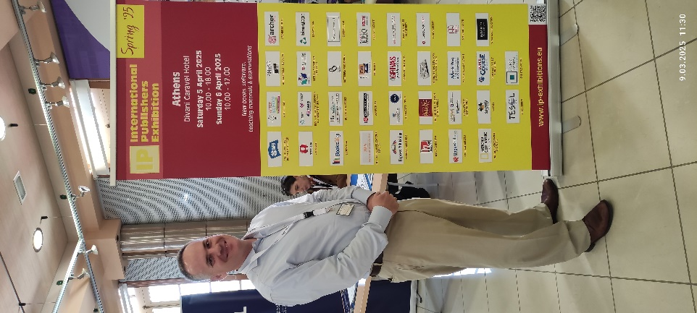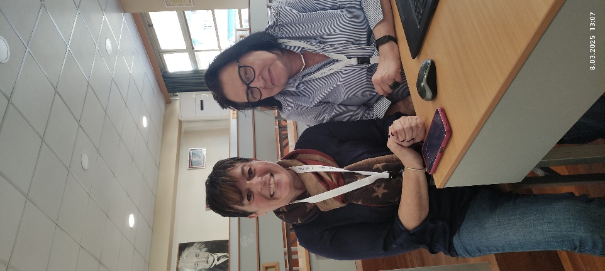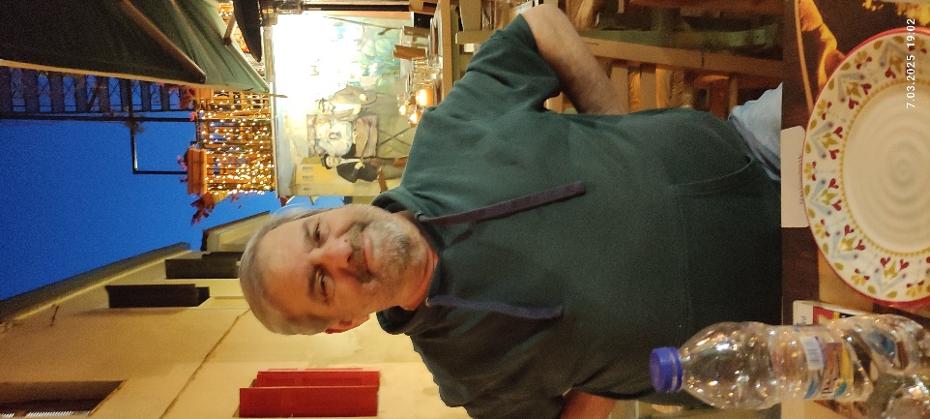
The photo below captures one of the last moments of the conference when the old Board handed over to the newly elected Board. Thank you Maria for your hard work, welcome Chryssanthi. All the best to you all in your new roles. You are doing a great job.
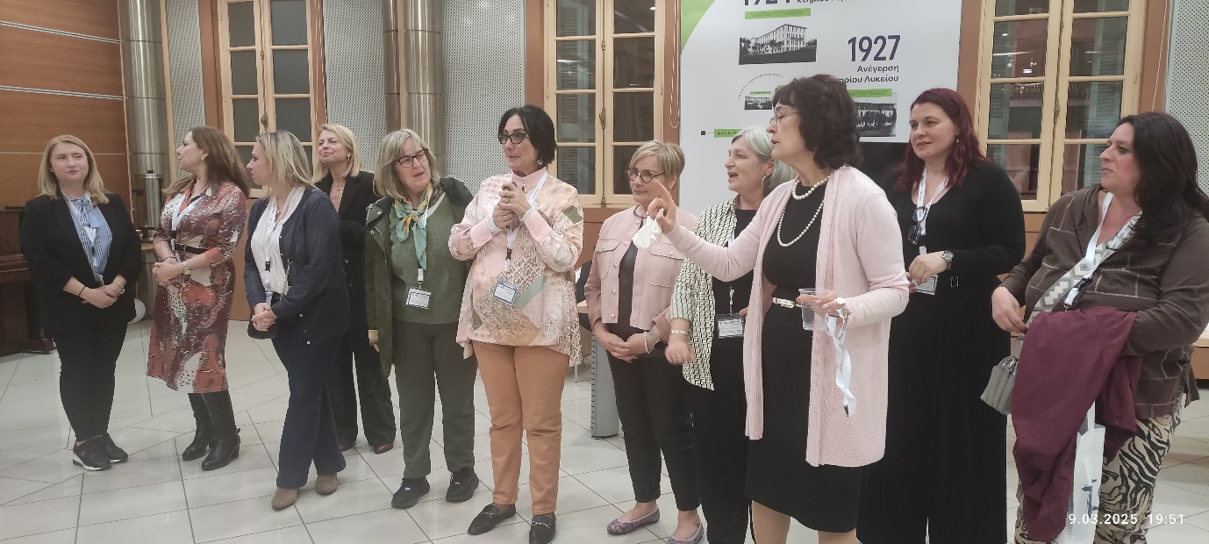
So, until we meet again. Acropolis Adieu… like in the song…

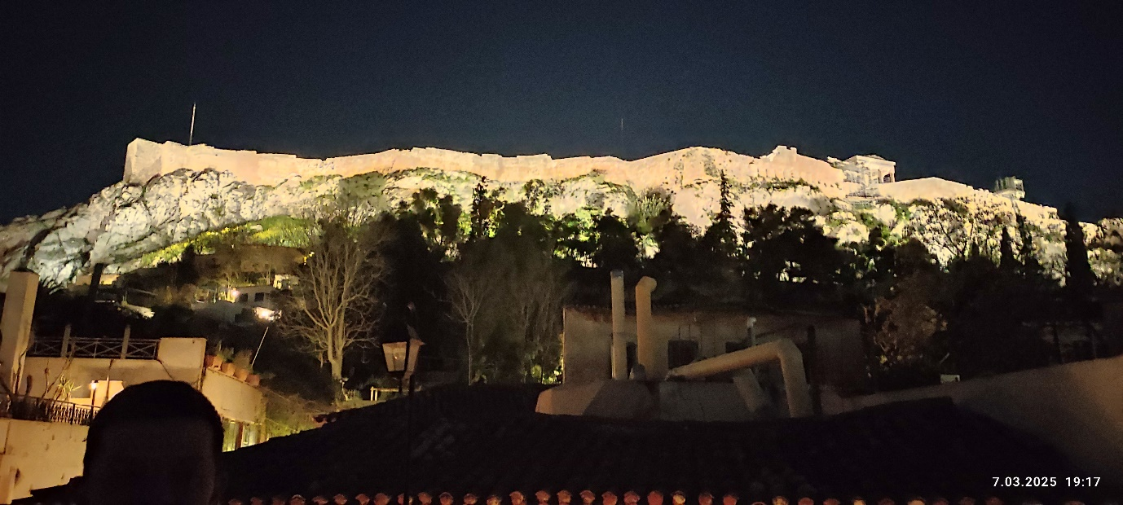

Please check the Pilgrims in Segovia Teacher Training courses 2025 at Pilgrims website.

Please check the Pilgrims f2f courses at Pilgrims website.

