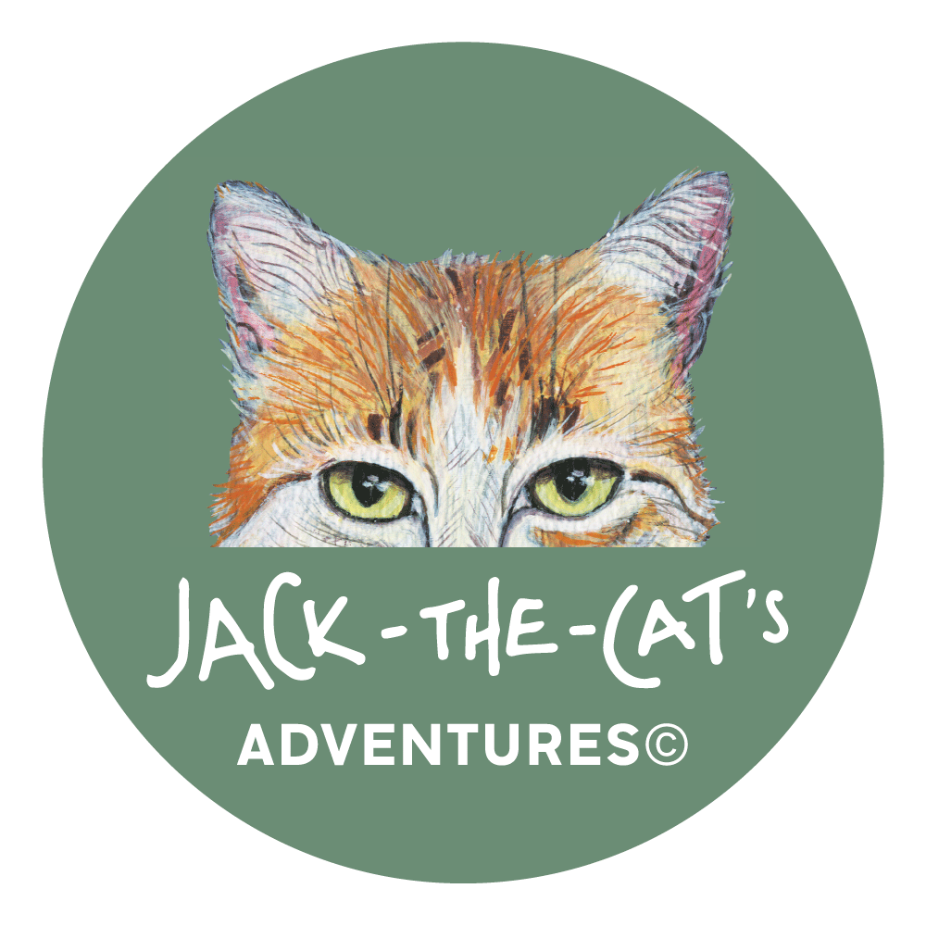

From Cat Tales to Classroom: Empowering Children Through Storytelling

Sezgi Yalın - United States/Cyprus

Sezgi Yalın is a freelance Pilgrims and CELTA teacher trainer and children's author. She aims to inspire self-fulfillment through her Jack-the-Cat's Adventures© children's book series. Sezgi seeks to educate and inspire, and always finds that others inspire her in return.
Email: sezgiriza@yahoo.com

Background

My journey as an educator began in diverse classrooms across the United States and in several other countries, where I gained experience in ESL/EFL teaching and teacher training. However, my true understanding of the learning process deepened significantly when I became a mother. Thirteen years ago, I welcomed my daughter, Dünya Nova, into the world. This transformative event shifted my perspective, moving me beyond the realm of theoretical pedagogy and into the realm of real-world, hands-on learning, particularly with young learners.
Dünya Nova and I embarked on numerous travel adventures during her early years. Our mission on these journeys was to discover English-language books about each country we visited, to learn about their unique history, culture, people, and natural wonders. This led to the accumulation of a diverse and fascinating collection of books from around the globe.
The books we encountered during our travels often presented factual information in a straightforward manner. However, I noticed a significant gap: a lack of engaging narratives to captivate young minds. This observation became the driving force behind my own children's book writing endeavors. I sought to create stories that blend factual information with captivating narratives, making learning both enjoyable and informative. These books would not only entertain but also serve as the foundation for the interactive workshops I now conduct with young learners here in Cyprus at primary schools, and one of which I intend to share with you here.

Meet Jack
Before settling in Cyprus, I lived in the USA. Upon my return to Cyprus, I brought with me a cherished companion: my cat, Jack. I vividly recall taking him to my mother's garden for the first time – a lush oasis of lemon and orange trees, a quintessential Mediterranean scene. I watched Jack, who had been confined to our apartment in Chicago, explore the garden with boundless energy, chasing butterflies with playful abandon. This sight sparked an idea: to tell the story of a cat's journey from a bustling city to a tranquil island. The underlying message: to pursue one's dreams, just as Jack was doing, albeit in his feline way.
Years later, my vision materialized. Jack-the-Cat's Dream, illustrated by the Greek Cypriot artist Louiza Kaimaki, was published in four languages: English, French, Greek, and Turkish. In addition to translating the book into French, the French Institute of Cyprus (Institut Francais) also produced a teacher's manual to be used with the French book.
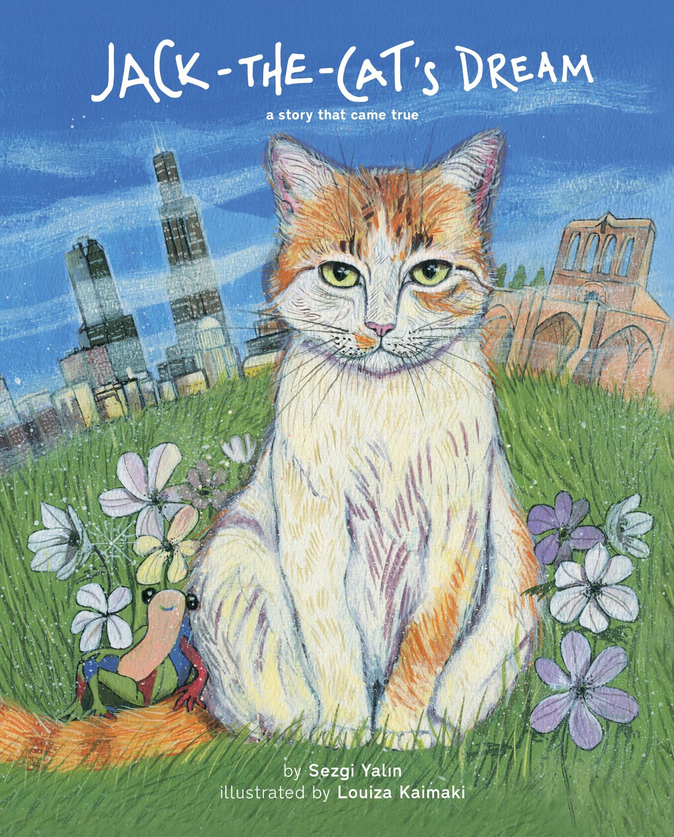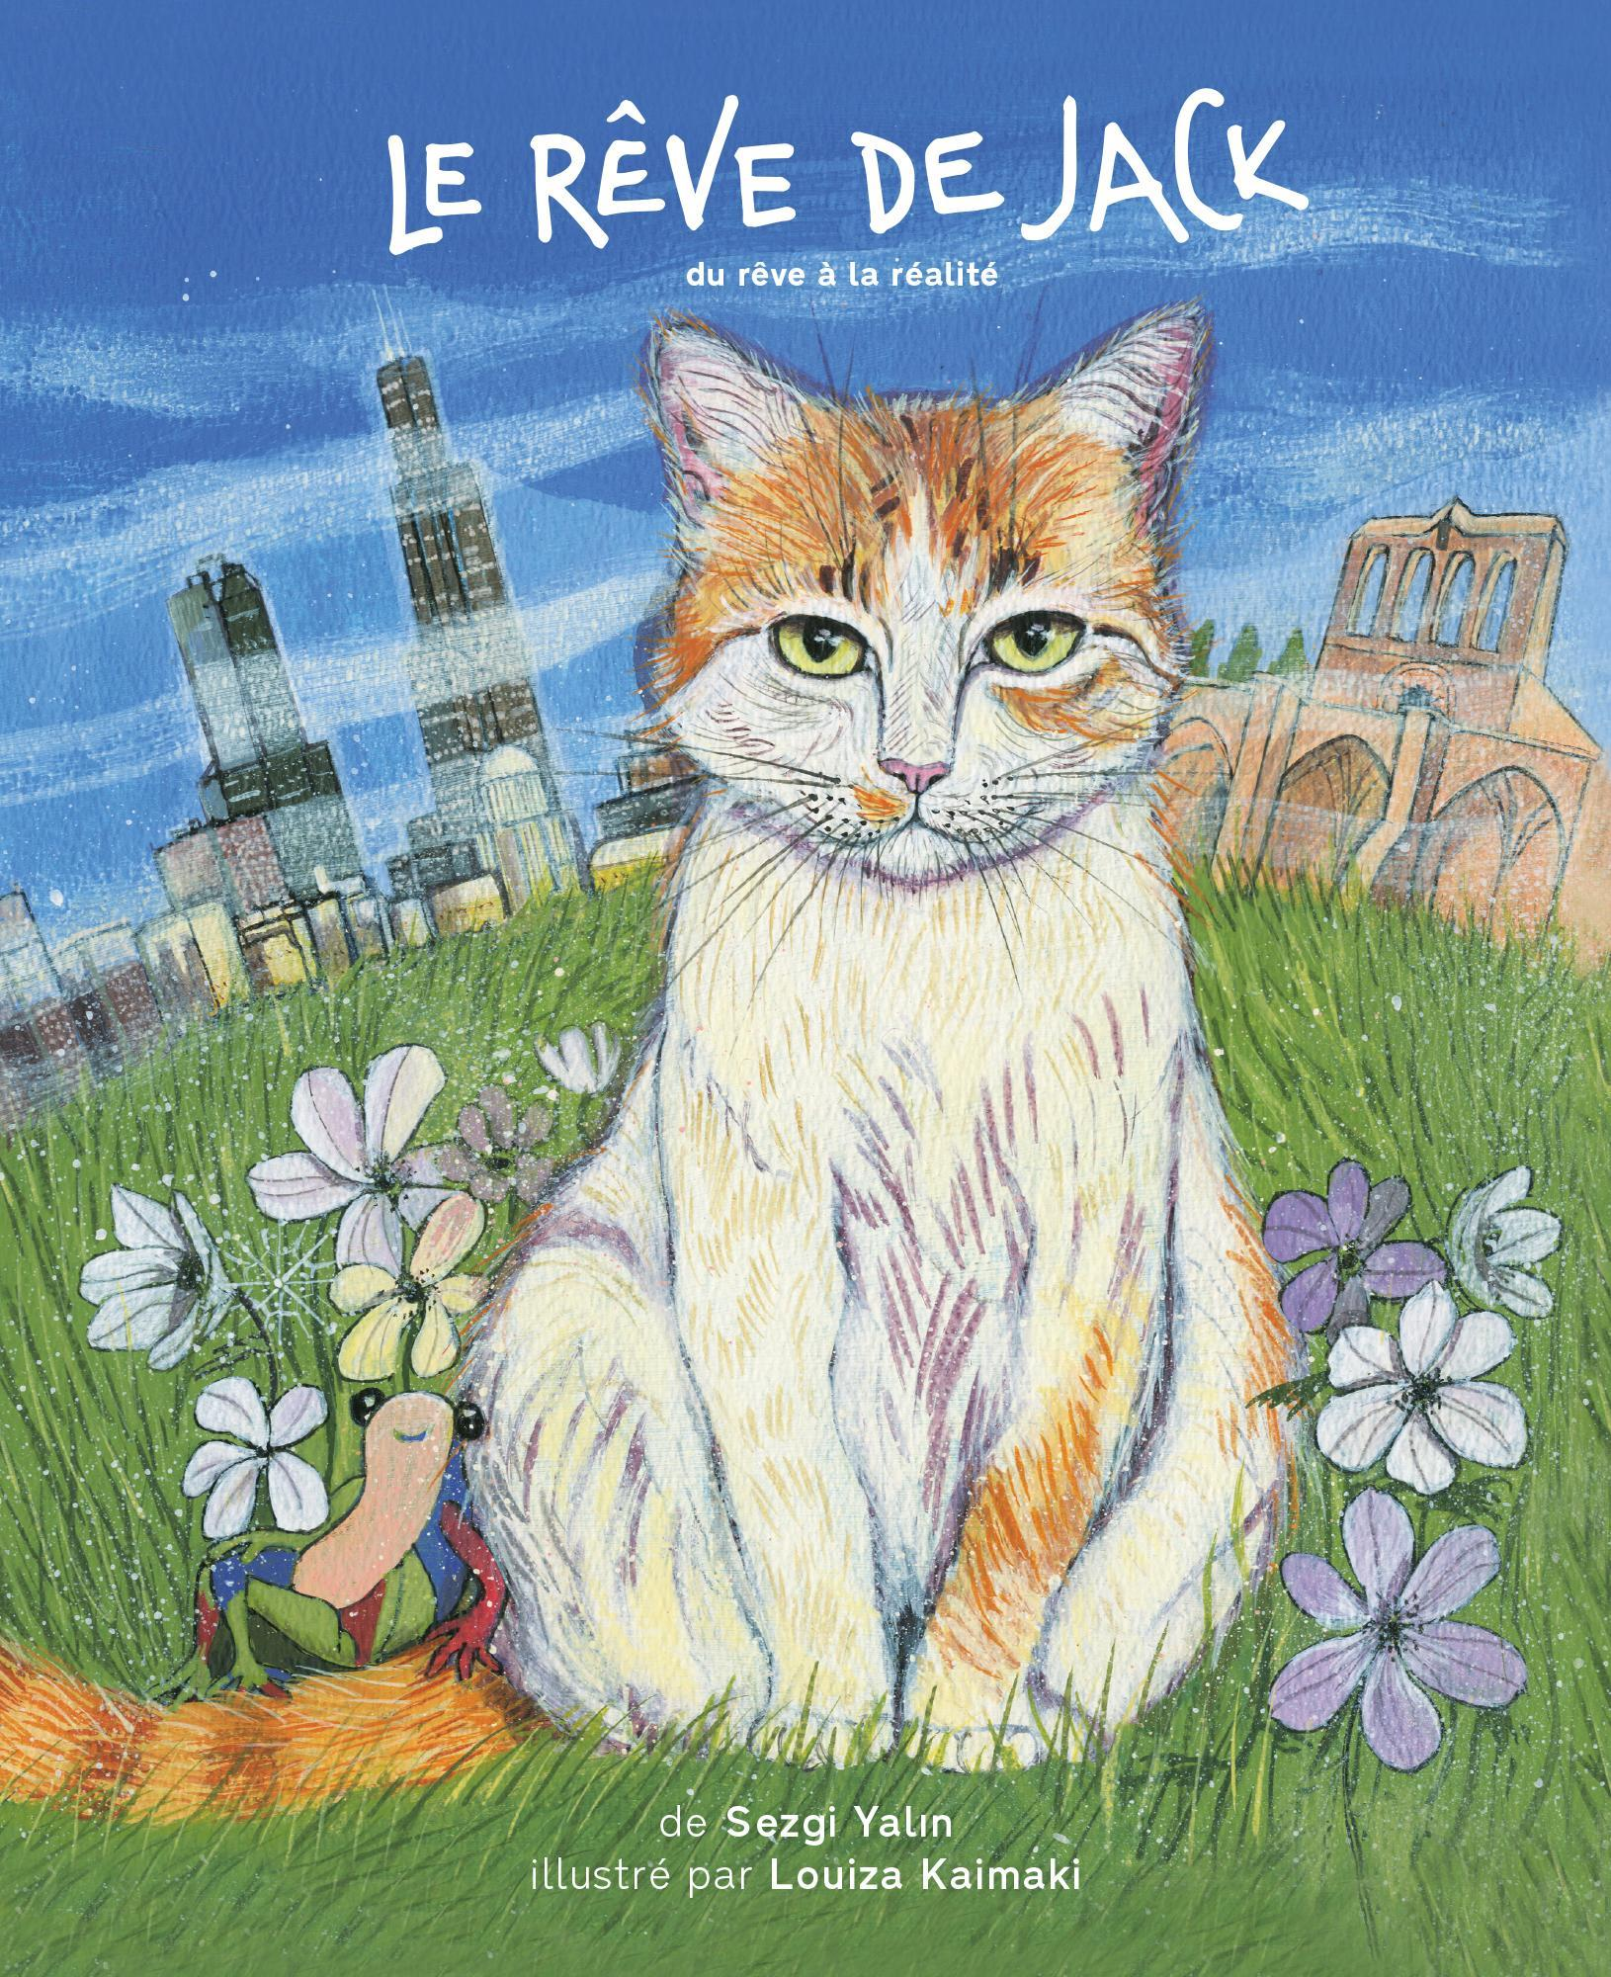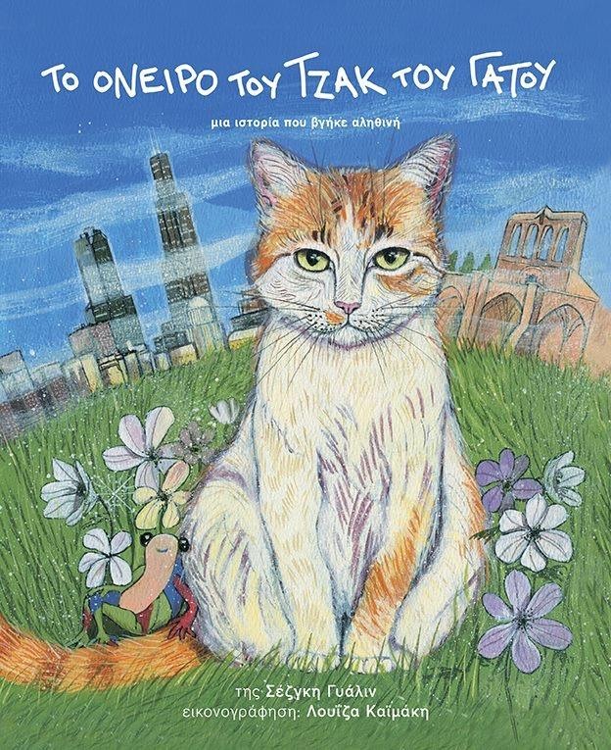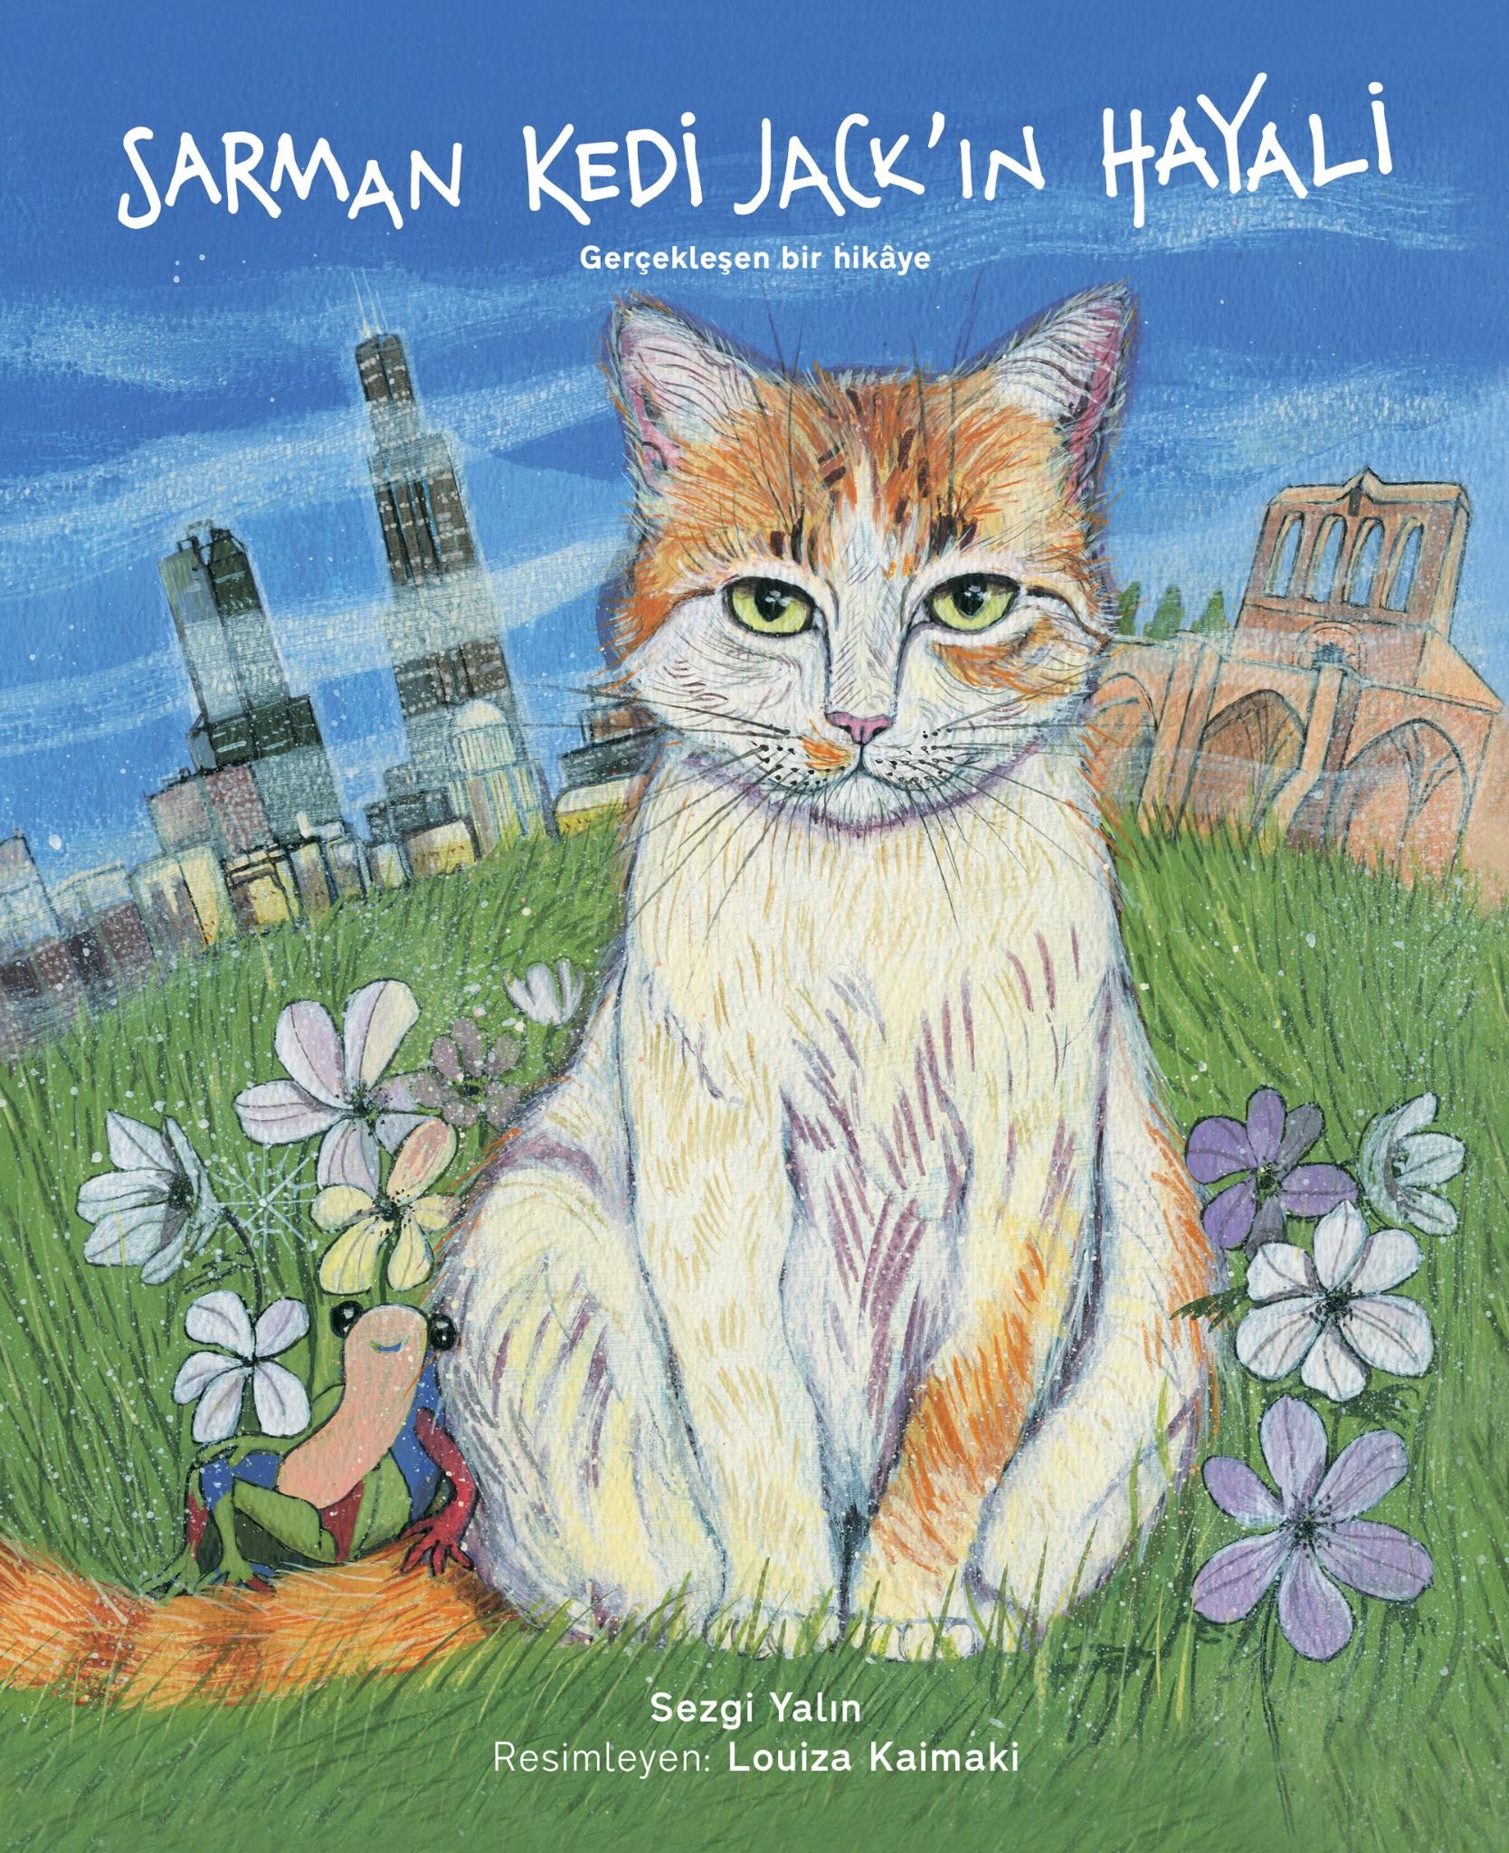Illustrations by ©Louiza Kaimaki
Jack-the-Cat's Dream is the first of four books in the Jack-the-Cat's Adventures© series, created to inspire Jolly, Adventurous, Caring, and Kind children (acronym: JACK).
The series aims to:
- Inspire children to fulfill the potential in their lives.
- Teach kids to value happiness, health, family, and friends.
- Role model how to stay true to oneself while cooperating with others.
- Introduce children to nature and wildlife in Cyprus and around the world.
- Transport children to different corners of Cyprus and the world.
- Teach children about people who shaped the history and lives of those on Cyprus.
- Re-introduce children to the special days celebrated in Cyprus and the rest of the world.
Jack's adventure in the first book, Jack-the-Cat's Dream, serves as a gentle reminder to children to embrace their own dreams and aspirations. When visiting primary schools, rather than reading Jack's story aloud, I conduct workshops with the help of the book's illustrations. During these workshops, I ask questions designed to guide and encourage students to reflect on their own potential and follow their own dreams.
The approach
How do I do this? Before I share with you the story framework I follow and the types of questions I ask learners, Jack's journey to realizing his dream of living in a sunny place in Jack-the-Cat’s Dream can be summarized in the following stages:
- Dreaming Big: Jack recognized his unhappiness with the cold Chicago winters and his desire for a place with sunshine. He acknowledged his longing for outdoor activities and a more fulfilling lifestyle.
- Research and Planning: Jack learned about sunny destinations, specifically focusing on Cyprus. He gathered information through conversations with other cats and by exploring books and pictures. This research phase highlighted the importance of seeking knowledge and exploring different options.
- Overcoming Fears: Jack faced fears about moving alone, learning a new language, and leaving his friends behind. He acknowledged these anxieties but also recognized his own strength and resilience. He understood that not everyone would share his dream, and that was okay.
- Taking Action: Jack overcame his fears by focusing on his bravery and his ability to adapt. He took concrete steps towards his goal by packing his belongings and traveling to Cyprus. This stage emphasized the importance of planning, preparation, and taking the first step towards achieving one's dreams.
- Making New Friends: In Cyprus, Jack met new friends who helped him explore his new surroundings and made him feel welcome. This highlighted the value of social connections and the support that friends can provide in new and unfamiliar environments.
- Enjoying Success and Continuing His Dream: Jack settled into his new life in Cyprus, enjoying the sunshine and outdoor activities. He maintained connections with his old friends in Chicago through letters, demonstrating the importance of preserving relationships even after significant life changes.
Overall, Jack's journey exemplifies the importance of recognizing one's dreams, conducting research, overcoming fears, taking action, building new relationships, and enjoying the fruits of one's efforts. These six stages could be applied to a story and a main character you create or ones you choose, adapting the following framework. The suggestions for adaptation of some of the questions to your own stories and characters are indicated in parentheses. At the end of the framework, there is also a personalized activity that can be used to encourage your learners to think about their own dreams and how to take action to realize them.
Steps in Story Framework and a Personalized Activity Used With Young Learners:
Jack's Journey as Steps to Success
- Dreaming big

  - "How did Jack feel about living in Chicago in the winter? (Adapt: How did the character feel about their current situation? What made them unhappy?)"
  - Discuss this with the class.
Answer: Jack disliked the winter weather in Chicago. He felt cold and grumpy about the snow.
  - "Why was Jack unhappy living in Chicago? (Adapt: What was the character longing for?)"
  - Discuss this with the class.
Answer: Jack wanted sunshine! He wanted a place where he could play outside all year.
  - "What did Jack miss most about not being able to go outside during the winter? (Adapt: What did the character miss most about their current situation? What were they unable to do?)"
  - Discuss this with the class.
Answer: Jack missed playing outside, chasing butterflies, rolling in the grass, and eating his yummy cat grass.
  - Learning Point: It's important to understand and acknowledge your own feelings and desires.

- Research and planning

  - "Jack learned that there are warm, sunny places with no snow! (Adapt: The character discovered that there are other possibilities, other ways to achieve their goals.)"
  - "He learned about Cyprus, a sunny island! (Adapt: The character researched and explored specific options or choices.)"
  - "How did Jack find out about Cyprus? Did he do any research? (Adapt: How did the character gather information about their chosen path? Did they research, talk to others, observe, etc.?)"
  - Discuss this with the class.
Answer: He talked to cats from warm places and looked at pictures in a book.
  - "How can we learn new things?”
Answer: Talk to people, read books, watch videos, or explore!
  - Learning Point: Encourage students to share their own experiences of learning new things.

- Overcoming fears

  - "Jack wanted to move to Cyprus. Do you think he was afraid? (Adapt: Explore the potential fears and anxieties associated with the character's chosen path. What challenges might they face?)"
  - Discuss this with the class.
  - "What was Jack afraid of? (Adapt: What were the character's specific fears? What obstacles were they worried about?)"
Answer: He was afraid of being alone and learning a new language. He wanted his friends to come too.
  - "Jack asked his friends to move with him. Did Jack's friends say ‘yes’? (Adapt: Did everyone support the character's decision?)"
Answer: No! Jack’s friends said ‘no’ for different reasons. Odin had family, Shadow was scared, and Jing liked cities.
  - "Is it alright if not everyone agrees with our decisions? (Adapt: Emphasize the importance of self-belief and the right to make independent choices, even if others disagree.)"
Answer: Yes!
  - Learning Point: It's important to remember that not everyone will agree with our choices, and that's okay.

- Taking action

  - "How did Jack overcome his fears? (Adapt: How did the character address their fears and build confidence? Did they seek support, develop coping mechanisms, or take small steps?)"
  - Discuss this with the class.
Answer: He knew he was brave and old enough to travel alone. He knew he could learn a new language if he tried. He knew he could make new friends there.
  - "What specific actions did Jack take? (Adapt: What specific actions did the character take to move forward? Did they make a plan, gather resources, or take the first step?)"
Answer: He packed his suitcase with essentials (frog toy, blanket, passport). He then traveled to Cyprus by plane.
  - "What can we do to prepare for significant changes? Plan, pack, and get excited!"
  - "Jack made a big change. What can we learn from his experience?"
Answer: We can learn that we can take steps to make our dreams come true.
  - Learning Point: Taking steps and making an effort are essential for achieving our goals.
  - "Jack was brave to go alone. What can we learn from his example?”
Answer: We can learn the importance of courage, self-reliance, and being willing to try new things.
  - Learning Point: We can be brave and try new experiences, even if we feel a little scared.

- Making new friends

  - "How did Jack make new friends in Cyprus? (Adapt: How does the character build new relationships and connections in their new situation? Do they join groups, seek out common interests, or be open to new experiences?)"
Answer: He met Kita and Bella, his neighbors who helped him explore.
  - "They showed him nice places and made him feel welcome.
  - "How can making friends help us when we try something new?
Answer: Friends can help us learn, have fun, and feel more comfortable in new places.
  - "What did Jack do every day? (Adapt: What does the character do every day?”
Answer: He explored beaches, caught grasshoppers, and enjoyed the sunshine.
  - Learning Point: Building and nurturing social connections is very important for personal growth and successful adaptation to new environments.

- Enjoying success and continuing his dream

- "How did Jack stay connected with his friends in Chicago? (Adapt: How does the character maintain relationships with people from their past? Do they use technology, write letters, or visit?)"
Answer: He wrote letters to tell them about his life in Cyprus.
- Why is it important to stay connected with the people we care about?
Answer: Staying connected with friends and family is important, even when we move to a new place.
- Did Jack achieve his dream? How do you know?
Answer: Yes, Jack achieved his dream. He was living in a sunny place, enjoying the outdoors, and feeling very happy.
- What's the importance of enjoying the journey?
Answer/Learning Point: It's important to enjoy the process of achieving our goals and celebrate our successes.
Personalized activity: My dream journey
- My Dream Steps:
  - Have children think about one of their dreams.
  - Guide them to brainstorm 2-3 concrete steps they can take to start working towards that dream.
  - Encourage them to write down their steps or draw a simple plan.
Closing remarks
By sharing Jack's story and the framework of his journey, I hope to inspire you to explore new ways of engaging young learners. Let us encourage our children to dream big, to research their passions, to overcome their fears, to take action, to build meaningful connections, and ultimately, to savor the journey of achieving their goals.
I believe that by nurturing a love of learning and encouraging children to embrace their unique talents and dreams, we can empower them to become the next generation of innovators, thinkers, and global citizens.

Please check the Pilgrims in Segovia Teacher Training courses 2025 at Pilgrims website.

Please check the Pilgrims f2f courses at Pilgrims website.

