The Need for a New School Experience

Roy Andersen, UK

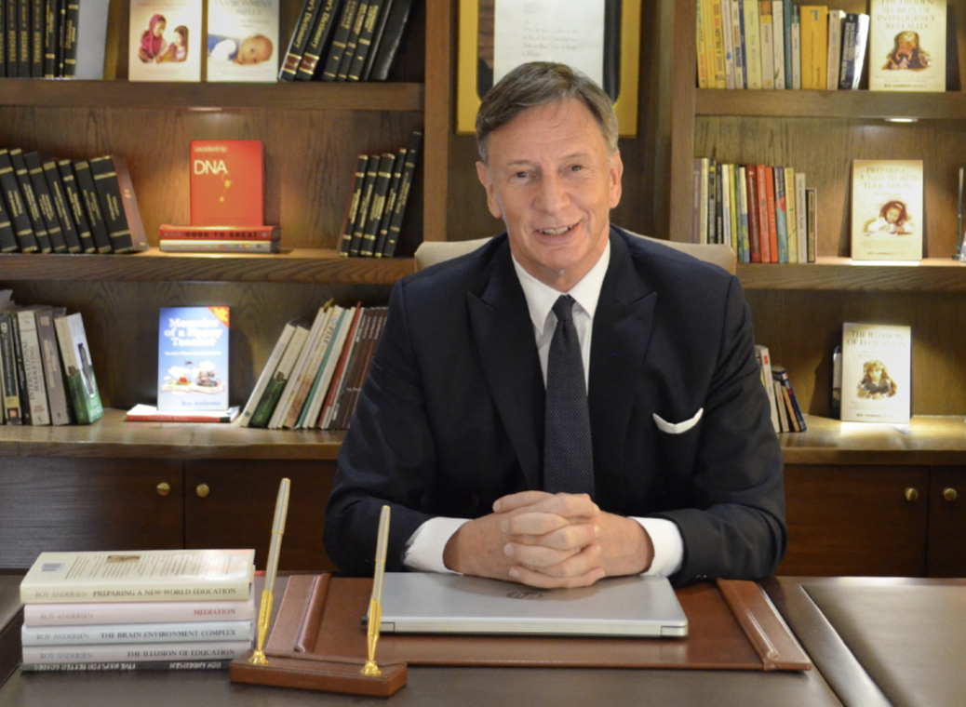

Roy Andersen is a distinguished educationalist, well recognised for his easy style of writing that enables all to fully understand the complications of education and learning. He is the author of 18 books that explore the intricate relationship between society, education and the evolving world of AI. Email: roy@andersenroy.com, https://andersenroy.com/

Introduction

AI technology is taking over our world faster than we realize. There is an urgent need for educationalists, parents and society to understand what is really happing in the school.

From the moment our child is born, we care for them. We love to see them happy and to laugh. We take notice when they cry, and we worry when they become ill. We love our child, and we do everything we can to help them. Then, when they are five, six or seven, depending upon our educational system, we hand them over to the school.

When we do this, we trust and we hope that the teachers they meet will do everything they can to give our child a good education, so they can go to a better university, and thereafter get a good job that will give them security -- and with this a hope of better happiness.

The reality of learning in school

What really happens is that from the moment our child enters school, they are confronted with a mass of children -- each trying to understand themselves, each driven by their own needs, and their own insecurities. Some will want to be their friends, some will not like them, some will want to hurt them. Each child will struggle to gain the security they want, the way they think they can get it. As our child struggles to understand themselves, amongst other children, they have to concentrate on rules to learn.
These rules begin by teachers telling them where they cannot stand, where they must sit, and when they can and when they cannot talk. These rules condition and conform the mind of our child from the 3-dimensional world of free play, to the 2-dimensional world of pen, paper and book.
So, these rules develop to tell our child how to hold a pen, where to write the first letter on a page, how to find the right page of a book, and then how to spell a word, make a sentence, and begin to understand how to move variables around in arithmetic.

How well the child will adapt their mind to understand these three Rs of reading, writing and arithmetic (providing they are happy and feel secure in their class), will largely depend upon the ways they have been prepared for the school experience by their parents. This relates to how well the parents taught them how to read, write and understand the concept of a story. The mental stamina they raised them on to hold their concentration and how they provided them with a sense of purpose for what they are doing. All these with a profound sense of love and emotional security.

The thing we need to grasp here is that the differences children display on ‘day one’ will largely remain with them throughout their whole school experience -- unless they meet a bully who disturbs their mind and causes them to fall behind in their learning. The role of the parent is very important in the ways they raise their child before they enter school and how they support them right throughout its many years.

The real purpose of school

What we do not readily understand is that the school experience was never designed to create equal opportunities for all children. This is because the educational system used by every country of the world today is a remodeled version of a design that arose in the industrial era, where school was to be a processing system as part of a processing society.

The purpose of school, and the one we still hold to today, is to produce the managers and the managed for work and society. In accordance with this design, children are not taught how to the think or how to reason during their school experience, because the most of these will take the role of the 'managed' citizen who is desired to think but not too much. Those children, and this is often due to the support of their parents, who gain the required grades to move to the university are educated in their reason for the more responsible roles they will take in society and industry.

Up until the 1980s and to enable this huge machine of education to function, in as cost effective way as possible, it clung to the old political idea that the natural ability of the child is related to the work role of their parents and so their social identity. To make this appear so, and in a basic sense, school selected the language of the ruling faction of its society, made this the standard language, and judged each child’s background familiarity with this to be a measure of their natural intelligence and the school grades they earned.

On this basis, teachers working through a highly conditioning and self limiting environment for the student, could give out information, mark the responses returned to them, and so evaluate the potential worth of each. In this scheme of things, there never was a desire, to teach the child “how to think” -- for the general citizen they would come to be.

This is how the school system worked until the 1980s, when the digital era required more students gain higher grades to enter the university. To make this possible the university lowered its entrance standards and school lowered the standard of the language it used in its textbooks, which enabled a wider range of students to understand better what was going on. This enabled them to perform better, which made it appear that school had improved and was now better than ever before. This is all an illusion.

The reality is that education is in a terrible mess. Teachers are frustrated and tired of battling a system that drains their energies, with most either waiting for retirement or seeking other forms of employment.

A survey in 2024 showed that 73% of teachers in the UK are considering leaving their profession due to excessive workloads and financial stress. ¹ The situation is further compounded with a predicted increase of 20% more children in school within the next ten years, when there are not enough teachers to educate the number of children now in education.

The struggle of the child to learn

However, the whole learning environment of school is wrong. The student of today seldom has the peace of mind to concentrate happily on their studies. Children live in a toxic world that we really do not understand, and only witness through increases in bullying and violence that are taking over the school atmosphere. It is not just that children are bullied, but by this the chemistry in their brain can be altered for life. And, while we focus upon bullying and violence in the school, we little grasp how this is affecting our next generation, and so the attitude they will have as our future citizens.

Yet, children still do not know why they are in school, and what they should do to learn better. They are as lost as we were. Indeed. too many students leave school with less capability in the three Rs than they did a century ago. This was made clear in a recent report, which revealed that 50% of primary school children failed to reach an acceptable level in these most elementary subjects.

So, because we do not understand what intelligence is and so how the child really learns, we spend 100,000s of dollars on new exciting classrooms, when all we really need is a teacher who can ‘sit on the floor’ and explain things to each child in their own terms with compassion and patience.

Yet, while students need more time with a real teacher, to understand what they do not, we find that school is now focusing upon gradually replacing the human teacher with AI to offset the number of teachers who can no longer cope with its system.

This is a very big mistake, least because computerized AI learning only improves the type of reasoning the student has developed, and does not restructure their reasoning as a human teacher could, but much, much more because children need to learn through the human experience where they share thoughts and feelings with others, because this is the skill they will most need in the lives they will lead in the AI dominated world.

In a basic sense, the world of our children will not be the world we know, and yet school is not providing them with the skills of reason they will need in their time. We still teach children to be dualistic thinkers, “Yes or NO” and not “WHY or HOW,” because this is what was required of the general citizen in the 19th century, which our school systems still base their operations upon.

Since the earliest times of formal education, people of good intent have sought to make the learning experience more enjoyable and more meaningful for children. Rousseau’s story of “Emile” in the 18th century intended to centre learning to a child’s perspective and more recently the work of Dewey, Piaget and even Gardener’s “Multiple Intelligences” not to mention Kolb’s “Learning Styles” all had and have the purpose to enable children to learn better.

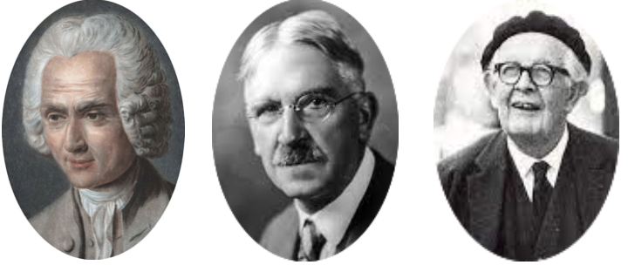

And yet, they do not! The same variation of student performance exists in every class as it always has done. One or two being the best. One or two being the worst and the rest struggling to be the best but never understanding why they are not.

The urgent need to redesign the purpose of school and the processing of our children for their life

In the AI driven world they will face, our children will need to be far more adaptable in their skills of intelligence -- to reason and to think better. After all, as Nanotechnology develops AI, it will alter our whole understanding of what work means. While it is reasoned by some that our children will be doing jobs we have not yet invented, others (as I have reasoned in The Real Dangers of AI) believe that AI will eventually replace some 90% of human jobs.

Should the latter occur, it will completely change the whole fabric of society. Without jobs, people will have no purpose to their lives. With no purpose they will be resentful of a system that has created their depression and the rises in alcohol, drug abuse and crime that are taking over their lives. Despite to maintain law and order, government directed AI will develop to become omnipresent in the lives of the citizen monitoring and correcting their behavior. We may beware that this has already begun.

Therefore, if we are to help our children to live in a safer, happier and more stable world, then we need to educate them in a very different way than school is now doing. I have dedicated my life to understand all I have mentioned here and far more, and sought to provide solutions through the many books I have written:

- Reimagining Education in the AI Era
- Ben Learns to Get Smart: and the hidden dangers of AI in learning
- The Real Dangers of AI: The struggle of man to survive by natural or artificial intelligence.
- All that is Wrong with School: What teachers and parents can do to fix it.
- The Illusion of School: The real reason why children fail.
- The Illusion of Education: How school designs the ability of the citizen
- Teach Better Learn Better: Understanding the art of sensitivity in awareness.
- Five Ways of Better Grades: How AI affects learning ability.
- For Parent for Teacher Mediation: Crafting the ability of the child for school.
- What Every Parent & Teacher Should Know: Real life stories by a senior educationalist
- Memoirs of a Happy Teacher: Stories of how the child learns
- Brain Plasticity: How the brain learns through the mind to create intelligence.
- Intelligence: The Great Lie (One of the most important books of this century - Dean Martin)

Links

https://the-educator.org/teacher-exodus-nearly-three-quarters-consider-leaving-the-profession-due-to-financial-difficulty-new-survey-reveals/#:~:text=73%%20of%20teaching%20staff%20are,jobs%20to%20supplement%20their%20income%20.

Please check the Pilgrims in Segovia Teacher Training courses 2025 at Pilgrims website.

Please check the Pilgrims f2f courses at Pilgrims website.

