Addressing the Crime of Human Trafficking and Modern Slavery: The Undeniable Power of Education

Judy Boyle, Greece

Judy Boyle is the founder of The NO Project, an award-winning, arts-based, global educational campaign against modern slavery and human trafficking. She has been involved in anti-slavery educational actions for over 23 years. Judy is a teacher, trainer, researcher and author. Her background also includes professional theatre and filmmaking. In 2022, Judy directed and produced It’s Just Business, an award-winning, surreal short film against modern slavery based on a spoken-word poem by a 16-year-old high school student.

The NO Project award-winning lesson plans

The NO Project has created free, downloadable teaching resources on human trafficking and modern slavery. Each lesson is based on a true narrative and is approached with dignity, sensitivity and respect. Designed for upper secondary, young adult and adult learners, The NO Project lessons are ideal for both on-line teaching and in the classroom. Each unit includes slides, artwork, authentic interviews, videos, lexical input, original listening material, and a gentle step-by-step teacher’s guide. Also provided are student autonomous learning resources with suggestions for project-based actions beyond the class. These teaching resources have been featured in the Master’s in Education Program at Havard Graduate School of Education and are being used by thousands of educators worldwide.
The teaching material was created in partnership with The Rights Lab, Nottingham University, UK. Email: judy@thenoproject.org

Something Doesn’t Feel Right
Something Doesn’t Feel Right focuses on identifying signs of possible human trafficking at airports and on flights. The heart of this lesson is a true narrative that occurred at the check-in counter of a domestic flight. Two teenage girls, 15 and 17, were checking in, but something didn’t ‘feel right’. Simply put, this major international and domestic airline had taken the remarkable initiative to educate 100,000 members of their ground staff and inflight crews to identify signs human trafficking.
So how does the impact of education, or in this case the training, of airline employees, relate to this lesson? One clue is in the lesson title, ‘Something doesn’t feel right.’ This is exactly what the airline employee increasingly felt as she proceeded to check-in the two teens. First one thing was a little strange, then another, then another…and when the employee reached the sixth troubling indicator, based on her informed knowledge of human trafficking, she decided not to let the girls board the flight. Also, as they were standing at the check-in counter, they were receiving texts from someone who was telling them what to say to the airline check-in person.
Can you guess all six indicators that made the airline employee feel that something ‘wasn’t right’? Unbelievably, the name of the person working the check-in desk that day was Denise Miracle. Here are three indicators…can you guess three more? Interestingly, the students we piloted this lesson with always managed to guess all six.
Three indicators were i) they were travelling with carrying barely any personal items – neither cabin nor check-in luggage ii) Their ID wasn’t quite right iii) there was no older person to see them off.
By the way, the girls believed they were going to be in a music video and earn $2,000. They had been recruited on-line.
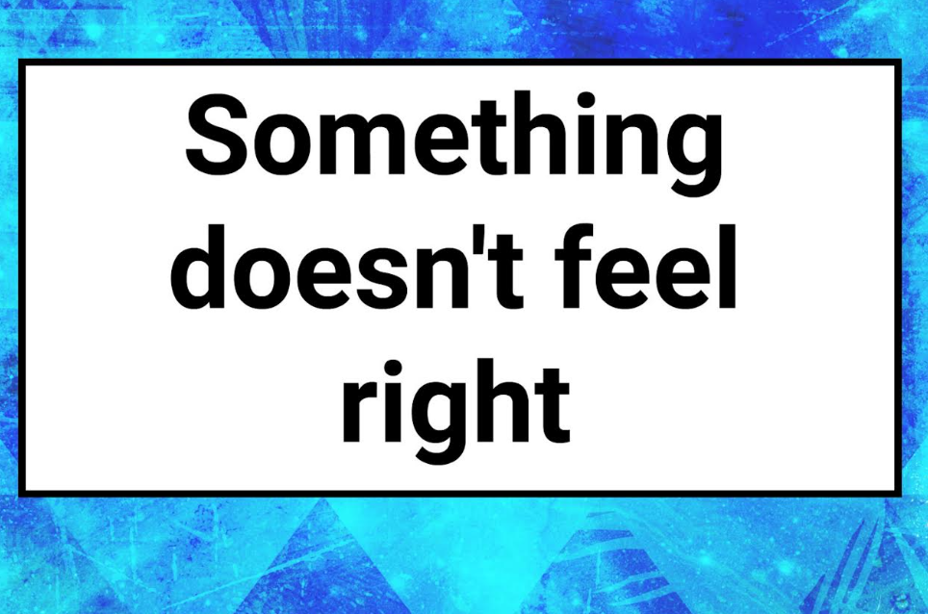
As you’ll see in the Teacher’s Guide for Something Doesn’t Feel Right, we suggest using this first slide on its own, without providing any context at all. The pedagogic goal is to engage the students’ curiousity and allow them time to come up with their own ideas. As with all The NO Project lessons, we approach each theme gradually and gently, adding more key information as the lesson unfolds. Please see the slides and Teacher’s Guide for further reference.

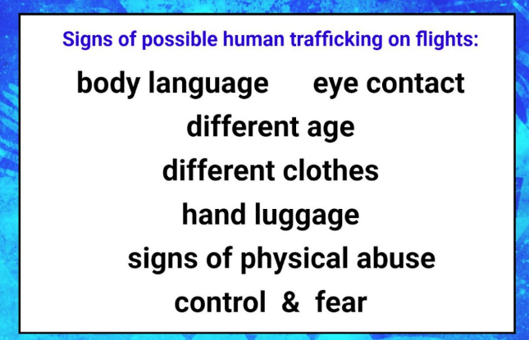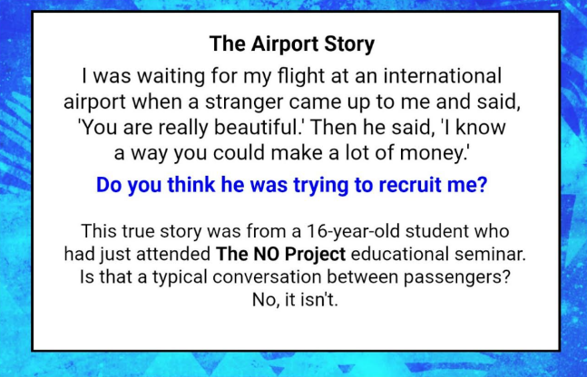

Something Doesn’t Feel Right also includes a true story where a member of the flight crew identified a case of human trafficking on board, during the flight. This is included in the downloadable teaching resources.

The Truth Behind Closed Doors

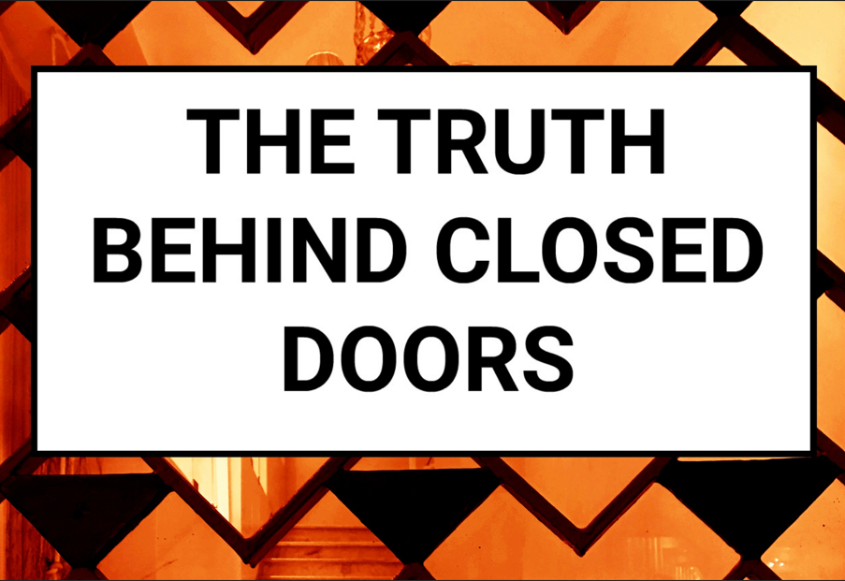

The Truth Behind Closed Doors addresses Domestic Servitude – the enslavement of domestic workers, usually in private homes, predominantly women and often recruited from a foreign country – but not necessarily. The heart of this lesson is a true narrative told by ‘Rosa’. Rosa was recruited from her home country and promised a job as a live-in domestic worker in a wealthy suburb of a European capital city. As you will discover when you read her story, the treatment she received was abusive, manipulative and exploitative.

So, how is education connected the lesson plan, The Truth Behind Closed Doors?
Several years prior to devising this lesson, which of course was with Rosa’s informed consent, The NO Project had been invited to present the multi-media educational seminar to students in a high school in a major European city. Free time for the seminar was limited. However, due to the courage, willingness and integrity of the school Director, admin managed to find a free 40-minute period. Around 300 students attended the seminar.

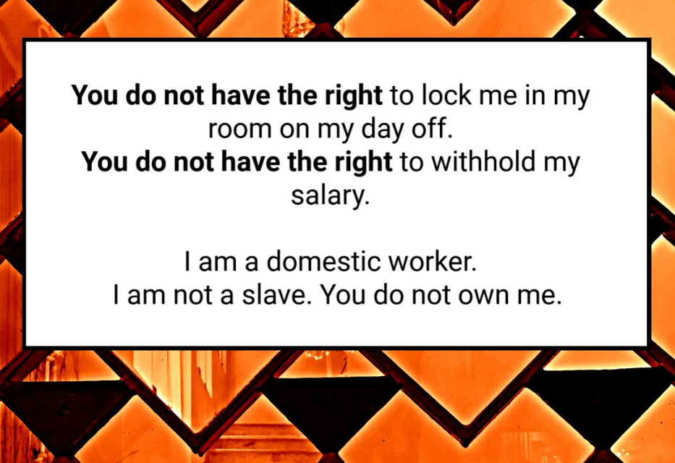

But then, out of the blue and years later, we received an email from a student who had been in the seminar that day. ‘I think I have come across a case of human trafficking and I want people to know about this crime.’ Long story short, several emails later, and documented informed consent forms this lesson had been downloaded thousands of times. We have even had feedback from Business English teachers who teach in house and on site. The CEO of an International Company was so upset and moved by the lesson content, that the HR department was called in to go through the lesson.

Simply put, had that student not been in the educational seminar that day – and learned about and remembered the indicators of human trafficking, she would not have realized that Rosa had been a victim of the crime of Trafficking in Persons (TIP). Please download the lesson and read her narrative, even if you are not able to use it with students at this time, as citizens we must know what to listen for.

We would love to hear from teachers who would like to pilot the material. Please do contact us: judy@thenoproject.org

‘You may choose to look the other way, but you can no longer say you do not know.’
William Wilberforce, Abolitionist (1759 –1833)

