Short Book Reviews
Hanna Kryszewska, Poland
Hanna Kryszewska is a teacher, teacher trainer, trainer of trainers. She was a senior lecturer at the University of Gdańsk, Poland. She is co-author of resource books: Learner Based Teaching, OUP, Towards Teaching, Heinemann, The Standby Book, CUP, Language Activities for Teenagers, CUP, The Company Words Keep, DELTA Publishing, and a course book series for secondary schools: ForMat, Macmillan. She is also co-author of a video-based teacher training course: Observing English Lessons, and online course for Orient Black Swan on 21st Century Skills and Teaching the whole person: Humanising language teaching. Hania is a Pilgrims trainer, OTA trainer and editor of HLT Magazine.
Email: hania.kryszewska@pilgrimsteachertrainig.eu

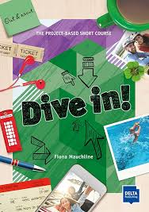

Dive in! The Project-Based Short Course. F Mauchline DELTA Publishing.(2019). ISBN 978312501304-9, pp.56. Dive in! is a book designed for learners aged 14-18 whose levels range from A2-B1 (The part under review is one in a series of 4).. This sentence may be puzzling as one could wonder how this could be possible – such an age and level span? This is possible because the publication is very special. It is not a coursebook; in my opinion, it is not even a course – even though this is what the publishers call it. It is a collection of projects to be conducted over a period of time. The author suggests it is 4 modules which will cover one week of teaching each, but the teacher could time it differently. I would call the material project templates or frameworks to be filled by the learners’ themselves. There are some short texts but mainly spaces to be filled in with own comments, notes or doodles. The topics involve being active, visiting places, outdoor activities, indoor activities, festivals, fun, and tourism. The projects involve in-class work, out-of-class activities, and using the knowledge the learners bring into class or research themselves. The projects involve teamwork and group work; collaboration is the key. The way the learners work with the book means they will personalise it or make it their own. At the end of the book there is a Language Workout section, a space for keeping My Journal, and pages for Language Support with elements of revision or input (depending on the level and abilities of the given learner0 and space for own practice. The book is a perfect alternative for summer courses, English language clubs and extracurricular activities in English. The publication is accompanied by teacher’s notes and online support.

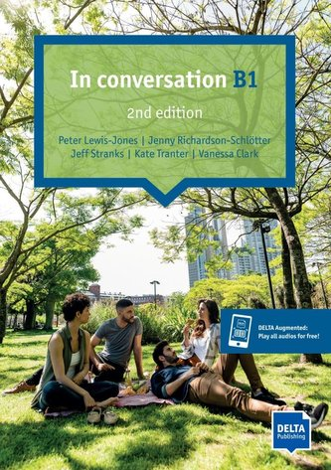

In conversation B1. 2nd Edition. P. Lewis-Jones, J. Richardson-Schlótter, J. Stranks, K. Tranter, V. Clark. DELTA Publishing (2024). ISBN 978312501553-1, pp.88. The idea of the book, and the whole series of three books, is to give B1 learners short courses in conversation. They learners engage in exchanging ideas with others on engaging topics. The topics are seemingly predictable like music, charity, good neighbours, personal space, high anxiety and alike, but the input through texts intended for reading or listening give the topics an interesting angle. The modular format of the book is very handy and can be easily fitted into regular lessons from the coursebook or be the basis for special oral exam preparation classes or language clinics. The teacher can dip into the book in any order. At the end of the book there are a phrase bank, pronunciation practice, transcripts of audio texts and ideas for homework. This is a useful ready-to-use supplementary resource for teachers or a model to follow when
creating own activities.

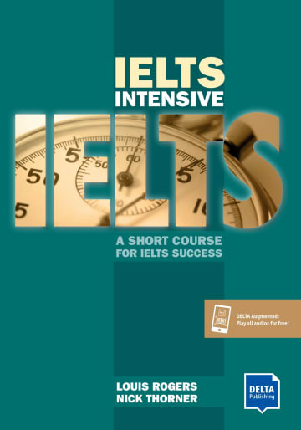

IELTS Intensive. A Short Course for IELTS Success. L. Rogers and N. Thorner. DELTA Publishing (2020). ISBN 978312501580-7, pp.120. When I read the phrase ‘short course’ I know I am all for it. In my experience an IELTS candidate has little time to polish exam skills and exam performance to reach a higher-grade band. When you are pressed for time you need to be focussed, get what you need and expect that using a particular coursebook will help them fetch the desired result. The authors state that it will take 40 hours to work through the material, and if the candidates complete the course successfully they should be aiming at band 5.5-6.5. The good news that the book is a mix of general language work within the areas of the four skills as well as exam training. This balance makes sure that the students will improve their exam skills through general language work as well as test practice. The realistic time frame is a good psychological trick as the students will be able to cover all the material and will not wonder what has been omitted in the book and why, or why they have spent a given amount of money, and they have taken advantage of half the investment. Another advantage is that the students not only do test type task but also analyse techniques and exam skills, and why a certain answer is correct or wrong. The promise is realistic: band 5.5-6.5; obviously a book like this cannot promise too big a progress. Finally, it can be used in class and for self study. So, the students can do some of the work at home, check against the key. Then the teacher will only spend time clarifying the queries. I can see benefits only.

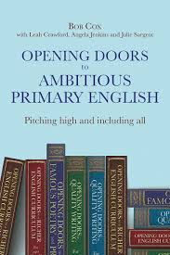

Opening Doors to Ambitious Primary English. Pitching high and including all. B. Cox with L. Crawford, A. Jenkins and J. Sargent. (2023) Crown House Publishing. ISBN 978-178583667-1, pp 196. HLT readers are already familiar with the Opening Doors series. There have been reviews of Opening Doors to a Richer English Curriculum for ages 6 to 9. B. Cox with Leah Crawford and Verity Jones (2019) Crown House Publishing. ISBN 978-178583398-4, pp 258. Opening Doors to a Richer English Curriculum for ages 10 to 13. August 2020 and August 2017. The addressees of the book are teachers of native primary children, but a lot of ideas and the approach are transferable to an EFL or ESL classroom, and not just primary but also secondary. Just like the title says the main idea is to motivate young learners and include everyone. The book is divided into three parts: Principles, Strategies and Applications. It is mainly B. Cox who explains the principles and strategies (with the occasional contribution from L. Crawford, while the applications come from a mix of contributors. Like all books in the series, they are easy to read as the texts include graphs representation, diagrams, tables or just illustrations to rest the eye. Less experienced teachers of young learners will find the theoretical part useful and inspiring; the more experienced ones will find it refreshing. My favourite section is the one containing practical activities like key points on using learning dialogues (p.102), focus points in analysing a story (p.110), or key points on taster drafts (p.87). The book will definitely broaden horizons of EFL teachers and be of use when researching a wide range or wider range of approaches coming from the outside of EFL world.

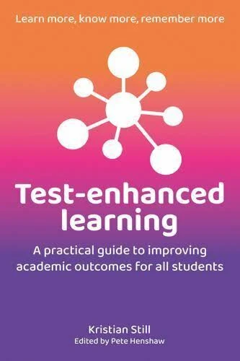

Test-enhanced learning. A practical guide to improving academic outcomes for all students. K. Still. (2023). Crown House Publishing. ISBN 9781785836589, pp. 169. In the days of formative assessment, and massive criticism of testing and how it negatively influences the way subjects are taught including washback effect, it is surprising to read about benefits of test-enhanced learning. So, what is it? “Test-enhanced learning, also known as retrieval practice or the testing effect, is the concept that actively retrieving information from memory through testing, even low-stakes quizzes, can significantly improve long-term retention and understanding. The act of retrieving information strengthens memory traces, making them more durable and easier to access later.” In other words, learners benefit from frequent test and pop quizzes as they train the learners memory by helping to make accessible and durable pathways for future retrieval and use. This in turn leads to enhancing overall learning outcomes and grades. To be fair, those who attended one of the plenaries at IATEFL Edinburgh 2025 delivered by Carolina Kuepper-Tetzel on Lessons learned: using the science of learning to inform teaching will clearly remember the research result in cognitive psychology she presented. The bottom line is that frequent testing, including low-stake pop quizzes, trains the brain to stay more focused and to retain more information. The theory presented in the book is supported by the free https://www.remembermore.app/ which uses digital flashcards. The book is a useful tool in the hands of all teachers as it gives justification to frequent testing. However, w mustn’t forget what happens after the test, how the test is viewed, how mistakes and wrong answers are treated, and hopefully
More here and here. You can look inside the book here.

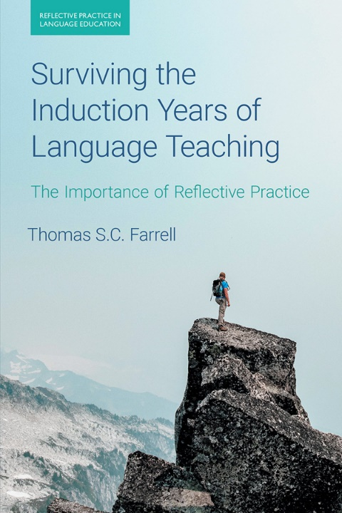

Surviving the Induction Years of Language Teaching. The Importance of Reflective Practice. T.S.C. Farrell (2024). Equinox. ISBN-9781781795521, pp. 208. On the one hand I feel I am the right person to review this book, as I have been in the teaching profession for 45 years, on the other hand I might not as my induction years are long gone. Yet I feel my biggest credibility comes from the fact that I worked with pre-service teachers and in-service teachers for over 30years, and for at least 15 I supervised teaching practices in primary and secondary schools. The author divides the Induction years into first year and third year; the latter in a covert way includes the second year. The book is informed by classroom observation and reflection of ESL teachers but many of the experiences and transferable to EFL teachers, and probably to novice teachers in general whatever the subject. The key figure is Roger (a pseudonym) who is the key figure, source of the data and reflections. The main approach is description, reflective break, description, reflective break etc, and then conclusion on e.g. theory, practice, philosophy, principles etc. The book is an excellent example of development through reflective practice each teacher novice teacher could follow. Personally, I am not sure if the ‘one size suits all’ approach will not bore after some tome and if Roger is like a medieval everyman who represents all mankind. On the other hand, many of the experiences may resonate with novice teachers and set them on the track of their own reflection and development.

You can find amore detailed description of the contents of the book here.

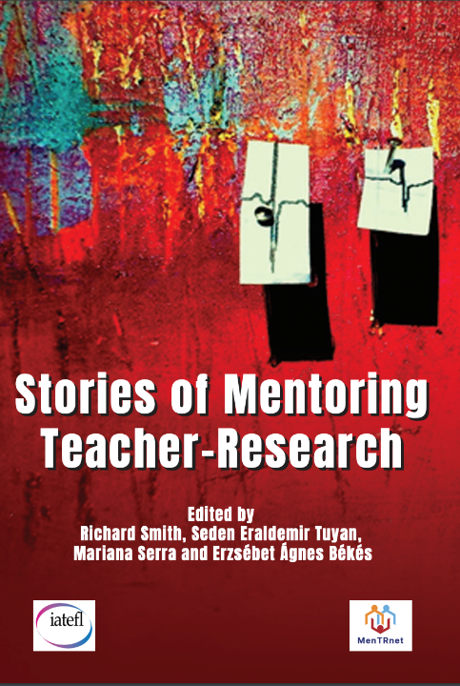

Stories of Mentoring Teacher-Research. eds. R. Smith, S. Eraldemir Tuyan, M. Serra and E. A, Békés (02024) IATEFL Research SIG in association with MenTRnet, pp.150.
This book is a product of teacher research carried out into areas teachers consider important in their work. Unlike many publications of this kind, the focus of this book is mainly on the Global South. Another difference is that it is the teachers themselves carry out the research, and they themselves are not subjects of research. MenTRnet (https://mentrnet.net/ ), an international network for teacher-research mentors that has been built up since 2021. Now it groups around 300 mentor or prospective mentor members across the globe. It works in association with IATEFL Research SIG, hence two publisher’s names. BTW this book is MenTRnet’s first publication. There are 20 contributions which don’t follow the same format; each one is unique and reflects the thinking and the personality of the mentor. My main takeaway is being reminded that each mentoring situation is different and that I am subconsciously stuck in my Global North world. Opening up to variety and wealth of options and paths of mentoring paths is vital as we need educate or guide mentors working with refuges teachers or planning to work in various educational environments.

You can download the book in pdf form here or here.
You can watch more here, here and here.

Please check the Pilgrims f2f courses at Pilgrims website.

Please check the Pilgrims in Segovia Teacher Training courses 2025 at Pilgrims website.

