IATEFL Slovenia 2025 – A Perfect Blend of Learning, Culture, and Relaxation!

Marta Bujakowska, Poland

Marta Bujakowska is a freelance teacher and teacher trainer from Poland with a strong
intercultural focus and special interest in creative methodology, CLIL, reflective teaching,
learner autonomy and flipped classroom. In her career she has taught all age groups and
levels changing her preferences from time to time, which helped her develop as a teacher
and led her into teacher training. Nowadays, she predominantly works with teachers, and
teaches adult and teenage learners of English. Email: marta.bujakowska@gmail.com

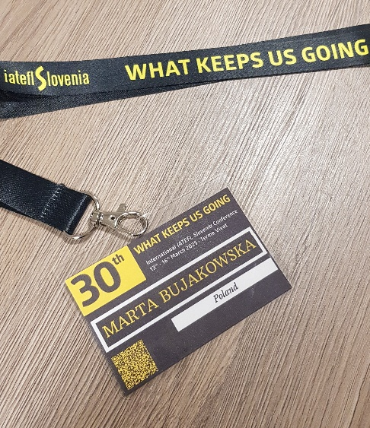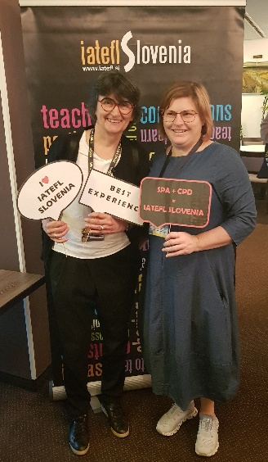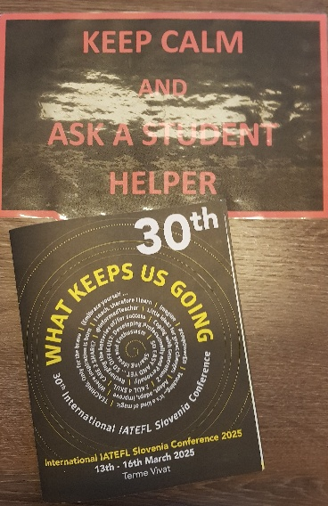
The 30th IATEFL Slovenia Conference at Terme Vivat from March 13th to 16th, 2025, was an unforgettable experience, seamlessly combining professional development with cultural exchange and relaxation.​
The conference commenced with inspiring addresses from the Ambassador of Great Britain and Northern Ireland and Ambassador of the Irish Embassy, setting a tone of international collaboration and shared learning.​
Plenary highlights
- Milan Mandeljc offered valuable insights in his session, contributing to the diverse range of topics covered during the conference.​
- Jeremy Harmer delivered an insightful plenary titled "When We Sing Together: Doing Things with Other People." He explored the paradox of modern connectivity, highlighting how, despite being more connected than ever through social media, individuals often experience increased feelings of loneliness and alienation. Harmer proposed that collaborative activities, such as group singing, can foster shared experiences and positivity, counteracting these negative effects. Using music as a central metaphor, he emphasized the profound impact of collective endeavors, drawing parallels between the harmony found in choirs and collaborative efforts in classrooms. To bring this concept to life, Harmer incorporated live singing into his session, allowing attendees to experience firsthand the unifying power of music. This interactive element underscored his message, leaving participants with a tangible sense of the benefits of collective engagement.​
- Sara Isakovič delivered an inspiring talk, drawing from her experiences to motivate and empower educators.​
- Cecilia Lemos Harmer presented a plenary rich in research and theoretical insights. While her academic contributions were valuable, some attendees felt that incorporating more practical applications for classroom teachers would have enhanced the session, fostering a stronger connection to everyday teaching practices.​
- Jamie Keddie presented an engaging plenary titled "Plot Keeps Us Going," emphasizing the omnipresence of stories in our lives. He explored the fundamental nature of storytelling, noting that stories are as essential to humans as water is to fish. Keddie delved into the mechanics of narratives, demonstrating practical storytelling principles that educators can employ to stimulate students' creativity, foster collaboration, and enhance speaking skills. Through interactive examples, he showcased techniques to develop students' storytelling abilities and deepen their understanding of narrative structures, ultimately enriching their communicative competencies.​
- Claudia Molnar concluded the conference with her plenary titled "Keep Motivation Going: The Magic of Inclusive Language." She addressed the growing challenge of maintaining student motivation in today's classrooms, especially when considering the diverse individual needs of learners. Molnar offered insights into the power of classroom language, illustrating how inclusive communication can engage and motivate all students. By emphasizing the importance of language that acknowledges and values each learner's unique contributions, she provided practical strategies for educators to foster an inclusive and dynamic learning environment.​
Workshops and social activities
Beyond the plenaries, the conference offered a diverse array of workshops catering to various interests and promoting relaxation and socialization:​
- Jeremy Harmer and His Guitar: An intimate musical session where Jeremy shared songs and stories, creating a warm and engaging atmosphere.​
- Paraffin Bath for Your Hands: A soothing experience that provided attendees with a moment of self-care and relaxation.​
- Paint and Wine: A creative workshop combining artistic expression with social interaction, allowing participants to unwind and connect.​
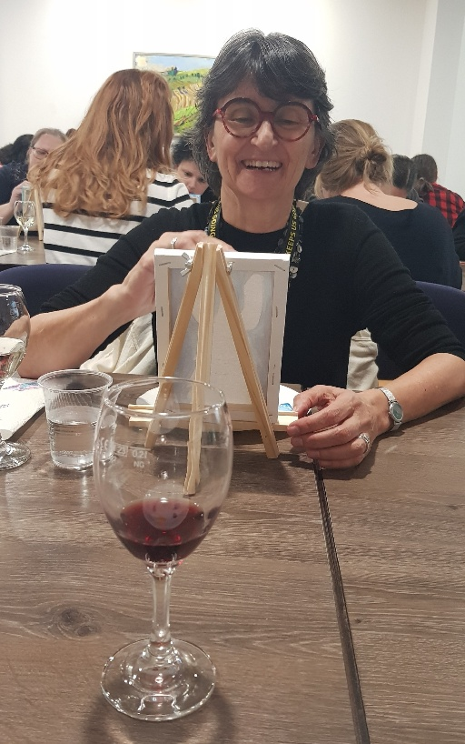
Artist at work
- Chocolate Pralines Workshop: A delightful session where attendees learned the art of making chocolate pralines, satisfying both their curiosity and sweet tooth.​
These activities exemplified the conference's commitment to balancing intellectual stimulation with opportunities for relaxation and community building.​
Saturday night party
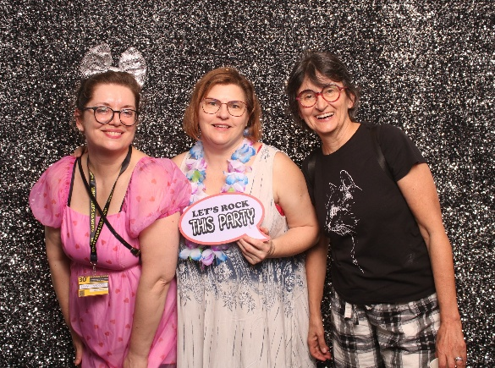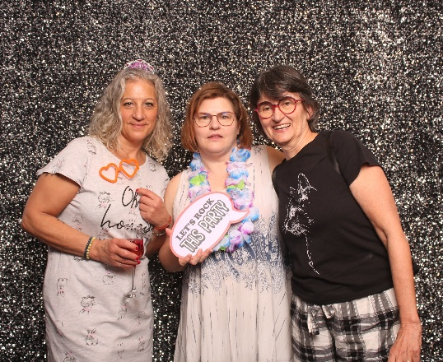
A highlight of the social events was the Saturday night party, themed "Wear Something You Wouldn't Wear to School on Monday." Attendees embraced the challenge with enthusiasm, showcasing creative and often humorous outfits that sparked conversations and laughter throughout the evening.​
Pilgrims has always been one of my favourite places to work—such a special part of my professional journey. I’m genuinely proud to be part of this inspiring, energetic community. The team spirit, creativity, and positive vibe at Pilgrims always give me a boost.
It was lovely to see that so many people at the IATEFL Slovenia conference already knew about Pilgrims and our courses or even have been to Canterbury. For those who didn’t, I was excited to share that Pilgrims is back—and we've now moved our summer courses to beautiful Segovia, Spain! It's an amazing new chapter for us, and we can’t wait to welcome participants there.
I also invited everyone to check out our Pilgrims Cafés—friendly, free of charge online meet-ups where we share ideas, chat about teaching, and connect with like-minded people in a relaxed, supportive space.
Looking forward to seeing some familiar faces from IATEFL Slovenia at one of the cafés—or maybe even in Segovia this summer!

Please check the Pilgrims in Segovia Teacher Training courses 2025 at Pilgrims website.

Please check the Pilgrims f2f courses at Pilgrims website.

