New from DELTA Publishing

  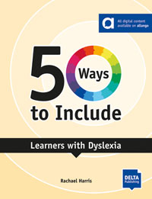
  50 Ways to Include Learners with Dyslexia
  This title will help you to find your way to including learners with dyslexia in your class by:
  • offering quick solutions to the challenge of including a learner with dyslexia
  • suggesting specific ways to include and support learners with dyslexia as you move through the stages of teaching from identifying students' needs to assessment.
  • providing opportunities for reflection and action planning
  Learn more!
  Digital Edition allango for teachers

  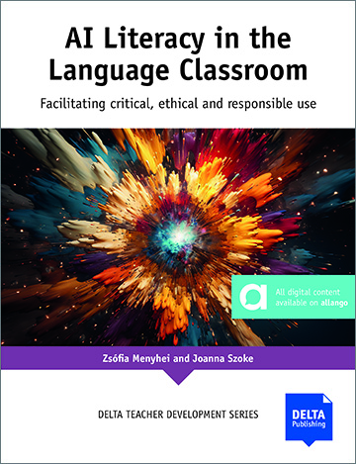
  AI Literacy in the Language Classroom
  AI Literacy in the Language Classroom aims to give language teachers the confidence and skills required to integrate AI successfully in their classrooms as they train students in the critical, ethical and responsible use of AI. Rather than focusing on specific tools, the authors offer practical ideas for integrating AI literacy development effectively. This book provides a bank of engaging activities designed to supplement any course and adaptable to most contexts, levels, language points, and even languages.
  Learn more!
  Digital Edition allango for teachers

