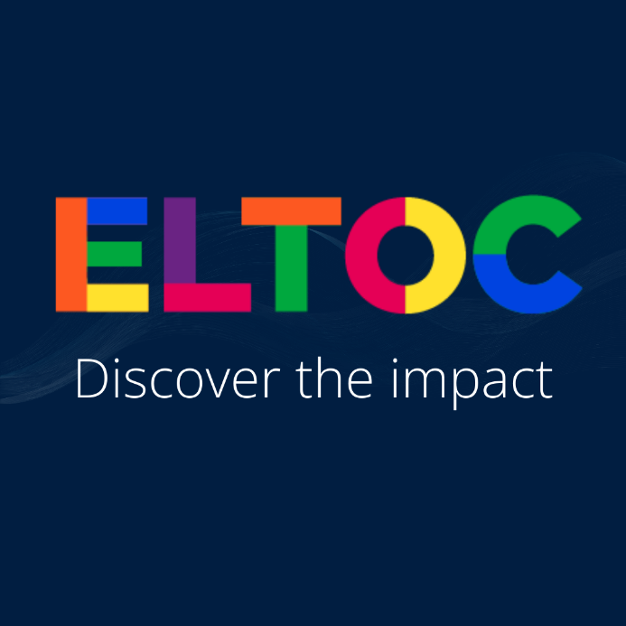

The last ELTOC event from Oxford University Press is ELTOC Chapter 10, took place on March 13-15, 2025.

Good news it is a recurrent event.
This three-day online event offers free professional development for ELT educators with expert-led sessions and discussions on trending topics. It's an opportunity to connect with peers, learn from experts, and gain access to a valuable resource pack.
English Language Teaching Online Conference
ELTOC is our English Language Teaching Online Conference where every English teacher in the world can access high-quality, expert-led professional development for free no matter where they are.
Grow personally and professionally as part of our global community and also get a certificate of attendance.
Be part of the biggest online event in the English Language Teaching calendar by signing up for the waitlist.
Delivered by experts, inspired by you.

If you want to stay informed… Join the ELTOC waitlist

If you missed a webinar, click here.

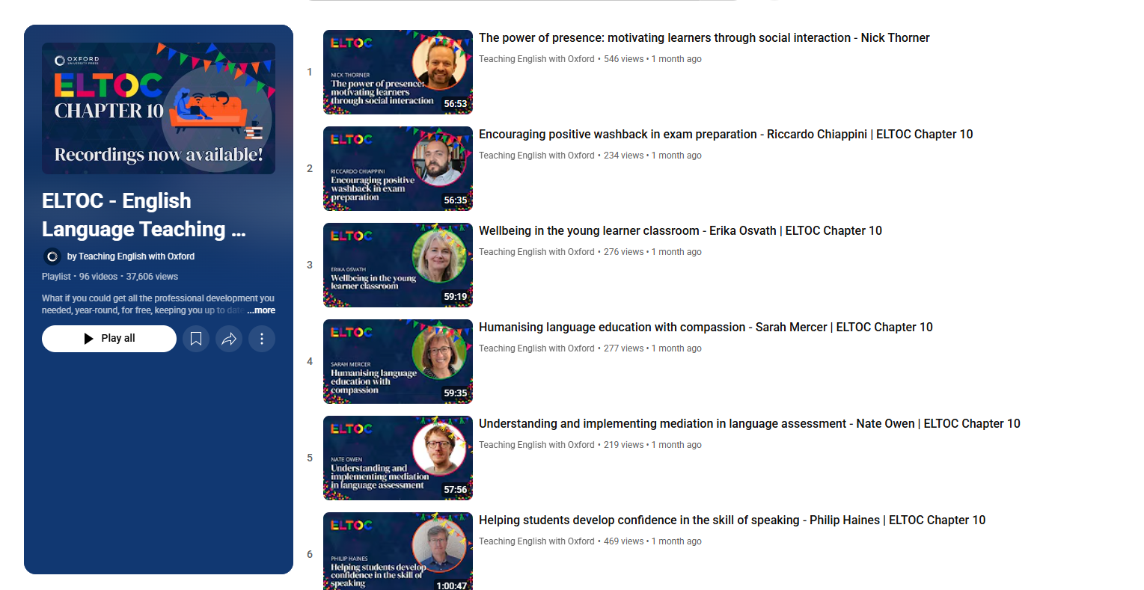

And many many more…

Watch out for more!
Oxford University Press

