New from Pavillion ELT


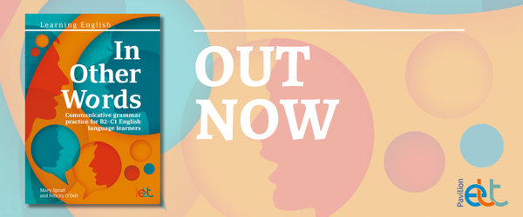

Comprehensive grammar practice for B2–C1 English language learners
by Mary Spratt and Felicity O'Dell
In Other Words is an easy to use grammar practice book tied to real-life English. Together with accompanying online listening materials, the book can be used both for self-study and as supplementary material for the classroom (whether face-to-face or online). It puts grammar in familiar contexts, provides guidance on its use, and then gives multiple opportunities for free and communicative use, mainly through speaking. In Other Words is far from a set of exercises!
In Other Words: Comprehensive grammar practice for B2–C1 English language learners is an easy to use communicative grammar practice book. Together with accompanying online listening materials, the book can be used both for self-study and as supplementary material for the classroom (whether face-to-face or online). It puts grammar in familiar contexts, provides guidance on its use, and then gives multiple opportunities for free and communicative use, mainly through speaking.
Divided into 70 double-page spread lessons, each with a single grammar focus, In Other Words allows both the teacher and the learner to take a dip in approach. This allows all users to orient themselves quickly in the materials. The short but effective format of each lesson means they can fit in well within the time constraints of lessons, and work alongside any learners’ course of study. It provides communicative and exam practice in key areas of grammar if needed, whilst also providing both the teacher and the learner with ample opportunity to tailor their grammatical focus according to their needs.
The book targets grammar known to be problematic at B2 and C1 level. It ranges from working on standard essential grammar such as tenses or modals to areas such as register, the features of spoken language and academic writing. The book aims to make working on grammar an enjoyable learning experience. It also aims to help learners to convert knowledge of grammar into use and the development of flexibility of expression.

You can take a look at a short sample from In Other Words here.

View in browser



Out now: Taking Your Language Teaching of Teenagers to the Next Level!

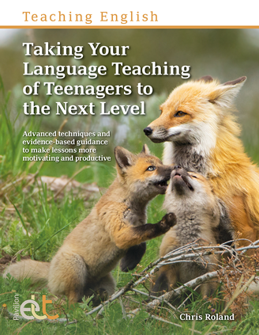

Teaching teenagers offers a range of challenges, but also comes with exciting and rewarding opportunities for both teachers and students. In this exciting new title, Chris Roland explores what it is like to be a teacher of teenagers, delving into the teenage brain to help you get the most out of teenage learners and improve learning outcomes.

Taking Your Language Teaching of Teenagers to the Next Level provides creative and advanced teaching techniques, alongside meaningful discussion, accompanying images and practical applications, to help teachers take their teaching practice to the next level. It offers detailed and honest analysis that explores the challenges and opportunities teaching teenagers offers. Questions and challenges are posed throughout to encourage teachers to reflect on their teaching practice and review the evidence.

For more watch this video interview.

