Celebrating the Man, Celebrating English: Jerzy Limon and the Gdańsk Shakespeare Theatre
Magdalena Zawadzka, Polska

Magdalena Zawadzka is a dedicated teacher, trainer, coach, and translator with a passion for helping others learn and grow. She works with individual students/ exam groups and conducts training sessions and workshops for teachers. She is especially interested in innovative teaching methods, fostering creativity in the classroom, and using art, literature, and culture to enhance language learning. Email: byronz@wp.pl
Acknowledgement

This project was sponsored by Theatrum Gedanense Foundation and is reprinted by permission.
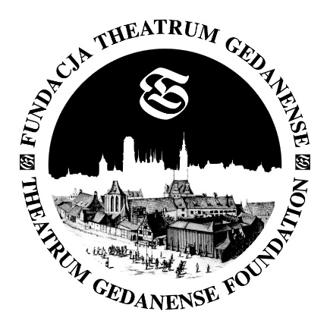

Introduction
Welcome to this set of 18 interactive cards, designed to take your students on a journey through the life and legacy of Professor Jerzy Limon - the Polish visionary behind the Gdańsk Shakespeare Theatre.
About J Limon
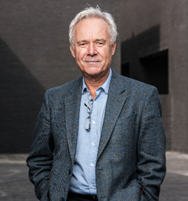

Jerzy Limon was born in 1950 in Malbork. At the age of 12, he set off on a journey to the United States aboard the ocean liner MS Batory, spending over a year with his uncle in North Carolina. That time abroad helped him become fluent in English — a skill that would shape the rest of his life.
Back in Poland, he studied English literature and art history, eventually completing both his master’s and doctoral degrees. His academic work focused on early 17th-century English theatre, and one of his key studies — on London theatre during the years 1623–1624 — was published by Cambridge University Press.
Over the years, he taught at the University of Gdańsk and spent time abroad as a visiting lecturer. His interests gradually turned to the travels of English actors across Central and Eastern Europe in the 1600s, including performances that had taken place in Gdańsk during Shakespeare’s era.
Inspired by this history, Jerzy Limon set out in the 1990s to bring Shakespearean theatre back to Gdańsk. To make this vision a reality, he created the Theatrum Gedanense Foundation, which launched the Gdańsk Shakespearean Days and later the International Shakespeare Festival. The construction of the theatre began in March 2011, and the building officially opened in September 2014. The project had the support of Prince Charles, as well as the acclaimed Polish director Andrzej Wajda. That same year, Professor Limon was awarded the Order of the British Empire for his work.
Professor Limon passed away in March 2021, due to complications from COVID-19. His funeral was held on March 27 — World Theatre Day — a fitting farewell for someone who dedicated his life to the stage.

About the Theatre
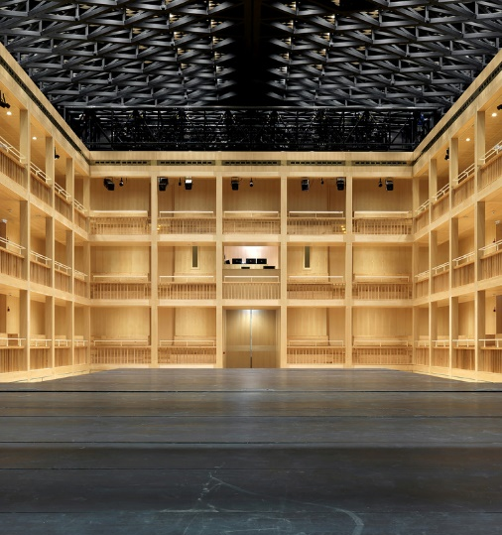 | 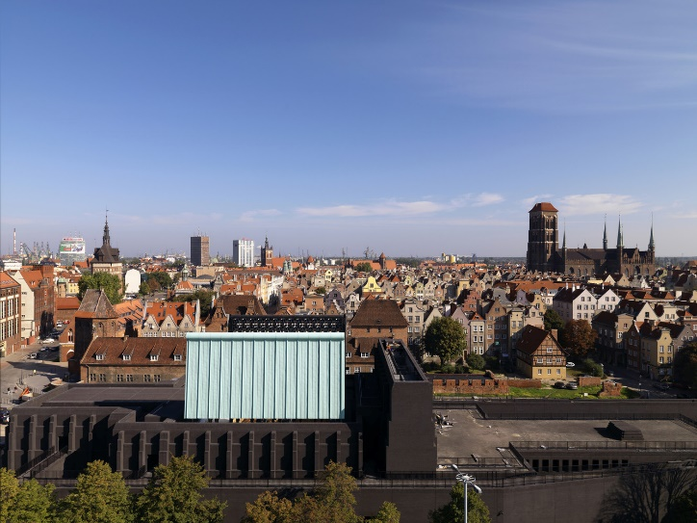
https://www.archdaily.com
@MatteoPiazza

The Gdańsk Shakespeare Theatre was built on the site of the 17th-century Fencing School. It was also the first public theatre in the Republic of Poland at the time. The building was modelled on the Fortune Playhouse in London. Equipped with an Elizabethan-style stage and similar to many English theatres of the Elizabethan era, it was used for fencing training and competitions, as well as for staging performances. The Gdańsk theatre was regularly visited by travelling actors, among others, to stage plays by English playwrights in Gdańsk – including Shakespeare, during his lifetime.

The current theatre was designed by Italian architect Renato Rizzi and opened in 2014. It is an impressive structure — spacious and full of clever design features. It includes a movable stage and seating system, which means the space can be easily adapted for different types of performances. One of its standout features is the roof, which can open in just three minutes, letting in natural light and fresh air for open-sky performances, just like in Renaissance times.

Depending on the setup, the theatre can host up to 600 people for traditional shows, or as many as 1,150 for concerts.

How is the material organised
There are 2 sets of cards – 17 at level B1 and 18 at level B2 cards (CEFR)
These cards serve two key purposes:
- To introduce students to Professor Limon’s remarkable story and his ambitious theatre project.
- To provide language and critical thinking exercises inspired by significant moments from his life.
Each card presents a unique activity, inviting students to engage in dictation, ask and answer questions, translate, perform, and complete creative writing and critical thinking tasks.
How to use the material in class/ outside the class
You can use the full set over time or pick selected cards to suit your needs. However, I recommend starting with Professor Limon’s introduction before diving into the rest:
- Option 1: Card 1 → Card 2 → Card 4
- Option 2: Card 1 → Card 2 → Cards 3A/3B → Card 4

The teaching methodology used in the project
The teacher’s notes provide valuable support, offering suggested answers, key vocabulary, and useful phrases to guide your lessons effectively. The activities are designed to develop not only language skills but also creativity, cultural awareness, and critical thinking.
Two special cards at the B2 level (Cards 9 and 13) introduce essential thinking tools—Bloom’s Taxonomy and the Venn diagram. Bloom’s Taxonomy helps students develop higher-order thinking skills, moving from basic recall to analysis, evaluation, and creation. The Venn diagram encourages comparative thinking by helping students visually organize similarities and differences between concepts. Both tools come with clear explanations and practical examples, ensuring that students can apply them confidently.
By integrating these methodologies, the project fosters a deeper understanding of language while enhancing students’ problem-solving and analytical abilities in a meaningful, engaging way.

Writing the materials
Writing this project has been an enriching experience that has significantly influenced my approach to teaching and material development. The process of designing these tasks and structuring them around Jerzy Limon’s life and the Gdańsk Shakespeare Theatre has allowed me to refine my methodology, making it more interactive, inquiry-based, and rooted in real-life narratives.
One of the key ways this project has matured my methodology is reinforcing the importance of storytelling in education. By embedding language learning into a historical and cultural context, I have seen how engagement deepens when students connect emotionally with the subject. The blend of reading, discussion, translation, creative writing, and critical thinking tasks also emphasized the value of a multidisciplinary approach. I have personally benefited from this by expanding my ability to craft lessons that are not only educational but also immersive and thought-provoking.
There were moments of joy and excitement in developing these materials, particularly when creating activities that encouraged students to think beyond the text—imagining themselves in young Jerzy Limon’s shoes, debating the role of rebellion in personal growth, or drafting letters to influential figures. It was rewarding to see how language learning can go hand in hand with intellectual curiosity and creativity.
However, there were also moments of doubt. Would students find the topic engaging? Would the level of difficulty be appropriately challenging yet accessible? Striking a balance between linguistic competence and cultural exploration required careful thought. There was also the challenge of ensuring the tasks were diverse enough to cater to different learning styles while maintaining coherence within the project.
Ultimately, this experience has reinforced my belief in the power of thematic, content-rich learning. It has made me more attuned to the ways in which history, literature, and personal narratives can be woven into language education, making it not just about mastering vocabulary and grammar, but about engaging with the world in a more profound way.

Reception and feedback from teachers and students

The project has been well received by both teachers and students, who appreciated its engaging, interactive approach.
Teachers have highlighted the versatility of the activities. Many have found the teacher’s notes and suggested answers particularly helpful in guiding lessons effectively.
Students have responded positively to the fact that all the activities were inspired by a real person and enjoyed the variety of tasks, especially the creative writing and role-playing exercises. They also appreciated the inclusion Bloom’s Taxonomy and the Venn diagram, which, for many, were new thinking tools.
Overall, feedback has emphasised the project’s ability to combine language learning with cultural content and critical thinking in a way which fosters reflection and deeper understanding.

Making ripples
These cards can inspire your students—or you, as a teacher or cultural animator—to create your own projects about people who have shaped the world around them.
You can focus on a well-known local figure or highlight a "silent hero"—someone whose contributions may not be widely recognized but have made a meaningful impact. Encourage students to research and creatively present these stories, using the cards as inspiration.
By engaging with real-life role models, students not only improve their language skills but also develop a deeper appreciation for the power of individual actions in shaping the world around us.
Let’s get started!
Enjoy the project!

Sources

https://teatrszekspirowski.pl/o-teatrze/

Downloadable contents
- Jerzy Limon and the Gdańsk Shakespeare Theatr: Celebrating the man, celebrating English A set of 17 cards with tasks at B1 level. Download at the bottom of the page.
- Jerzy Limon and the Gdańsk Shakespeare Theatr: Celebrating the man, celebrating English A set of 17 cards with tasks at B1 level. Teacher’s Notes. Download at the bottom of the page.
- Jerzy Limon and the Gdańsk Shakespeare Theatr: Celebrating the man, celebrating English A set of 18 cards with tasks at B2 level. Download at the bottom of the page.
- Jerzy Limon and the Gdańsk Shakespeare Theatr: Celebrating the man, celebrating English A set of 18 cards with tasks at B2 level. Teacher’s Notes. Download at the bottom of the page.

Please check the Pilgrims in Segovia Teacher Training courses 2025 at Pilgrims website.

Please check the Pilgrims f2f courses at Pilgrims website.

