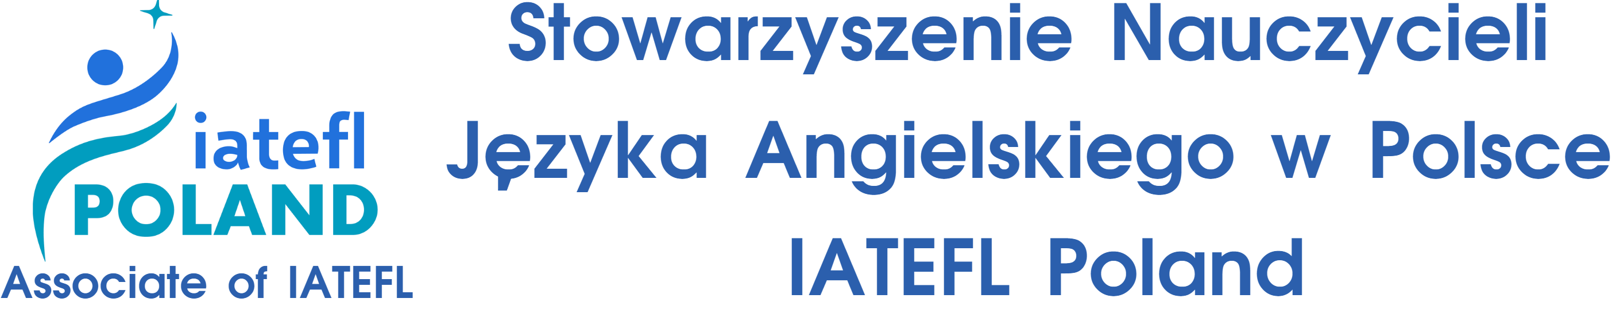
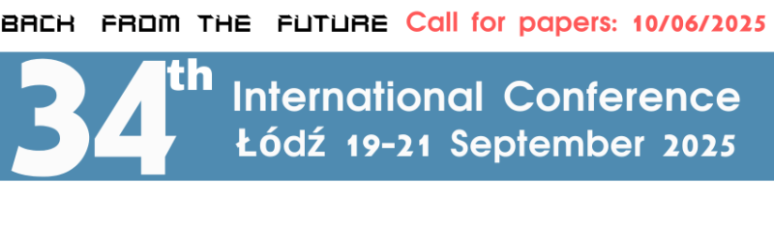
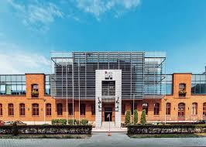

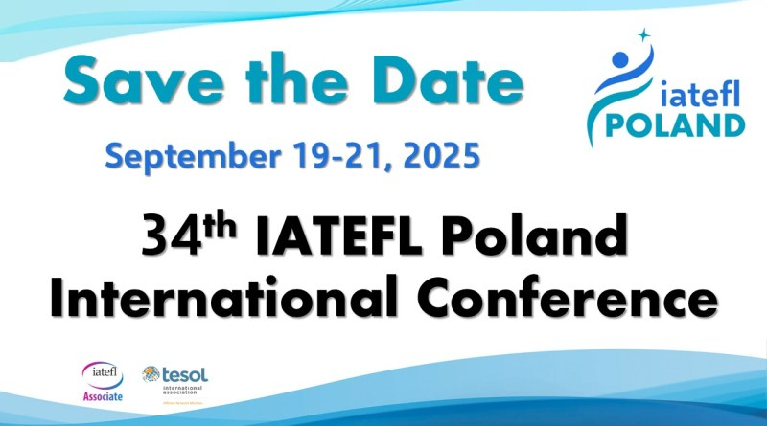
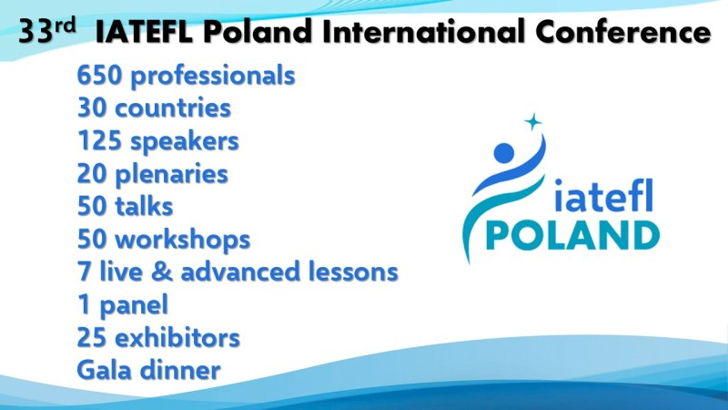

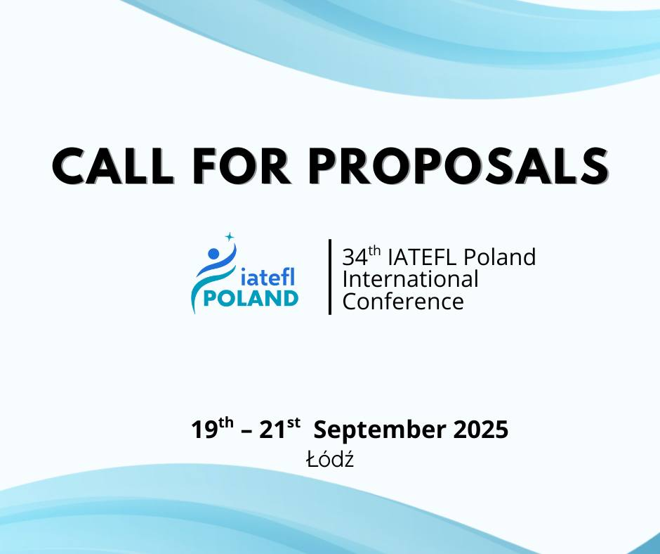

34th IATEFL International POLAND Conference
Łódź, 19th – 21st September 2025
CALL for PROPOSALS
We cordially invite you to the 34th IATEFL Poland International Conference in Łódź. The conference is one of the largest events for teachers of English as a foreign language with hundreds of participants willing to seek new ways and innovative solutions to be adopted in the learning-teaching environment.
The conference theme is: Back from the Future
To help explore the variety of issues connected to the main theme of the conference, this Call for Proposals welcomes contributions covering any of the topics in the following areas:
- Pedagogy, Methodology, Technology – which comes first?
- Responsible use of AI for Teachers and in the Classroom
- Special Educational Needs (SEN)
- Diversity, Equity, Inclusion and Belonging
- Teacher Training and Development
- Teacher’s Self-Care and Resilience
- Psychology in Teaching and Teachers’ Careers
- Teaching Different Age Groups: Young Learners, Teenagers, and Adults
- Power Skills and Employability
- Sustainability in ELT
- Drama, Art, Literature and Culture in Language Education
- Content and Language Integrated Learning (CLIL)
- Feedback, Evaluation and Assessment
- Critical Thinking in Teaching and Learning
- English for Specific Purposes
- English Language Teaching Management and Leadership
- Practical Takeaways for your Classroom
If you are interested in the topic of the conference and would like to attend the conference as a speaker, please fill in the online Speaker’s Proposal and
Registration Form. To cover all areas and all levels, we are not only interested in contributions from experienced presenters but would especially welcome proposals from first-time speakers and new teachers.
Presentations options are:
- Plenaries (60 mins.)
- Talks (60 or 30 mins.)
- Workshops (60 mins.): workshop sessions must include active audience participation through experiencing and discussing tasks provided by the workshop facilitator.
- Live Lessons (60 mins.): workshops with real learners (various age groups). Lessons are observed by attendees of the conference. The organisers can provide groups of learners.
- Advanced Lessons for Teachers (60 mins.): workshops with active participation of teachers – attendees of the conference who would like to polish up their English
- Computer-based Digital Tools Workshops (60 mins.): workshop sessions will use a computer lab to allow for hands-on demonstrations of software or platforms
The language of the conference is English. Summary of sessions
You are asked to submit a 100-word summary of the content and structure of your session and provide biodata (max. 50 words). Presentations will be chosen based on your summary, which must accurately reflect the content of your presentation. The programme committee will evaluate all speaker proposals based on quality and relevance.
Important dates
Submissions – Open as of: 26th April 2025 Submissions – Deadline: 10th June 2025
Notification of Acceptance: 25th June 2025
If you have any questions about the conference submission process or require additional information, please send your query to office@iatefl.org.pl
For further information please visit our website www.iatefl.org.pl
REGISTRATION | EARLY by 22.08.202 | LATE 5 by 06.09.2025*
IATEFL Poland Members | 730 PLN | 840 PLN
Non-IATEFL Poland Members | 880 PLN | 990 PLN
Exhibitors | 830 PLN | 830 PLN
Students* | 300 PLN | 300 PLN
*If you wish to register after the LATE REGISTRATION deadline, please contact the conference office: conference@iatefl.org.pl
* Student’s ID card must be sent by email and displayed upon arrival at the conference during registration

Make sure to save the date for the 34th IATEFL Poland International Conference will be held from September 19-21, 2025, with the location to be announced soon. Building on the success of last year’s event in Gdansk, which attracted over 650 professionals from over 30 countries, this year’s conference promises to continue fostering global collaboration in English language teaching. The 2024 conference featured 125 speakers, 20 plenaries, 50 talks, 50 workshops, and 7 live & advanced lessons presented from an amazing lineup of well-known international speakers from the ELT community. Attendees also had the opportunity to engage with 25 exhibitors and enjoy a sumptuous Gala Dinner with entertainment.
The 2025 edition is set to bring together even more ideas and innovations for the ELT community. Planning and preparations are well underway for the event, and we will announce the location along with the Call for Proposals, hotel information, etc. as soon as all of the contracts are signed. Stay tuned to our social media and website for the latest information.
So, mark your calendars for September 19th to 21st for the largest EFL event in Poland, and in Europe. We know you don’t want to miss this.



I hope this message finds you well. I am writing to extend an invitation to you as a plenary speaker at the upcoming 34th IATEFL Poland International Conference, which will be held in the beautiful city of Lodz from September 19th to 21st, 2025.
This year, our theme is “Back from the Future”. The idea is in this tech and AI heavy environment to reflect and consider responsible use in the classroom. We are planning an all-day tech thread and as an alternative a thread on Neurodiversity for all Ages. Both threads will have their own plenaries and panel discussions.
Another exciting announcement is that we are offering a 70% discount for Ukrainian teachers living in the Ukraine, which is being promoted by IATEFL Ukraine, TESOL Ukraine, and UALTA Ukraine as well as many private schools. As we expect a large turnout from this, we will be running a special Friday morning thread for Ukrainian teachers and those teaching them with the help of the British Council and Lodz University of Technology.
To streamline the registration process and ensure your participation, we kindly ask that you submit your talk proposals via our website and complete your registration at the following link: https://iatefl.org.pl/conference/index.php?a=login.
We hope you will consider this invitation to contribute to what promises to be an enriching and engaging conference. Please do not hesitate to reach out if you have any questions or require further information.
Looking forward to welcoming you to Lodz.
Warm regards,

Rob Howard
IATEFL Poland President
tel. (048) 503017030
www.iatefl.org.pl


