The Exploration of a Play and Creative Puppetry-Based Approach to Teach Modern Languages at Early Years Primary Level

Tania Czajka, UK
Based in Scotland since 1991, Tania Czajka is French and started her career in education as an Early Years Practitioner, in parallel to performing her bilingual puppet shows throughout the UK. Through research and Masters studies, she developed the Creative Puppetry for Languages approach, which is designed to support language learning and teaching through play, stories and creativity. A qualified teaching artist, she is also the author of 2 bilingual and accessible picture books Lapin is Hungry and Lapin is Cold, both published by CALEC.
https://lepetitmonde.co.uk/ Email: tania.czajka@gmail.com
Editorial

The text is republished by permission form SLR - Scottish Languages Review, Spring Issue 37 March 2024, https://scilt.org.uk/Research/ScottishLanguagesReview/Issue37-Spring2024/tabid/8625/Default.aspx

Abstract
The publication of Realising the Ambition: Being Me by Education Scotland in 2020 shows a strong national commitment to providing a play-based education for early years children from nursery to Primary 2 and beyond. However, it would appear that teaching languages – referred to in the Curriculum for Excellence as Modern Languages – is teacher-led and less play-based than other subjects. This article discusses the current Scottish Modern Languages (ML) teaching context, with an account of the main tools available to support teachers, and provides a brief overview of how languages are largely taught to early years groups. Focus then turns to the exploration of an approach to teach ML, based on creative puppetry. Firstly, an explanation of what the practice entails and how it can fit within educational theories is discussed. The article then focuses on a case study, which set out to test the creative approach within two primary classes, and to analyse what differences, if any, it would make to the participating teachers’ learning and professional development. The findings are then outlined and suggest that such an approach could positively impact on the children’s engagement and confidence in speaking the language while supporting the teachers in their play-based practice.
Note: This study was conducted before the Early Level for Modern Languages document was officially published in May 2021.

The Modern Languages teaching context in Scotland

In Scotland, teachers and early years educators use the Curriculum for Excellence (CfE) – which covers all levels from 3 to 18 years - as their main guide and tool for delivering learning experiences and lessons in all taught subjects. Although the early years ages can vary depending on the literature, for the purpose of this article, I will refer to the early years as Early Primary, with reference to the Realising the Ambition: Being Me (Education Scotland, 2020) document, known as RtA. Primary teachers deliver all curriculum subjects, including ML, from P1. In nurseries, meanwhile, the exploration of new languages through play-based experiences can be a response to the children’s learning or personal context, but this is not mandatory.

The CfE strongly encourages a cross-curricular approach to teaching where possible. For ML, this can take the form of learning to count through French numbers or exploring IT possibilities to teach the language, as can be seen in McCrossan’s study (2013).
ML teaching is also supported by A 1+2 Approach to Language Learning (Education Scotland, 2017) from Primary 1 onwards, a policy which aims at ensuring that every child has the opportunity to learn a modern language from P1 until the end of the broad
general education (S3). The use of mouth puppets by teachers is promoted in this document to encourage playful verbal interactions in the target language.

With the support of the comprehensive RtA guidelines and other resources such as The Early Level Play Pedagogy Toolkit (Education Scotland, 2020), play-based learning is gradually becoming embedded throughout primary schools and particularly in P1 and P2 classes. RtA is designed to inspire and guide teachers in adopting a play-based pedagogy and delivering all taught subjects accordingly. However, it is important to note that the emphasis is on literacy and numeracy, and that modern languages are not mentioned in the document.

For Early Primary, all ML teaching is verbal, mainly based on playing games, singing songs, carrying out simple instructions and playing with simple poetry and rhyme, as outlined in the CfE document. However, research appears to indicate that language learning throughout all primary levels, although playful, interactive and child-centred, is widely based on teacher-directed strategies rather than those which promote independent learning (Clingan and Coles, 2017). Teachers appear to choose such methods to allow for greater exposure to listening to and using the language (Mc Crossan, 2015).

Regarding training, although teaching a modern language is mandatory from P1, there is no indication of the expected level of teacher language proficiency (Valdera Gil & Crichton, 2020) and language upskilling and pedagogy are not yet core to all primary Initial Teaching Education programmes (Jones, 2018).

Thus, in Scotland, primary teachers are asked to follow policies and guidelines to teach modern languages to children from their first year in primary school, potentially without any knowledge of the language. Although the curriculum encourages a cross-curricular and child-centred approach to learning, this aspect of the guidance does not appear to be a priority, as structured and teacher-led pedagogy prevails as the preferred means to ensure acquisition of the language. Moreover, the main play pedagogy guidelines in RtA do not include ML examples of practice to support teachers. In this paradoxical context, it would seem worthwhile to explore a child-led, cross-curricular and play-based approach to ML teaching called creative puppetry.

What is creative puppetry?

For the teacher and lecturer Smith (2018), creative puppetry entails children and practitioners designing, making and manipulating puppets together. She continues by describing the practice as one of the easiest ways to use puppets, able to activate any material and engage all learning styles, ages and abilities. Creative puppetry, therefore, appears to be an accessible and inclusive teaching method. Since children and adults co- construct their knowledge through interactions with people and the environment as outlined in Dewey’s socio-constructivist framework (Dodd-Nufrio, 2011; Wheeler, 2020), creative puppetry clearly belongs to this teaching model. According to Dewey’s theory, teachers are facilitators or guides who, designing and making the puppets with their pupils, give them opportunities to develop as active and independent learners (Hohmann & Weikart, 1995). Creative puppetry, as described by Smith (2018), clearly calls for such a vision of the teacher’s role.

Smith’s practice was also directly inspired by the creative puppetry technique Hunt & Renfro (1982) define as “puppetizing”, where teachers guide children in using puppets for acting out stories, poems or songs, and where performing is for one another, without an audience or a stage. Conformed to Dewey’s teaching model, this practice also fits Vygotsky’s theory, where teachers share their skills, as “more knowledgeable others within the zone of proximal development”, the area where the most sensitive instruction or guidance should be given (Mcleod, 2018). With an emphasis on the process rather than the performance, it also recalls the “freedom with guidance” learning principle from the Froebel approach, stated on the Froebel Trust website. Thus, through creative puppetry, teachers can provide rich, cross-curricular, child-led and active expressive arts experiences to support their pupils’ learning.

As a teacher, Smith has applied the art form extensively to core curricular areas in the USA, such as science, history and literacy, but never to language learning (Czajka, 2018).

Creative Puppetry for teaching French project

What we did

The aim of the study was to pilot the creative puppetry approach in a Modern Languages learning context and analyse what differences, if any, it would make to teachers in delivering ML to Primary 1 and 2 pupils. The study focused on three teachers’ learning and professional development in this curriculum area. The participants worked in a school where a play-based pedagogy was already in place.

They described their own levels of confidence in using French language as low, medium and high, and they delivered four lessons. In Lesson 1, a bilingual picture book, written for non-French speakers and young learners of the language, was introduced to the children, with characters speaking French only. In Lesson 2, working in groups of five, they made 3-D puppets and in Lesson 3 they practiced to re-enact the story of the book. The pupils performed for two guests in Lesson 4 and had the opportunity to play alone with the puppets for a few days afterwards. The story was reintroduced at the start of each lesson in different ways: the teacher reading from the printed copy; children listening to the audio version; watching a video of myself, as the author, reading the book; and, again, the teacher reading from the printed copy. To enable everyone to see the images and words, the e-book version was also projected on the smart board to support readings of the printed book.

Following a community of practice research model called Lesson Study (Dudley, 2011), each lesson had two teachers: one delivering while the other observed and took notes. The second teacher, who works in the school but with separate class groups, then delivered the lessons to twenty Primary 1 and twenty-five Primary 2 pupils. This allowed the P1 and P2 teachers to observe their own learners. As the author of the picture book, I provided the teachers with printed copies. As an experienced puppeteer, I also devised clear puppet-making guidelines for them. Ethical approval was sought and granted before the beginning of the project.

To get a better idea of the teachers’ working context, experience and practice, I interviewed them individually before the intervention. Once the lessons were over, I interviewed them again to gather their feedback and thoughts on the project.

In accordance with Dudley’s Lesson Study model, we reflected on and planned each lesson as a group through discussions. The teachers chose a collective aspect of learning they wished to focus on for each lesson, such as ‘listening and understanding’ or ‘sequencing the story’.

Themes emerged in relation to the children and teachers’ learning. These enabled me to write a rich and holistic account of their experiences. As the study took place during the Covid-19 pandemic, regulations were observed: all discussions with teachers were conducted remotely. I did not visit the school or meet the pupils.

What we found
Although the study focused on the teachers’ professional development, it quickly became clear that the approach had made an impact on the children’s learning of French.

A Impact on children’s learning

The teachers commented that most pupils were highly and emotionally engaged throughout the four lessons. The children who did not physically or verbally show engagement had additional support needs and happily observed what was happening. A strong ownership of learning was observed through pupils making and manipulating their own puppets. Most children appeared to have enjoyed performing the bilingual story, and remembered the French words very well, developing their working memory skills in the process. Moreover, regarding ML learning, the teachers agreed that introducing the story in different ways supported the pupils’ engagement and confidence in speaking French, while making the learning process fun, lively and exciting.

Perhaps a less expected finding was that the approach also supported the pupils’ development of literacy skills. To the teachers’ surprise, most children spontaneously wrote French words from the book, beside their drawings. This reaction was most welcome, especially as some pupils would not usually be keen to write. The children also made connections to their prior learning, linking French and English vocabulary and recalling words or sounds they had heard. For instance, they mentioned that une sounds like one and that the colour Green Vert sounds exactly like Ver, the worm. Regarding literacy skills, the teachers felt that the bilingual storybook, written using a flowing continuity between English and French and without any translations, supported the Literacy Across Languages approach they were developing in the school.

In addition, the project gave the children the opportunity to develop their social skills. Working in groups, they supported each other in making the puppets, speaking French and performing. P1 children spontaneously set up chairs, with snacks and teddies to watch their peers practice their show. Others clapped their friends’ performances.

After the performances, the puppets were set up in tuff trays so pupils could play or act out their own stories by themselves, if they wished. Teachers noticed very few children decided to engage in these activities but were not sure why. This lack of interaction during free play could indicate that the children became less confident in using the language without the support of a teacher.
Overall, the teachers felt very proud of all pupils for their strong engagement and for how much they had achieved in such a short time. Importantly, they also reported that the approach had made an impact on their own learning.

B Teachers’ learning

The teachers fedback that, through the Lesson Study model (Dudley, 2011), the project gave them an invaluable and rare opportunity to observe their pupils actively learning. They reported noticing behaviours or interactions they had never seen before, such as learners appearing fidgety and unfocused but showing they had been listening, through their drawings. Supported by a Teaching Artist and with the opportunity to observe a more experienced and confident colleague delivering lessons, they also valued the Lesson Study collaborative approach. Within this context, they felt confident to explore new tools, which allowed them to reflect on what worked well and on which aspects of their current practice could be improved. For instance, they all felt that allowing for time to go over the vocabulary repeatedly, but in different ways, was beneficial to the children and that, at times, they were going too quickly in their own lessons.

Inspired by the approach, they felt more confident in using stories and stated an intention to provide more play opportunities for French language learning. More precisely, the teacher who described her confidence in French as low felt that this type of book could support her in delivering quality lessons. The teacher who was highly confident felt inspired to involve the older pupils in writing bilingual stories and share them with the early years groups.

Although the making of the puppets was time consuming and some pupils needed support, all participants valued its benefits as a learning tool. They also felt that the accessible bilingual writing of the picture book, along with the engaging illustrations, could support a scaffolding approach to ML learning. This view directly connects to Vygotsky’s scaffolding teaching strategy, where teachers guide pupils in completing small and manageable tasks in order to build up their learning (Van Der Stuyf, 2002). Overall, this whole child-led and play-based experience created a safe environment for both teachers and pupils to step in and confidently interact with the French language. The teachers concluded that this type of approach could complement their current practice.

Things to consider

As positive and encouraging as these findings are, it is important to remember that this was a small case study conducted in a school which had a play-based learning ethos already in place and where staff welcomed new methods to further develop their practice. Moreover, most pupils had experienced interacting with a puppet, manipulated by teachers, in their French lessons. Thus, although teacher-led, they were familiar with the puppet concept. Additionally, as the author of the book used in the project, I was able to respond to requests from teachers and pupils to provide extra resources, such as very short videos, which fed the multi-modal approach in engaging with the story. This practice would not be sustainable in a wider context, and meant that the teachers and I could not be completely objective in our discussions. Finally, due to the pandemic, my participation and support took place remotely and was therefore somewhat limited.

What this study revealed

Creative puppetry, supported by accessible and engaging storybooks, can be a valuable cross-curricular and inclusive tool for teaching languages, as part of a socio- constructivist, child-led and play-based pedagogy. Through re-enacting bilingual stories with their own puppets, young pupils can be motivated to confidently interact with the language and gain a strong sense of ownership of their learning. It also creates a real life context for them to explore and play with.

Therefore, creative puppetry can play a role in embedding the play-based pedagogy currently embraced in Scotland.
Teachers may need support in developing such practice. However, as this study has revealed, making time and adopting a cross-curricular ‘making’ culture with pupils could help in developing basic creative skills and ownership of learning.
Importantly, the study has also revealed a lack of accessible and inclusive picture books, written for scaffolding ML teaching and learning, which all teachers could use confidently, whatever their level and confidence in the target language, and that all children could emotionally engage with.
Given that teachers believe such resources could support the Literacy across Languages approach to learning, it may be worthwhile to explore this further, especially with literacy being currently a main focus in Scottish Education.

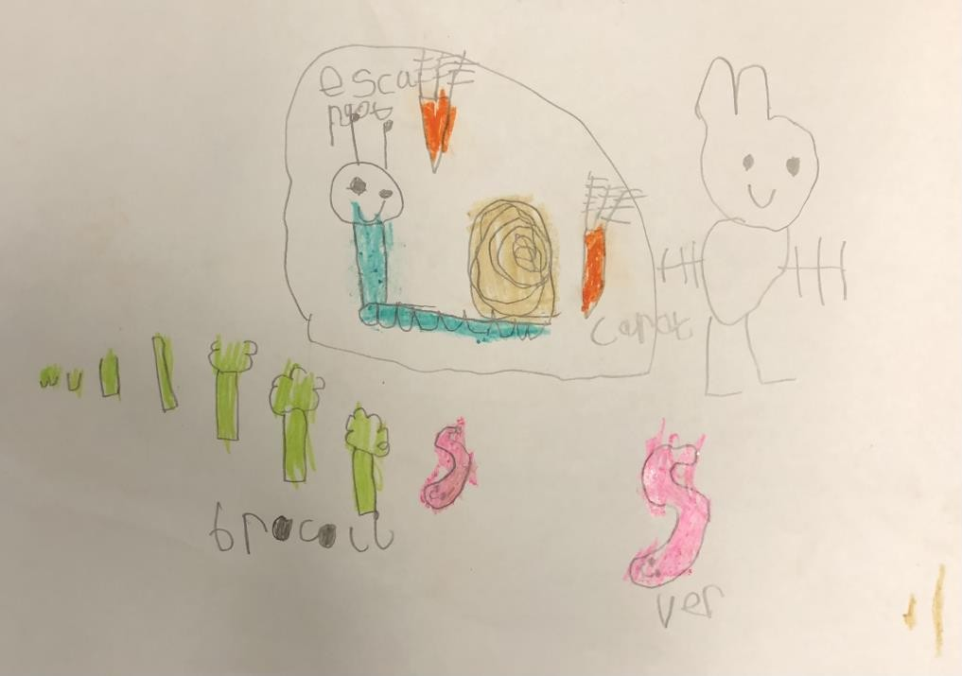
A drawing featuring the rabbit, the snail and the worm with some of the vegetables from the story accompanied by the appropriate French words (Lesson 1)

Acknowledgments

The author wishes to thank the MEd Learning & Teaching in Performing Arts team of lecturers at the Royal Conservatoire of Scotland, Lynne Jones and Karen Faulds from SCILT and the teachers who participated in this study. Her thanks also go to CALEC for publishing her Lapin bilingual books.

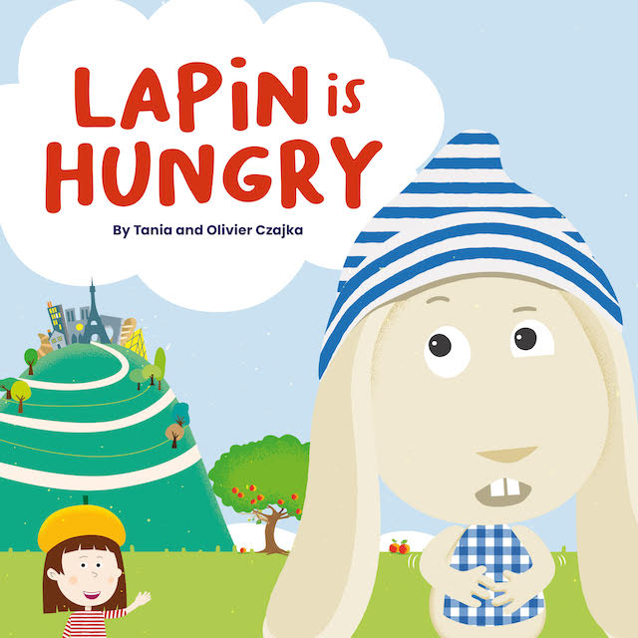
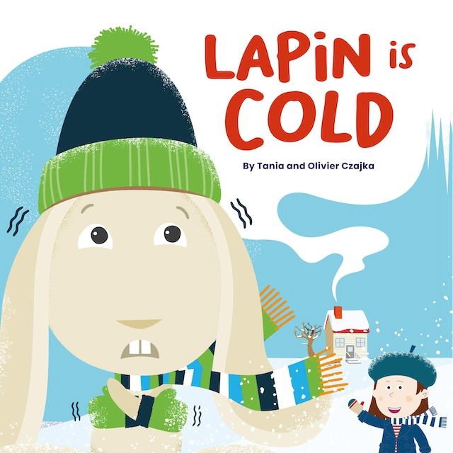

References

Clingan, E. and Coles, S. (2017) ‘Modern Languages in the multi-composite primary classroom: Meeting the challenge ’Scottish Languages Review 33
Czajka, T. (2018) Conversation with Johanna Smith, author of Puppetry in Theatre and Art Education Head, Hands and Heart. Unpublished.
Dodd-Nufrio, T. A. (2011) ‘Reggio Emilia, Maria Montessori, and John Dewey: Dispelling Teachers ’Misconceptions and Understanding Theoretical Foundations ’Early Childhood Education 39
Dudley, P. (2011) Lesson Study: a handbook. Available at: https://lessonstudy.co.uk/wp- content/uploads/2012/03/new-handbook-revisedMay14.pdf (Accessed: 31 August 2023)
Education Scotland (2017) A 1+2 approach to language learning from Primary 1 onwards. Available at: https://education.gov.scot/improvement/documents/modlang12- 1plus2approachmar17.pdf (Accessed: 31 August 2023)
Education Scotland (2018) Curriculum for Excellence: Experiences and outcomes. Available at: https://education.gov.scot/Documents/All-experiencesoutcomes18.pdf (Accessed: 31 August 2023)
Education Scotland (2019, updated 2020) Early Level Play Pedagogy Toolkit. Available at: https://education.gov.scot/improvement/learning-resources/early-level-play-pedagogy- toolkit/ (Accessed: 31 August 2023)
Education Scotland (2020) Realising the ambition: Being me. National practice guidance for early years in Scotland. Available at: https://education.gov.scot/media/3bjpr3wa/realisingtheambition.pdf (Accessed: 31
August 2023)
Froebel Trust About us: Froebelian principles. Available at: https://www.froebel.org.uk/about-us/froebelian-principles (Accessed: 1 September 2023)
Hohmann, M. & Weikart D. P. (1995) ‘Educating Young Children: Active Learning Practices for Preschool and Child Care Programs ’in Educating Young Children, a curriculum guide High/Scope Press, USA, pp. 13-41
Hunt, T. & Renfro, N. (1982) Puppetry in Early Childhood Education Nancy Renfro Studios, USA
Jones, L. (2018) Foreign language teaching policy in primary schools: Scotland Research in Primary Languages. Available at: https://ripl.uk/foreign-language-teaching-policy-in- primary-schools-scotland/ (Accessed: 1 September 2023)
McCrossan, G. (2013) ‘Creativity In Action in MLPS’ Scottish Languages Review 26 McCrossan, G. (2015) ‘French at Early level: A Pilot Study’ Scottish Languages Review 30
McLeod, S. A. (2014, updated 2023) Vygotsky’s Sociocultural Theory Of Cognitive Development Simply Psychology. Available at: https://www.simplypsychology.org/vygotsky.html (Accessed: 1 September 2023)
Scottish Government (2012) Language Learning in Scotland: A 1+2 approach to Modern Languages. Available at: https://www.gov.scot/publications/language-learning- scotland-12-approach/ (Accessed: 1 September 2023)
Smith, J. (2018) Puppetry in theatre and arts education – Head, Hands and Heart
Methuen Drama, Bloomsbury
Valdera Gil, F. & Crichton, H. (2020) ‘Mother tongue plus two languages: are Scottish primary teachers confident to deliver?’ The Language Learning Journal 48:4
Van Der Stuyf, R. (2002) ‘Scaffolding as a Teaching Strategy’, in Academia, Adolescent Learning and Development Fall 2020
Wheeler, S. (updated 2020) The Pedagogy of John Dewey: a Summary TeachThought. Available at: https://www.teachthought.com/learning/pedagogy-john-dewey-summary/ (Accessed: 4 September 2023)

Please check the Pilgrims in Segovia Teacher Training courses 2025 at Pilgrims website.

Please check the Pilgrims f2f courses at Pilgrims website.

