Letter 1
Hi Everyone,

We're still accepting presentations for the MATSDA/TMAC Conference on Humanising Language Teaching Materials on June 7th-8th.

I've provided a link below for the promotional video for the Conference and would be grateful if you could pass this on to anyone you think might be interested in presenting or just attending the Conference.

https://fltm2025.aconf.org/en-us/index.html

Best wishes,

Brian Tomlinson

Letter 2



 Our Greatest Hits!

Hello, Language Learners and all stripes of jokesters!
This week, we're diving into the topic of humor in language learning. In this issue, you'll find resources to help you better understand the role of humor across cultures and languages. We've also provided a learning activity for analyzing and engaging in humor.
Humor's a key ingredient in a meaningful life. So, here's a brief tour of yucking it up across languages!


Humor

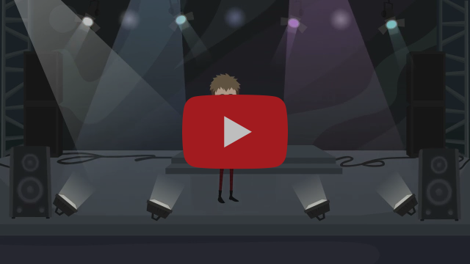
This video helps language learners understand how humor plays a role in their target language!

Learning Activity: Joke Analysis



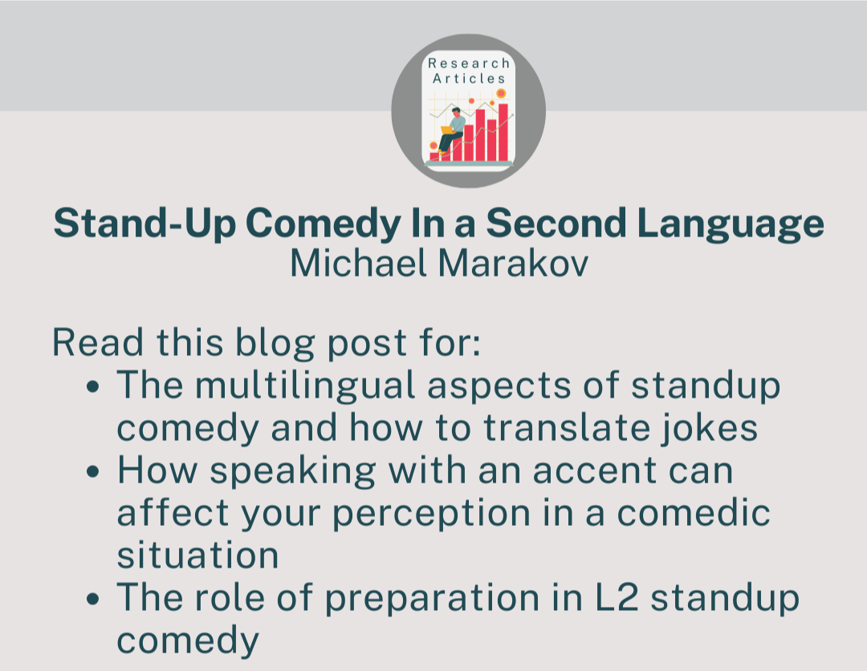



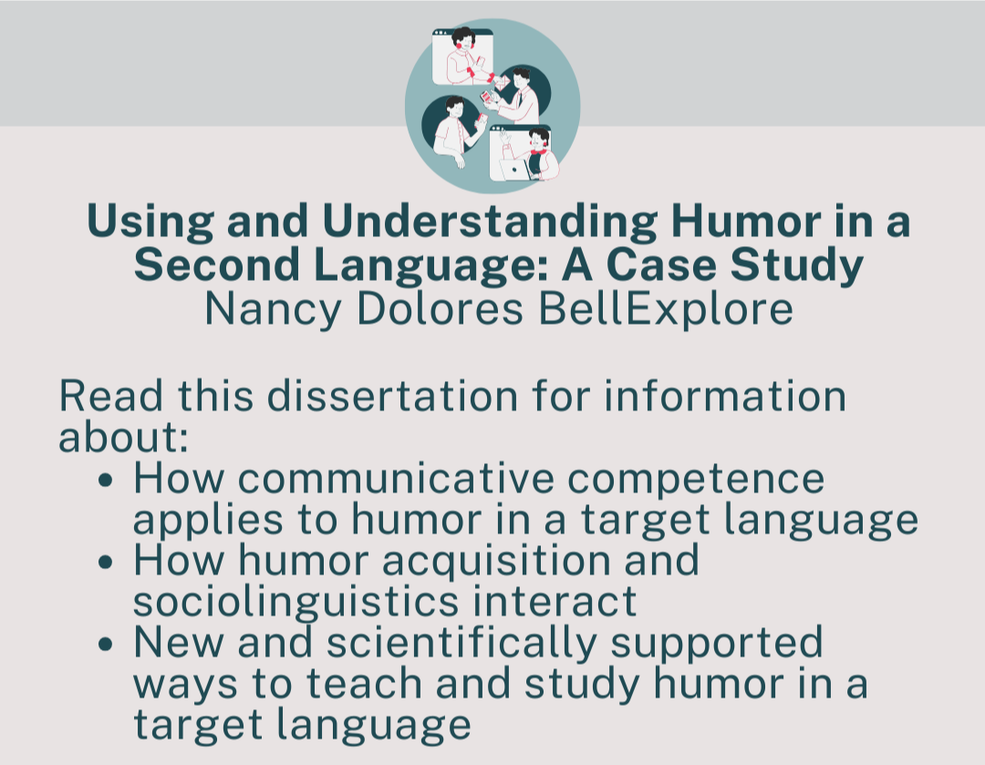

Click on each tile to access the link!



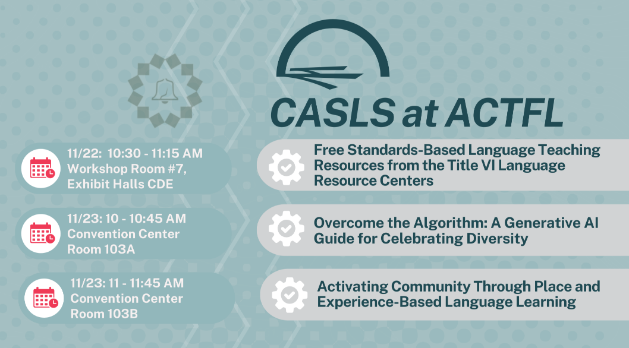

Letter 3

Dear Hania

I have just made this video. Can you help me to share it please. I try to give knowledge to teachers and parents all around the world

Is AI making our children stupid ? A book trailer by Roy J. Andersen

https://www.youtube.com/watch?v=sIxmMcEBcOY

Thank you my friend

Roy

Letter 4

Hi
If you've missed any of our online seminars, or you’d like to rewatch them, just log in to your DELTA Publishing account here and go to:
Recordings of past events
Make a splash in summer with "Dive in!"

Join Fiona Mauchline (author and teacher trainer)
Monday, 28 April | 4 pm UK time
Running short of face-to-face summer materials for teenagers this year, or perhaps you're already thinking ahead to next year? "Dive in!" could be just what you need. This dynamic, project-based short course with 4 modules from DELTA Publishing has fun, effective, engaging, personalisable activities designed specifically for teenagers attending summer courses. In this online workshop, we'll explore the kind of topics that can appeal to teens on summer programmes and we'll look at how project work is at the heart of each "Dive in!" module. We'll also look at the great mix of in- and out-of-class activities that will ensure practical, relevant language skills are acquired by teens during their short-stay English course.

See you
The DELTA Team

