Ready to Run offers a free online library of authentic video materials for teaching at levels A1 to B2 and is the winner of the latest ELTons award. The resources include a broad selection of short video stories from broadcast and real-life YouTuber sources, licensed for teaching use and professionally re-edited and graded for ELT lessons. Each video has subtitles (optional) and learning materials written by ELT experts: a teacher’s lesson guide with exercises to support all four skills, a student pack, and a transcript. The lesson design is suitable for online or classroom use, the units align to standard ELT topics, while characters speaking at level in a range of global English accents ensure students benefit fully from the authentic material.

For teaching online, Ready to Run features a one-click button for teachers to give students their own direct access to each film. It allows classes to play and replay the content on their own mobiles at home, as they work through the exercises. As a way to engage and motivate students in the YouTube generation, video with high production values and a global content is a strong proposition. Ready to Run also offers teachers advice and tips including simple ways to teach online.

To help English classes to succeed during school closures, Ready to Run has made its usual teacher package free. Sign up for the Video Pro bundle of 35 units at A1-B2 levels at https://readytorun.digitallearningassociates.com

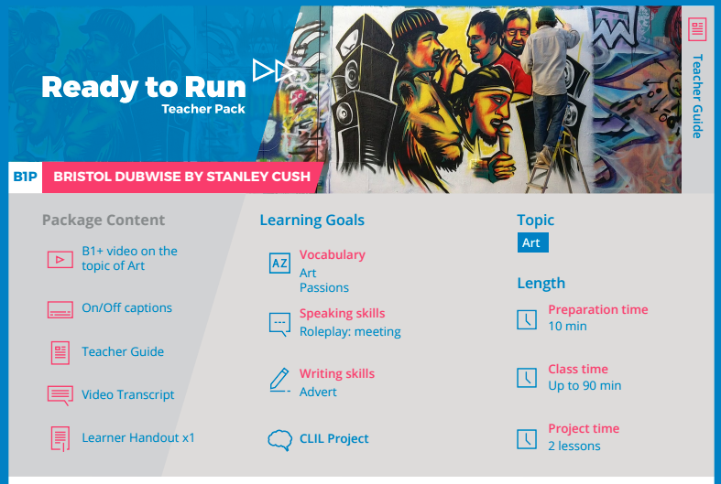
Sample resource pack for B1+ unit on language for arts and creativity.

Dodaj pdf na dole

